¹⁸F-Labeling of Peptides and Proteins with Silicon Fluoride Acceptors (SiFAs) for Positron Emission Tomography

Authors: Katy M. Orchowski, Joshua Chin, Vadim Bernard-Gauthier, Ralf Schirrmacher, Alexey P. Kostikov

Authors: institution(s)/affiliation(s) for each author:

Katy M. Orchowski
McConnell Brain Imaging Centre, Montreal Neurological Institute, McGill University
Integrated Program in Neuroscience, McGill University
katy.orchowski@mail.mcgill.ca

Joshua Chin
McConnell Brain Imaging Centre, Montreal Neurological Institute, McGill University
Department of Chemistry, McGill University
joshua.chin@mail.mcgill.ca

Vadim Bernard-Gauthier
McConnell Brain Imaging Centre, Montreal Neurological Institute, McGill University
Département de Chimie, Université de Montréal
vadim.bernard-gauthier@umontreal.ca

Ralf Schirrmacher
McConnell Brain Imaging Centre, Montreal Neurological Institute, McGill University
Lady Davis Institute of Medical Research, Jewish General Hospital, McGill University
ralf.schirrmacher@mcgill.ca

Alexey P. Kostikov
McConnell Brain Imaging Centre, Montreal Neurological Institute, McGill University
alexey.kostikov@mail.mcgill.ca

Corresponding author: Ralf Schirrmacher

Keywords: radioactive labeling, in vivo imaging, positron emission tomography (PET), fluorine-18, silicon fluoride acceptor (SiFA)

Short Abstract: The synthesis of fluorine-18 (¹⁸F) labeled radiopharmaceuticals for positron emission tomography (PET) is challenging, typically requiring many years of radiolabeling experience. Silicon fluoride acceptor (SiFA) building blocks attached to imaging agents provide a simple ¹⁸F-labeling protocol that is independent of costly equipment and preparatory training.

Long Abstract:
Fluorine-18 (109 minute half-life, 97% positron emission ¹⁸F) is among the most important radionuclides for positron emission tomography (PET), a noninvasive imaging method that visualizes and quantifies the bio-distribution of radiolabeled tracers for various diseases ¹. Peptides and proteins are especially difficult to label with ¹⁸F because they require building blocks formed by multi-step syntheses ². Otherwise, macromolecules would constitute a large proportion of available PET tracers. To reduce the complexity of ¹⁸F-radiolabeling, silicon fluoride acceptors (SiFAs) were recently introduced as reliable tools ³. The SiFA group consists of a central silicon atom connected to two tertiary butyl groups, a derivatized phenyl moiety, and a non-radioactive fluorine atom. The two tertiary butyl groups impart hydrolytic stability to the silicon-fluoride bond, which is a critical feature for in vivo applications of SiFA conjugates as imaging agents. When attached to a bio-molecule, the SiFA building blocks bind radioactive ¹⁸F anions by exchanging ¹⁹F for ¹⁸F at nanomolar concentrations without forming significant amounts of radioactive side products ⁴ (Figs. 1,2). Moreover, a high radiochemical yield is quickly achieved by labeling the SiFA moiety in dipolar aprotic solvents at low temperatures. This is in stark contrast to classical isotopic exchange reactions, which produce radiotracers of low specific activity ⁵. In these cases, large amounts of precursor (in the range of milligrams) must be used to obtain a reasonable incorporation of ¹⁸F. Isotopic exchange reactions using SiFAs are far more efficient, as confirmed by kinetic studies and density functional theory calculations ^{6,7}. Labeled SiFAs are easily purified by solid phase extraction since both the labeled and unlabeled SiFA compounds are chemically identical; normally, the labeling precursor and the labeled product are two different chemical species that must be separated by high-performance liquid chromatography (HPLC). Using SiFA building blocks, peptides and proteins are successfully labeled with ¹⁸F by one- and two-step labeling protocols devoid of complicated purification procedures ^{4,8,9}. Moreover, some SiFA-labeled compounds are reliable in vivo imaging agents for blood flow and tumors ¹⁰. The simplicity of SiFA chemistry enables even untrained investigators to use ¹⁸F for radiotracer synthesis and development.

Protocol Text:

1) Azeotropic Drying of ¹⁸F-Anion

1.1) Precondition a QMA SepPak Light cartridge (Waters) with 0.5 M K₂CO₃ (10 mL) followed by deionized water (10 mL).

1.2) Pass aqueous [¹⁸F]F⁻/H₂[¹⁸O]O (5-50 mCi) through the preconditioned QMA cartridge. Discard the H₂[¹⁸O]O.

1.3) Elute the fixed ¹⁸F⁻ from the QMA cartridge into a Wheaton vial with a premade solution of Kryptofix 2.2.2® (10 mg), 0.2 M K₂C₂O₄ (50 μL, 10 μmol), and acetonitrile (1 mL). Place the vial in a mineral oil bath positioned on a hot plate.

1.4) Remove the solvents under a gentle vacuum (Heidolph pump, 500 mbar) and a sweep stream of argon at 90°C. Remove any remaining traces of water by azeotropic co-evaporation with acetonitrile (1 mL). Complete this step twice to ensure dryness.

1.5) Once the solvents are visibly removed, stop the argon flow, set the vacuum to maximum (10 mbar), and dry for another two minutes.

1.6) Add acetonitrile (1 mL) to the dry residue to make a solution of highly reactive ¹⁸F⁻ (5-50 mCi).

2) One-Step SiFA-Peptide Labeling

2.1) Precondition a C-18 SepPak Light cartridge (Waters) by subsequently rinsing it with ethanol (10 mL) and distilled water (10 mL).

2.2) Add the ¹⁸F⁻ (450-500 μL, 5-50 mCi) to a solution containing a SiFA-peptide (Fig. 1A). Allow the labeling reaction to proceed for five minutes at room temperature without stirring the solution.

2.3) Add 0.1 M phosphate buffer (9 mL, pH 4) to the solution, and load the mixture onto the preconditioned C-18 cartridge.

2.4) Wash the cartridge with distilled water (5 mL), elute trapped [¹⁸F]SiFA-peptide from the C-18 cartridge with ethanol (300 μL), and dilute with sterile phosphate buffer for injections (3 mL).

2.5) Pass the purified [¹⁸F]SiFA-peptide through a sterile filter. To obtain a clear PET image, the final product's concentration should be between 0.5-2 mCi/mL (Fig. 1A).

2.6) Inject a small aliquot (40 μL) of the purified [¹⁸F]SiFA-peptide onto an HPLC system (Agilent Technologies) equipped with a reversed phase C-18 column (LiChrosorb RP-select) to confirm that the radiochemical purity is greater than 95% (Fig. 1B).

3) Two-Step Protein Labeling via succinimidyl 3-(di-tert-butyl[¹⁸F]fluorosilyl)benzoate ([¹⁸F]SiFB)

3.1) Precondition a C-18 SepPak Light cartridge (Waters) with ethanol (10 mL) followed by distilled water (10 mL).

3.2) Add a solution of 0.1 M H₂C₂O₄ (50 µL, 5 µmol) in anhydrous acetonitrile to the ¹⁸F⁻ solution (1 mL, 30-50 mCi).

3.3) Add succinimidyl 3-(di-tert-butylfluorosilyl)benzoate (SiFB) (50 µL, 130 nmol, 1 µg/µL in acetonitrile) to the ¹⁸F⁻ solution. Keep the reaction mixture at room temperature for five minutes.

3.4) Dilute the mixture with distilled water (10 mL), pass through the preconditioned C-18 cartridge, and wash the C-18 cartridge with water (10 mL). Elute the [¹⁸F]SiFB from the cartridge with diethyl ether (3 mL).

3.5) Evaporate the diethyl ether under a stream of argon.

3.6) Use radio-thin layer chromatography (Raytest) to confirm that the radiochemical purity is greater than 98% (Fig. 3).

3.7) Re-dissolve the [¹⁸F]SiFB in borate buffer (0.5 mL, pH 9), and add to a solution of protein (0.5 mL). In this example, we used rat serum albumin (RSA) dissolved in borate buffer (0.5 mL, 2 mg/mL).

3.8) After 30 minutes at room temperature, inject 5 mCi of the solution onto an HPLC system equipped with a size exclusion column (BIOSEP-SEC-S4000) to purify the labeled protein. Use the collected [¹⁸F]SiFB-labeled RSA protein fraction (Fig. 4) in animal PET studies to visualize the blood pool.

4) Applying SiFA-Protein Labeling In Vivo using Positron Emission Tomography

4.1) Inject [¹⁸F]SiFB-RSA (1 mCi) into a healthy, anesthetized rat that is positioned in a micro-PET scanner (Siemens).

4.2) Acquire dynamic PET data for one hour. Reconstruct the PET image using two-dimensional filtered backprojection to create a time-series of three-dimensional images.

4.3) Define volumes of interest within each time frame to determine the amount of activity in a specific region over a period of time.

Representative Results: The SiFA technique is an easy approach to labeling peptides and proteins with a minimum amount of complexity. Peptides can be labeled with ¹⁸F in one step without involving HPLC purification. After solid phase extraction, the labeled peptide has a radiochemical purity greater than 95% (Fig. 1B) and can be easily formulated for in vivo PET applications. Labeling larger molecules, like proteins, requires the synthesis of small SiFA-bearing labeling synthons, such as [¹⁸F]SiFB, followed by active ester labeling of free amino groups in the lysine side-chains of a protein. After purification by size-exclusion chromatography, labeled proteins have a radiochemical purity greater than 98% (Fig. 3). Labeled proteins can also be used for in vivo applications; in this example, the labeled rat serum albumin was a valuable tool to measure the blood pool in a healthy rat using PET (Fig. 5).

Tables and Figures:

A)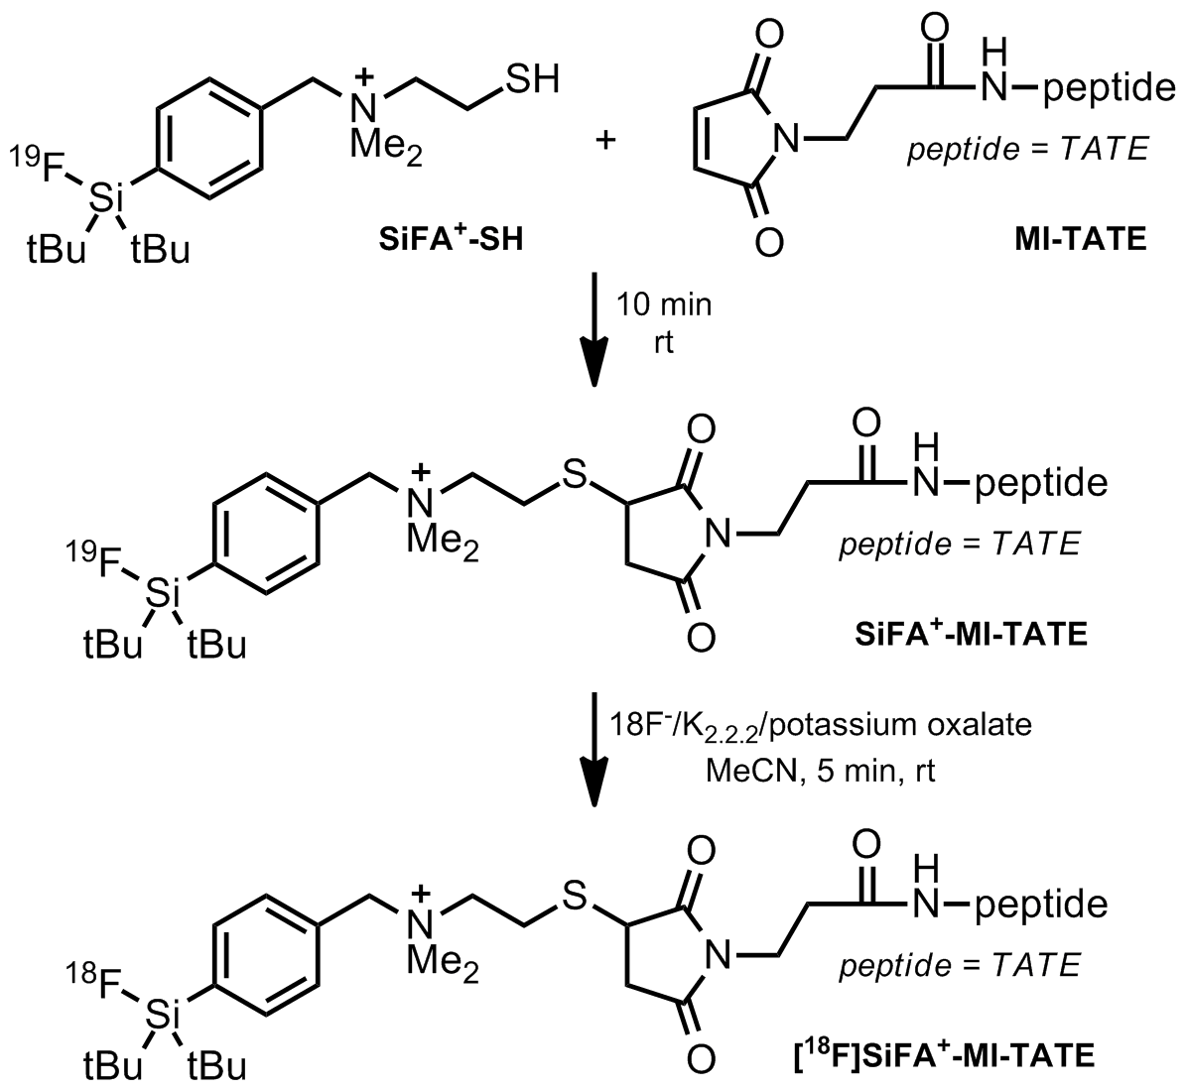

B) 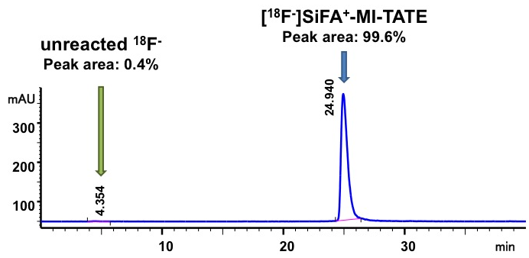

Figure 1: Synthesis of [¹⁸F]SiFA⁺-maleimido-Tyr³-octreotate ([¹⁸F]SiFA⁺-MI-TATE): A) Solution phase conjugation of SiFA⁺-SH to MI-TATE at pH 9 and radioactive labeling of [¹⁸F]SiFA⁺-MI-TATE via simple isotopic exchange (¹⁹F-¹⁸F); B) HPLC quality control of solid phase cartridge purified [¹⁸F]SiFA⁺-MI-TATE showing 99.6% purity of the labeled peptide and total absence of un-reacted ¹⁸F⁻

A)
B)

Figure 2: Succinimidyl 3-(di-tert-butyl[¹⁸F]fluorosilyl)benzoate ([¹⁸F]SiFB): A) Synthesis and B) Bio-conjugation to a protein

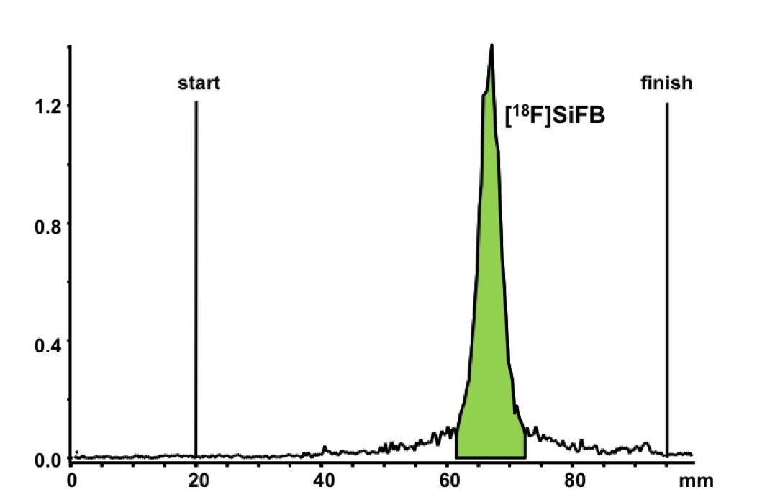

Figure 3: Radio-TLC quality control of the labeling synthon [¹⁸F]SiFB after solid phase purification

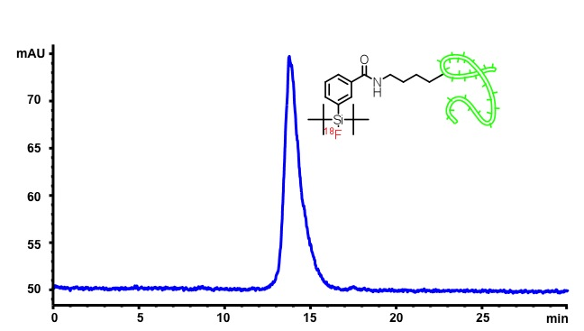

Figure 4: Final radio-HPLC chromatogram of the purified [¹⁸F]SiFB-labeled RSA

A)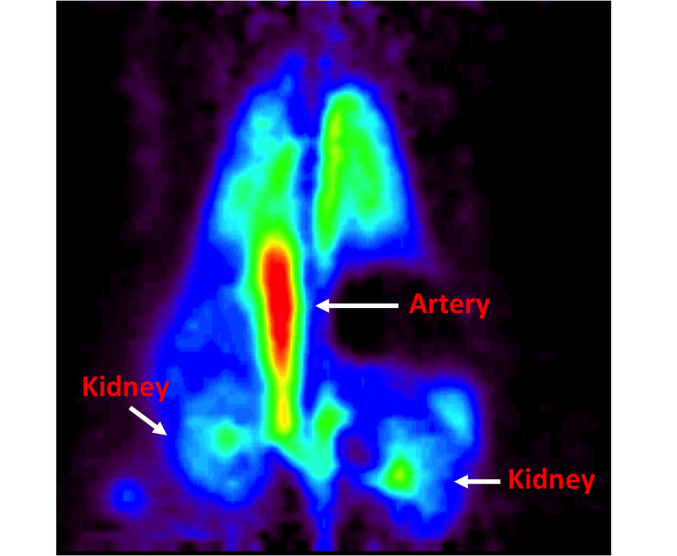 B) 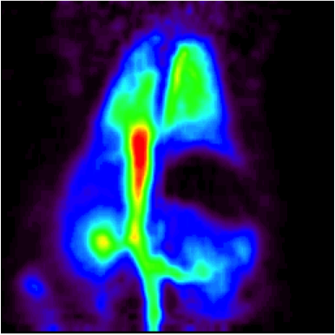
C)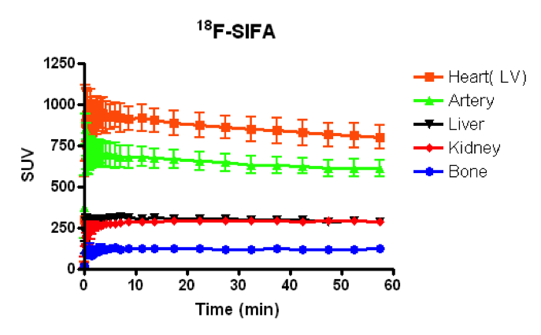

Figure 5: micro-PET data: A) Reconstructed image of [¹⁸F]SiFB-labeled RSA; B) Reconstructed image of [¹⁸F]SFB-labeled RSA; C) Time-Activity curve for [¹⁸F]SiFB-labeled RSA

Discussion: SiFA labeling chemistry represents one of the first ¹⁸F-labeling methods employing an extraordinarily efficient isotopic exchange reaction at room temperature or below. In common radiochemistry, which is based on the formation of a carbon-fluorine bond, final purification of the labeled compound from its precursor requires a laborious HPLC separation. With the SiFA technique, the labeling precursor and ¹⁸F-labeled compound are chemically identical. Moreover, no side products are usually observed since the reaction proceeds under very mild conditions. These features make it possible to purify ¹⁸F-labeled SiFA compounds using simple solid phase extraction.

Peptides derivatized from the SiFA building block (e.g. SiFA-octreotate) can be labeled with ¹⁸F in one step; however, SiFA labeling of proteins requires a two-step protocol. A small, highly reactive SiFA-prosthetic group (e.g. [¹⁸F]SiFB) has to be prepared and reacted with the given protein, and the labeled protein must then be purified by HPLC. Afterwards, the pure protein fraction can be injected into a rat and scanned using micro-PET to demonstrate the bio-distribution of the SiFA-labeled protein. In this example, a thorough analysis of the PET data revealed that [¹⁸F]SiFB-labeled RSA is a reliable in vivo blood pool imaging agent.

Acknowledgments: R.S. wishes to thank the Canadian National Science and Research Council and the Quebec Bio-Imaging Network, FRSQ for support.

Disclosures: I have nothing to disclose.

Table of specific reagents and equipment:

Name | Company | Catalogue number | Comments
Reagents:
[¹⁸F]F⁻/H₂[¹⁸O]O | Huayi Isotopes | (none)
Potassium carbonate | Aldrich | 209619
Kryptofix 2.2.2® | Aldrich | 291110
Acetonitrile anhydrous | Aldrich | 271004
Deionized water | Baxter | JF7623
Ethanol anhydrous | Commercial Alcohols | (none)
Oxalic acid | Aldrich | 241172
Diethyl ether | Fisher | E-138-4
Rat serum albumin | Aldrich | A6272
Equipment:
Vacuum pump | Heidolph
QMA SepPak Light cartridge | Waters | 186004051
C-18 SepPak Light cartridge | Waters | WAT023501
Sterile filter 0.22µm | Millipore
Radio-TLC Mini Gita | Raytest
HPLC 1200 | Agilent Technologies
HPLC size exclusion column BIOSEP-SEC-S4000 | Phenomenex
HPLC C-18 column LiChrosorb RP-select B 5 µm | MZ-Analytical
micro-PET R4 Scanner | Siemens

References:

1. Wahl, R.L. & Buchanan, J.W. (eds). Principles and practice of positron emission tomography. Lippincott Williams & Wilkins, Philadelphia, PA (2002).

2. Wängler, C., Schirrmacher, R., Bartenstein, P. & Wängler, C. Click-chemistry reactions in radiopharmaceutical chemistry: Fast & easy introduction of radiolabels into biomolecules for in vivo imaging. Curr. Med. Chem. 17, 1092-1116 (2010).

3. Schirrmacher, R. et al. 18F-labeling of peptides by means of an organosilicon-based fluoride acceptor. Angew. Chem. Int. Ed. Engl. 45, 6047-6050 (2006).

4. Kostikov, A.P. et al. Oxalic acid supported Si-18F-radiofluorination: One-step radiosynthesis of N-succinimidyl 3-(di-tert-butyl[18F]fluorosilyl)benzoate ([18F]SiFB) for protein labeling. Bioconjug. Chem. Published online (2011).

5. Cacace, F., Speranza, M., Wolf, A.P. & Macgregor, R.R. Nucleophilic aromatic substitution; kinetics of fluorine-18 substitution reactions in polyfluorobenzenes. Isotopic exchange between 18F- and polyfluorobenzenes in dimethylsulfoxide. A kinetic study. J. Fluor. Chem. 21, 145-158 (1982).

6. Schirrmacher, E. et al. Synthesis of p-(di-tert-butyl[(18)F]fluorosilyl)benzaldehyde ([(18)F]SiFA-A) with high specific activity by isotopic exchange: A convenientlabeling synthon for the (18)F-labeling of N-amino-oxy derivatized peptides. Bioconjug. Chem. 18, 2085-2089 (2007).

7. Kostikov, A. et al. N-(4-(di-tert-butyl[18F]fluorosilyl)benzyl)-2-hydroxy-N,N-dimethylethylammonium bromide ([18F]SiFAN+Br-): A novel lead compound for the development of hydrophilic SiFA-based prosthetic groups for 18F-labeling. J. Fluor. Chem. 132, 27-34 (2011).

8. Wängler, B. et al. Kit-like 18F-labeling of proteins: Synthesis of 4-(di-tert-butyl[18F]fluorosilyl)benzenethiol (Si[18F]FA-SH) labeled rat serum albumin for blood pool imaging with PET. Bioconjug. Chem. 20, 317-321 (2009).

9. Iovkova, L. et al. para-Functionalized aryl-di-tert-butylfluorosilanes as potential labeling synthons for (18)F radiopharmaceuticals. Chemistry. 15, 2140-2147 (2009).

10. Wängler, C. et al. One-step 18F-labeling of carbohydrate-conjugated octreotate-derivatives containing a silicon-fluoride-acceptor (SiFA): In vitro and in vivo evaluation as tumor imaging agents for positron emission tomography (PET). Bioconjug. Chem. 21, 2289-2296 (2010).

