Combining stereotaxic brain infusions with pancreatic clamp studies in conscious non–restrained rats.
Suggested reviewers:
Tony Lam, University of Toronto, tony.lam@uhnres.utoronto.ca
Kevin Niswender, Vanderbilt University, kevin.d.niswender@vanderbilt.edu
Matthias Tschöp, University of Cincinnati, matthias.tschoep@uc.edu
Owen McGuinness, Vanderbilt University, Owen.McGuinness@vanderbilt.edu
David Wassermann, david.wasserman@vanderbilt.edu

Authors:
Thomas Scherer, Elizabeth Zielinski, James O’Hare, Christoph Buettner
Authors:
Thomas Scherer
Department of Medicine and Department of Neuroscience
Mount Sinai School of Medicine
New York, NY
thomas.scherer@mssm.edu

Elizabeth Zielinski
Department of Medicine and Department of Neuroscience
Mount Sinai School of Medicine
New York, NY
Liz.zielinski@gmail.com

James O’Hare
Department of Medicine and Department of Neuroscience
Mount Sinai School of Medicine
New York, NY
james.ohare@mssm.edu

Christoph Buettner
Department of Medicine and Department of Neuroscience
Mount Sinai School of Medicine
New York, NY
christoph.buettner@mssm.edu
Corresponding author:
Christoph Buettner
Keywords:
brain; stereotaxic cannulation; intracerebroventricular infusion; pancreatic clamp studies; rats

Short Abstract:
A method to assess the isolated brain effects of hormones/drugs on glucose metabolism in conscious non-restrained rats is described. In order to control for circulating insulin and glucose levels, which can be altered by intracerebral infusion of hormones/drugs, pancreatic clamp studies are combined with stereotaxic brain infusions.

Long Abstract:
In the last decade the brain has emerged as an important metabolic organ that can regulate not only food intake, but also energy metabolism. Stereotaxic brain infusion in rats is a valuable tool to evaluate hormone and/or drug effects in defined anatomical brain regions, since specific nuclei within the brain can be targeted. However, intracerebral administration of certain hormones and/or drugs can alter pancreatic insulin secretion and circulating glucose levels^{1,2,3}. This is especially of concern in metabolic studies, because both insulin and glucose are able to affect energy metabolism. Therefore, in order to assess the isolated brain effects of hormones and/or drugs on energy metabolism in vivo, glucose and insulin levels have to be controlled. Here we show how to achieve this by combining stereotaxic brain infusions with euglycemic pancreatic clamp studies, which allows simulation of fasted or post-prandial circulating insulin levels while maintaining euglycemia^{4,5,6}. In order to perform these experiments in conscious non-restrained rats, we equip animals with indwelling brain cannulae⁷ (targeting any desired brain region) as well as chronically implanted jugular and arterial catheters, which enable simultaneous infusion and blood sampling, respectively. The study protocol presented consists of a baseline period, where only the brain infusion is running, followed by a euglycemic pancreatic clamp. The two-step protocol allows us to assess the effects of a stereotaxic brain infusion before and during a clamp. Furthermore, by using this approach we are able to analyze the changes that might occur due to the transition into the fed state, which is mimicked by increasing systemic insulin levels during the clamp. Finally, this method can be extended by combining it with stable isotope and/or radioactive tracer infusions to analyze in vivo metabolite flux.
Protocol Text:
- Rats are stereotaxically fit with cannulae targeting desired brain regions 2 weeks before the study⁷. One week before the clamp, carotid arterial and jugular venous catheters are implanted for blood sampling and infusion, respectively. After both surgeries, rats are monitored daily and s.c. injected with buprenorphine (0.01-0.05 mg/kg) BID for 3 consecutive days. Rats are required to recover to within 10% of pre-surgical body weight (BW).
- Place rat in a new cage with bedding, allow ~15 minutes to habituate.

- Catheter Syringe Preparation
  - For the arterial catheter: attach a luer stub, made by blunting a 23 gauge needle, to one end of 75 cm of PE 50 tubing. To the other end, attach a catheter coupler made from a doubly blunted 23 gauge needle.
  - For the venous catheter: attach a luer stub, made by blunting a 20 gauge needle, to one end of 75 cm of PE 90 tubing. To the other end, attach a catheter coupler made by blunting a 20 gauge needle and pulling it out of the plastic luer piece.
- Flush both pieces of tubing through with heparinized saline (40 U/mL) from 10 mL syringes.
- To prevent rats from biting tubing, thread arterial and venous tubing through a plastic guard created by cutting the tip of a 1 mL syringe cylinder.

- Preparation of stereotaxic infusion
  - Fill a Hamilton glass syringe with d-H₂O, avoiding any bubbles in the syringe.
  - Prepare a piece of PE50 tubing long enough to reach from the pump to the rat by attaching an infusion cannula to one end, and a 23 gauge luer stub (described in 3a) to the other. Flush the tubing through with water and insert the Hamilton syringe into the needle, there must not be any air in the infusion system at this point. Flush out any remaining water from the system.
  - Aspirate 1 µL of air into the tubing to separate the d-H₂O from the treatment, and then aspirate the desired treatment.
  - Secure syringe to pump and prime the infusion system.

- Connecting Catheters
  - Carefully, expose catheters without irritating the rat.
  - Clamp tubing, remove venous catheter plug and insert catheter coupler attached to syringe (described above in 2). Draw back blood until it reaches the syringe, and flush so that the tubing is filled with heparinized saline and no blood.
  - Repeat with arterial catheter. Once flushed, clamp arterial catheter syringe tubing with a hemostat.
  - Remove dummy cannula and insert the primed infusion cannula to the stereotaxically implanted guide cannula. Secure the infusion cannula to the guide with glue. Generally, the rats do not have to be restrained during these procedures.
  - Swivel usage (optional)
    - The tubing from the brain infusion and the venous catheter can alternatively be connected to a 2-channel swivel, which prevents tangling. Flexible silicone tubing can then be used to connect the swivel to the rat.

- Blood Sampling
  - Hold all syringes upright to avoid air bubble injection.
  - Draw back blood from the arterial catheter until it reaches the tip of the catheter syringe. Clamp the line with hemostat, remove the syringe, and replace it with a 1 mL syringe (“Dead Volume” syringe).
  - Draw back 0.5 mL of blood (the dead volume), then insert a new 1 mL syringe (the “Sample” syringe) and take a sample.
  - Immediately re-inject dead volume, flush catheter and clamp with hemostat.
  - Collect blood into an EDTA tube. Measure glucose and centrifuge for 2 min. to collect plasma, saving 150 μL for use in the insulin preparation described below (Step 10).
  - Resuspend remaining blood cells in saline and reinject after each sample to minimize overall blood loss.

- Start brain infusion and timer (t=-120). Protocol outline depicted in Fig 1.

- Solution preparations
  - Insulin Solution, based on an infusion rate of 25 µL/min: prepare 5 mL of insulin mixture in a 10 mL syringe with a 23 Gauge luer stub consisting of:
    - 150 µL plasma (5% plasma solution, to prevent insulin from sticking to PE tubing),
    - Insulin Dose, calculated as follows: BW (kg) * insulin dose (mU/kg/min) * 200 (conversion factor) = µL of insulin from a 1 mU/mL insulin stock,
    - 3 µg/kg/min, calculated as follows: BW (kg) * 1200 (conversion factor) = µL of a 0.5 µg/µL SRIF stock,
    - Add saline to reach a total volume of 5 mL.
  - Glucose: Prepare about 3 mL of 25% glucose in a 10 mL syringe with a 23 Gauge luer stub.
  - Tracer (optional).
- Prepare the Infusion Tubing outlined in Figure 3. Prime glucose, insulin, and (optional) tracer lines and clamp each with hemostat.
  - Prepare catheter coupler (as in 3b) to connect PE50 tubing to PE90 venous tubing and insert to Infusion Tubing.
  - Draw back blood into the venous catheter to visualize successful infusion and connect the Infusion Tubing to venous catheter.

- Collect a pre-clamp blood sample (t=120). Begin infusions by starting pumps and unclamping each line.
  - Insulin infusion begins at a rate of 44 µL/min for 1 minute, followed by 25 µL/min until the end of the clamp.
  - Set Glucose Pump rate according to insulin dose. For example, a 1 mU clamp starts at 3 µL/min whereas a 3 mU clamp starts at a rate of 10 µL/min.
  - (Optional) Tracer infusion may be initiated at any time before the clamp.

- Monitor blood glucose every 10 min and adjust Glucose Pump rate accordingly (as shown in Representative Results). GIR is calculated based on BW and pump rate as in Equation 1. Collect samples when desired.
- Terminate clamp by injecting rat with ketamine or pentobarbital slowly IV.
Representative Results:

Body Weight (kg) | 0.32 |  |  |  | Body Weight (kg) | 0.31
 |  |  | 1 mU Clamp |  |  |  |  | 3 mU Clamp
Time (min) | Glucose (mg/dL) | Pump Rate (µL/min) | GIR (mg/kg/min) |  | Time (min) | Glucose (mg/dL) | Pump Rate (µL/min) | GIR (mg/kg/min)
-120 | 111 |  |  |  | -120 | 118
0 | 93 |  |  |  | 0 | 118
30 | 94 |  |  |  | 30 | 113
60 | 96 |  |  |  | 60 | 110
70 | 92 |  |  |  | 70 | 127
80 | 86 |  |  |  | 80 | 118
90 | 91 |  |  |  | 90 | 115
100 | 88 |  |  |  | 100 | 113
110 | 90 |  |  |  | 110 | 116
120 | 86 |  |  |  | 120 | 113
150 | 85 | 4 | 3.13 |  | 150 | 133 | 15.5 | 12.38
180 | 107 | 3.8 | 2.93 |  | 180 | 131 | 12.3 | 9.78
190 | 106 | 3.5 | 2.73 |  | 190 | 122 | 10 | 7.99
200 | 100 | 3.5 | 2.73 |  | 200 | 127 | 10 | 7.99
210 | 110 | 3.5 | 2.73 |  | 210 | 115 | 9 | 7.19
220 | 102 | 3 | 2.34 |  | 220 | 114 | 9.5 | 7.59
230 | 125 | 3 | 2.34 |  | 230 | 111 | 9.5 | 7.59
240 | 122 | 1 | 0.78 |  | 240 | 117 | 9.5 | 7.59

Plasma Insulin (ng/mL)
 | 120 | 180 | 240
1 mU Clamp | 1.6 | 1.5 | 1.5
3 mU Clamp | 1.6 | 3.5 | 3.7

Glucose was sampled at the indicated time points. Brain infusion began at t = -120, and the clamp was initiated at t = 120. Note that the pump rate was adjusted according to the blood glucose levels. Plasma insulin levels were measured after the experiment from samples obtained before and after the initiation of the clamp. GIR was calculated according to Equation 1. The hyperinsulinemic clamp (3 mU) resulted in about a doubling of circulating insulin levels while the basal (1 mU) clamp maintained insulin levels from baseline.

Tables and Figures:
Fig. 1
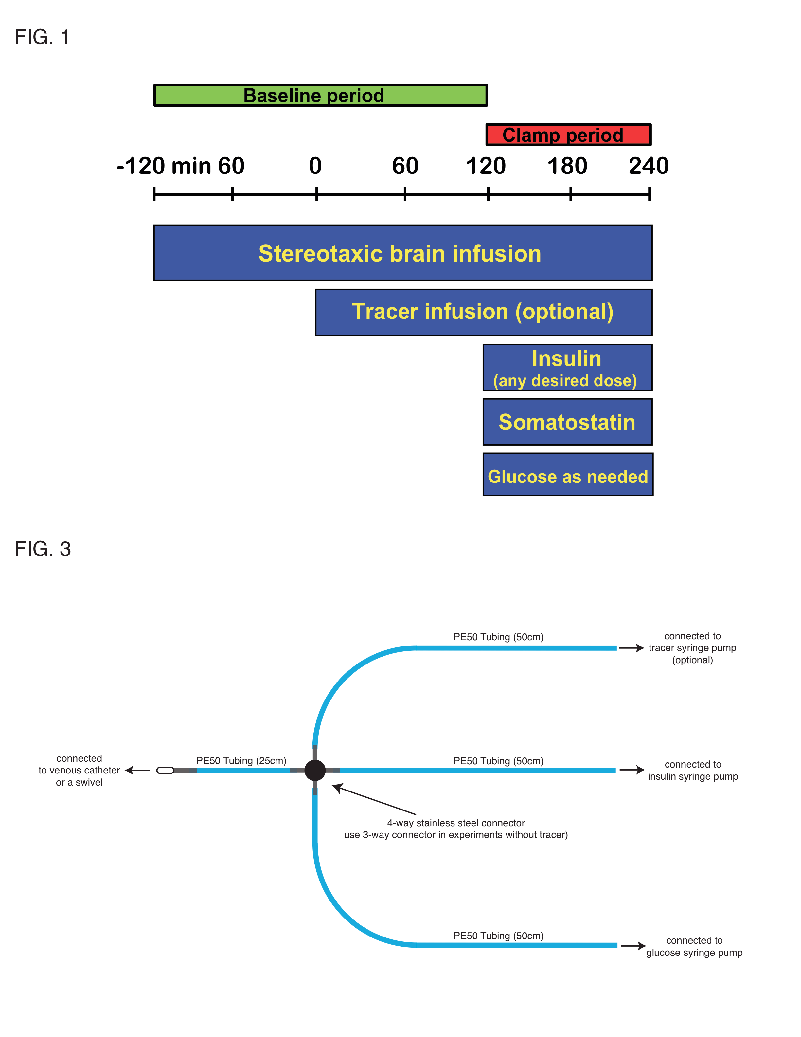
Figure 1: Overview. Study outline consists of a 4 hour baseline period followed by a 2 hour clamp period. Protocol can be adjusted as needed.

Fig. 2
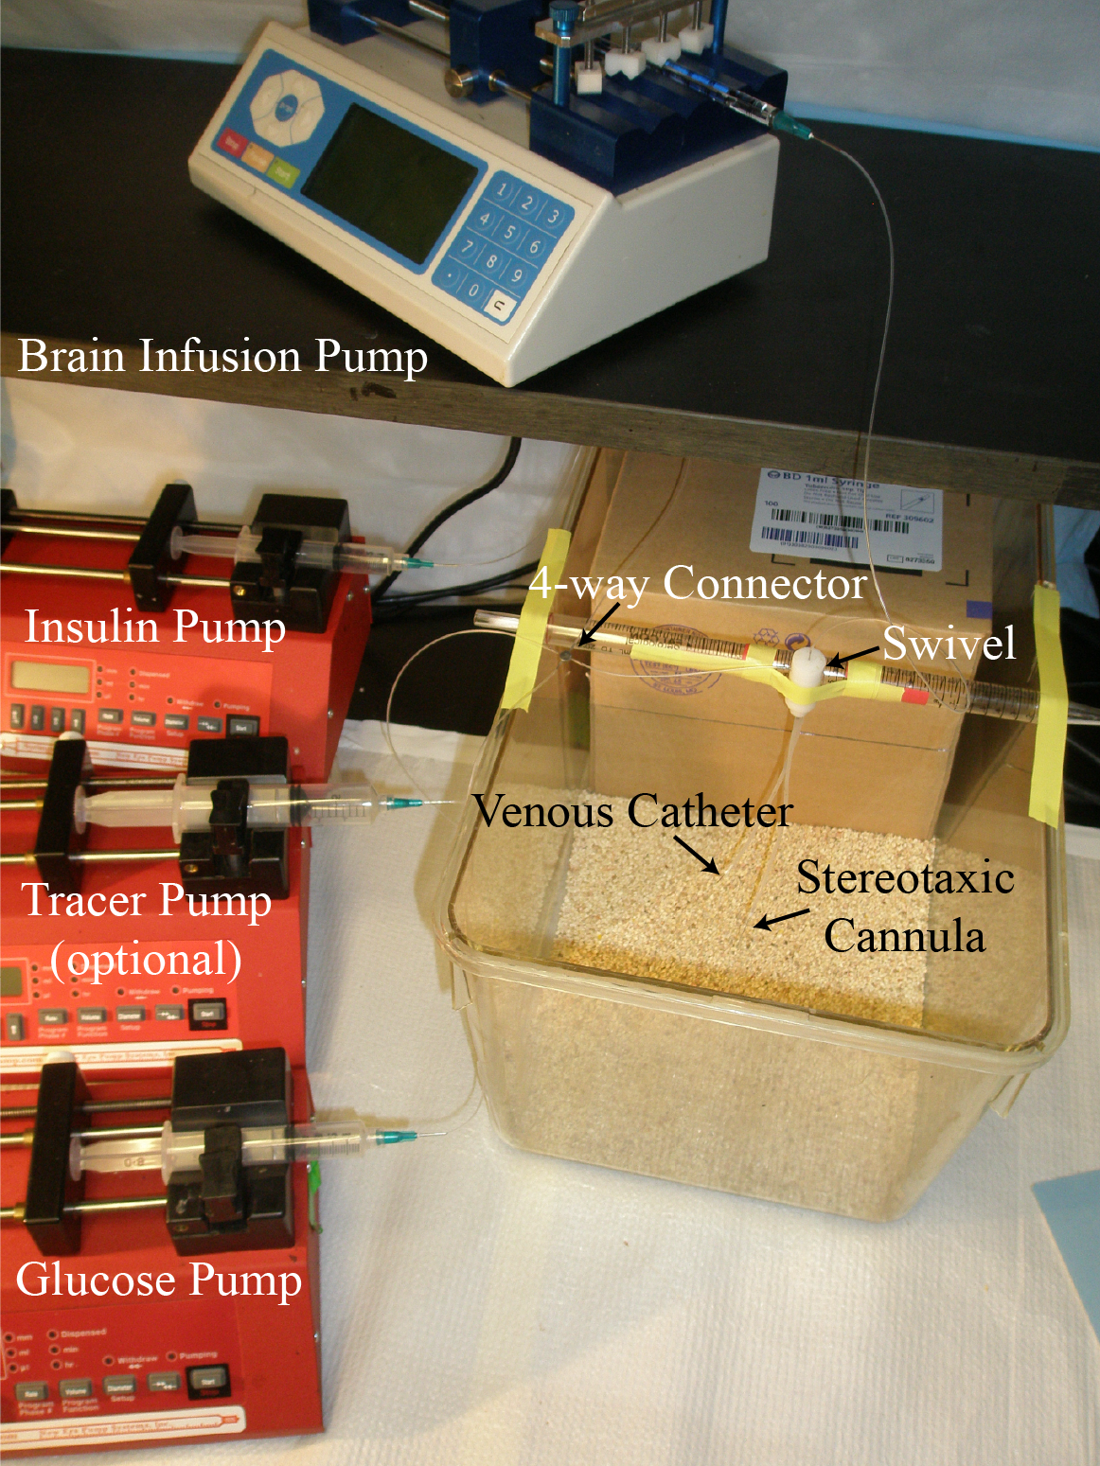
Figure 2: Clamp setup. Here we depict the setup utilizing the optional 2-channel swivel.
Fig. 3
Figure 3: Schematic outline for tubing preparation.
Equation 1:

Discussion:
1) Postoperative care is key to a successful experiment. Closely monitor the rats for signs of infection, pain and distress. Measure body weight daily.
2) The most critical step is hooking up the rats in a stress-free manner. In order to achieve this, rats should be given some time in the new cage to explore and habituate to the environment.
3) When manipulating and connecting the catheters care should be taken. Use forceps in order to grab catheters close to the body of the animal. This is less scary for the rat than having a human hand too close. Avoid sudden movements! Even though the rat may pull back or startle, it very rarely bites. When connecting the catheters to the syringe tubing try to follow the movements of the rat within the cage avoiding too much tension on the catheters.
5) Routinely, we do not use a swivel to connect venous catheters and brain infusion, since rats sleep most of the time during the procedure. However, when a rat is stressed and turns frequently within the cage, a swivel can be very helpful. We usually keep the arterial catheter for blood sampling separate from the swivel, because it has a lose end and can be untangled easily.
6) Insulin should not be used for longer than 3 weeks after opening. The addition of fresh plasma to the insulin syringe is essential to ensure the delivery of insulin at the desired dose.
7) Plasma insulin should be measured before and during the clamp to ensure insulin delivery and control.
Acknowledgments:
This work was supported by NIH Grants DK074873, DK083568 and DK082724 to C.B., DK073683 to S.F. and a European Foundation for the Study of Diabetes grant to T.S.. C.B. is the recipient of a Junior Faculty Award from the American Diabetes Association.
Disclosures:
The authors declare that no competing financial interest exists.
Table of specific reagents and equipment:
Name of the Reagent | Company | Catalogue Number | Comments (optional)
Luer Stub 20 G | BD | BD305175 | made from Precision Guide 20 G needle
Luer Stub 23 G | BD | BD305193 | made from Precision Guide 23 G needle
Catheter Couplers 20 G | BD | BD305175 | made from Precision Guide 20 G needle
Catheter Couplers 23 G | BD | BD305193 | made from Precision Guide 23 G needle
PE 50 (0.58mm) Polyethylene Tubing | Intramedic Clay Adams Brand | 1417012B
PE 90 (0.86mm) Polyethylene Tubing | Intramedic Clay Adams Brand | 1417012D
Flexible Silicone Tubing | Instech | BSIL-T015 | 0.015"ID x 0.078"OD
4-way Connector | Ziggy’s Tubes and Wires | Custom made
3-way Connector | Ziggy’s Tubes and Wires | Custom made
1 mL Syringe w/ Luer-Lok | BD Syringe | BD309602
10 mL Syringe w/ Luer-Lok | BD Syringe | BD309604
20 mL Syringe w/ Luer-Lok | BD Syringe | BD309661
1700 Series Gastight 50 μL Syringe | Hamilton Co | 60376-048
Infusion Cannula System | Plastics One Inc |  | Consisting of guide cannula, dummy cannula and infusion cannula
Swivel- 2 Channel | Plastics One Inc |  | Also made by Instech and Harvard Apparatus
Bulldog Serrefine Clamp, Curved | Fine Science Tools USA Inc | 18051-50
Hemostat (Schwartz Temporary) Clamp | Biomedical Research Instruments | 14-1360
Brain Infusion Pump | Chemyx, Inc | Fusion 400
Infusion Pumps | New Era Pump Systems, Inc | NE-300
Humulin-R, 100 U/mL | Lilly | HI-210
Somatostatin 25mg | Bachem Biosciences Inc | H-1490.0025
D-(+)-Glucose Solution (45%) | Sigma-Aldrich Inc | G8769-100mL

References:
¹ Muzumdar, R. et al. Physiologic effect of leptin on insulin secretion is mediated mainly through central mechanisms. FASEB J. 17, 1130-1132 (2003).
² Fan, W. et al. The central melanocortin system can directly regulate serum insulin levels. Endocrinology 141, 3072-3079 (2000).
³ Chen, M., Woods, S. C. & Porte, D., Jr. Effect of cerebral intraventricular insulin on pancreatic insulin secretion in the dog. Diabetes 24, 910-914 (1975).
⁴ Buettner, C. et al. Leptin controls adipose tissue lipogenesis via central, STAT3-independent mechanisms. Nat Med 14, 667-675, doi:nm1775 [pii]10.1038/nm1775 (2008).
⁵ Pocai, A. et al. Hypothalamic K(ATP) channels control hepatic glucose production. Nature 434, 1026-1031, doi:nature03439 [pii] 10.1038/nature03439 (2005).
⁶ Buettner, C. et al. Critical role of STAT3 in leptin's metabolic actions. Cell Metab 4, 49-60, doi:S1550-4131(06)00154-9 [pii] 10.1016/j.cmet.2006.04.014 (2006).
⁷ Geiger, B. M., Frank, L. E., Caldera-Siu, A. D. & Pothos, E. N. Survivable stereotaxic surgery in rodents. J Vis Exp, doi:880 [pii] 10.3791/880 (2008).

