Submission ID #: 2155

Editor Name: Christina Zelano

Videographer name: Ian McGuire

Film Date: 5/11

Authors and Affiliations:
Prasad R Shirvalkar, Matthew L Shapiro

Prasad R Shirvalkar
Department of Neuroscience, Friedman Brain Institute
Mount Sinai School of Medicine
PShirvalkar@gmail.com

Matthew L Shapiro
Department of Neuroscience, Friedman Brain Institute
Mount Sinai School of Medicine
Matthew.Shapiro@mssm.edu

Title:
Design and construction of a cost effective headstage for simultaneous neural stimulation and recording in the water maze

Keywords: neuroscience, brain, stimulation, recording, water maze, local field potential

Short Abstract: We present a low-cost method to design and construct a light headstage pre-amplifier system with simultaneous neural recording and stimulation capability. This device can be waterproofed for use in swimming animals.
Long Abstract: Headstage preamplifiers and source followers are commonly used to study neural activity in behavioral neurophysiology experiments. Such headstages reduce the impedance seen by attached tether cables and serve to reduce noise caused by motion or capacitive artifacts along the cable. Available commercial products are often expensive, not easily customized, and not submersible. Here we describe a method to design and build a customized, integrated circuit headstage for simultaneous 4-channel neural recording and 2-channel simulation in awake, behaving animals. The headstage is designed using a free, commercially available CAD-type design package, and can be modified easily to accommodate different scales (e.g. to add channels). A customized printed circuit board is built using surface mount resistors, capacitors and operational amplifiers to construct the unity gain source follower circuit. The headstage is made water-proof with a combination of epoxy, parafilm and a synthetic rubber putty. We have successfully used this device to record local field potentials and stimulate different brain regions simultaneously via independent channels in rats swimming in a water maze. The total cost is < $30/unit and can be manufactured readily.

Authors, please fill out the brief questionnaire below.

A. Will you require assistance with video microscopy, such as filming a complex dissection or microinjection technique (Y/N, please specify steps by number. Also, please list make and model of your microscope)? ______Nikon SMZ645 Stereo microsope____
B. Does your protocol include detailed, step-by-step, descriptions of software usage (Y/N, please specify steps by number)? __N_______
C. Which steps of your protocol will viewers benefit most from having filmed? Please list 4-6 steps__Part (3) 4.1 - 4.6____
D. What is the single most difficult aspect of this procedure?
The single most difficult aspect is soldering the small electronic components on to the Printed Circuit Board.

1. Introduction (Schematic Overview and Interview)

A. Schematic Overview (read by voice talent at JoVE):
Authors, please select from “Procedural Narrative” or “Conceptual Narrative” and complete the statements below. Please do not add additional steps. Then, attach your finished graphic overview. See accompanying instructions for details and examples.

Conceptual Narrative:
This video demonstrates a procedure to construct a headstage - preamplifier system which simultaneously records and stimulates chronically implanted electrodes in awake behaving animals (Intro). First, a printed circuit board is designed for a headstage with a targeted number of recording and stimulating channels. Two examples of source follower circuits are shown (a and b, (1)) (C1). The electronic components are then soldered to the circuit board (C2), and the headstage and tether cable connectors are constructed to provide an interface between the headstage and the animal's implant. (C3). With no loose connections in the system, reliable Local field potential recordings can be obtained from the rat hippocampus (C4).
Paste a copy of your graphic overview here. The original file should be adobe illustrator (preferred) or powerpoint (see instructions) and should be uploaded through your online submission on the JoVE website. 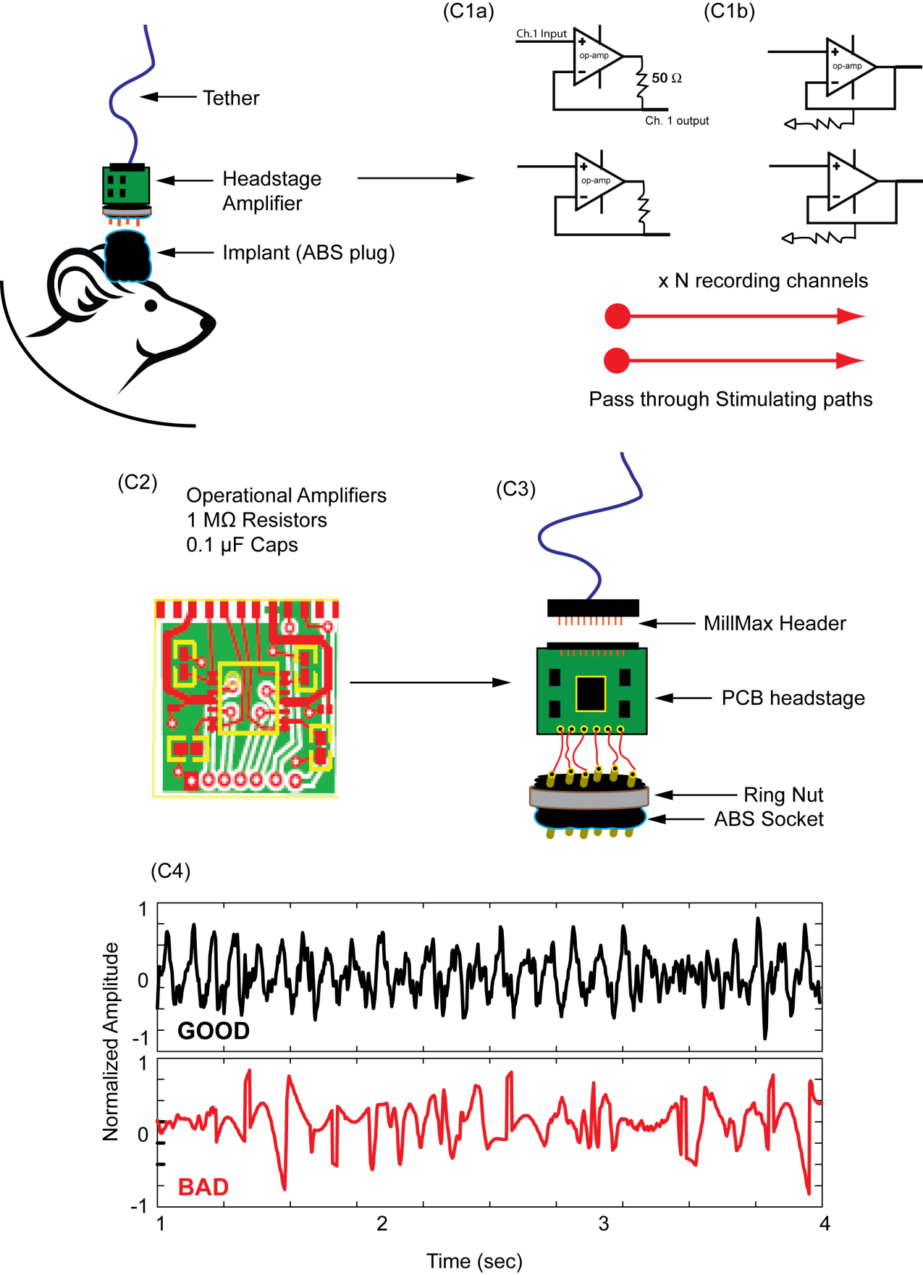

B. Interview: (Said by you on camera. Don’t forget to smile!)

Authors: Below are statements we would like you to complete that are complementary to the information contained within the schematic overview. Only one statement should be chosen and completed per author who will be on camera demonstrating the protocol.

  - PRS - The main advantage of this technique over existing methods, like _purchasing a commercially available headstage amplifier, is that _this method can be thousands of dollars cheaper and easily customized for specific stimulation and recording experiments.

  - MLS - Because this method allows simultaneous recording and stimulation of the behaving brain, it can help identify and control neural mechanisms of cognition. In turn, these methods may ultimately help to improve function and treat brain disorders in people.

Protocol (read by voice talent at JoVE):

Authors: In order to ensure that your protocol can be filmed in a single day, the protocol text must be limited to 30 steps – each step being defined as 3 lines of 12 pt text in our formatting style below. This amounts to 3 pages of protocol text. The scope of the scripted protocol text should include only those aspects of the procedure that require visualization in order to be well understood.

- Part 1. Overview of the headstage pre-amplifier system

  - The low-cost headstage pre-amplifier system featured in this video allows simultaneous neural recording and stimulation, and can be made waterproof for use with swimming animals.
    - CU: Shot of the system in its entirety.
    - provided media: image of a swimming animal set up with the system.
  - A completed system consists of the following components: A computer-designed integrated circuit board with four recording channels and two stimulation channels.
    - CU: Shot of the circuit board
    - CU/ECU: Shot of the four recording channels input and the 2 output stimulation channels
  - Gold pins that relay brain signals to the headstage and stimulation signals to the brain via separate connectors on the animals head stage.
CU: Shot of the recording / stimulation electrodes Not provided
    - ECU: Shot of the head stage so we can see the connectors on it.
  - A tether cable and connector that relays the recording and stimulation channels through a slip-ring commutator to a computerized physiology workstation
    - CU: Shot of the tether cable and connector
    - CU: Talent connects the cable to the workstation
  - Two forms of waterproofing on the head stage and on the integrated circuit. Now lets take a look at the design and layout of the headstage.
2.5.1. CU: Shot of the headstage so we can see the waterproofing. If it is not clear, talent may want to point out the waterproofing components.

- Part 2. Design and Layout of the Headstage

  - Using a commercially available software CAD package (www.expresspcb.com), a printed integrated circuit board with 4 unity-gain source followers and 2 pass through stimulation channels is designed (this example uses the circuit pictured in C1b).
    - provided media: Screen shot of the design software interface
    - provided media: Image of a final design
  - First, create connector pads on both sides for the pin connectors on the tether and animal connection.

3.2.1. provided media: use Fig3-8.pdf, page 2
  - A Quad-FET operational amplifier can accept up to 4 channels of +/- input
    - provided media: Fig3-8.pdf, page 3.
  - Two power lines are needed, each which can be connected to ground via 0.1μF capacitors to prevent possible induced oscillations in the operational amplifiers.
    - provided media: Fig3-8.pdf, page 4.
  - To make a unity gain amplifier circuit, route the signal into the positive input of the operational amplifier and then connect the output back to the inverting input.

3.5.1. provided media: Fig3-8.pdf, page 5
  - Then, add 10 MOhm resistors in series with the positive input to ground.

3.6.1. provided media: Fig3-8.pdf, page 6
  - For the stimulation channels, lay pass-through traces connecting the outputs to inputs, using vias to guide the traces to the other layer of the board and back.

3.7.1. provided media: Fig3-8.pdf, page 7
  - Finally, create a large ground plate on the back side layer to connect all vias that are meant for ground. The ground plate then should be connected to the ground pin out to the tether and animal side.

3.8.1. provided media: Fig3-8.pdf, page 8

  - A single headstage is designed, and the design pattern is tiled across a larger sheet of circuit board to provide many headstages at a lower cost.

3.9.1. provided media: Fig3-8.pdf, page 9
  - The CAD file is transmitted to the printed circuit board (PCB) manufacturing service where double sided, two layer boards are printed using top and bottom copper layers with all holes plated through.
    - WIDE: Talent approaches work bench, picks up the printed board(s)
    - CU: Talent holding the board so we can see the double-sided, two layer nature of the board and the holes.
  - The boards use tin/lead solder plated traces and pads that correspond to industry standard FR-4 laminate.

3.11.1. CU/ECU: Shot of the traces. Talent may want to point to them if it is not clear in the shot.
  - Individual headstages are cut from the large tiled PCB sheet and electronic components are connected with solder. Now lets see how to connect the electronic components.
    - CU: Talent cuts from the large tiled sheet

3.12.2. ECU: An individual headstage that has been cut out of the sheet.

- Part 3. Preparation and soldering of electronic components

  - Begin preparations for soldering of electronic components by organizing the components on the circuit board to prepare them for soldering.
    - WIDE: Talent sits down at the microscope and begins organizing the components on the circuit board.
    - SCOPE: Organized components
  - Place a small amount of solder on the tin/lead pad to be soldered, and bring the tip of the soldering iron close to melt and adhere the solder to the pad.
    - SCOPE: Talent places solder on the pad to be soldered, then brings the tip of the soldering iron close to melt the solder to the pad.
  - Solder the capacitors first, resistors next, and then the operational amplifiers.
    - SCOPE: Talent solders a capacitor
    - SCOPE: Talent solders a resistor
    - SCOPE: Talent solders an amp
  - Because the op-amps can be destroyed by over heating, use a variable heat soldering gun and the lowest heat necessary to melt the solder.
4.4.1. CU: Contiuation of 4.3.3, Talent at the microscope working, but focus on the variable heat gun
  - Talent to camera, documentary style: It is best to minimize the heating time used to make a good solder joint. We find it convenient to create a small reservoir of solder that flows into the footprint pad by applying solder along the communication or power traces.
4.5.1. SCOPE: Talent creates a small reservoir of solder which flows into the footprint pad, applies solder along the communication traces
(The statement was NOT said by the author and needs to be narrated)

  - Now use an ohmmeter to test that the resistance across the resistors meets the expected value.
    - CU: Talent tests the resistance across the resistors.
    - ECU: face of the ohmmeter showing the expected value.
  - Inspect each pad closely to ensure that no solder is connecting or bridging adjacent pads. If there is a solder bridge, heat and melt the solder and use a tweezer to break the bridge. Now lets see how to assemble and fabricate tether interfaces.
    - SCOPE: Shot of a pad with solder bridging two adjacent pads.
    - SCOPE: Talent uses a tweezer and breaks the melted bridge.

- Part 4. Assembly and fabrication of tether interfaces.

  - First insert a piece of 19 Ga hypodermic tubing into one of the unused ports of the 9 pin ABS socket for mechanical support.
    - WIDE: Talent sitting or standing at the work area
    - CU: Talent inserts a piece of 19 Ga hypodermic tubing into one of the unused ports of the 9 pin ABS socket
  - Cut six 2 cm length pieces of insulated magnetic wire for connecting the female amphenol pins to the ABS socket.
    - CU: Talent cuts some 2cm length pieces of magnetic wire.
    - ECU: shot of the 6 2cm pieces.
  - Now using a small amount of solder in each pin, heat the pin from the tip to solder the female pins to the magnetic wire.
5.3.1. CU/ECU: Talent heats the pin from the tip to solder the female pins to the wire. Get the shot close enough so we can see how this is done.
  - Solder the other end of each magnetic wire into the ABS sockets.
5.4.1. CU/ECU: Talent slders the other end to the ABS sockets.
5.4 Should be removed. The statement and shot should be at 5.6.2 Which is now provided.
  - Position the male - female MillMax pins over the pads on the tether side of the headstage, and squeeze the pins over the PCB to ensure a pressure fit. Then, solder each pin to each pad in order.
    - CU: Talent positions the male-female millmax pins over the pads on the tether side of the headstage.
    - CU/ECU: Talent squeezes the pins over the PCB to ensure fit.
    - CU/ECU: Talent solders a pin to one of the pads.
  - Next, position the ring nut over the neural implant connector and push all the female pins into the desired slots on the plastic base.
5.6.1. CU: Talent positions the rung nut over the neural implant connector and then pushes all the female pins into the slots on the base.
5.6.2 Solder the other end of each magnetic wire into the animal side vias.
CU/ECU: Talent solders the other end to the vias.

  - Apply acrylic glue to the top of the ABS socket connector and secure it to the base of the headstage. Finally, glue the 23Ga tube to the tether side of the headstage for support. Now lets see how to waterproof the headstage.
    - CU: Talent applies glue to the ABS socket connector and secures it to the base of the headstage.
    - CU: Talent glues the 19Ga tube to the tether side of the headstage.

- Part 5. Waterproofing the headstage

  - To waterproof the headstage, encase the entire integrated circuit and any exposed metal surfaces with 5 minute epoxy. Allow 5-10 minutes for initial curing, and 60 minutes for permanent curing.
    - WIDE: Talent at the work area, picks up epoxy.
    - CU: Talent encases the entire circuit with epoxy
  - Apply poster tack putty to the surface of the 9 pin ABS socket around the female pins protruding from the animal end.
6.2.1. CU: Talent applies poster tack putty to the surface of the 9pin socket around the female pins
  - For maximal waterproofing, the ABS socket and ABS plug should be mated and the ring nut should be tightened.
    - ECU: Shot of the ABS socket and plug mated
    - CU/ECU: Talent tightens the ring nut.
  - Wrap a small strip of parafilm around the interface to prevent water from contacting the pin connectors.
    - CU: Talent wraps a strip of parafilm around the interface.
    - ECU: Final shot of the entire waterproofed system. reuse 2.1.1

- Representative Results-(second to last section)

Authors, please provide an image file for 7.1 if you have not already done so.
  - Now we’ll show some representative results. Shown here is an example of a successful recording. A good recording will follow an input source signal without cutting in and out during movement. For a good reference on electrophysiology or Lfps, see (2).

-LAB MEDIA: 2155_Shirvalkar_Figure1.ai (c4)

  - When passing a current through a particular input channel, the user should ensure that there is no crosstalk of the signal into adjacent channel. This can be done by passing the signal through each channel and testing the output of all other channels. If there is crosstalk between channels, please refer to the following article for useful suggestions (3).
  - Design and adding channels: the user may desire the headstage to be positioned flat on the animal's head or with additional channels. We have successfully manufactured such headstages with additional channels and configurations.

-LAB MEDIA: 2155_Shirvalkar_Figure_3.ai

Authors, see instructions below

Representative Results Narration

(C4)

INSTRUCTIONS FOR AUTHORS:
Please ensure that the representative results narration is appropriate and correctly describes your images, movies, or figures. Our editors have ensured that the results are written in our format.

We consider this section a critical aspect of the video, because here is where you provide validation for your experiments. For example, if this is a cell culture preparation, this section is where the video will show your cells at various time points following culturing. If this is an imaging prep, then this part is where you will show examples of your imaging experiments.

Please limit the extent of narration to no more than 2-3 lines of text per image or movie file being described. Figures with multiple panels submitted with the original protocol should be broken up so that each panel is a separate image. Like the schematic, each image or movie file supplied in the results should be referenced by annotation in parenthesis, however for the results, the specific filename should be given in parenthesis.

Below is an example of results text:

EXAMPLE REPRESENTATIVE RESULTS

5. Evaluation of Morpholino Injection and Knockdown
5.1 Representative results of both morpholino injection and mRNA injection are shown here. The
uninjected control at 48 hours post fertilization looks normal, as expected
-LAB MEDIA: 0123_PIname_Figure1.tif (Replace 0123 with your jove video #)

5.2 However, embryos injected with the morpholino heg_e3i3_egfr1, which knocks down Heg isoforms
containing the first of two EGF-like repeats, exhibit brain edema.
-LAB MEDIA: 0123_PIname_Figure2.tif

5.3 Injection of heart of glass mRNA also produced an obvious phenotype. At 24 hours post fertilization,
the heads of the uninjected controls look normal
-LAB MEDIA: 0123_PIname_Figure3.tif

5.4 Conversely, some of the embryos injected with the mRNA exhibit cyclopia
-LAB MEDIA: 0123_PIname_Figure4.jpg

Please visit the following URL to see an example of how the results will look when complete:
http://www.jove.com/index/Details.stp?ID=1597

- Conclusion (said by authors on camera

Authors: Below are statements we would like you to complete that summarize and conclude the video. Only one statement should be chosen and completed per author who will be on camera demonstrating the protocol.

  - PRS - Once mastered, this technique can be done in an assembly line fashion to build multiple headstages at the same time, so we can establish replicability and provide quick a backup for damaged headstages.__________.

  - MLS-
This procedure can be used in combination with other methods, such as targeted drug infusion or optogenetic stimulation, to investigate how different neurotransmitters and neuromodulators contribute to brain mechanisms of memory and cognition. We used this combination of techniques to record and modify brain rhythms in the rat hippocampus, which predicted memory performance (4).

Provided Media

Authors, Please list all images, movie files, or 3-D rendered animations that can be included in the video per editor’s request. The step in the script/video where these images will be inserted should be specified. For example:

6.2 – 0123_PIname_Figure1.tif - dual color imaging of tumor angiogenesis at 40X
6.2 – 0123_PIname_Figure2.tif - dual color imaging of tumor angiogenesis at 100X

Formats: For static images we prefer .tiff files at dimensions of at least 720X480 pixels and 300 dpi. The higher resolution, the better. Likewise any exported movie files should have at minimum these dimensions and be rendered to .mov, .mp4, or .avi files.

Insert your media filenames here.

1.1 - 2155_Shirvalkar_Figure1.ai UPDATED
3.1 - 2155_Shirvalkar_Figure2.ai
7.3 - 2155_Shirvalkar_Figure3.ai
3.2-3.9 - 2155_Shirvalkar_Jove_Fig3-8.pdf

General Preparation

It’s critical for a smooth and organized shoot that all reagents are accounted for, in advance.

Any overnight or long incubation steps should be recognized and specimens/samples be prepared in advance so that prior steps can be recorded and shooting can continue with pre-prepared specimens/samples.

All tubes/flasks should be pre-labeled neatly before we arrive.

Ex. Luciferase assay done in 96 well plates should be labeled with negative/positive control wells and experimental samples are labeled accordingly.

Acknowledgements
We would like to acknowledge Kevin G. Guise and Justin Riceberg for assisting with construction and development of headstages. This research was supported by the Mount Sinai Medical Center and a NIH fellowship to PRS: F30 AG034003-01A1;

References:
1. Schoenbaum G (2002) in CRC Series: Methods in Chemosensory Research. eds Simon SA & Nicolelis MAL (CRC Press, Boca Raton, FL), pp 411-412-427.
2. Niedermeyer E & Lopes da Silva F (2004) Electroencephalography: Basic Principles, Clinical Applications, and Related Fields, eds Niedermeyer E & Lopes da Silva F (Lippincott Williams & Wilkins, pp 1256.
3. Stephens R (2005) Reducing crosstalk of an op amp on a PCB. Analog Applications Journal (TI) 190: 5/11/2010.
4. Shirvalkar PR, Rapp PR & Shapiro ML (2010) Bidirectional changes to hippocampal theta-gamma comodulation predict memory for recent spatial episodes. Proc Natl Acad Sci U S A 107: 7054-7059.

