Title:
Whole animal perfusion fixation for rodents
Authors:
Karen L Smith
Division of Translational Medicine
Wadsworth Center, New York State Department of Health, Albany, NY 12201
smithk@wadsworth.org

CS Bjornsson
Center for Biotechnology and Interdisciplinary Studies
Rensselaer Polytechnic Institute, Troy, NY 12180

bjornc@rpi.edu

Leah Hains
Division of Translational Medicine
Wadsworth Center, New York State Department of Health, Albany, NY 12201
lhains@wadsworth.org

William Shain
Division of Translational Medicine
Wadsworth Center, New York State Department of Health, Albany, NY 12201
Shain@wadsworth.org

Corresponding author: William Shain

Keywords: Paraformaldehyde, physiological pressures, vascular system, brain, preservation.

Short Abstract:
A procedure is described for rapid and uniform perfusion fixation of the rat brain. A constant pressure system is used to introduce buffer and 4% paraformaldehyde through the heart and into the vascular system to obtain the best possible tissue preservation.

Long Abstract:
The goal of fixation is to rapidly and uniformly preserve tissue in a life-like state. While placing tissue directly in fixative is effective for small pieces of tissue; in larger specimens like the intact brain immersion fixation is not efficient because diffusion of the fixative is slow and thus does not reach all regions of the tissue at the same rate. Often, changes in response to hypoxia begin before the tissue can be preserved. The advantage of directly perfusing fixative through the circulatory system is that the chemical can quickly reach every corner of the organism using the natural vascular network. In order to utilize the circulatory system most effectively, care must be taken to match physiological pressures. It is important to note that physiological pressures are dependent on the species used. Techniques for perfusion fixation vary depending on the tissue to be fixed and how the tissue will be processed following fixation. We present here perfusion fixation techniques for the rat brain which provide for consistent, uniform fixation resulting in tissues properly preserved for immunohistochemistry procedures.
Equipment need:
ANESTHETIC:
•Anesthetic may vary per laboratory and institution. However, a surgical plane of anesthesia must be maintained throughout the entire procedure.
•We are currently using a Ketamine/xylazine mixture (up to 80 mg/kg body weight ketamine and 10 mg/kg body weight xylazine).
•Anesthesia is administered intraperitoneally by 27gauge needle with a 1cc syringe (TB syringe).

SURGERY:
•1 pair large blunt/blunt curved scissors (~14.5 cm)
•1 pair straight iris scissors
•1 pair standard forceps
•1 pair fine (Graefe) forceps
•1 large hemostat forceps - curved or straight (~19 cm)
•2 standard hemostat forceps - straight serrated (14 cm)
•1 modified hemostat (with 15-gauge hole filed through the tip)
•1 15-gauge blunt or olive-tipped needle (perfusion needle)

PERFUSION:
•HyPerfusion™ system or equivalent (see diagram)
•300 ml buffer: phosphate buffered saline, pH 7.4
•250 ml fixative: 4% paraformaldehyde in 0.1 M phosphate buffer, pH 7.4
•Shallow glass or plastic tray, approximately 10” x 10”
•Crushed ice
•Water bath (37ºC)
•Timer
•50 mL syringe

DISSECTION:
•1 pair standard sharp/blunt straight scissors (~12 cm)
•1 pair medium curved or straight rongeurs (14-16 cm) or skull bone removal pliers
•1 pair straight iris scissors (~9 cm)
•1 micro-spatula (double 2” flat ends, one rounded, one tapered to 1/8”)

POSTFIXATION & STORAGE:
•1 50 mL glass vial
•40 mL HEPES-Buffered Hanks Solution (HBHS) with sodium azide

RECIPES:
Fixative: 4% Paraformaldehyde in 0.1M Sodium Phosphate Buffer, pH 7.4:
1. First prepare 8% Paraformaldehyde stock:
Add 40 g Paraformaldehyde to 500 mL dH₂O. Heat the solution to 60 - 65°C while stirring. Do not exceed 65°C, doing so can adversely affect the success of the immunohistochemical procedure. To clear the solution, reduce heat and add 2-3 ml of 1.0 M NaOH with a dropper. Filter and store at 4°C for up to 1 month.
2. Next prepare 0.2M Sodium Phosphate Buffer, pH 7.4
For the sodium phosphate monobasic stock, add 27.8 g NaH₂PO₄* H₂O to 1 L dH₂O.
For the sodium phosphate dibasic stock, add 28.4 g Na₂HPO₄ to 1 L dH₂O.
Add 810 ml of the monobasic stock to 190 ml of the dibasic stock.
3. Lastly add equal parts 8% paraformaldehyde stock to 0.2M Sodium Phosphate Buffer to yield the 4% paraformaldehyde fixative. Note: this fix is best prepared fresh, no more than 72 hours in advance.

Perfusion Buffer: Phosphate Buffered Saline, pH 7.4
1 L dH₂O
9 g NaCl
144 mg KH₂PO₄
795 mg Na₂HPO₄

HEPES Buffered Hanks Solution (HBHS) with Sodium Azide, pH 7.4:
990 mL dH₂O
7.5 g NaCl
0.3 g KCl
0.06 g KH₂PO₄
0.13 g Na₂HPO₄
2 g Dextrose/Glucose
2.4 g 10 mm Hepes
0.1 g MgCl₂ 6 parts dH₂O
0.05 g MgSO₄ 7 parts dH₂O
0.165 g CaCl₂ 2 parts dH₂O
90 mg NaN₃

PERFUSION APPARATUS
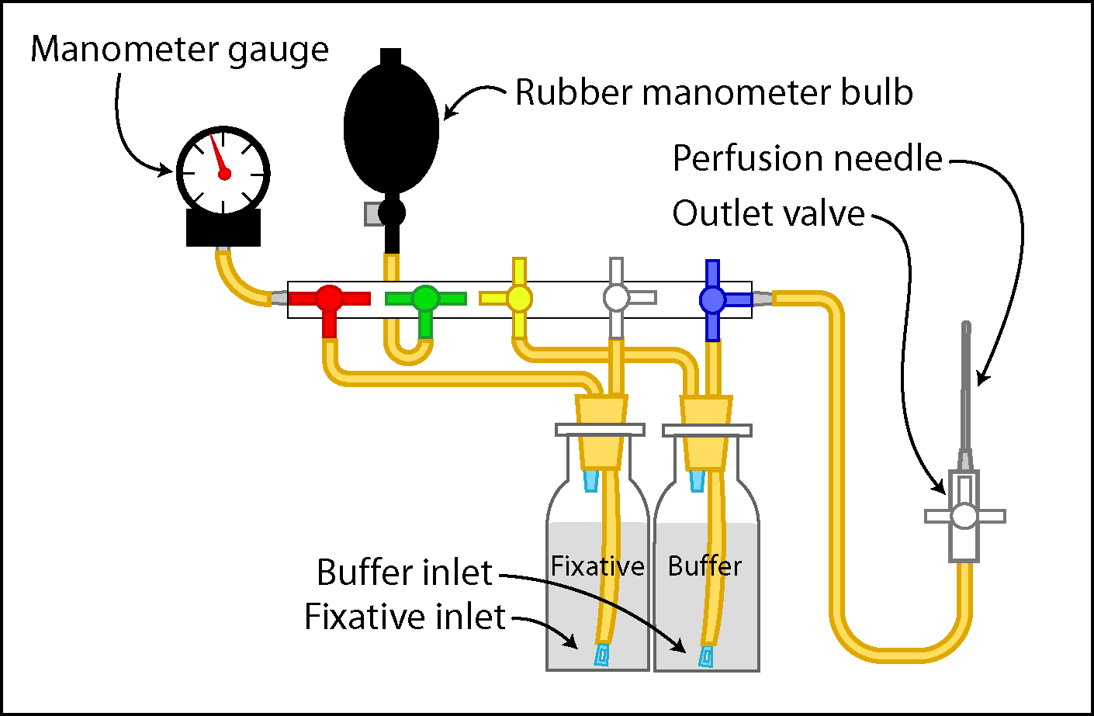

A. APPARATUS SET-UP
1. Using the water bath, warm perfusion buffer to 37ºC. Place outlet valve in a beaker filled with buffer. Fill a 50 ml syringe with buffer and attach to fixative tubing. Flush tubing repeatedly by expelling and withdrawing buffer.
2. Clear the line with buffer until all air bubbles in the tubing are eliminated. It is crucial for the success of a perfusion not to have air bubbles in any of the lines.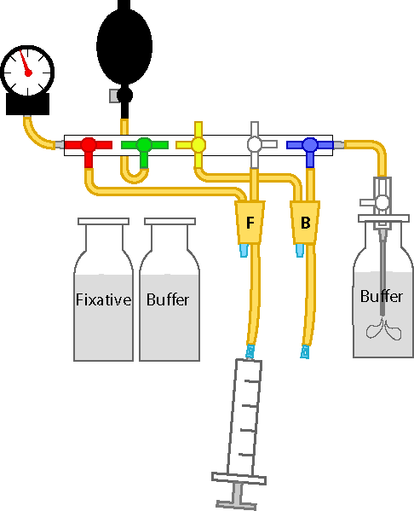
3. Remove the syringe and connect the 4% paraformaldehyde fixative (room temperature) container. To avoid air bubbles at the tubing end, squeeze the tube while positioning the tube into the container so that a drop of buffer protrudes from the end to contact the fluid surface within the container.

4. Close the outlet port. Turn buffer valve (blue) to the same position as the fixative valve (white). This will allow flow from the buffer line only.
5. Open the outlet port and repeat step A1 through A3 for filling the buffer line. After all the air bubbles are eliminated close the outlet port, remove the syringe and connect the buffer container, taking care not to introduce air bubbles into the tubing.

6. Test system for ability to hold pressure by pumping the rubber manometer blub. There is normally some resistance due to the compression of air in the system.
7. Setup surgery tools in order for easy access. Fill perfusion needle with buffer to eliminate the possibility of air bubbles.

B. Anesthetic Administration
Prior to surgery, a ketamine/xylazine mixture (up to 80 mg/kg body weight ketamine and 10 mg/kg body weight xylazine) is administered via intraperitoneal injection (27 gauge needle and 1cc syringe). Additional administration of anesthetic will be performed as necessary during the course of each operation to maintain a surgical plane of anesthesia.
C. Surgery for Perfusion
1. Once the animal has reached a surgical plane of anesthesia, place it on the shallow tray filled with crushed ice. (Use toe pinch-response method to determine depth of anesthesia. Animal must be unresponsive before continuing.)

2. Make a 5-6 cm lateral incision through the integument and abdominal wall just beneath the rib cage. Carefully separate the liver from the diaphragm.
3. Make a small incision in the diaphragm using the curved, blunt scissors. The position and pressure of your finger can aid in the ability to cut the diaphragm.

4. Continue the diaphragm incision along the entire length of the rib cage to expose the pleural cavity.

5. Place curved, blunt scissors along one side of the ribs, carefully displacing the lungs, and make a cut through the rib cage up to the collarbone. Make a similar cut on the contralateral side

6. Lifting the sternum away, carefully trim any tissue connecting it to the heart. Clamp the tip of the sternum with the hemostat and place the hemostat over the head (this hemostat remains in place until dissection begins, but is omitted from future illustrations for clarity). When done properly, the thymus lifts away from the heart along with the sternum, providing a clear view of the major vessels.

7. Make a small incision to the posterior end of the left ventricle using iris scissors (black arrowhead)

8. Pass a 15-gauge blunt- or olive-tipped perfusion needle through the cut ventricle into the ascending aorta. The tip should be visible through the wall of the aorta, and should not reach the aortic arch where the brachial and carotid arteries diverge.

9. Use a hemostat to clamp the heart, this secures the needle and prevents leakage. If desired, the modified hemostat can be used to clamp the aorta around the needle tip (these hemostats remain in place until dissection begins, but are omitted from future illustrations for clarity).
10. Finally, make an incision to the animal’s right atrium using iris scissors to create as large an outlet as possible without damaging the descending aorta (black arrowhead).
At this point the animal is ready to be perfused.

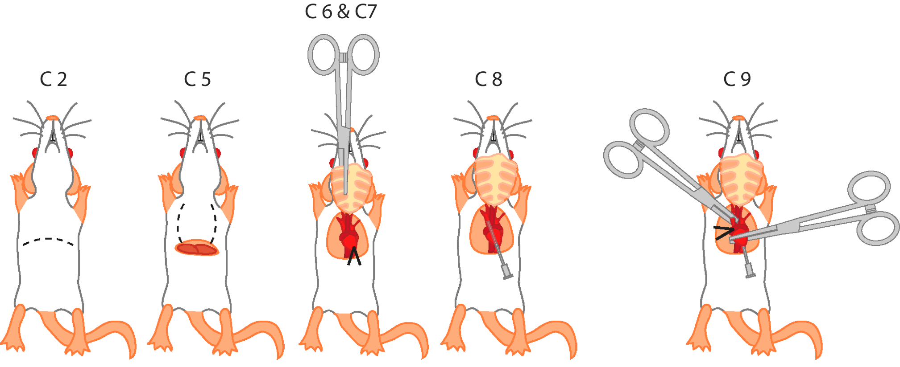

Note for a successful surgery:
- Once the diaphragm is breached, precede rapidly as hypoxia and hypercapnia will initiate irreversible physiological changes that may confound subsequent analysis.
- When the needle is inserted and clamped in place, the residual pressure will push blood to the base of the needle (flashback). In fact, larger animals may vigorously expel blood. It is critical that blood at least reach the base of the needle to avoid introducing air bubbles that will present an obstacle to complete perfusion. If no blood is observed at the needle base, remove the needle and refill with buffer by attaching it to the outlet port of the perfusion rig. Once buffer has been run through the tip, the needle can be reinserted into the heart.
- Proper placement of the needle within the aorta is critical, it should not reach as far as the aortic arch.
D. Perfusion
A timer is used to record four distinctive stages of the perfusion: At the completion of the buffer stage, fluid should be running clear, a physical reaction or "muscle twitch" should be seen in response to the fixative, and at the completion of fixative the animal should be stiff and the soft tissues should be firm to the touch. Recording the timing of these stages can serve as an indication of a successful perfusion and any individual animal differences. Examples of good range of step times are listed below.
Start time = 0
End of Buffer time = 1:50 - 3:00 min
Time when a reaction to the fixative is physically noted = 2:00 – 3:20 min (usually the fixative takes ~20 seconds to flow through the lines and see a reaction)
End of fixative time = 5:50 – maximum of 8 min

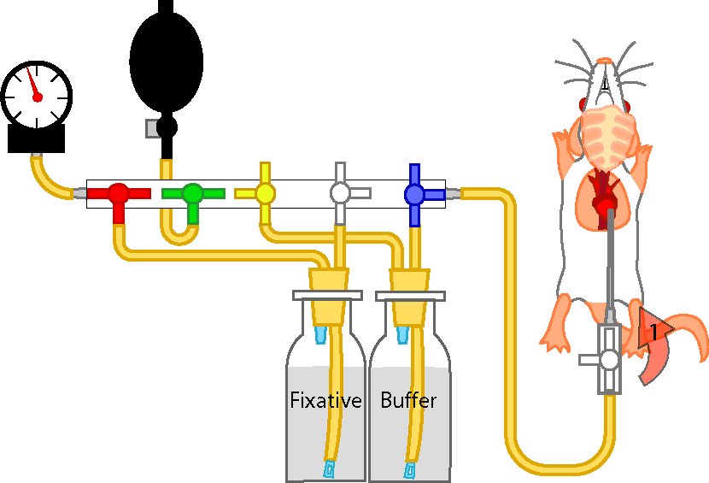

1. Open and attach outlet port to needle base taking care not to introduce any air bubbles.
2. Pump up the manometer bulb to a pressure of 80 mm Hg quickly & evenly. Maintain this pressure throughout the buffer infusion period. Start the timer.
3. Adjust the needle angle. The angle of the needle is critical to the achievement of a maximum flow rate (note the flow change with angle adjustment).
4. Switch the buffer valve (blue) once buffer is almost finished (200 ml). The fluid should be running clear. Indicate time for your records.
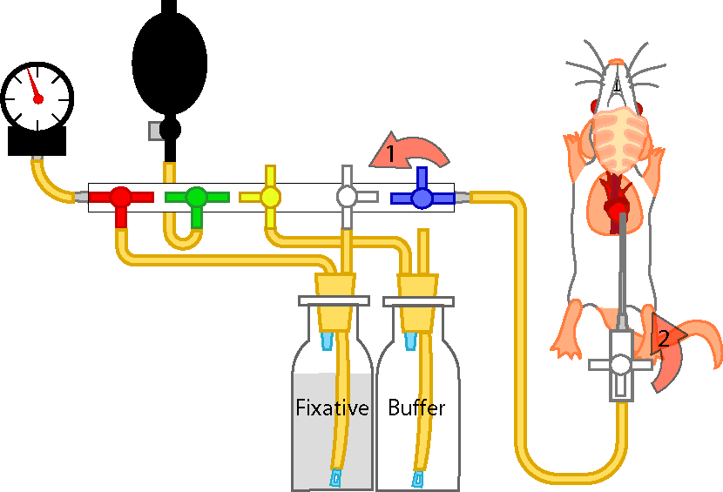

.

- Fixation tremors should be observed within seconds; this should be considered the true time of fixation. Indicate time for your records.
- At this time, the pressure can gradually be increase up to a maximum of 130 mm Hg, to maintain a steady flow rate.
- Close the outlet valve when the fixative is nearly finished. Indicate ending time for your records.
- The rat should be stiff at this stage.
- The used paraformaldehyde must be collected and stored for disposal according to the regulations of your institution.
Important indicators of a good perfusion for detailed immunohistochemistry
- When the pressure and time from each step of the perfusion procedure falls within the acceptable ranges.
- During the buffer perfusion step observe the color change (from red to pale pink) in organs (particularly the liver) and features (nose, eyes, paws, and ears), which indicates the clearance of blood.

- Muscle contractions following the start of the fixative perfusion.

- Fluid coming out of the nose indicates the fluid is going into the lungs – not a good perfusion. This is usually due to the tip of the needle located too far up the ascending aorta. With other perfusion methods this can also indicate that the applied pressure is too high. This is not the case with this method since the pressure is controlled and monitored throughout the perfusion.
- The final indicator of perfusion outcome is the condition of the tissue. There should be little or no blood seen in the surface blood vessels on the brain. This will be also true within tissue sections destined for staining and immunohistochemistry.

E. Dissection
1. Remove the head using a pair of scissors.
2. Make a midline incision along the integument from the neck to the nose and expose the skull.
3. Trim off the remaining neck muscle so that the base of the skull is exposed; remove any residual muscle using scissor or rongeurs.
4. Place the sharp end of a pair of iris scissors into the foramen magnum on one side, carefully sliding the scissors along the inner surface of the skull.
5. Next, make a cut extending to the distal edge of the posterior skull surface. Make an identical cut on the contralateral side. Use the rongeurs to clear away the skull around the cerebellum.
6. Carefully slide the scissors along the inner surface of the skull as the tip travels from the dorsal distal posterior corner to the distal frontal edge of the skull, lifting up on the blade as you are cutting to prevent damage to the brain. Repeat for opposite side.
7. Using rongeurs peel the dorsal surface of the skull away from the brain. Trim away the sides of the skull using rongeurs as well.
8. Using a spatula, sever the olfactory bulbs and nervous connections along the ventral surface of the brain.
9. Gently tease the brain away from the head, trimming any dura that still connects the brain to the skull using iris scissors.
10. Remove the brain and place it in a vial of fixative containing fluid at least 10x the volume of the brain itself. Swirl the vial occasional

F. Post-fixation & Storage
1. Keep the brain in fixative for 24 hours at 4ºC, swirling occasionally.
2. After 24 hours, wash the brain with phosphate buffered saline by exchanging the media 3 times and swirling each time.
3. Brains can then be stored in phosphate buffered saline or HBHS with sodium azide and kept at 4ºC.

Acknowledgments:
Disclosures: “I have nothing to disclose.”

References:
Tao-Cheng, J, Gallant, P.E., Brightman, M.W., Dosemeci, A., Reese, T.S. Structural changes at the syanpses after delayed perfusion fixation in different regions of the mouse brain. J Comp. Neurol. 501, 731-740 (2007)
Kasukurthi, R., Brenner, M.J., Morre, A.M., Moradzadeh, A., Wilson, Z. R., Santosa K.B., Mackinnon, S. E., Hunter , D.A., Transcardial perfusion versus immersion fixation for assessment of peripheral nerve regeneration. J. of Neurosci. Meth. 184, 303-309. (2009)
Walker, W.F., Vertebrate dissection. Philadelphia: W. B. Saunders Comp. Sixth Ed. (1980).

