Text:
Turfgrasses are used for many different purposes such as lawns, golf courses, athletic fields, parks, and around important landmarks. The increasing use of turfgrasses has led to the development of damaging pest and disease problems that may require management inputs. To conduct research on the efficacy of management inputs, researchers often must go to where the pest problems exist such as a golf course. Conducting research at remote locations can present unique challenges not encountered at University turfgrass research centers. One significant challenge is the marking of plot locations since the use of aboveground markers are not permissible in most locations where the turf is mowed and used for one of the above stated purposes.
Establishing turfgrass research plots:
- Find a permanent fixture such as an irrigation head or tree.
- Measure from this fixture and another fixed point to form the point of a triangle (Fig 1.) over the location where one of the four corners of the study area is to be established.
- Record the distance from the two fixed points to the location where the corner will be established.
- If possible, mark with paint, tape, etc. the exact point on the permanent fixtures from where the measurements were taken.
- Use brightly colored spray paint to temporarily mark this corner.
- At this corner, use a 12.7 -cm center punch to drive a 5.08- x 0.31 -cm steel carriage bolt (Hillman Fastener, Cincinnati, OH) below the soil surface.
- From this corner use two tape measurers to measure the research area required to accommodate the number of plots needed for the study.
- Use the Pythagorean Theorem to ensure field dimensions are correct, then use spray paint to temporarily mark these corners of the research area.
- At each of these corners, use the center punch to drive a steel bolt below the soil surface.
- Use the tape measures to measure the corners of each plot according to the required plot dimensions, incorporating any alleys between plots as needed.
- Temporarily mark all plot corners with spray paint and use the center punch to drive a steel bolt below the soil surface at each plot corner.
- Randomly assign treatments to the newly established plots (Fig. 2).

After the plots are established, in one plot per block a treatment is applied (Fig. 3). A non-treated control plot is included in every block.
Locating hidden turfgrass research plots:
- Return to the permanent fixtures used during the establishment of the research plots and measure the same distance from each to the point of the triangle where the corner of the research area is located.
- Use a metal detector to determine the vicinity of the steel bolt marking that corner.
- To locate the steel bolt, use two, 5.08 - x 2.54 - x 1.27 -cm neodymium, rubber-coated, grade 52 magnets (K & J Magnetics, Inc., Jamison, PA) to sweep the vicinity of the plot corner.
- Mark this corner with brightly colored spray paint.
- Using the metal detector and magnets locate all remaining steel bolts in the study area and identify with paint.

Representative Results:
Using this technique, the time required to find each bolt is usually less than 10 seconds. Previous methods used to find the bolts required use of the metal detector, measuring tapes, and a metal implement to probe below the soil surface and make contact with the top or side of the buried bolts. This technique can require 1 – 2 minutes or more to find each bolt and occasionally is not a successful technique to find every buried bolt.
Discussion:
Researchers often place only a small number of markers, perhaps only one at each corner of the entire study site, and then rely on measuring tapes to locate individual plots. Factors such as wind, changes in turfgrass mowing height, surface undulations, or other environmental features will affect the ability to accurately locate plot corners. For 3 m square plots, it may be possible to misidentify a plot’s location by 100 cm or more in one direction, which can translate into a significant proportion of the surface area of a plot not treated, incorrectly treated, or mistakenly evaluated. When all plot corners are marked with steel bolts during establishment, accurate location is ensured. Previous efforts to locate bolts using a metal detector, measuring tapes, and a probe such as a screwdriver can be extremely time consuming and may require excess hours of effort depending on activities being conducted on the turf. We found that our new technique, adding the use of high-powered magnets, reduces the time required to find plot markers to seconds, often by using only the metal detector and the magnets.
Precautionary statement
Steel bolts not inserted deep enough into the soil will damage mowing equipment. Magnets can erase computer-related, magnetic storage devices and can cause injury if not properly handled.
Acknowledgments:
This work was approved for publication by the Director of the Oklahoma Agricultural Experiment Station and supported in part under Project 2420.
Figure Legends:
Fig 1. Use two fixed points to aid in the future finding of a corner of a plot in the study area.
Fig 2. In every plot, in all four corners a metal bolt is placed below the soil surface. The space (alley) between plots can absent or variable in width.
Fig 3. Representation of treatment randomization and replication in a study area.
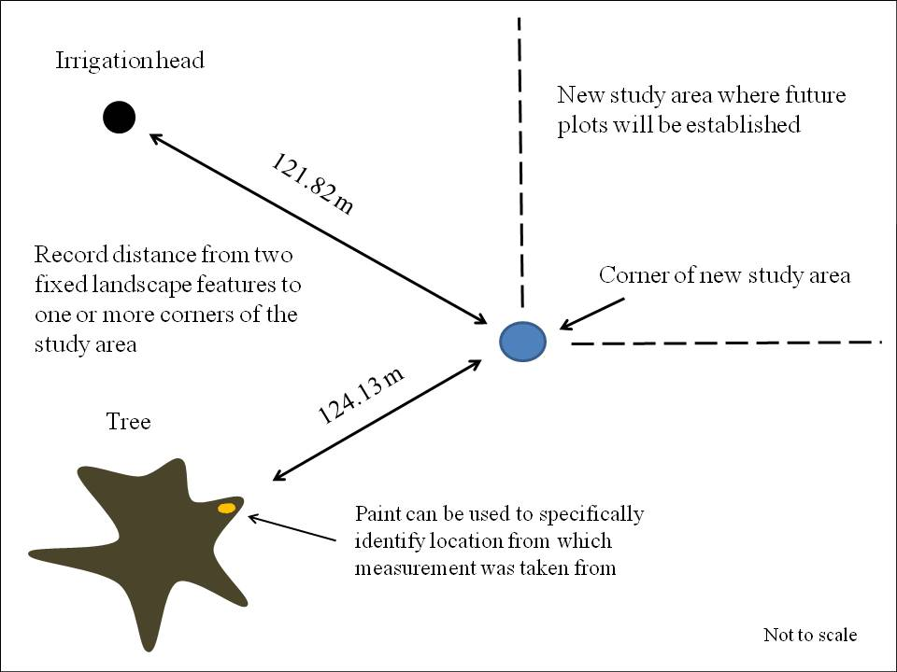
Fig. 1
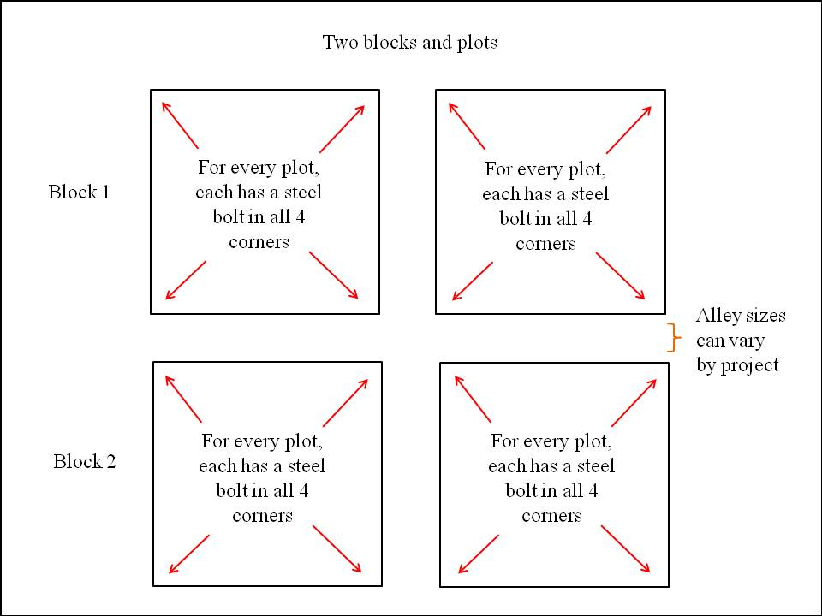

Fig . 2

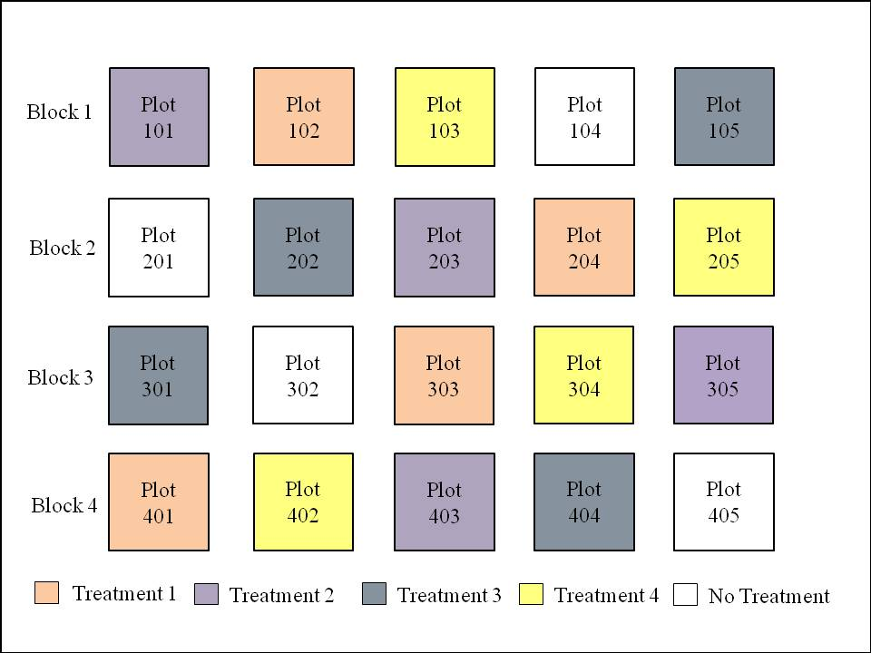
Fig. 3

