Biological Sample Preparation and Basic Image Acquisition for Scanning Electron Microscopy (SEM)

Overview

Source: Peiman Shahbeigi and Sina Shahbazmohamadi, Biomedical Engineering Department, University of Connecticut, Storrs, Connecticut
A scanning electron microscope (SEM) is an instrument that uses an electron beam to nondestructively image and characterize conductive materials in a vacuum. As an analogy electron beam to SEM is what light is to optical microscope. The difference is that electron microscope can yield much higher resolution and magnification. The best optical microscopes will typically have a resolution down to 200 nm, while SEMs usually claim a resolution of .5 nm. This is due to the fact that optical microscopes are limited by the diffraction of waves, a function of the wavelength, which is around 500 nm for visible light. Conversely, the SEM uses an energized electron beam with 1 nm wavelength. This characteristic makes them very dependable tools for the study of nano and microstructures, and can be beneficial when studying biological samples with feature sizes too small for optical microscopy.
This experiment provides an introduction to sample preparation and initial image acquisition for scanning electron microscopy of biological samples. In this case, a collagen – hydroxyapatite cellular scaffold developed from the collagen of rat tails will be studied. The vacuum environment of the SEM and the induced charging by the electron beam on non-conductive samples (such as organic matter) creates challenges that will be addressed in the preparation. The advantages and disadvantages of different imaging methods as they relate to resolution, depth of focus and sample type will also be discussed. The purpose of this demonstration is to give the participant more information on SEM to determine if this microscopy module is the best fit for a type of biological sample.

Principles
When a high-energy electron beam (typically ranging from 5 – 30 keV) hits a sample, a range of signals are emitted from the sample. These interactions can be used in order to study topography, crystallography, and electrical potential and local magnetic fields. The electrons undergo two types of scattering: elastic and inelastic. Inelastic scattering causes the emission of secondary electrons. These low energy electrons (~50 eV) are the outer shell electrons of the sample atoms that acquired just enough energy to leave the surface of the atom. The scattering of secondary electrons provides topographical information, as the energy level of the electrons leaving the sample atom is not high enough to travel through the sample, and therefore only surface level information is collected by the detector.
Elastic scattering, on the other hand, is not the dislodged electrons from the sample atoms, but rather it is the principal beam electrons after interaction with the nucleus as seen in Figure 1. These electrons do not change their energy or speed, but change their moving direction due to the interaction with the nucleus. The detection of these electrons provides compositional information and their varying contrast upon interaction with atoms of different atomic weights allows the user to distinguish differences in sample composition. In biological samples, this can be used to study embedded or attached nanoparticles and nanostructures with heavier atomic weights such as gold or iron.

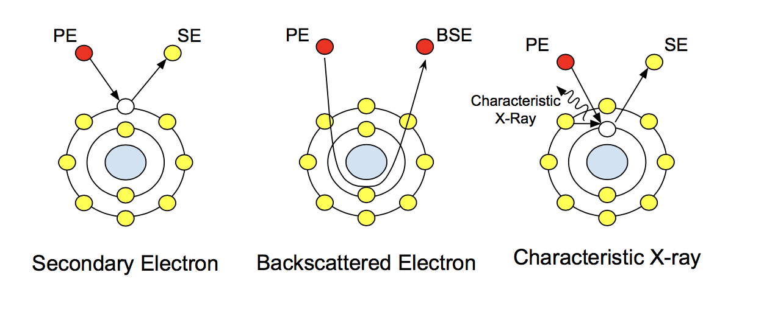
Figure 1: Atomic interactions with the principal electrons (PE) and how they create the different signals
.

The sample preparation is an important procedure especially when dealing with biological samples. In order to get high-resolution SEM images, electrons need to reach the sample and then signals which are the result of the interaction between the electrons and the sample need to reach the detectors. This means that the instrument needs to work under high vacuum in order to prevent electron scattering before the beam reaches the sample and the signals reach the detectors. This vacuum is highly sensitive and can pull particulate matter off of samples, meaning it is important to make sure the sample is dried and free of particulates.
Another consideration in sample preparation is the nature of the electron beam. Because the beam is composed of highly charged particles, when you bombard a non-conductive sample with them there is a buildup of these charges on the surface which affect the deflection of the electron beam and cause a large increase in beam scatter. By coating the sample with a conductive layer before imaging, these charging artifacts in the image can be avoided.
The methods described here are applicable to most non-conductive materials, in that a coating is necessary in order to mitigate charging artifacts. For our collagen-HA cellular scaffold, the sample was made using rat tail collagen and was made first by co-precipitation of collagen with HA onto the composite gel, then through slurry creation and freeze casting, and finally by crosslinking the scaffold and doing a final drying. This final drying is done over 5 days in a vacuum dryer and sufficiently dries the sample to be ready for SEM analysis without affecting the structural properties of the scaffolds. However, if imaging cells the main concern when preparing the sample is preserving the cell structure. Chemical and resin-based fixation methods are commonly used to observe cells while preserving the structure of cells, including glutaraldehyde fixation and epoxy and acrylic resins. Typically, glutaraldehyde is used as a fixative that creates cross linkages in the cytoplasm of cells, but also causes a drop in the pH so buffering is needed when preparing samples with glutaraldehyde. The addition of these techniques allows the structure of the cell to most resemble its structure when it was alive [3].

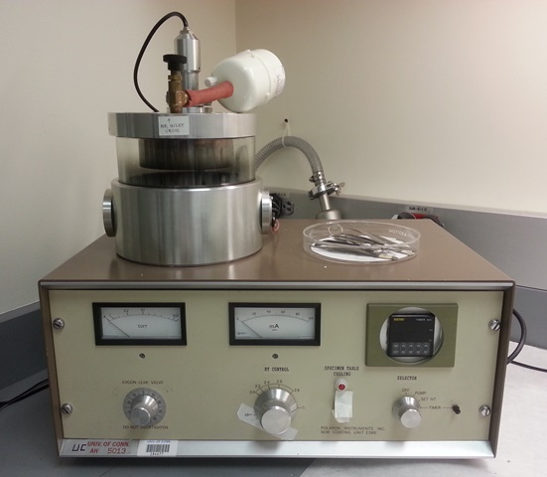
Figure 2: Gold-Palladium sputter coater showing the sample chamber (silver vessel on top) and vacuum (left) and current (right) gauges. In this model, a current of 2 mA is used with a chamber vacuum of .1 torr, which is kept constant using an Argon leak valve.

Procedure
- Sample Preparation
  - Wear gloves and take precautions to avoid contamination when handling the sample.
  - Make sure that the sample on the slide is dried and there is no contamination on the sample. This is because SEM measures surface characterization, and these defects can severely hinder the signal.
  - If the sample is loaded on a standard glass slide, decrease the size of the sample by scoring the slide with a diamond tipped glass cutter in a straight line and gently push on the crack away from the body until the glass fractures along the line.
  - Depending on the sample, choose a coating that does not have the same elemental composition (it would hinder the signal received by EDS). For this demonstration, a gold-palladium coating will be used.
  - Use the sputter coater as directed. Let the machine sputter the sample for around 40 s for a thin coating with adequate coverage.
  - Mount the sample onto an SEM stub using conductive double sided carbon tape. This tape should also be placed from the stage to the top of the slide that was sputtered in order to allow for a grounding of the sample if it is mounted on a non-conductive slide. A thin layer of conductive silver paint could also be used to increase the conductivity of the sample to the stage.
  - Mount the stub onto the stage and tighten the screw on the side.

Imaging Procedure

  - Load the stage into the chamber. Shut and seal the door. Then hit the “Transfer” button to open the passage from the loading chamber to the vacuum.
  - Once the transfer button stops blinking and the internal door is open, the sample can be moved into the vacuum chamber by screwing in the metal rods and pushing the sample into the chamber.
  - Unscrew the rod, retract and secure the rod fully into the load chamber, and press “store” to close off the load chamber from the vacuum chamber. The sample is now loaded and the rest of the process takes place from the computer workstation.
  - Move the stage using the controller and by opening the stage navigation panel until it is in your field of view.
  - Move the sample vertically until the working distance is 5 - 10 mm. When moving the stage in the z direction, turn on the chamber camera to ensure your sample does not get to close to the electron gun.
  - Turn the EHT beam ON (may also need to open column if it has been off for a while)
  - Select the SE2 signal from the detector options.
  - Use a kV setting of about 5 kV for initial imaging, and then increase up to 20 - 30kV for more signal using the back-scatter mode. If the sample wasn’t coated, keep the keV low to prevent too many charging artifacts in the image and to prevent sample damage.
  - If there is no clear image, turn the focus, brightness, and contrast knobs until a structure is visible. This will be a reference for refinement.
  - Turn the focus knob on coarse mode until an image is visible. Then switch to fine to find the best focus.
  - Use stage navigation (not in the z-direction) and the magnification to find an area to save an image from.
  - Decrease the scan speed and turn on line averaging to acquire a better image for saving.
  - Save the image by right clicking and saving to a file location.
  - Insert the BSD detector and move stage back to z-position where the sample was focused.
  - Repeat steps 8 - 11, looking for areas of contrast that indicate a higher atomic number.
  - Remove the BSD detector when done.
  - When ready to remove the sample, hit the button “exchange”.
  - Move the sample back into the load chamber and hit “store” then “vent".

Representative Results
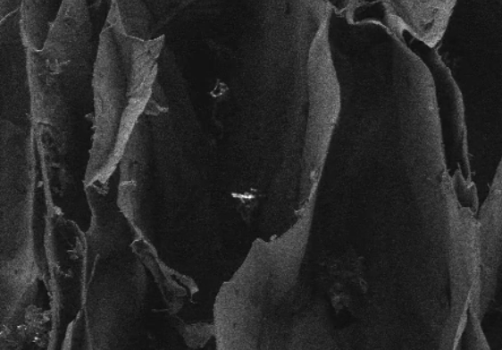
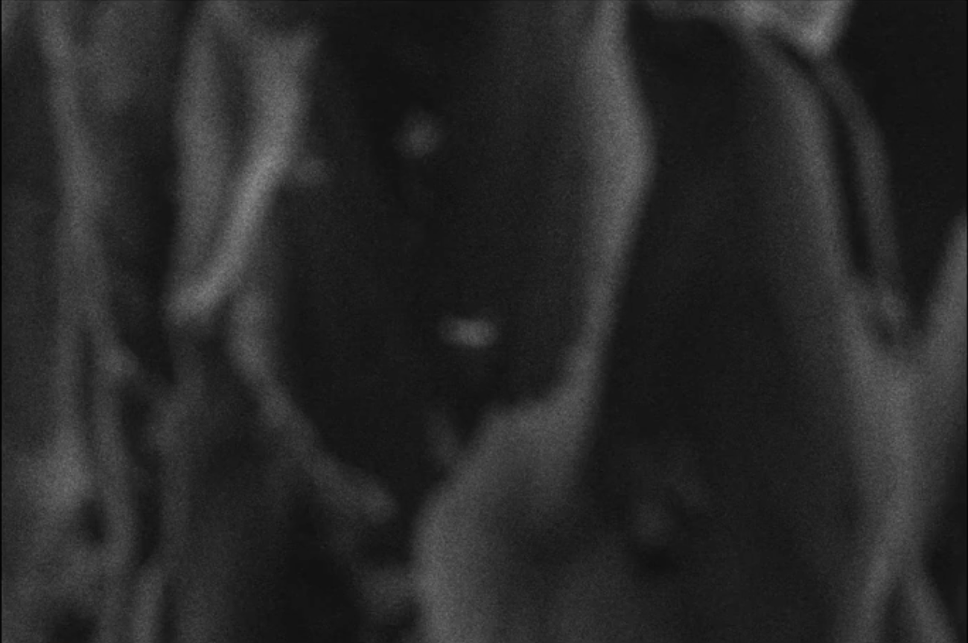
The SEM images in Figures 3 and 4 show that the imaged structure is highly three dimensional with microscale features. Image quality is highly effected by the focus and the thickness of the sputter coating.

Figure 3. The following images demonstrate how the sample being in and out of focus can affect image quality. In the image on the right, the whole field of view is in focus, while on the left it is out of focus. Playing with parameters like the focus can give you a much better image.

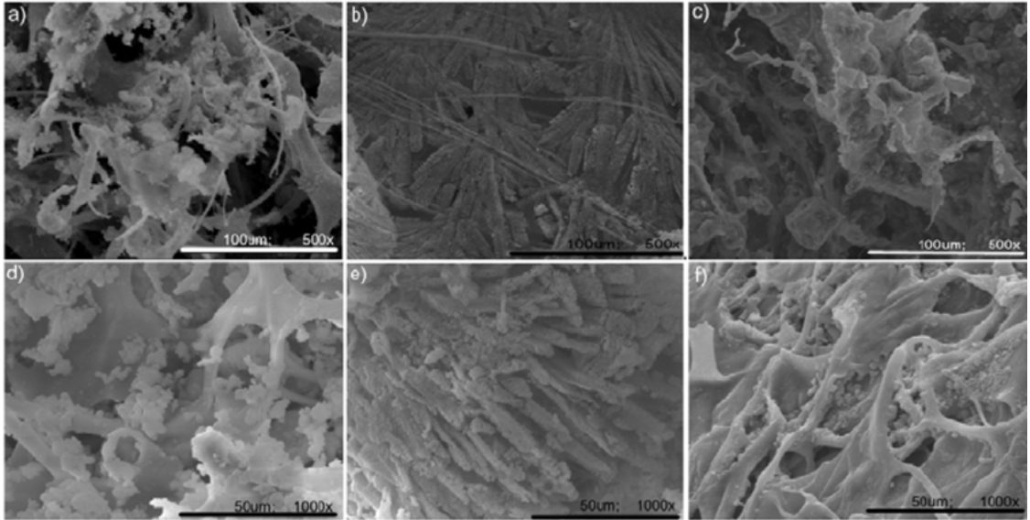
Figure 4: The above images are taken from a different collagen-hydroxyapatite sample as an example of what to see. This will be updated with results from our samples.

Summary and Applications
This experiment demonstrated the depth of focus, field of view and maximum resolution and magnification of an electron microscope and how these properties can be used to view biological samples. This project was designed to help the participant decide which microscopy module is the best for a certain application. As demonstrated, SEM has a very high depth of focus and much higher resolution and can reach higher magnifications but is not appropriate for all the sample types.
This experiment focused on giving an introduction to electron microscopy but application of electron microscopes in the research labs goes even beyond application of optical microscopes. These microscopes are used for inspection, characterization and quality control. From ICs to circuit boards and from crack propagation to nano-electromechanical systems. In the field of biology these instruments play a key role as well. There are even electron microscopes especially designed to accommodate wet/ bio samples. These bio samples can cover a large range from tissue to bone and cells and microorganisms. Using additional detectors can enable even more analysis and can draw an elemental map or do rather precise surface analysis.

Materials List
Name | Company | Catalog Number | Comments
Equipment
Biosample
Carbon or Gold coater
Cross beam-SEM | ZEISS
Collagen-Hydroxyappetite Cellular Scaffolds | Developed by Wei Laboratory at University of Connecticut

References
[1] Oatley, C. W., W. C. Nixon, and R. F. W. Pease. "Scanning electron microscopy." Advances in Electronics and Electron Physics 21 (1966): 181-247.
[2] Goldstein, Joseph, et al. Scanning electron microscopy and X-ray microanalysis: a text for biologists, materials scientists, and geologists. Springer Science & Business Media, 2012.
[3] Carol Heckman, et al. Preparation of cultural cells for scanning electron microscope. Nature Protocols Network, 2007, doi:10.1038/nprot.2007.504

