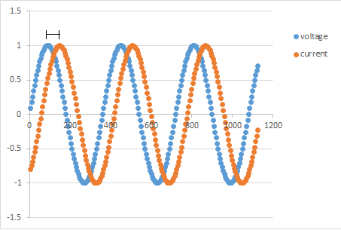

Figure 1. A representation of the phase shift between the applied voltage and the measured current.

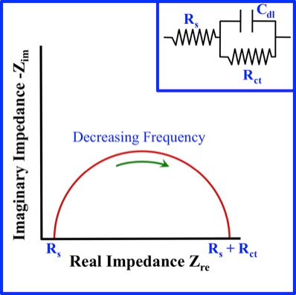

Figure 2. Image of a simple Nyquist Plot and its equivalent Randle cell model.

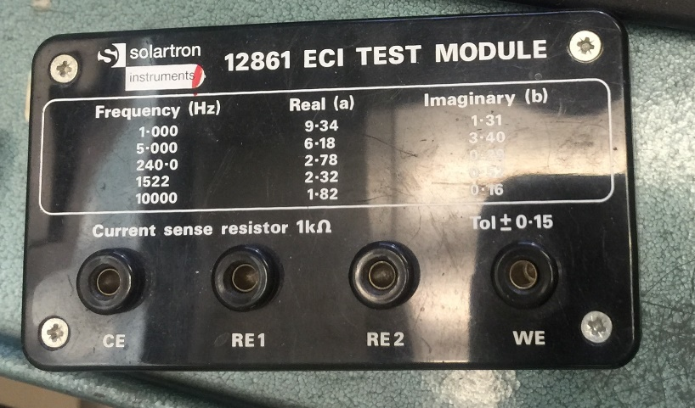

Figure 3. A test module from Solartron.

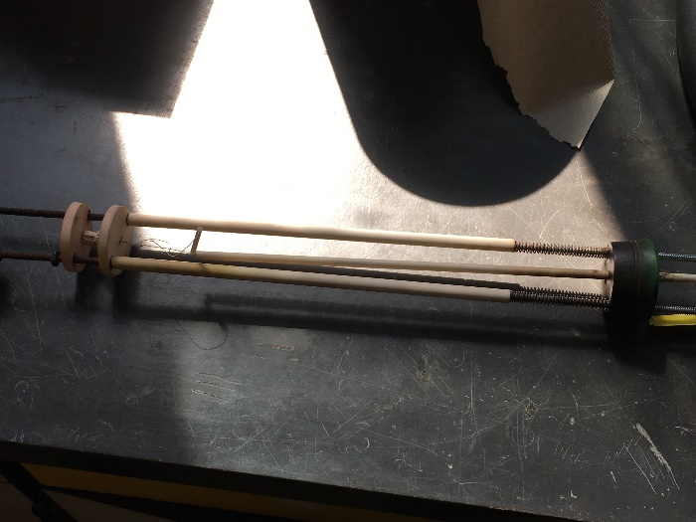

Figure 4. Assembly that sample will be inserted into.

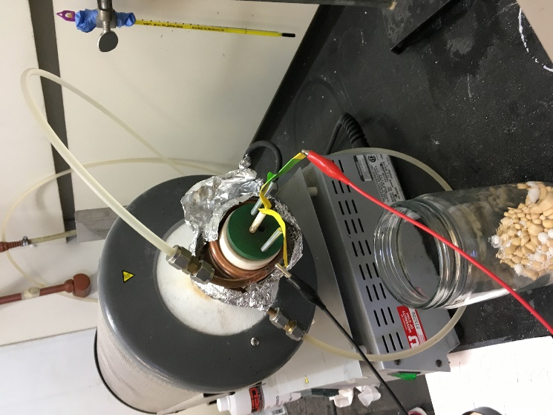

Figure 5. Sample assembly, in the hood fume, with electrodes attached.

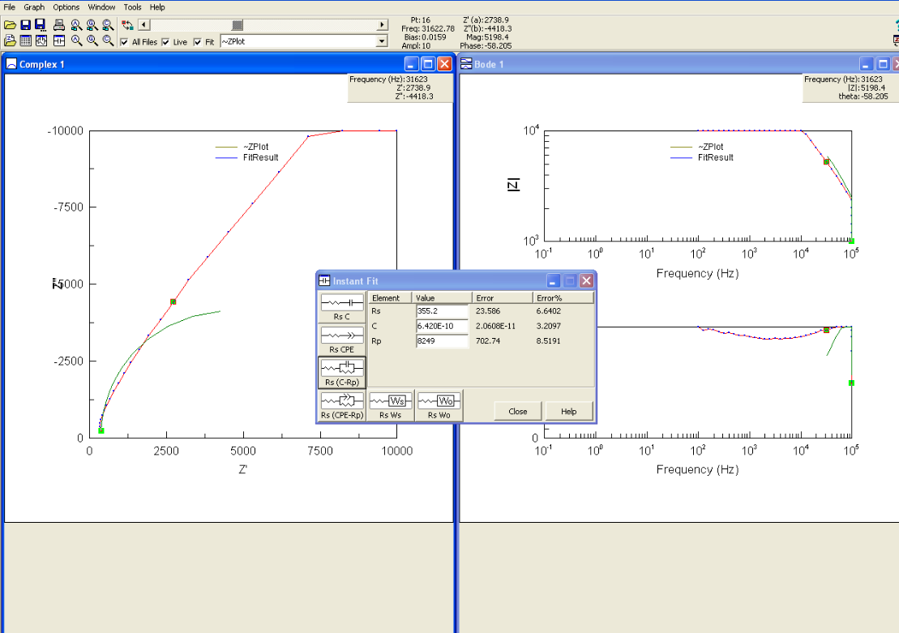

Figure 6. Screenshot of computer after Nyquist plot was obtained.

