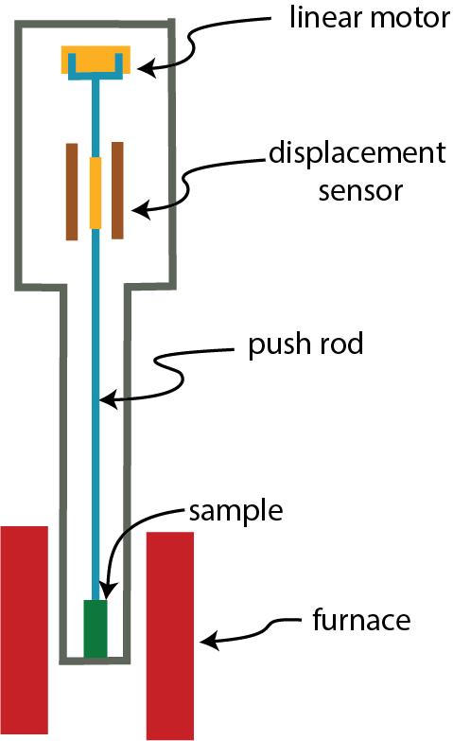

Figure 1: A schematic of a standard vertical push-rod dilatometer.

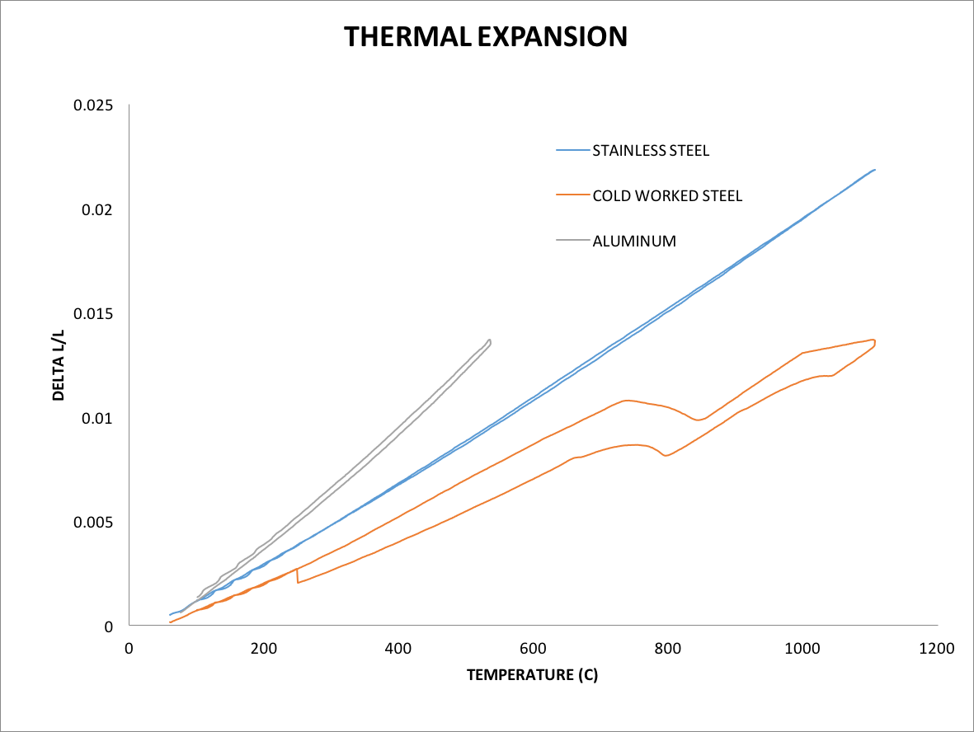

Figure 2: The change in length as function of temperature is plotted for stainless steel, cold worked steel, and aluminum. Samples are heated and then cooled with continuous length measurements to observe whether any hysteresis exists.

