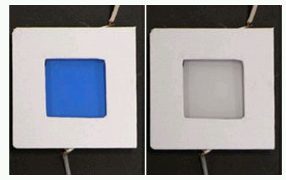

Figure 1: Prussian Blue in its colored and bleached states.

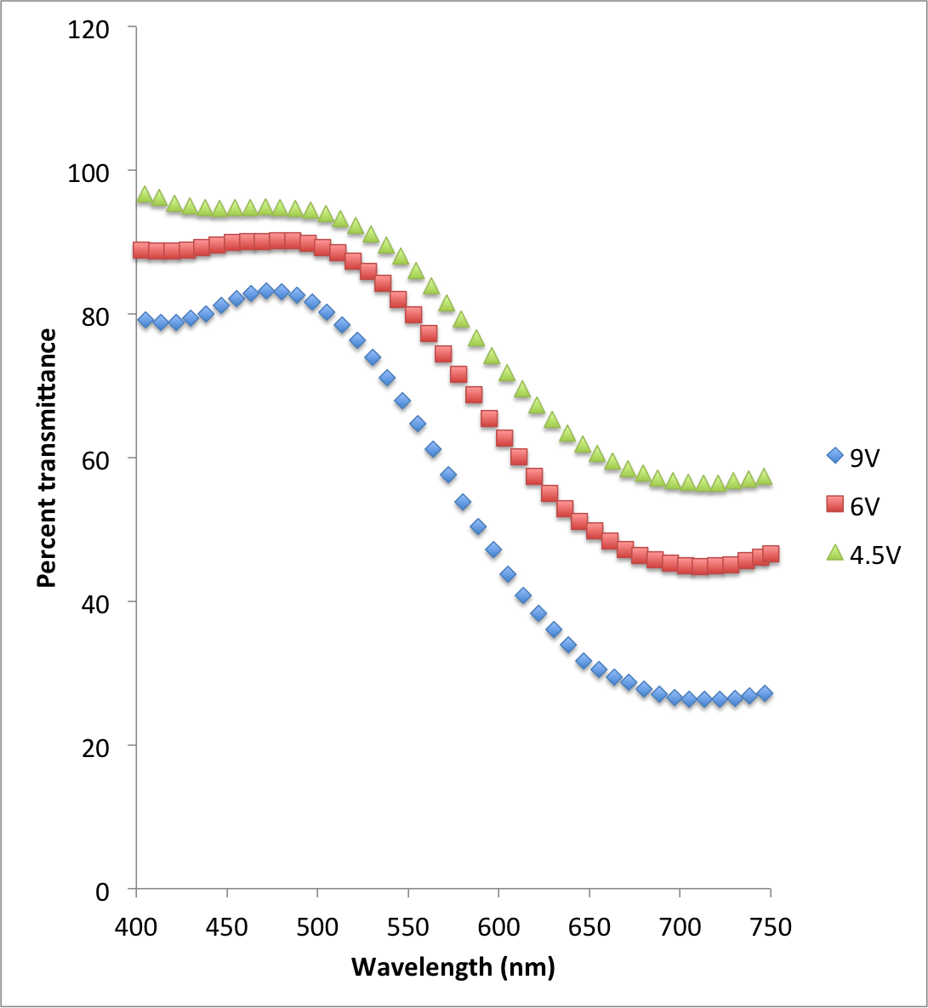

Figure 2: UV-Vis spectroscopy of Prussian Blue in its colored state for various electrochemical deposition voltages.

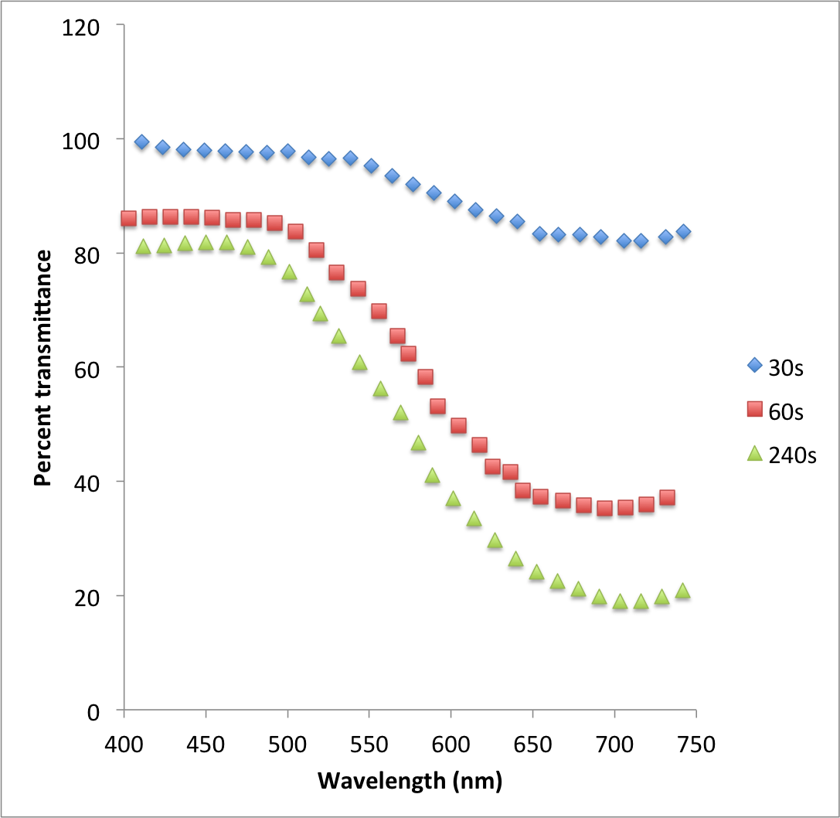

Figure 3: UV-Vis spectroscopy of Prussian Blue in its colored state for various electrochemical deposition times.

