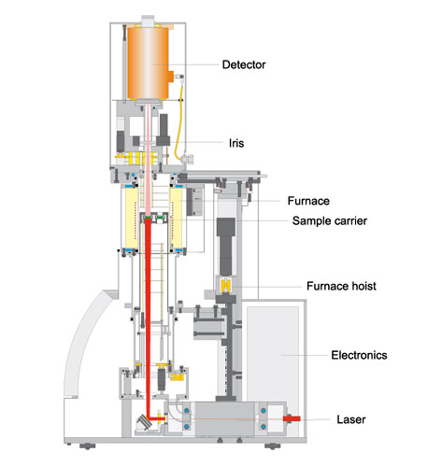

Figure 1: Schematic of LFA Instrument

Figure 2: Laser signal vs time plot at 48.2 °C for an iron standard run in the LFA 457. The blue trace represents the signal from the laser hitting the sample. The thin red line represents the calculated pulse for the Cowan model.

Figure 3: Laser signal vs time plot at 600.6 °C for an iron standard run in the LFA 457. The blue trace represents the signal from the laser hitting the sample. The thin red line represents the calculated pulse for the Cowan model.

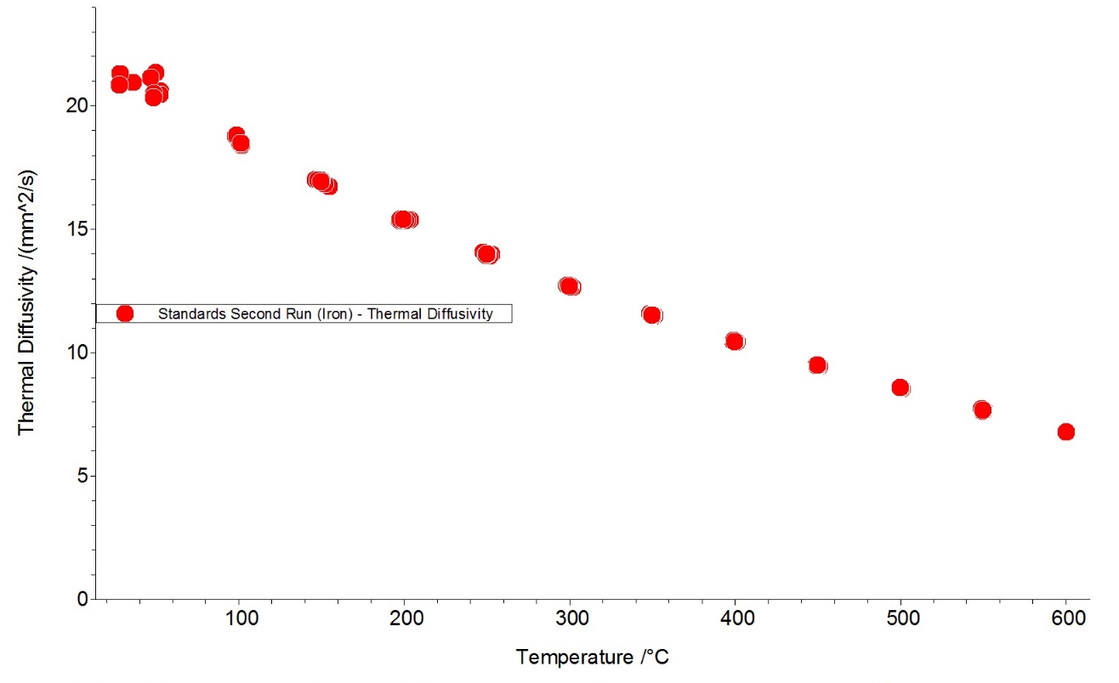

Figure 4: Thermal diffusivity () vs temperature plot for an iron standard disk, run in the LFA 457. Each red circle represents one laser pulse.

