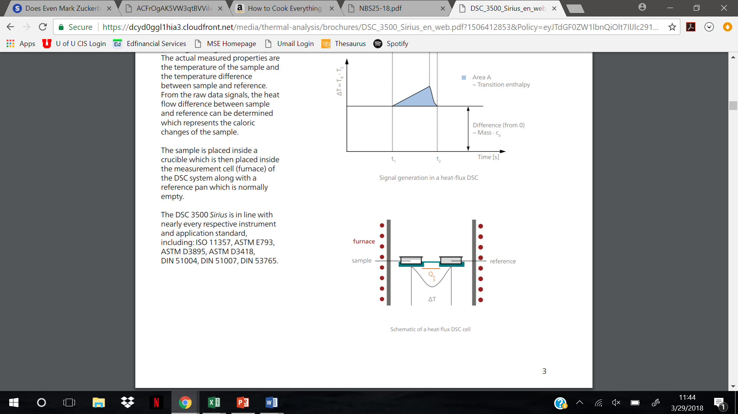
N₂ atmosphere

Figure 1: DSC sample set-up and heat cell schematic.

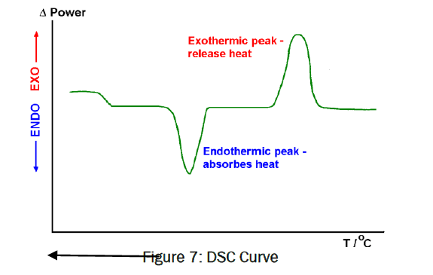

Figure 2: Schematic of a DSC results curve. Exothermic and endothermic peaks are labeled.

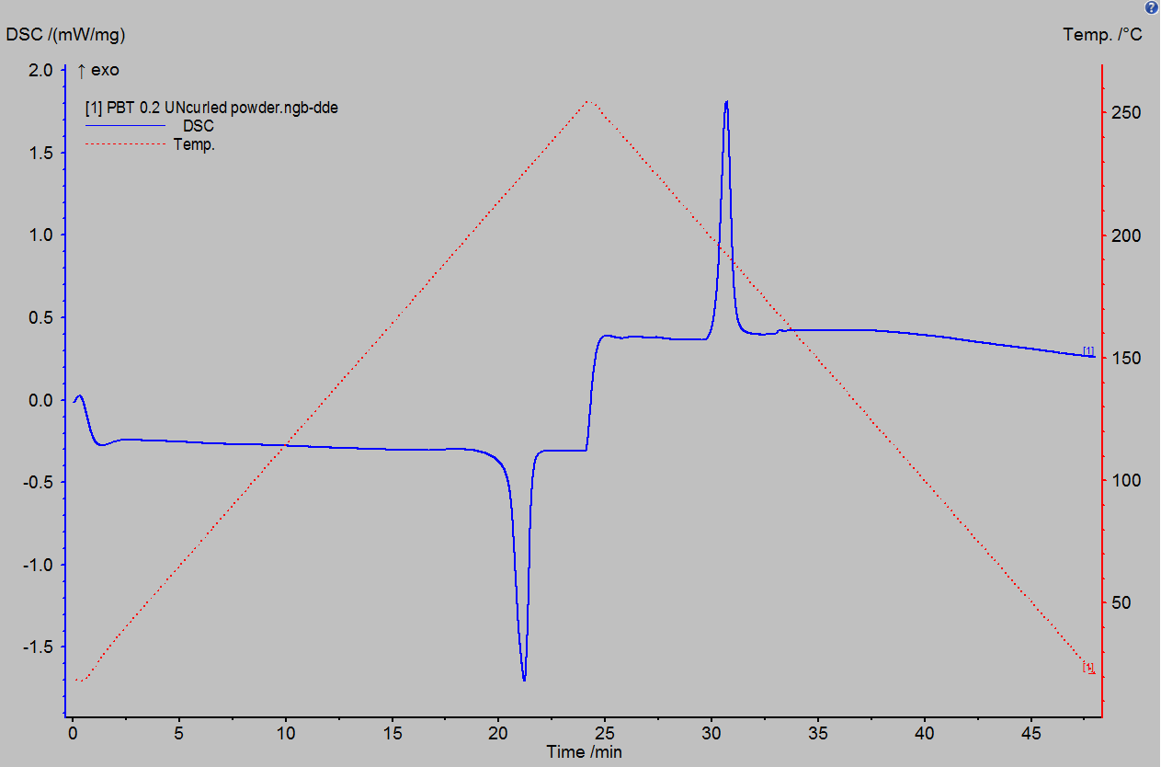

Figure 3: DSC reading vs time for a polybutylene terephthalate polymer sample, run using the DSC 3500. The temperature program used is also shown as the red dashed curve.

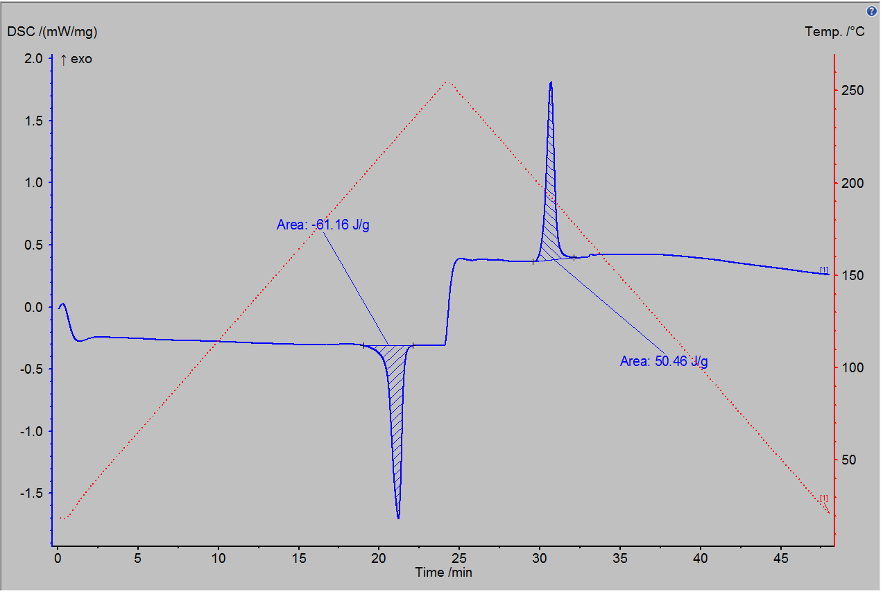
-61.16 J/g
50.46 J/g
A
B

Figure 4: Zoomed view of the endothermic peak (A) and the exothermic peak (B) of PBT polymer DSC scan. Areas under each curve are calculated; these correspond to the heat of melting and heat of cold crystallization of the PBT polymer sample, respectively.

