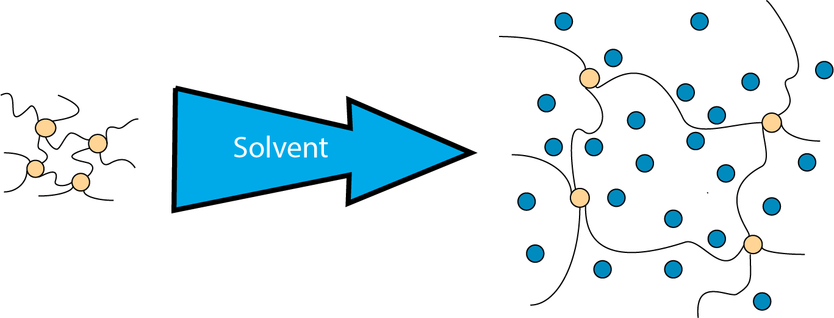

Figure 1: Hydration of a hydrogel

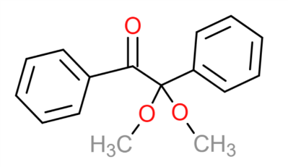
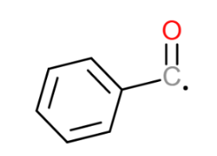
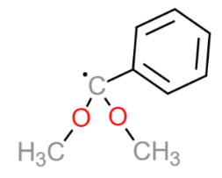

Figure 2: 2,2-Dimethoxy-2-phenylacetophenone fragmenting into two free radical-carrying molecules

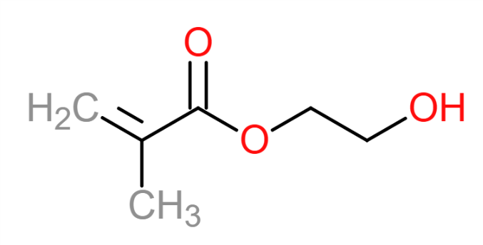

Figure 3: 2-hydroxyethyl methacrylate

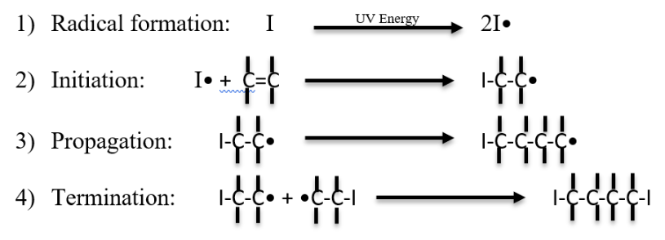

Figure 4: UV initiated free radical polymerization steps

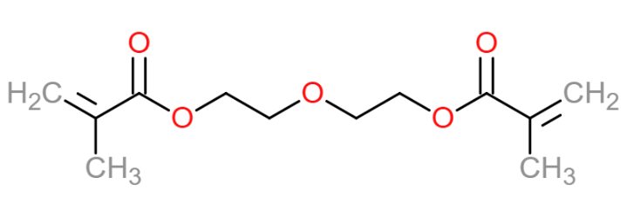

Figure 5: tetraethylene glycol dimethacrylate

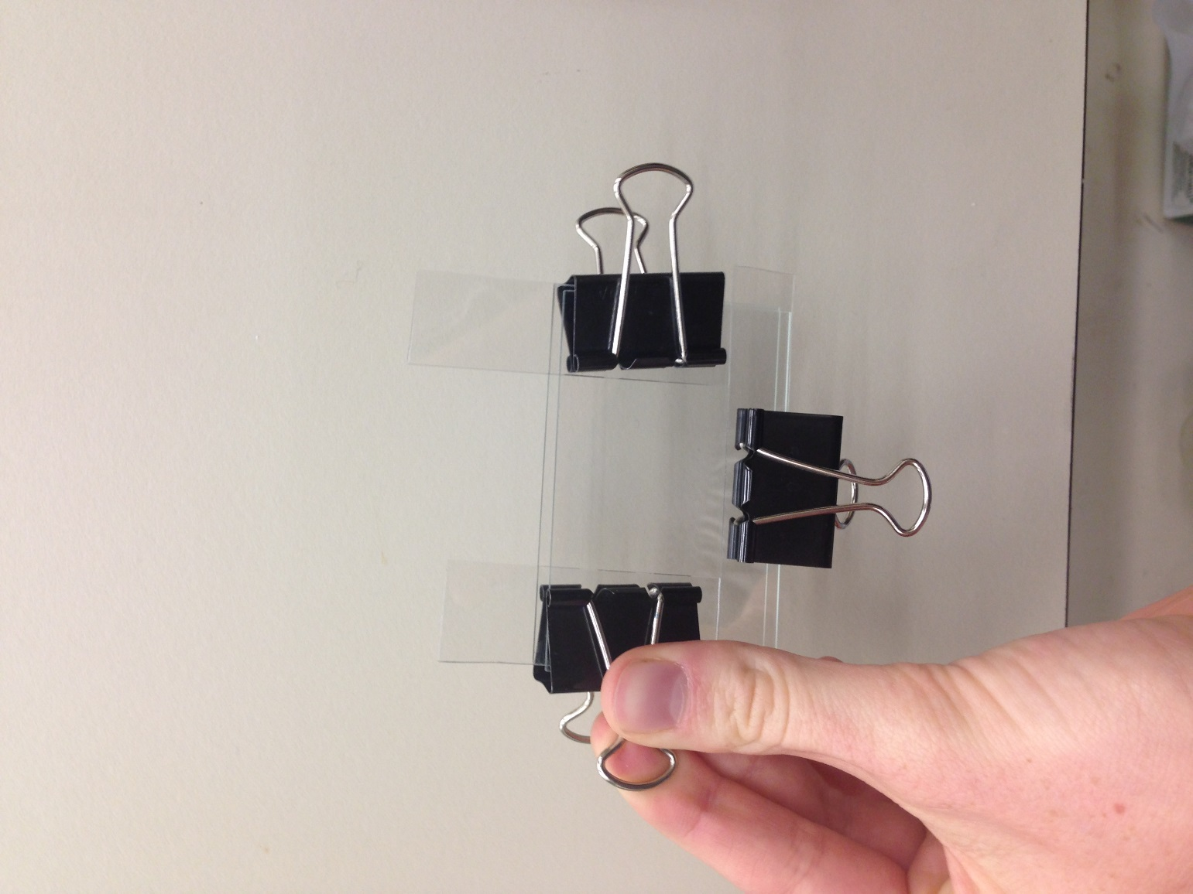

Figure 6: Hydrogel synthesis mold, created from two glass slides, three strips of 520-micron thick polyolefin-sheet as spacers, and large binder clips.

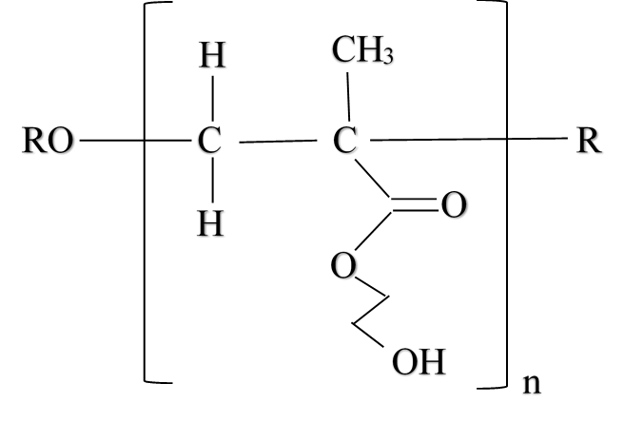

Figure 7. Monomer created from photoinitiator DMPAP, HEMA backbone, TEGDMA crosslinker, EG solvent and photochromic pigment after free radical polymerization.

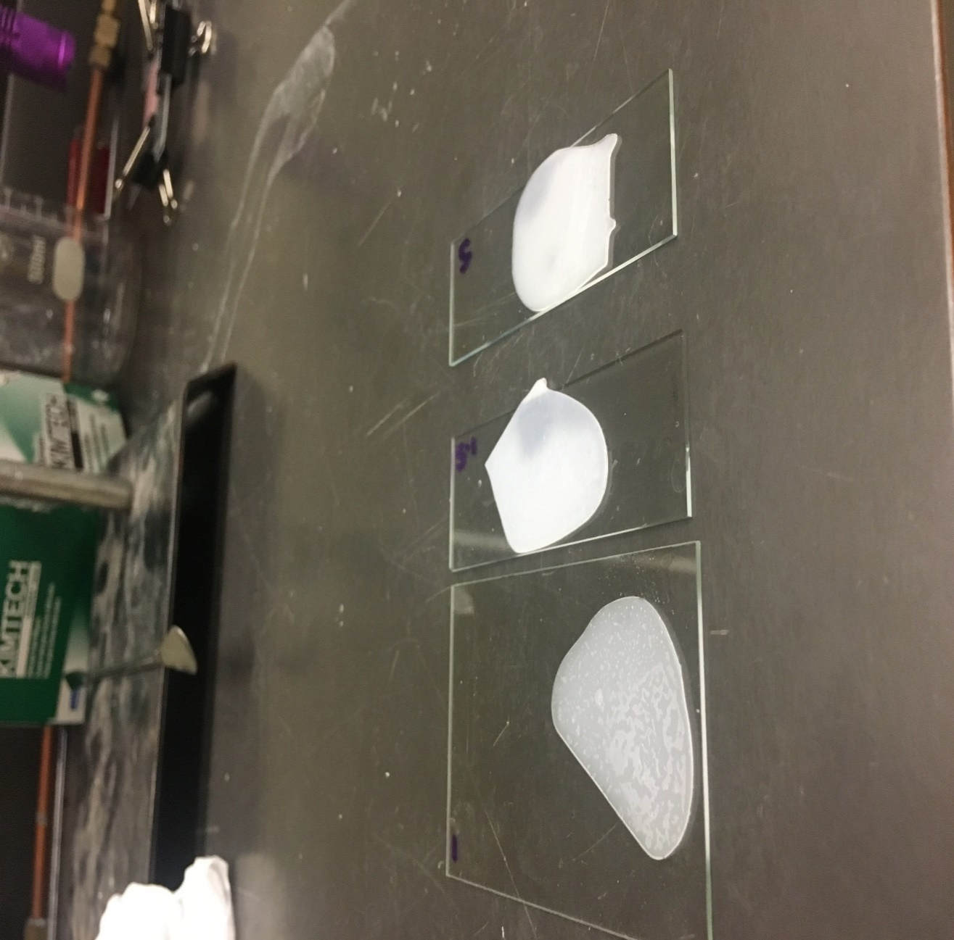

Figure 8: Hydrogels after polymerization. From left to right: 1 minute under UV light during polymerization, 1.5 minutes under UV light during polymerization, 5 minutes under UV light during polymerization. The 1-minute sample appears more transparent and gel-like then the 1.5 minute and 5 minutes samples, which had increasing degrees of polymerization.

