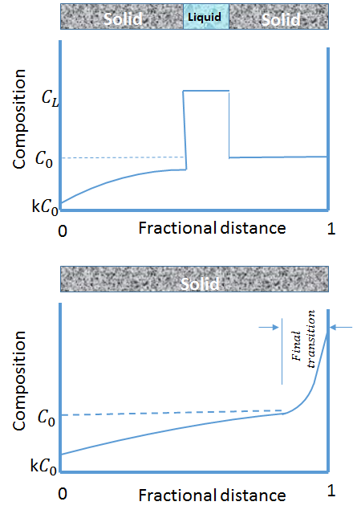
Figure 1: Schematic of the composition change during zone melting directional solidification.

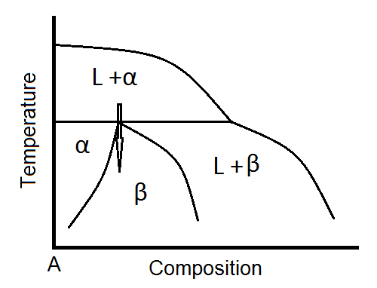
Figure 2: Schematic of peritectic reaction in a phase diagram.

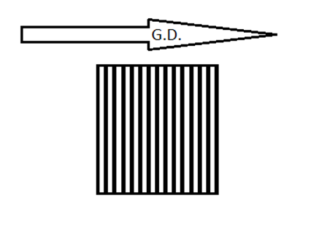
Figure 3: Schematic of banded structure (white: α, black: ß, G.D.: Growth Direction).

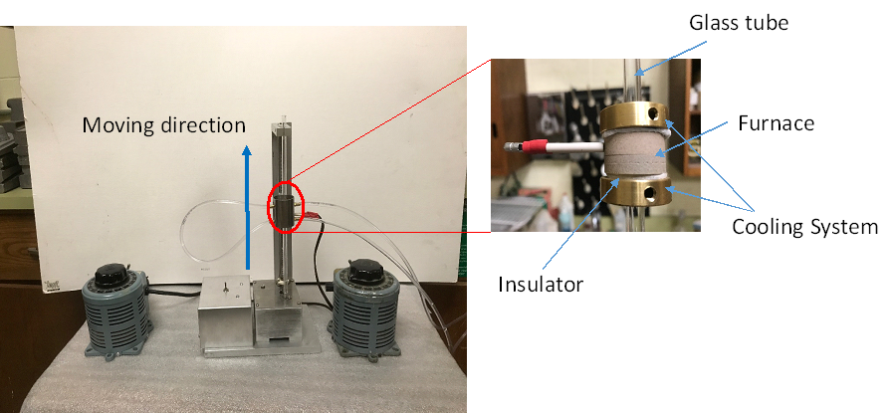
Figure 4: Zone melting-freezing directional solidification furnace, developed at UConn.

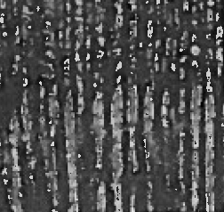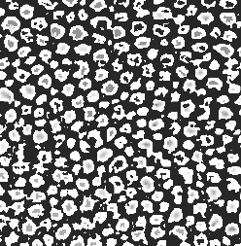
Figure 5: Longitudinal and transverse micrographs of Sn1.5Cd alloy, showing how the stable microstructures develop during zone melting directional solidification.

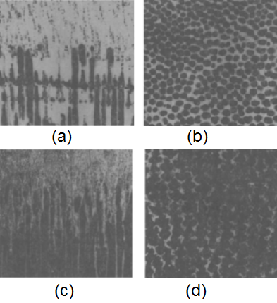
Figure 6: Longitudinal (a & c) and transverse (b & d) micrographs of Pb-28Bi alloy, showing how the aligned stable microstructures develop during zone melting directional solidification. (a), (b) G/V=1.55×10⁶ (ºC.Sec/Cm²) and (c), (d) G/V=1.03×10⁶ (ºC.Sec/Cm²).

