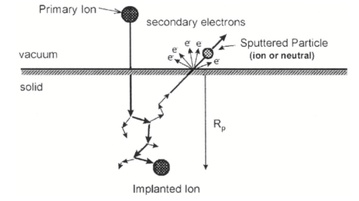
Figure 1: Ion Beam-Solid Interactions – Primary ions bombard the surface, sputter material, eject secondary electrons and implant themselves.

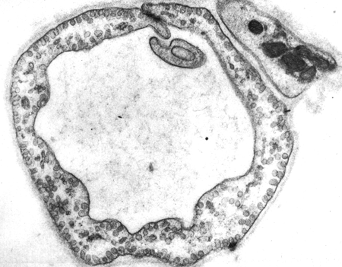

Figure 2: Endothelial cytoplasm in the kidney acts as a filter of particles based on size

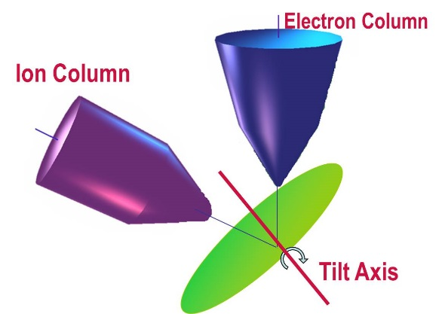

Figure 3: Coincident-eucentric point for SEM/FIB system – Both beams are centered on the sample for tilt angles 0-54 degrees.

Figure 4: FIB milled holes in silicon oxide membrane creating particle filter

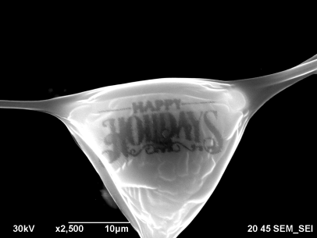
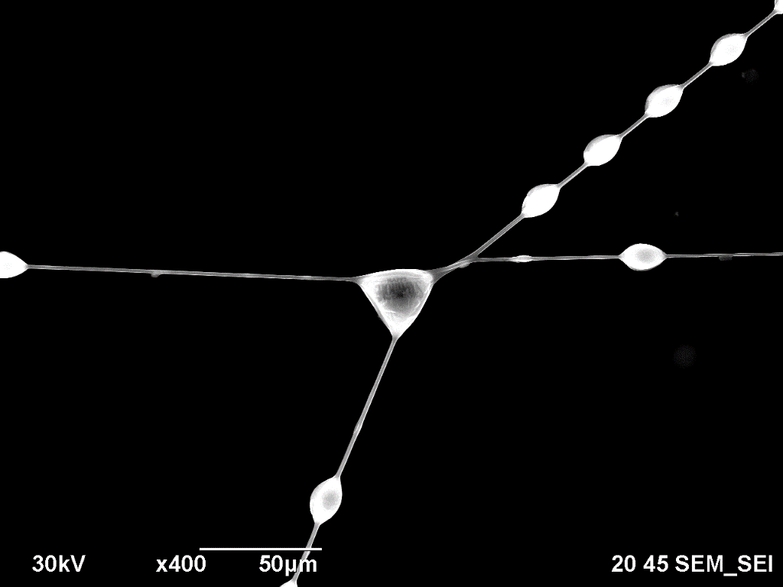

Figure 5: “Happy Holidays” milled on a spider web with FIB

