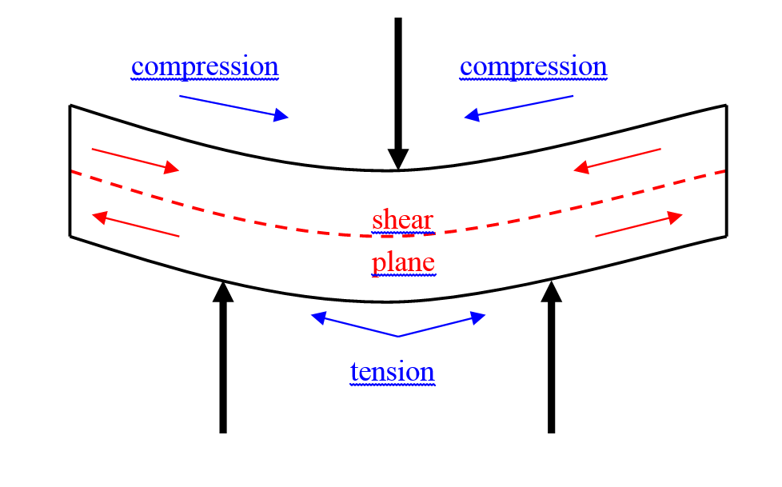
Figure 1: Schematic representation of the 3-point bend test.

