Title: Quantitative Strain Mapping for Three-Dimensional Imaging Data
Overview
Authors: Hannah L. Cebull, Arvin H. Soepriatna, and Craig J. Goergen, Weldon School of Biomedical Engineering, Purdue University, West Lafayette, Indiana
The mechanical behavior of soft tissues such as blood vessels, skin, tendons, and other organs are strongly influenced by their composition of elastin and collagen, providing elasticity and strength. The fiber orientation of these proteins depends on the type of soft tissue, ranging from a single preferred direction to intricate disordered networks, and can become altered from diseases. Therefore, soft tissues often behave anisotropically on cellular and organ level, creating a need for three-dimensional characterization. Developing a method for reliably estimating strain fields within complex biological tissues or structures is important for mechanical characterization and understanding disease. Strain represents how the soft tissue is relatively deforming over time and can be described mathematically through various estimations.
Acquiring imaging data over time allows deformation and strain to be estimated. However, all medical imaging modalities contain some amount of noise, which increases the difficulty of accurately estimating in vivo strain. The technique described here successfully overcomes these issues by using a direct deformation estimation (DDE) method to calculate spatially varying 3D strain fields from volumetric image data.
Current strain estimation methods include digital image correlation (DIC) and digital volume correlation. Unfortunately, DIC can only accurately estimate strain from a 2D plane, severely limiting the application of this method. While useful, 2D methods, such as DIC, has difficulty quantifying strain in regions that undergo 3D deformation since of out-of-plane motion creates deformation errors. Digital volume correlation is a more applicable method that divides the initial volume data into regions and finds the most similar region of the deformed volume, thereby reducing out-of-plane error. However, this method proves to be sensitive to noise and requires assumptions about the mechanical properties of the material.
The technique described here eliminates these issues by using a DDE method, thus making it very useful for analyzing medical imaging data. Furthermore, it is robust to high or localized strain. Here we describe acquisition of gated, volumetric 4D ultrasound data, conversion of the data into format that can be analyzed, and use of a custom Matlab code capable of estimating 3D deformation and corresponding Green-Lagrange strains, a parameter that better describes large deformations. The Green-Lagrange strain tensor is implemented in many 3D strain estimation methods because it allows for F to be calculated from a Least Squares Fit (LSF) of the displacements. The equation below represents the Green-Lagrange strain tensor, E, where F and I represent the deformation gradient and second order identity tensor, respectively.
$E= \frac{1}{2}\left(F^{T}F-I\right)$ (1)
Principles
4D ultrasound is a dynamic volume that is acquired utilizing a linearly translating motor attached to an ultrasound transducer, allowing the acquisition of sequential, cardiac- and respiratory-gated video loops across a region of interest. This method is useful for visualizing complex structures such as the heart, where hypertrophy or infarction leads to complicated geometries, or aortic aneurysms where asymmetric vessel expansion and dissection often occur in tortuous vessels. Additionally, 4D data can provide high-resolution spatial and temporal information, which is also important for cardiovascular imaging.
The DDE method applied to the 4D ultrasound data is superior to other methods partly because it uses non-rigid image registration. Deformation gradient tensors are traditionally estimated from displacements fields following digital volume correlation. In contrast, the DDE method intrinsically estimates deformation gradient tensors during volume registration by optimizing a warping function that is carefully chosen to be directly analogous to the deformation tensor. The warping function depends on both spatial position and the warping parameter (p):
$W\left(x;p\right)= \left[\begin{matrix}1+p_{1} & p_{4} & p_{7} & p_{10} \\ p_{2} & 1+ p_{5} & p_{8} & p_{11} \\ p_{3} & p_{6} & 1+ p_{9} & p_{12} \\ 0 & 0 & 0 & 1\end{matrix}\right] \left[\begin{matrix}x \\ y \\ z \\ 1\end{matrix}\right]$ (2)
The first four elements of this function represent the deformation gradient tensor, F, allowing the calculation of deformation to be directly incorporated into the warping function. This warping method has been proven to increase the accuracy and precision of strain estimation when compared to similar previous techniques because it allows for large or localized deformations commonly found in soft tissues.
Procedure
- 4D Ultrasound Setup

  - When using the imaging software, use a laptop capable of running Matlab to automate the 4D acquisition process. Connect the laptop with this custom code to the ultrasound system via the USB port. Note that the imaging software has a 4D ultrasound feature integrated into the Vevo software.

  - After turning on the ultrasound system, set up the physiological monitoring unit while also ensuring that the Heart Rate and Temperature buttons are on. Initialize the 3D motor stage attached to the transducer holder.

  - Use the appropriate stage and ultrasound transducer for image acquisition. Ensure that all proper connections are made.

  - Proceed with anesthetizing and preparing the animal for imaging. Add ophthalmic ointment to the eyes to prevent corneal desiccation, secure the paws to the stage electrodes, insert the rectal temperature probe, and remove the hair in the area of interest using a depilatory cream.

  - Apply a generous amount of the warmed ultrasonic transducing gel to the animal. It is especially important to create a good connection over the entire region of interest for 4D imaging.

- 4D Ultrasound Acquisition

  - Begin a new study on the ultrasound system and open the imaging window in B-Mode (brightness mode). Lower the transducer onto the animal and locate the region of interest using the x- and y-axis knobs on the stage, making sure the respiratory rate does not decrease substantially by monitoring this at the bottom of the screen.

  - Position the transducer within the middle of the region of interest. From there, approximate the distance needed for the transducer to move up and down such that the entire region of interest is included.

  - Enter the approximated dimensions into the Matlab code, including a step size which is typically ~0.2 mm. Begin running the Matlab code after ensuring the animal’s heart and respiratory rates are stable. This is important for reducing errors when reconstructing images.

  - After completing the image acquisition, export the data as raw XML files.

- 4D Ultrasound Data Conversion

  - Input the raw XML files into software that can convert the data into the proper format for the 3D stain analysis. Here we use Matlab to convert XML files into MAT files.

  - For proper conversion, the number of frames, step size, and desired output resolution will also need to be input.

  - After resampling the matrix in through plane, import the new MAT file into the 3D strain analysis code.

- 3D Strain Code Analysis

  - Begin analysis by properly adjusting the imported MAT file. For example, the image volume may need to be rescaled to decrease computation time.

  - Input the region to be analyzed and determine the appropriate mesh template used for segmenting the image data as simple boxes or a manually chosen polygons. The box size of the regions and spacing between the center points may need to be altered for each data set. The optimal numbers chosen for box size will be around the order of pixels of the feature being tracked, which can be approximated by looking at the number of pixels in two dimensions of one slice. The spacing of the boxes will determine the resolution of the strain fields. More boxes will increase the resolution, but may substantially increase computation time.

  - Begin computing the Jacobians and gradients iteratively within each of these regions. After the precomputation is complete, the warping function can be applied.

  - Following this, the deformation gradient tensor can then be calculated. First calculate strain, and then calculate eigenvalues and eigenvectors using the direct deformation estimation method.

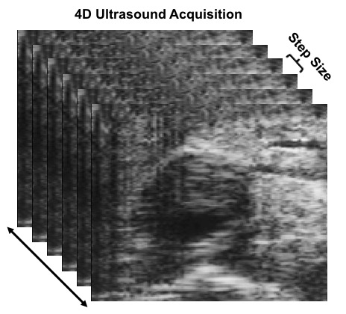
  - Plot these results in the desired planes, using a technique such as color mapping of a cut plane to represent the strain field over your region of interest.
Figure 1: ECG-gated Kilohertz Visualization (EKV) loops of the aorta are acquired from manually inputted starting and ending locations, following a step size of 0.2 mm.
Results
Using the procedure described above, 4D ultrasound of an angiotensin II-induced suprarenal dissecting abdominal aortic aneurysm (AAA) was acquired from a mouse. Multiple short-axis EKV video loops were acquired along the aorta and combined to create 4D data as shown in Figure 1. This data was then converted into a MAT file using a custom Matlab code, which was then analyzed in a 3D strain calculation code using a warping function. After optimizing the parameters of the code for a specific data set, a representative, long-axis view with corresponding strain values can be produced as well as a 3D slice visualization plot with an overlaid strain color map (Figure 2). This DDE technique and strain data highlight the heterogeneous spatial variations in strain, particularly when thrombus is present. These results can then be correlated with vessel structure to determine the relationship between in vivo deformation and aneurysm composition.
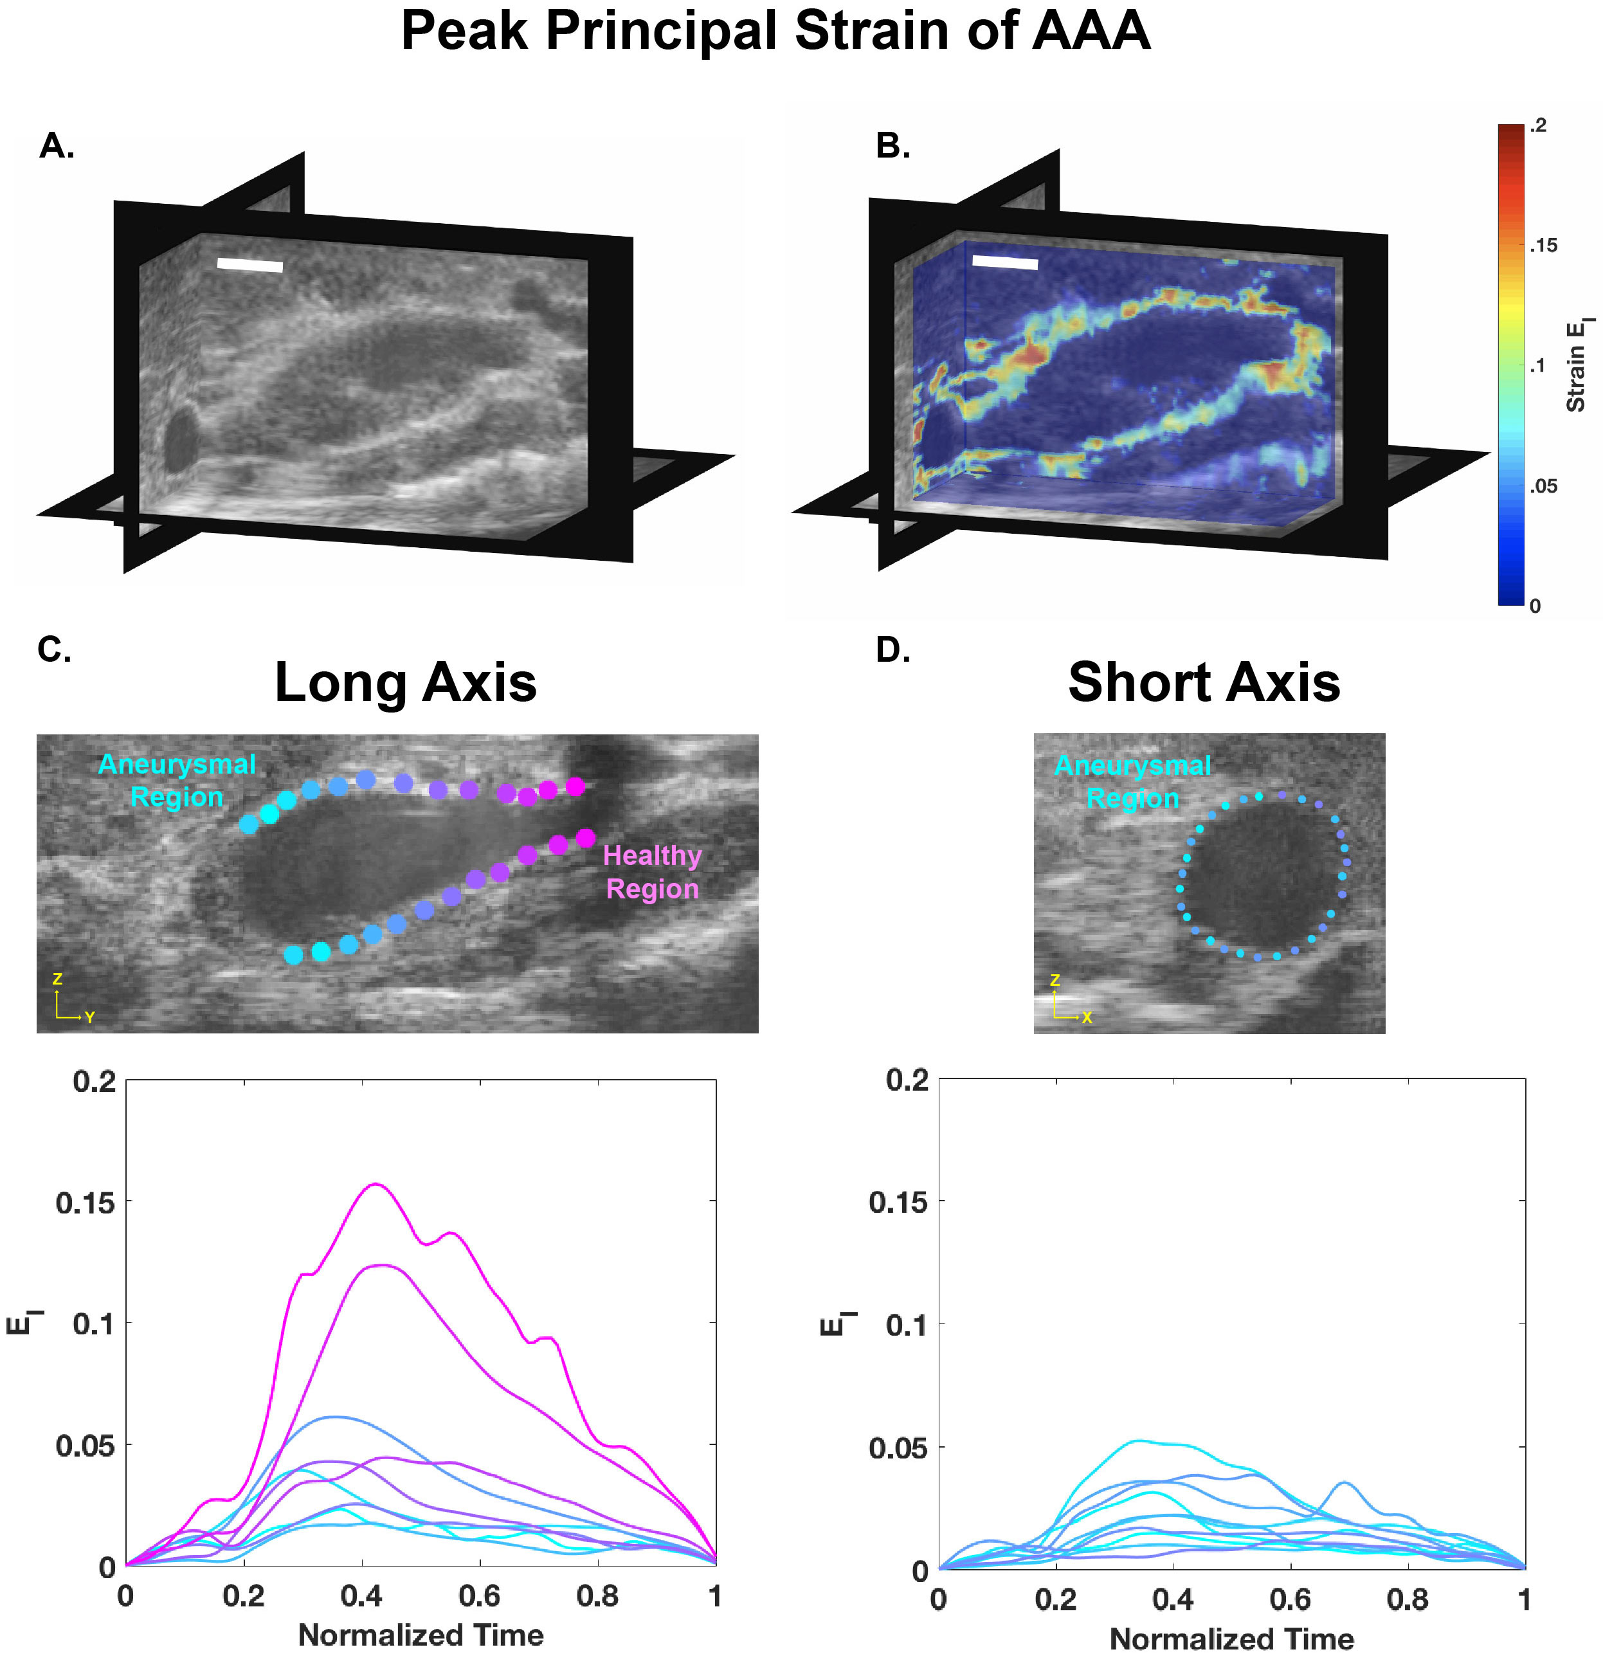
Figure 2: 4D high frequency ultrasound data of a murine dissecting abdominal aortic aneurysm represented at systole (A) with principal strain fields estimated and overlaid (B) (Scalebar = 5 mm). Long- and short-axis views representing both aneurysmal and healthy regions corresponding principal strain over one cardiac cycle (systole: t= 0.4) (C, D). These data show relatively high strain levels in healthy regions and reduced strain values within the dissecting aneurysm.
Summary and Applications
Localized in vivo mechanical characterization is an important part of understanding growth and remodeling of biological tissues. Compared to existing approaches, the strain quantification procedure described here uses an improved method of accurately calculating 3D strain through optimally warping the undeformed image before cross-correlation. This method does not use any material assumptions in determining strains within tissue volumes. Unfortunately, the strain estimation is reliable only down to a kernel size of 15x15x15 voxels when using ultrasound data, suggesting that this DDE approach may not detect subtle features within a strain field. Despite this limitation, it remains an important tool for investigating mechanical responses, diagnosing pathology, and improving disease models.
Many areas of research beyond aortic aneurysms can benefit from this strain measurement tool. Cardiac strain can also be easily quantified using this method. Because the myocardium undergoes 3D deformation during the cardiac cycle, quantifying strain in three dimensions is integral to reliably characterizing the dynamics of this tissue. Reliable strain data is especially important when tracking disease progression in animal models.
3D strain analysis can also be applied to intestinal ultrasound imaging. Mechanical characterization of intestinal tissue is most commonly conducted in vitro. However, this is not always a true representative of the actual behavior of the intestines in vivo because of effects from surrounding structures. As an example of clinically translating this approach, calculating the strain from images of intestinal fibrosis due to abnormal luminal pressure could provide early detection of problematic areas that require surgical intervention.
Beyond the larger scale applications, this method can also be applied to the cellular level by using higher resolution imaging techniques such as confocal microscopy. Characterizing the extracellular matrix is important for understanding how cells communicate. Much research has been conducted on the biochemical characterization, but understanding how communication can be conducted through mechanical responses requires an understanding of the deformation and strain that is occurring. Bulk strain is not beneficial in this case because there is no way to determine the origin of the deformation change. Applying a high-resolution DDE approach could directly reveal how the extracellular matrix responds to mechanical changes.
Acknowledgements
We would like to acknowledge John Boyle, Guy Genin, and Stavros Thomopoulos for the contribution of the DDE custom Matlab code capable of directly estimating Green strain.

