Title: Noninvasive Blood Pressure Measurement Techniques in Humans and Rodents
Overview
Authors: Hamna J. Qureshi and Craig J. Goergen, Weldon School of Biomedical Engineering, Purdue University, West Lafayette, Indiana
This paper will highlight the key similarities and differences of noninvasive blood pressure measurement techniques between humans and rodents and examine the engineering principles that govern blood pressure. The principles that govern current cuff technology to acquire systolic and diastolic pressures will also be discussed.
Commercially available cuffs that connect with mobile devices are typically compact and portable, thereby allowing measurements to be taken virtually anywhere. Noninvasive, portable blood pressure cuffs are especially useful for patients with hypertension and other cardiovascular health problems that require careful monitoring and early detection of any changes in blood pressure.
Similarly, noninvasive blood pressure measurement systems are also available for rodents. This technology is used in laboratory settings and is useful for monitoring animal health throughout a study. While radiotelemetry is the gold standard of blood pressure measurement for rodents, this technique is invasive and can lead to animal mortality if done incorrectly. Noninvasive methods, therefore, are convenient for taking measurements in animals as they can provide valuable data without the need for device implantation. A commercially available system will be used to demonstrate how blood pressure can be measured in humans outside of a clinical setting. This technique allows patients to monitor their own blood pressure periodically without having to visit a clinic each time they want these measurements taken.
The methods described here take advantage of blood flow through the tail of the rodent by using pressure sensors and occlusion cuffs. Both mobile blood pressure cuffs for humans and noninvasive tail-cuff methods for take advantage of similar hemodynamic principles to acquire blood pressure measurements that can provide useful data for users—whether they are clinicians, researchers, or patients.
Principles
Blood pressure measurements consist of systolic and diastolic components, which are both important indicators of cardiovascular health. Systolic blood pressure is defined as the maximum intraluminal pressure exerted against artery walls due to heart contraction, while diastolic blood pressure is defined as the minimum intraluminal pressure when the aortic valve is closed.
Blood pressure measurements taken with commercially available cuffs use oscillometric methods to take measurements. In clinical settings, auscultatoric methods are commonly used to take blood pressure. Clinicians typically inflate blood pressure cuffs around the brachial artery in the arm until the vessel is completely occluded. Once they deflate the cuff, clinicians listen for the point at which they first hear the beating sound through the stethoscope. This point indicates the systolic blood pressure, as the pressure within the artery is large enough to open the vessel. The cuff then continues to deflate until no repetitive sound is heard. This point indicates the diastolic blood pressure, as the vessel remains open. Oscillometric technology is similar to auscultatoric technology except it is automated. Instead of listening for a sound, an algorithm for the cuff will detect oscillations in blood flow once the blood pressure cuff starts deflating. These oscillations will begin when blood starts flowing through the artery again, indicating systolic blood pressure, and the oscillations will start to level out when blood flow becomes steady, indicating diastolic blood pressure.
Noninvasive methods to take blood pressure in rodents also take advantage of automated technology. The system described here includes an occlusion cuff that will inflate and deflate around the tail artery analogous to how clinical blood pressure cuffs inflate and deflate around the brachial artery. A volume pressure recording (VPR) sensor is also placed around the tail. This sensor can determine blood pressure using a pressure transducer that can indicate when systolic and diastolic pressures occur within the animal’s tail, a close surrogate for true system blood pressure.
Procedure
- Wireless Blood Pressure Cuff for Humans

  - Turn on the cuff and pair it with a mobile device onto which results will be outputted. Pairing can be done via Bluetooth.

  - Strap cuff onto upper arm with blood pressure monitor placed against inner bicep. Strap should be secured tightly on arm.

  - Open application for cuff on mobile device. Ensure that cuff is paired with mobile device.

  - Position yourself so that you are seated with your arm resting such that the cuff is at the same level as your heart. Make sure you are in a calm environment so that you can stay relaxed while data is being collected.

  - Once you are positioned correctly, begin the blood pressure measurement. Multiple trials can be run so that an average of these measurements is reflected in the results.

  - After measurements have been collected, results will be outputted onto mobile device screen. Take note of the results. Unstrap the cuff from arm and shut it off.

- Noninvasive Blood Pressure Measurements for Rodents

  - Turn on heated stage, blood pressure system, and desktop computer. Attach VPR cuff and occlusion cuff to blood pressure system. Use software to check that the cuffs are properly calibrated and are working as expected. Setup software to be ready to acquire data according to desired parameters.

  - Prepare animal (mouse or rat) for placement into an appropriately sized holder. Make sure environment is calm with minimal unexpected noises. Try to calm animal before placing it in its holder to prevent the animal from experiencing unnecessary stress.

  - Gently coax animal into the holder. Make sure its paws do not get stuck in the attachments of the holder and that the tail is outside of the restrainer.

  - Once the animal is secured, place the holder on the heated stage. Slide the occlusion cuff onto the base of the tail and then slide the VPR cuff on just behind the occlusion cuff. Leave 1 - 2 mm of space in between the two cuffs. If using an occlusion cuff and VPR cuff sized for mice, you may secure them using a strip of plastic tubing.

  - After the cuffs are on, tape them to the stage to prevent the animal’s tail from moving too much. Allow the tail to heat up to about 32 – 34 °C to promote vasodilation and subsequent blood flow through the tail.

  - Once setup is complete and the tail is sufficiently heated, begin acquisition of blood pressures. While blood pressure is being measured, make note if the animal moves substantially within restrainer. Try to keep the cuffs’ position constant. If the cuffs slide down the tail or if the animal moves inside the restrainer, press the Pause button and readjust the cuffs/animal once the ongoing run has completed. Maintain a calm environment throughout this process.

  - Check to make sure blood pressures are being acquired as expected. Repeat measurements if necessary. Multiple trials are recommended (typically 20 - 40 measurements).

  - Once data has been collected, save measurements for further analysis. Remove animal from holder and place it back into its cage. Turn off heated stage and blood pressure system and clean the surfaces that were in contact with the animal.
Results
A typical graph obtained from taking rodent blood pressure using the CODA Kent Scientific Noninvasive Blood Pressure System is shown in Figure 1. There are two curves on the graph: one for the VPR sensor and one for the occlusion cuff. The inflection points of the VPR sensor curve are where systolic and diastolic blood pressures are taken as depicted in Figure 1. A status is indicated at the bottom of the figure that communicates whether this measurement is deemed acceptable by the system. In order to obtain acceptable readings, blood pressures are taken multiple times per trial to ensure accurate and precise results.
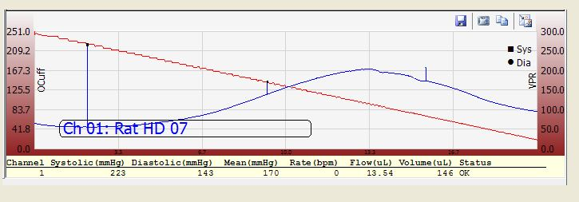
Figure 1. Systolic and diastolic blood pressures are obtained by the CODA system from this graph. The red curve represents the occlusion cuff pressure and the blue curve represents the VPR sensor curve. The inflection points of the blue curve are used to calculate systolic and diastolic pressure.
Systolic BP
Diastolic BP

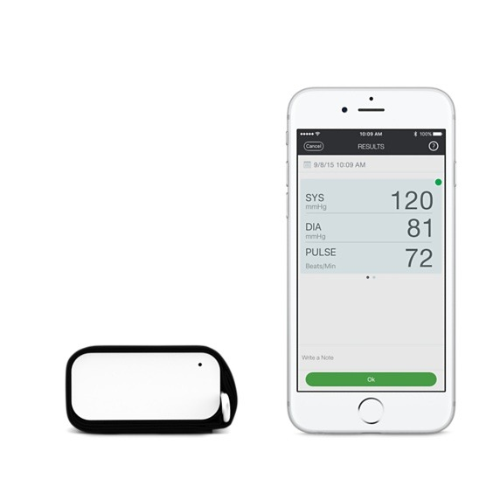
For a commercially available cuff, the results of the blood pressure measurement are outputted on a screen as shown in Figure 2. Users can see their systolic and diastolic blood pressure measurements using this technology. Blood pressure can be taken multiple times so that the results output an average of the data that was collected.
Figure 2. Screenshot of systolic and diastolic blood pressure.

Summary and Applications
Both commercial cuffs available for at-home use and noninvasive methods for animal research studies take advantage of automated technologies. By tracking changes in blood flow with sensors, algorithms can detect when systolic and diastolic pressures occur and can communicate these results to users. While technologically similar, there are some key differences between the two measurement techniques that should be noted. When taking blood pressures in human subjects, the environment is typically relaxed as the subject is unrestrained and fairly comfortable. Conversely, animals must be restrained or anesthetized. Restraining can make the animal anxious and therefore skew blood pressure measurements to be higher, while anesthesia can lead to hypothermia and vasoconstriction, making reliable measurements harder to acquire. This is why it is preferable to obtain rodent blood pressures in conscious animals that are in a calm, dimly lit environment where they can be kept warm with no startling noises. Vasodilation through heating is also promoted in rodents undergoing blood pressure measurements to promote blood flow through their tail. Acclimating animals to the holder and cuffs before acquiring data can help reduce discomfort and allow collection of more accurate results. Also, if a user is collecting measurements for the same animal on multiple days, the results will be more meaningful if acquired at roughly the same time each day.
Being able to take blood pressure measurements with a user-friendly, compact cuff is an extremely useful tool for patients to have as it allows patients to monitor their blood pressures at their own convenience. Commercially available blood pressure cuffs, however, are not meant to replace clinically obtained measurements; rather these cuffs are meant to help patients monitor their systemic blood pressure between visits. Commercial cuffs are also subject to noise and do not always collect accurate results. Similarly, noninvasive measurements of rodent blood pressure are also noisy, especially when the animal moves. As such, it is important to be judicious when looking at data from these systems.
Portable noninvasive blood pressure measurement methods are useful for a variety of applications. Commercial cuffs allow hypertensive patients to monitor their health between visits to the clinic. This method can help patients become more conscious of their dietary and exercise decisions, as they can see the direct impact that their lifestyle has on their blood pressure. Commercial cuffs can also help pregnant women track their blood pressures in the final months of their pregnancies. Pregnant women are at risk for developing preeclampsia. Therefore, it is important for these women to know if they are at risk for this condition during the late half of gestations. Using a portable cuff would help these women track their blood pressure in the critical months before the baby is born.
For animal use, noninvasive blood pressure measurements are valuable for research purposes, especially those regarding cardiovascular health. Taking blood pressures of animals after procedures and studies, such as those inducing hypertension in rodents, can show the effects of these actions on an animal’s health. While other invasive techniques can provide more consistent data, the noninvasive nature of tail-cuff systems make them an attractive method for those using animal models of cardiovascular disease.

