Title: Three-dimensional visualization of knee joint degeneration after ACL injury using micro-computed tomography

Overview
Source: Lindsey K. Lepley^{1,2}, Steven M. Davi¹, Timothy A. Butterfield^{3,4} and Sina Shahbazmohamadi⁵, Department of Kinesiology, University of Connecticut, Storrs, CT; ²Department of Orthopaedic Surgery, University of Connecticut Health Center, Farmington, CT; ³Department of Rehabilitation Sciences, University of Kentucky, Lexington, KY; ⁴Center for Muscle Biology, Department of Physiology, University of Kentucky, Lexington, KY, Biomedical Engineering Department, University of Connecticut, Storrs, CT

Anterior cruciate ligament (ACL) injury to the knee dramatically increases the risk of post-traumatic osteoarthritis (PTOA), as approximately one-third of individuals will demonstrate radiographic PTOA within the first decade following ACL injury. Though ACL reconstruction (ACLR) successfully restores knee joint stability, ACLR and current rehabilitation techniques do not prevent the onset of PTOA. Hence ACL injury represents the ideal model to study the development of PTOA after traumatic joint injury.

Rat models have been used extensively to study the onset and effect of ACL injury on PTOA. The most widely used model of ACL injury is ACL transection, which is an acute model that surgically destabilizes the joint. Though practical, this model does not faithfully mimic human ACL injury, due to the invasive and non-physiological injury procedures that mask the native biological response to injury. To improve the clinical translation of our results, we have recently developed a novel non-invasive model of ACL injury, where the ACL is ruptured through a single load of tibial compression. This injury closely replicates injury conditions relevant to humans and is highly reproducible.
Visualization of joint degeneration through micro- computed tomography (μCT) provides several major advancements over traditional OA staining techniques including rapid, high-resolution, non-destructive 3D imaging of whole joint degeneration. Hence the goal of this demonstration is to introduce the state of the art non-invasive ACL injury in a rodent model and the use of μCT to quantify joint degeneration.

Principles

The ACL is a band-like structure of dense connective tissue that runs anteriorly, medially and distally through a large portion of the intercondylar notch of the femur. Structurally, the ACL serves as both a passive stabilizer of the knee, working in concert with other ligaments as well as thigh musclarature to help control the joint during dynamic movement. The ACL is the primary restraint to anterior tibial displacement, and plays an essential role in maintaining knee joint stability. Beyond structural support the ACL aslo acts as a pathway for neural information between the knee joint and central nervous system. The greatest stress on the ACL occurs when the knee is near extension, and it is during this time that the ACL is at the highest risk of injury.

The ACL is the most commonly injured knee ligament during sport and work related activities. Non-contact ACL injuries account for nearly 70% of all ACL injuries and occur when a person generates sufficient forces and/or moments at the knee that leads to excessive loading of the ACL. Although the mechanism of non-contact ACL injury has been investigated using a variety of research models (prospective, retrospective, observational, in vivo and in vitro) a direct determination of how injury occurs remains elusive. ACL reconstruction is often performed by surgically inserting a portion of the individuals hamstring or patellar tendon into the area where the ACL once was. The aim of surgical reconstruction is to maximize knee stability and functional capacity that were lost following the injury, thereby facilitating a return to sport and promoting long-term knee joint health. However, despite the best efforts of clinicians and researchers, nearly two-thirds of ACL reconstructed patients do not return back to activity at 12 months post-reconstruction and more than 50% of ACL reconstructed knees have radiographic signs of PTOA 5-14 years after injury.

Animal models provide both a practical and clinically relevant way to study the natural history and response of treatment to joint health. Importantly the knee of a rat has similar anatomy and function to knees in humans, which makes the rat knee a useful model to study PTOA after ACL injury. To improve the clinical translation of our results, we have recently developed a novel non-invasive model of ACL injury, where the ACL is ruptured through a single load of tibial compression. This injury closely replicates injury conditions relevant to humans and is highly reproducible.

The load device consists of two custom-built loading platforms (Figure 1); the top knee stage is rigidly mounted to a linear actuator (DC linear actuator L16-63-12-P, Phidgets, Alberta, CA) that positions the right hindlimb in 30deg¹⁻³ of dorsiflexion and 100deg¹ of knee flexion while providing room for anterior subluxation of the tibia relative to the femur; the bottom stage holds the flexed knee and is mounted directly above a load cell (HDM Inc., PW6D, Southfield, MI). Rats will be anesthetized and then the right hindlimb will be subject to single load of tibial compression at a speed of 8mm/s.¹ ACL injury will be noted by a release of compressive force during injury that will be monitored via our custom program (LabVIEW, National Instruments, Austin, TX). Post-injury, the PI will clinically confirm an ACL rupture has occurred by use of the Lachman’s test, where the femur is secured by while and anterior force is applied to the tibia with excessive anterior tibial translation indicating ACL deficiency. ACL injured hindlimbs will then be extended and secured in a custom 3D printed device. Images will be acquired using the Zeiss XRM Xradia 520 versa to characterize changes in trabecular structure related to PTOA development.⁴

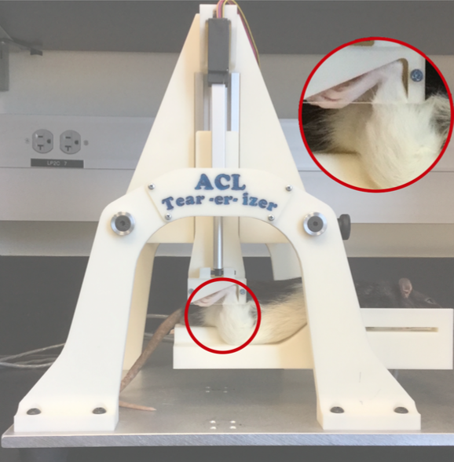
Procedure:
Figure 1: Tibial compressive load causing isolated non-invasive ACL injury.

Non-invasive ACL Injury

Anesthetize the rats using an induction chamber with 5% isoflurane and 1 L/min oxygen, and maintain the flow of anesthesia using via a nose cone with 1 - 3% isoflurane and 500 mL.
- Position the right hindlimb at 30° of dorsiflexion and 100° of knee flexion while providing room for anterior subluxation of the tibia relative to the femur.
- Rigidly mount the top knee stage to a linear actuator.
- Position the flexed knee on the bottom stage, which is mounted directly above a load cell.
- Induce ACL injury using a single load of tibial compression at a speed of 8 mm/s.
- ACL injury is noted by a release of compressive force during injury that will be monitored via our custom program.
- Post-injury, perform a Lachman’s test to clinically confirm an ACL rupture has occurred. A Lachman’s test is a clinical test used to evaluate the integrity of the ACL by assessing sagittal plan stability. While stabilizing the femur, pull the tibia forward (in an anterior direction) to assess the amount of motion. An intact ACL will produce a ‘firm endpoint’ where the clinician will not be able to translate the tibia forward. An injured ACL will produce a ‘soft or mushy endfeel,’ indiciative of a torn ACL.

μCT imaging of joint degeneration

2-D images are obtained using scanner settings of 70 KV, current 86 μA (Figure 2B). Data is collected every 0.5° rotation step at a resolution of 11 μm through a complete 180°. Cross-sectional images are reconstructed using a smoothed back-projection algorithm and on the stack of reconstructed images (Figure 2C). Trabecular structure in these are analyzed by segmentation in software, whereby a 1.53mm sphere is centered in the epiphyseal plate of the medial and lateral tibial plateaus and femur to determine bone volume (BV, mm trabecular thickness (μm), trabecular separation (μm) and trabecular number (1/mm).^{5,6}
- Extend and secure ACL injured hindlimbs in a custom 3D printed device (Figure 2A).
- Acquire images using μCT.
- Obtain frontal plane radiographs to determine joint space narrowing (between the femoral condyle and tibial plateau [measured in mm]) compared to the non-injured limb
- Obtain 2-D images using the following scanner settings: 70 KV and current 86 μA
- Collect the data every 0.5° rotation step at a resolution of 11 μm through a complete 180°.
- Reconstruct cross-sectional images using a smoothed back-projection algorithm on the stack of reconstructed images.
- To ensure a consistent region of interest is measured, place a 1.53 mm sphere is placed in the epiphyseal plate of the medial and lateral tibial plateaus and femur to determine trabecular thickness (μm), trabecular separation (μm), and trabecular number (1/mm).
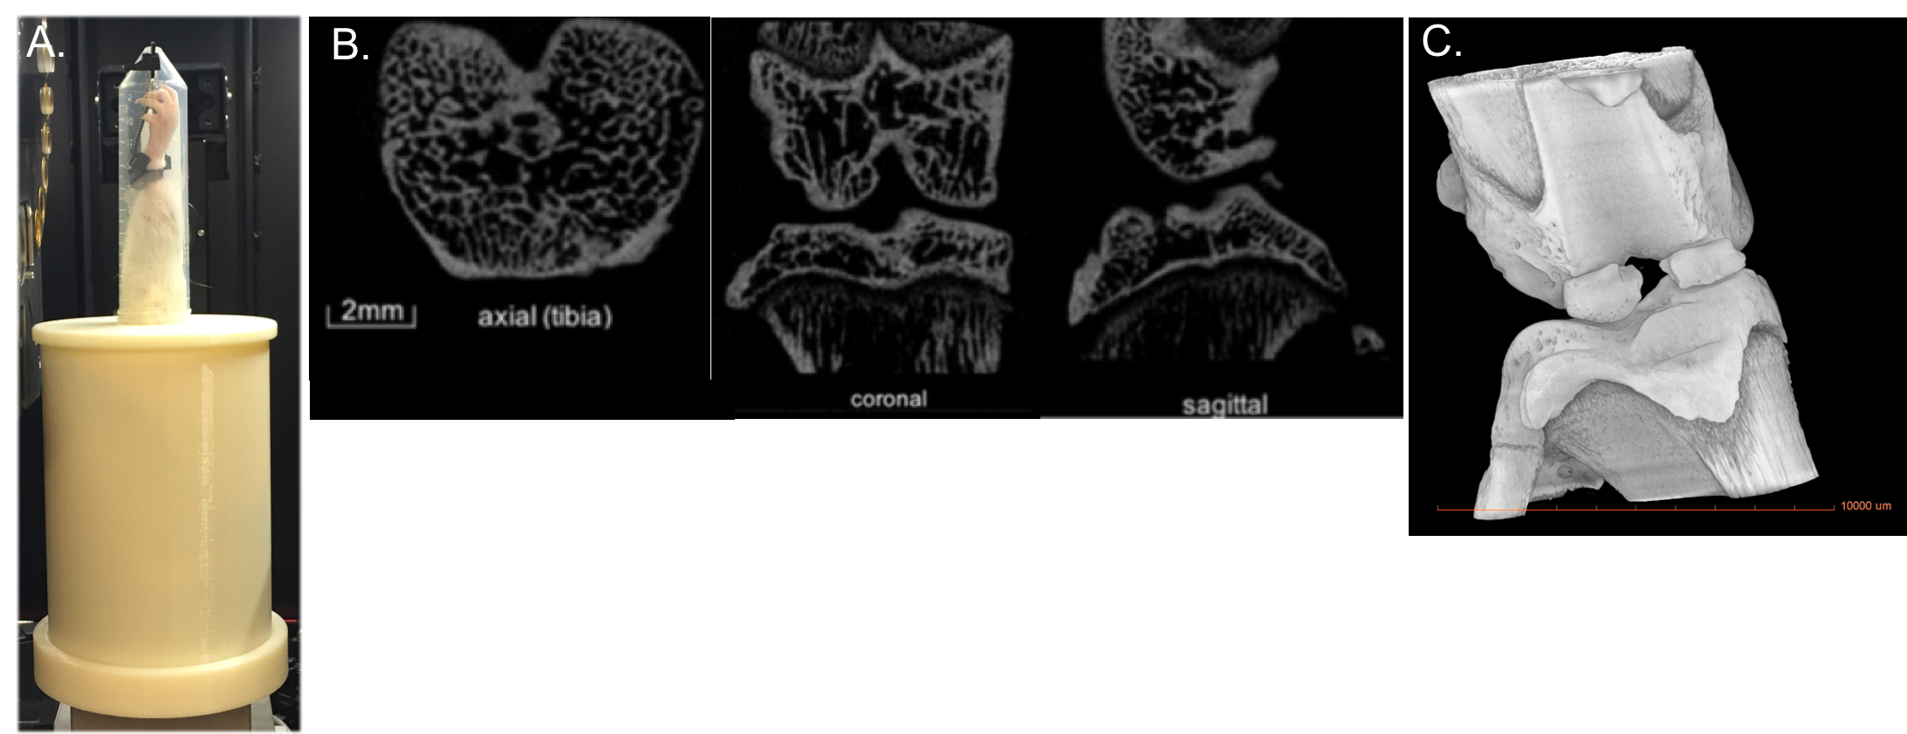
Figure 2: A) Custom printed device to hold hindlimbs during μCT, B) Example of pilot uCT images that have been collected at UConn and will be used to quantify changes in bone microarchitecture, C) three dimensional μCT.

Results

Smaller trabecular number, reduced trabecular thickness and greater trabecular spacing, all hallmark characteristics of PTOA onset, were evident 4 weeks after the non-invasive ACL tear (Table 1 and Figure 3). An image of a dissected ACL of healthy limb versus acute injured limb is shown in Figure 5. The novel non-invasive model of ACL injury, where the ACL is ruptured through a single load of tibial compression, was able to produce an isolated proximal tear of the ACL.
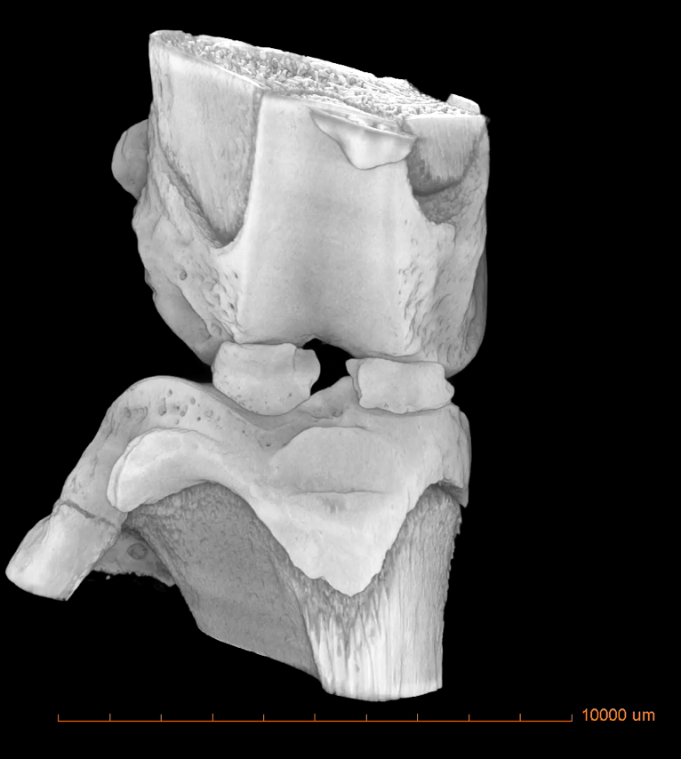
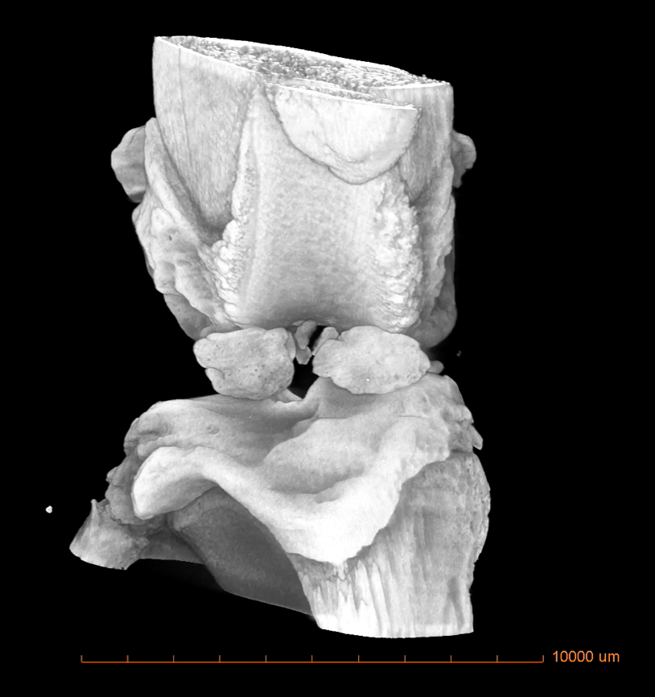
Figure 3: 3-D reconstructed μCT image of an acute ACL-injury (left) and 4 weeks post-ACL injury (right) in a rat.
Table 1: Characteristic measurements of PTOA onset.
Animal | Tb.N  (1/mm) | Tb.Th  (µm) | TB.Sp  (µm)
Acute ACL injured | 3.11 | 168.5 | 217
4 wks post-ACL injury | 2.63 | 166.7 | 213

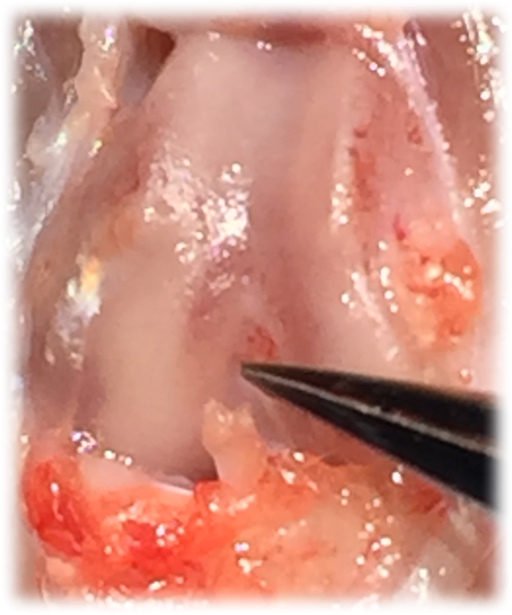
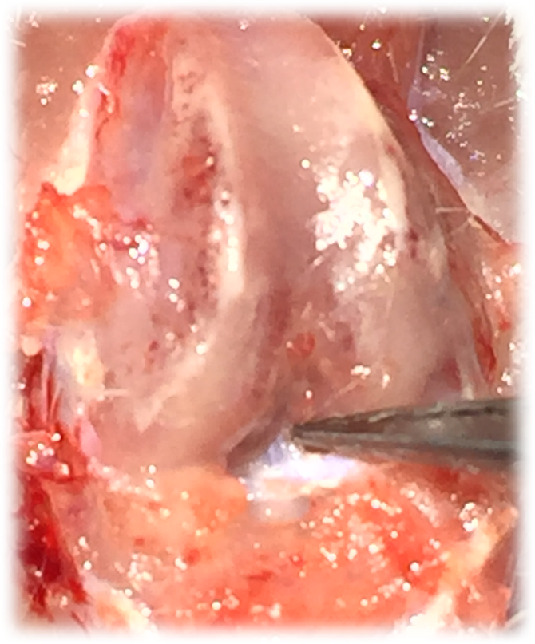

Figure 4: Intact, healthy image of a rat ACL (left) and image of an acute injured ACL limb (right).

Summary and Applications

This experiment demonstrates how a linear actuator can be used to produce an isolated non-invasive ACL rupture in rats. This injury closely replicates injury conditions relevant to humans and is highly reproducible. To overcome several of the major limitation of traditional OA staining techniques, this experiment then uses μCT for quantification of whole joint degeneration and trabecular structure.

Evidence-based interventions to improve musculoskeletal rehabilitative outcomes is a highly significant area that has changed little in the past two decades even though significant advances in basic biology have suggested that alterations to rehabilitation protocols are long since overdue. The issue is that classically rehabilitation specialists have used anecdotal reports to shape clinical practice rather than using basic science to provide informed hypotheses that are tested in model organisms before being translated into the clinic. The procedures described here provided scientists with a method to closely replicate a traumatic joint injury that is relevant to humans and to use μCT to track the progression of joint health.

Materials List:
Equipment | Company | Catalog Number | Comments
Linear actuator | Phidgets | L16-63-12-P
Load Cell | HDM Inc. | PW6D
μCT | Zeiss | XRM Xradia 520

References
1. Maerz T, Kurdziel MD, Davidson AA, Baker KC, Anderson K, Matthew HW. Biomechanical Characterization of a Model of Noninvasive, Traumatic Anterior Cruciate Ligament Injury in the Rat. Ann Biomed Eng. 2015;43(10):2467-2476.
2. Christiansen BA, Anderson MJ, Lee CA, Williams JC, Yik JH, Haudenschild DR. Musculoskeletal changes following non-invasive knee injury using a novel mouse model of post-traumatic osteoarthritis. Osteoarthritis Cartilage. 2012;20(7):773-782.
3. Lockwood KA, Chu BT, Anderson MJ, Haudenschild DR, Christiansen BA. Comparison of loading rate-dependent injury modes in a murine model of post-traumatic osteoarthritis. J Orthop Res. 2014;32(1):79-88.
4. Blair-Levy JM, Watts CE, Fiorentino NM, Dimitriadis EK, Marini JC, Lipsky PE. A type I collagen defect leads to rapidly progressive osteoarthritis in a mouse model. Arthritis Rheum. 2008;58(4):1096-1106.
5. Mohan G, Perilli E, Kuliwaba JS, Humphries JM, Parkinson IH, Fazzalari NL. Application of in vivo micro-computed tomography in the temporal characterisation of subchondral bone architecture in a rat model of low-dose monosodium iodoacetate-induced osteoarthritis. Arthritis Res Ther. 2011;13(6):R210.
6. Jones MD, Tran CW, Li G, Maksymowych WP, Zernicke RF, Doschak MR. In vivo microfocal computed tomography and micro-magnetic resonance imaging evaluation of antiresorptive and antiinflammatory drugs as preventive treatments of osteoarthritis in the rat. Arthritis Rheum. 2010;62(9):2726-2735.

