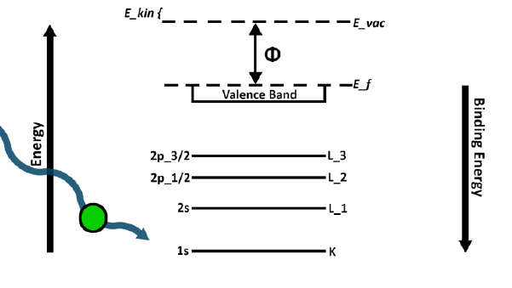
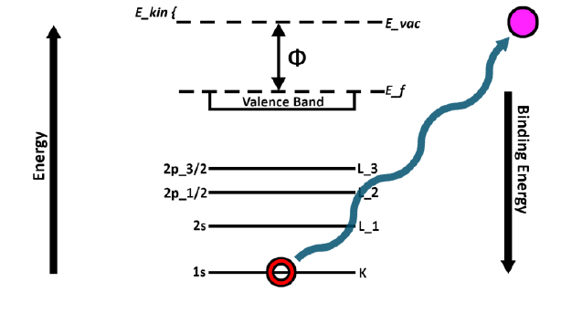
E_s

Figure 1: Illustration of the principles of XPS.

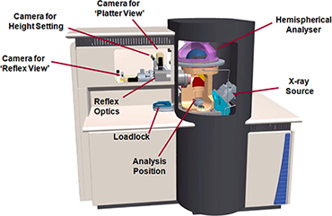

Figure 2: Schematic of XPS instrument

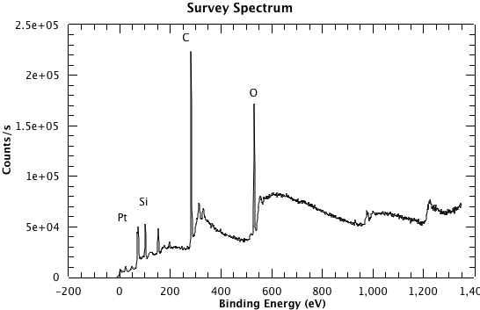
Figure 3: A survey spectrum from the sample, clearly showing the Pt, Si, C and O emissions.

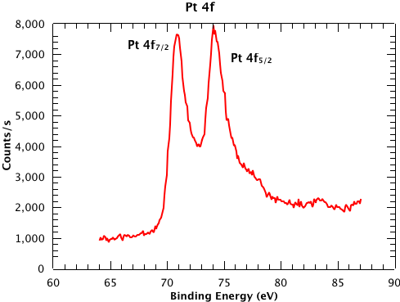
Figure 4: High resolution scan of the Pt 4f_{7/2} and 4f_{5/2} peaks from the sample.

