Acquisition and Analysis of an ECG (electrocardiography) Signal

Overview
Source: Peiman Shahbeigi and Sina Shahbazmohamadi, Biomedical Engineering Department, University of Connecticut, Storrs, Connecticut
An electrocardiograph is a graph recorded by electric potential changes occurring between these electrodes, demonstrating cardiac activity. ECG tracks heart rhythm and many cardiac diseases like poor blood flow to the heart muscles, and heart abnormalities can be diagnosed by measuring ECG signal. The action potential created by heart wall contraction spreads electrical currents from the heart throughout the body. The spreading electrical currents create different potentials at different points on the body, which can be sensed by electrodes on the skin surface using biological transducers made of metals and salts. In practice 10 electrodes get connected to different parts of the body. (see Figure 2) There is a standard procedure for acquiring and analyzing ECG. A typical ECG wave of a healthy individual is as follows:
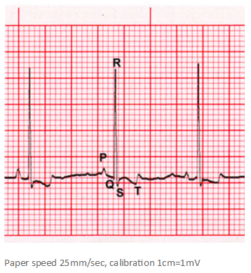
Figure 1. ECG wave
The "P" wave corresponds to atrial contraction, the "QRS" complex to the contraction of the ventricles, it is much larger than the "P" wave due to the relative muscle masses of the atria and ventricles - and masks the relaxation of the atria. The relaxation of the ventricles can be seen in the form of the "T" wave.
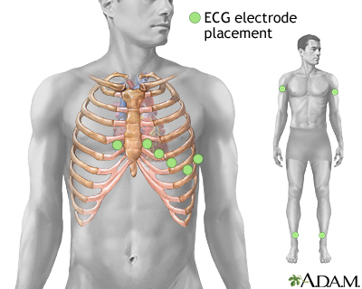
Figure2. ECG electrode placement
In this demonstration, one of the limb leads, lead I, will be examined, and the electrical potential difference between two arms will be recorded. As in all ECG lead measurements, the electrode connected to the right leg is considered the ground node. An ECG signal will be acquired using a biopotential amplifier, then it will be displayed using LabVIEW, where a gain control will be created to adjust its amplitude. Finally, the recorded ECG will be analyzed in LabView.

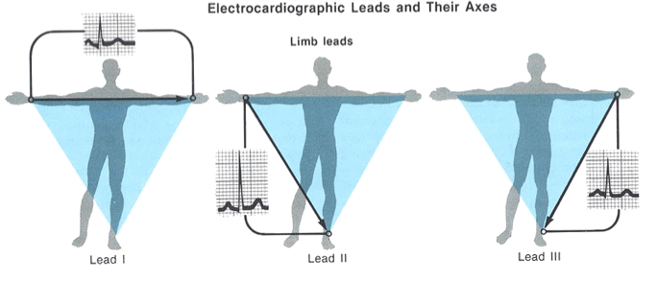
Figure 3. ECG limb leads

Principles
The electrocardiograph must be able to deal with extremely weak signals ranging from 0.5 mV to 5.0 mV, combined with a DC component of up to ±300 mV (resulting from the electrode-skin contact) plus a common-mode component of up to 1.5 V, resulting from the potential between the electrodes and ground. The useful bandwidth of an ECG signal depends on the application and can range from 0.5 Hz to 100 Hz, sometimes up to 1 kHz. It is generally around 1-mV peak-to-peak in the presence of much larger external high frequency noise plus 50 or 60Hz interference and DC electrode offset potential. Other noise sources are movement artifacts that change the skin-electrode interface, muscle contraction or electromyographic spikes, respiration (which may be rhythmic or sporadic), electromagnetic interference (EMI), and noise from other electronic devices that couple into the input.
The first step in the experiment is to connect the electrodes and measure the potential difference between two arms. After acquiring the signal, we need a biopotential amplifier to process it (step two). The main function of a biopotential amplifier is to take a weak electric signal of biological origin and increase its amplitude so that it can be further processed, recorded or displayed.
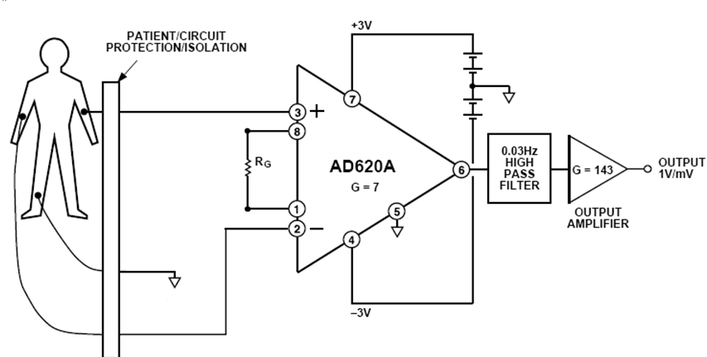
Figure 4. ECG amplifier
To be useful biologically, all biopotential amplifiers must meet certain basic requirements:
- They must have high input impedance, so that they provide minimal loading of the signal being measured. The characteristics of biopotential electrodes can be affected by their load, which leads to distortion of the signal.
- The input circuit of a biopotential amplifier must also provide protection to the subject being studied. The amplifier should have isolation and protection circuitry so that the current through the electrode circuit can be kept at safe levels.
- The output circuit drives the load, usually an indicating or recording device. To obtain maximal fidelity and range in the readout, the amplifier must have low output impedance and be capable of supplying the power required by the load.
- Biopotential amplifiers must operate in the portion of the frequency spectrum in which the biopotentials that they amplify exist. Because of the low level of such signals, it is important to limit the bandwidth of the amplifier to obtain optimal signal to noise ratios. This can be done by using filters.
Figure 4 is an example of an ECG amplifier, and Figure 5 is the circuit of the ECG amplifier that will be built during this demonstration. It has three main stages: the protection circuit, the instrumentation amplifier and the high pass filter.
Instrumentation amplifier stage
High pass filter stage
Figure 5. Biopotential amplifier
Patient protection stage
The first stage is the patient protection circuitry. A diode is a semiconductor device that conducts current in one direction. When a diode is forward biased, the diode acts as a short circuit and conducts electricity. When a diode is reverse biased, it acts as an open circuit and does not conduct electricity, I_{r} ≈ 0.
When diodes are in the forward biased configuration there is a voltage known as the threshold voltage (VT = approximately 0.7 V) that must be exceeded in order for the diode to conduct current. Once VT has been exceeded the voltage drop across the diode will remain constant at VT regardless of what V_{in} is.
When the diode is reverse biased the diode will act as on open circuit and the voltage drop across the diode will be equal to V_{in}.
Figure 6 is an example of a simple protection circuit based on diodes that will be used in this demonstration. The resistor is used to limit the current flowing through the patient. If a fault in the instrumentation amplifier or diodes short-circuits the patient’s connection with one of the power rails, the current would be less than 0.11 mA. The FDH333 low-leakage diodes are used to protect the inputs of the instrumentation amplifier. Whenever the voltage in the circuit exceeds 0.8V in magnitude, the diodes change to their active region or “ON” state; and the current flows through them protecting the patient and the electronic components.

Figure 6. Protection circuit

The second stage is the instrumentation amplifier, IA, which uses three op amps. There is one op amp attached to each input to increase the input resistance. The third op amp is a differential amplifier. This configuration has the ability of rejecting ground-referred interference and amplifying only the difference between the input signals.
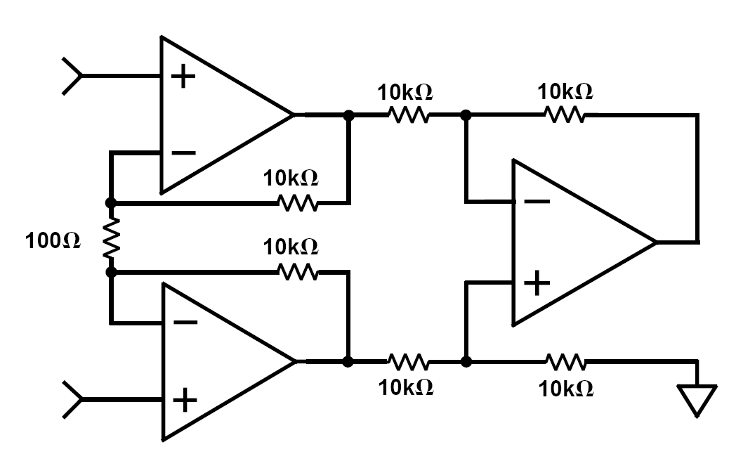
RG
Figure 7. Instrumentation amplifier

The third stage is the high pass filter, which is used to amplify a small AC voltage that rides on top of a large DC voltage. The ECG is affected by low frequency signals that come from the patient movements and respiration and a high pass filter reduces this noise.
High pass filters can be realized with first-order RC circuits. Figure 8 shows an example of a first order high-pass filter and its transfer function. The cut-off frequency is given by the following formula:
,

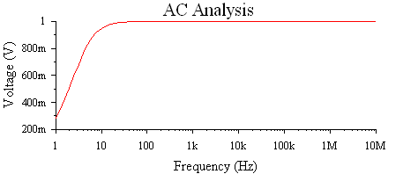
Figure 8. High pass filter

Procedure
- Acquiring an ECG Signal
  - Adjust the voltage of the sources to +5 V and -5 V and connect them in series.
  - Build the circuit seen in Figure 5. Calculate the values of the resistors and capacitors. For the high pass filter, the cut off frequency should be 0.5 Hz. The capacitor value should be chosen from the table below (according to availability)
Available Capacitor Values (µF )
0.001 | 1 | 100
0.022 | 2.2 | 220
0.047 | 4.7 | 470
0.01 | 10 | 1000
0.1 | 47 | 2200

$f_{c}=0.5 Hz, C=1μF\underset{→}{yields}R=330KΩ$P

$1.3$Place electrodes on right arm, left arm and right leg (this is reference) and connect them to the circuit.
1.4 Use the oscilloscope to look at the ECG signal (Vo). Press Auto Set and adjust the horizontal and vertical scales if needed. You should be able to see the R peaks despite of the noise in the signal

- Displaying the ECG signal using LabVIEW
  - . Write a LabVIEW program that displays the ECG signal using the DAQ assistant and a waveform graph. Once an analog input has been selected, configure the DAQ assistant with the following settings:
  - Signal input range >> Max = 0.5; Min = -0.5
  - Terminal Configuration >> RSE
  - Acquisition mode >> continuous
  - Samples to read = 2000
  - Sampling rate = 1000
  - Acquire the ECG signal and observe the waveform with LabVIEW. You will see a signal similar to Figure 3.
  - Adjust the scaling of the x-axis to show time in seconds.
  - It is often necessary in instrumentation to amplify the signal of interest to specific amplitude. Create a gain control and set it so that the amplitude of the ECG is 2Vp.

- Analyzing the ECG signal
In this section, an ECG signal will be filtered and analyzed to determine the heart rate using LabVIEW. The following block diagram shows the components of the program.
Read the signal
Low-pass filter
fc = 100Hz
Stop-band filter
fc = 60Hz
Plot the signal
BPM detector
BPM indicator
Plot the signal
Calculate and plot the spectrum
  - Use a waveform graph to display the signal.
  - Evaluate the spectrum of the signal using the Amplitude and phase spectrum subvi (in Signal processing → Spectral) and display its magnitude using a waveform graph. The horizontal axis corresponds to frequency. It is discrete because the computer uses a Fast Fourier Transform (FFT) algorithm to calculate the spectrum of the signal. Frequency goes from k = 0 to k = (N-1)/2, where N is the length of the sequence, in this case 4000. To calculate the corresponding analog frequency, you can use the following formula:
where fs is the sampling frequency. Note that most of the energy of the signal is in the low frequencies, and also that there is a peak of high intensity in the medium frequencies. Calculate the frequency of that peak using the formula provided above and include this value in the report.
  - Implement a low-pass filter using Butterworth of Chebyshev functions. Choose the cutoff frequency equal to 100 Hz. Make sure that the filter provides an attenuation of at least -60 dB/decade in the stopband.
  - Connect the output signal of the read from spreadsheet subvi to the input of the low-pass filter.
  - Implement a stop-band filter using Butterworth or Chebyshev functions. The objective is to reduce the 60 Hz interference without modifying the other frequencies. Try border frequencies close to 60 Hz.
  - Connect the output of the lowpass filter to the input of the stopband filter.

  - Find the peaks using the peak detector subvi (it is located in Signal processing → Sig Operation). You are required to provide a threshold, look at the signal’s amplitude to choose the most appropriate value.
  - Extract the locations of the peaks using the index array subvi (in Programming → Array).
  - Subtract the lower position from higher position, then, multiply by the sampling period T = 1/fs to obtain the RR interval.
  - Calculate the reciprocal and adjust units and place an indicator to display the BPM.

Representative Results
In this demonstration, three electrodes were connected to an individual, and the output passed through a bio-potential amplifier. A sample result of ECG graph in this stage before applying any digital filtering is shown below (Figure 9).
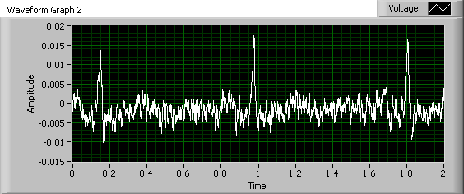

Figure 9. ECG signal without digital filtering

After designing the filters and feeding this data to the developed algorithm, the peaks on the graph were detected and used to calculate heart beat rate (BPM). Figure 10 displays the raw data an ECG signal displays (before any filtering) in time and frequency domain. Figure 11 shows the result of filtering that signal.

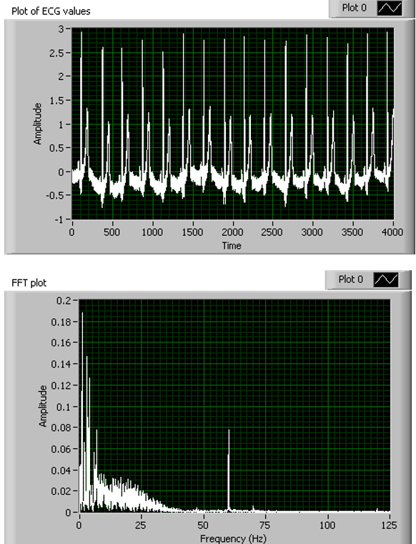
Figure 10. ECG signal before filtering

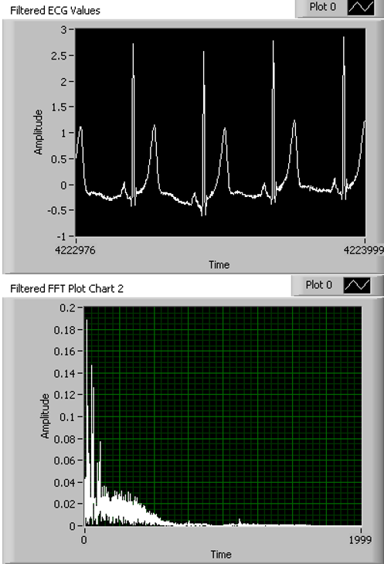
Figure 11. Filtered ECG signal
The original ECG plot had slightly visible P, QRS, and T complexes, but with many fluctuations from the noise. The spectrum of the ECG signal also showed a clear spike at 65 Hz which was assumed to be noise. When the signal was processed using a lowpass filter to take out extraneous high frequency portions, then bandstop filtered in order to remove the 65 Hz signal component, the output looked significantly cleaner. The ECG plot shows each component of the signal clearly and the spectrum has only the important low frequency components with all noise removed.
In addition, the measured heart rate was approximately 61.8609 beats per minute.

Summary and Applications
Contraction of cardiac muscle during the heart cycle produces electric currents within the thorax. Voltage drop across the resistive tissue can be detected by electrodes placed on the skin and recorded by an electrocardiograph. Since the voltage is weak, in the range of 0.5 mV, and small comparing to noise magnitude, processing the signal and filtering it is inevitable. In this experiment, an electrocardiograph device consisted of two parts analog signal processing circuit, which was a biopotential amplifier, and digital signal processing, which was designed for analyzing the result, and calculating the heartbeat rate.
This experiment focused on the fundamental of the electronic circuit and filters applied on ECG devices. This experiment employed some practical signal processing techniques for extracting a weak signal out of a noisy background. These techniques can be used in almost any other similar application where signal amplification and noise reduction is necessary.

Materials List
Name | Company | Catalog Number | Comments
Equipment
Power supply | B&K Precision | 1760A
Multimeter
Oscilloscope
Proto-board
4 FDH333 diodes
1 AD620
3 47kΩ resistor
2 100nF capacitors
3 ECG electrodes
Several alligator clips and Tektronix probe.

Image is taken from “http://research.vet.upenn.edu/ECGTutorial/NormalECGs/”
Image is taken from “https://medlineplus.gov/ency/imagepages/19865.htm”
Image is taken from “https://www.practicalclinicalskills.com/ekg-slides?coursecaseorder=7&courseid=311”

