Acquisition and Analysis of an ECG (electrocardiography) Signal
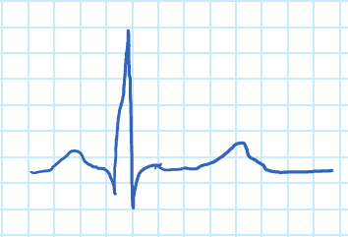
Figure 1. ECG wave.

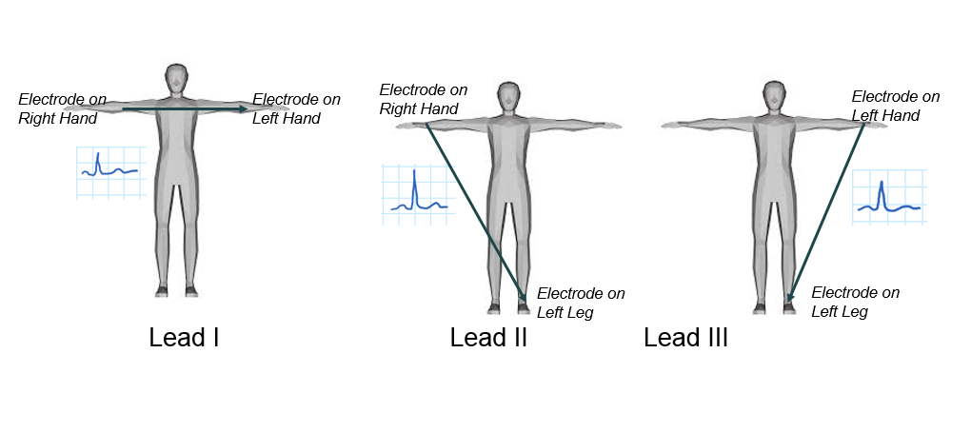Figure 2. ECG limb leads.

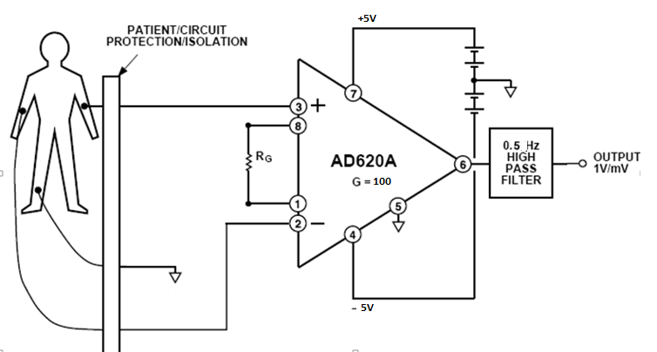
Figure 3. ECG amplifier.

Patient protection stage
High pass filter stage
Instrumentation amplifier stage

Figure 4. Biopotential amplifier.

