Title: Pressure Transducer: Calibration Using a Pitot-static Tube

AUTHORS:
CORRESPONDING AUTHOR:
KEYWORDS:
SHORT ABSTRACT:
LONG ABSTRACT:
Source: Shreyas Narsipur, Mechanical and Aerospace Engineering, North Carolina State University, Raleigh, NC

Overview
Fluid pressure is an important flow characteristic that is required to determine the aerodynamics of a system. One of the oldest and still existing pressure measurement systems is the manometer due to its accuracy and simplicity of operation. The manometer is generally a U-shaped glass tube that is partially filled with liquid, as shown in Figure 1. The U-tube manometer requires no calibration because it does not have any moving parts and the measurements are functions of gravity and the liquid’s density alone. This makes the manometer a simple and accurate measurement system.

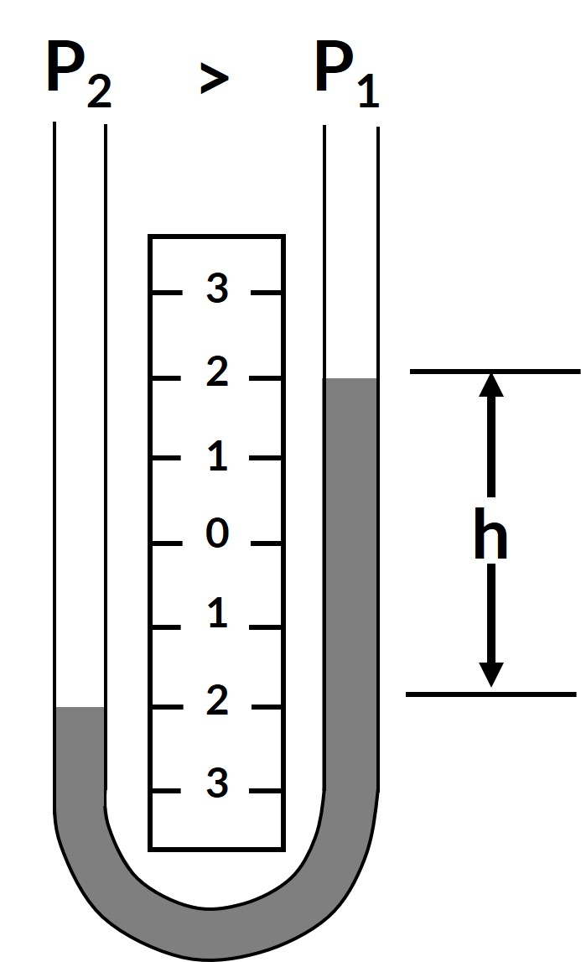
Figure 1. Schematic of a U-tube manometer.

Real-time pressure measurements are obtained in aircrafts by connecting the stagnation and static pressure ports of a pitot-static probe, a device that is commonly used to measure fluid flow pressure, to the ports of a pressure measurement device to obtain existing flight conditions and to also warn the pilot if any changes to the flight conditions occur. While manometers provide very accurate pressure readings, they are inherently bulky. A more realistic solution is needed to measure aircraft pressures as one of the major design objectives is to keep the overall aircraft weight as low as possible. Today, electromechanical pressure transducers, which convert the applied pressure to an electric signal, are widely used for pressure sensing applications on aircrafts as they are small, lightweight, and can be placed almost anywhere in the airframe. The above characteristics not only help reduce weight but also reduce the amount of tubing required to connect the pitot-static probe to the transducer, thereby decreasing the data response time. Additionally, in experimental aircraft flight testing, miniature pressure transducers come in handy as they allow researchers to maximize pressure data collection without significantly adding to the weight of the aircraft. While different types of pressure transducers with varying measurement techniques exist, one of the more common transducers are capacitive pressure transducers. As transducers are capable of only sending signals in terms of voltage and current, calibration of the transducer is required to relate the strength of a particular signal to the pressure that causes the transducer to generate the signal. The final curve fit that relates the transducer current or voltage to a physical measurement, in our case pressure, is commonly referred to as the transducer calibration curve.

In this experiment, a pitot-static probe is placed in a subsonic wind tunnel with the stagnation and static pressure ports connected to the total and static ports of both the U-tube manometer and the pressure transducer. The wind tunnel is then run at different dynamic pressure settings and the corresponding pressure reading from the U-tube manometer and current readings produced by the transducer are recorded. This data is then used to generate calibration curves for the pressure transducer.

INTRODUCTION:
In order to measure the dynamic pressure, each leg of the U-tube manometer is connected to unknown pressures from the static and total pressure ports of the pitot-static tube. The resulting difference is given by the following equation:

 | $$P_{dynamic}= P_{total}- P_{static}$$ | (1)

which translates to a difference in column height on the U-tube manometer. This difference in pressures, or dynamic pressure, can be calculated using the expression:

 | $$ΔP= P_{dynamic}= P_{2}- P_{1}= ρ_{water}gh_{manometer}$$ | (2)

where &#961;_{water} is the density of water (the fluid in the U-tube manometer), g is the acceleration due to gravity, and h_{manometer} is the difference in column heights in the U-tube manometer. In some cases, the manometer can have an offset due to insufficient amount of fluid in the chamber and the offset in height, h_{off}, will have to be accounted for in the above equation as:

 | $$P= P_{2}- P_{1}= ρ_{water}g(h_{manometer}- h_{off})$$ | (3)

The pressure transducer is based on the working principle of a capacitor which consists of two conductive plates separated by an insulator (Figure 2).

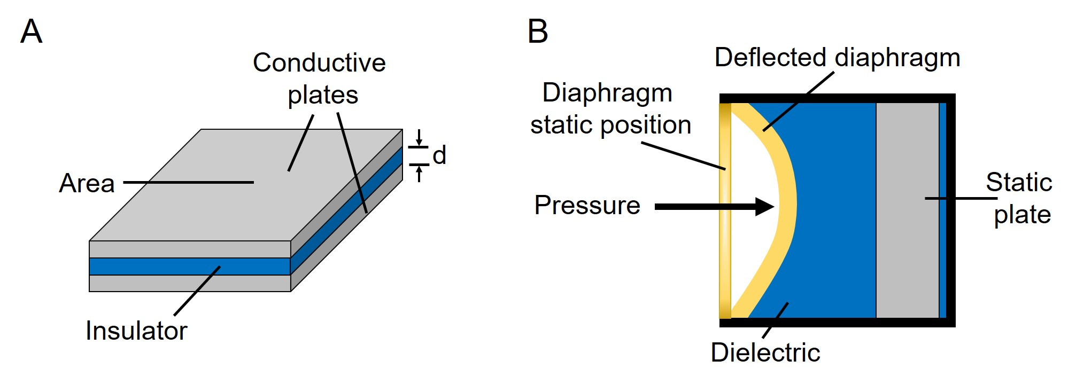
Figure 2. Schematics of a capacitor (A) and a capacitance pressure transducer (B).

Capacitance is measured using the equation:

 | $$C= \frac{μA}{d}$$ | (4)

where &#181; is the dielectric constant of the material, A is the area of the plates, and d is the spacing between the plates. In a capacitance pressure transducer, one of the conductive plates is replaced by a flexible conducting diaphragm, as shown in Figure 2. When pressure is applied, the diaphragm deflects, which causes a change in d, thereby leading to a change in capacitance. The electronics in the transducer are calibrated to generate specific voltage changes for corresponding changes in capacitance, which in turn can be used to measure the current for a given applied pressure.

PROTOCOL:

1. Pressure Transducer Calibration
In this demonstration, a subsonic wind tunnel with a 2.6 ft x 3.7 ft test section and maximum dynamic pressure setting of 25 psf was used. A pre-calibrated pressure transducer was used to set the dynamic pressure in the wind tunnel test section and a differential U-tube manometer with colored water and scale was used to measure fluid height (Figure 3). A differential pressure transducer (Figure 4), standard voltage supply (to power the transducer) and multimeter (to read the output current from the transducer), as shown in Figure 5, were also used.

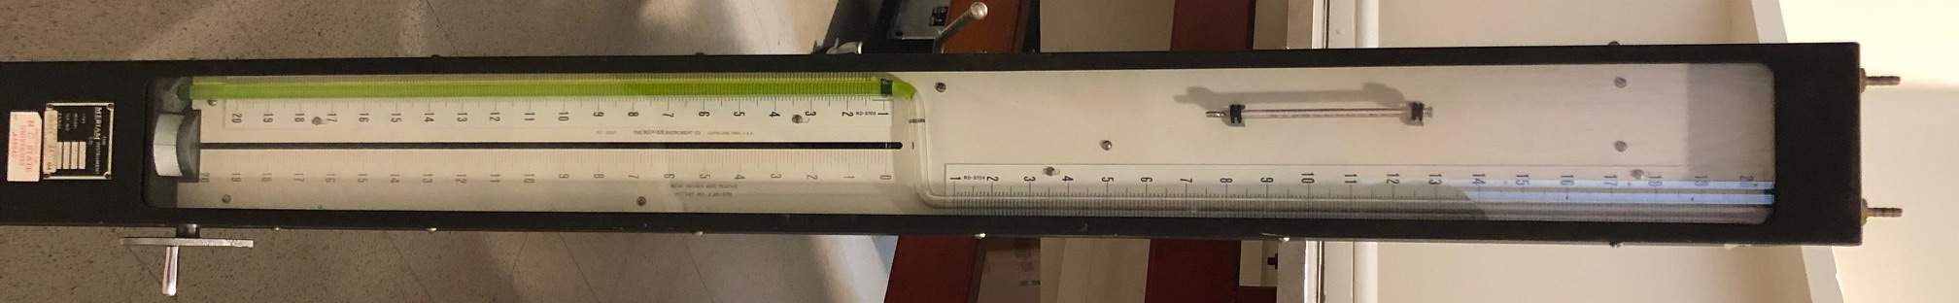
Figure 3. Differential pressure U-tube manometer.

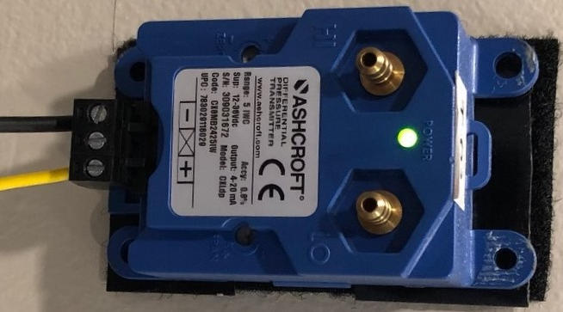
Figure 4. Differential pressure transducer.

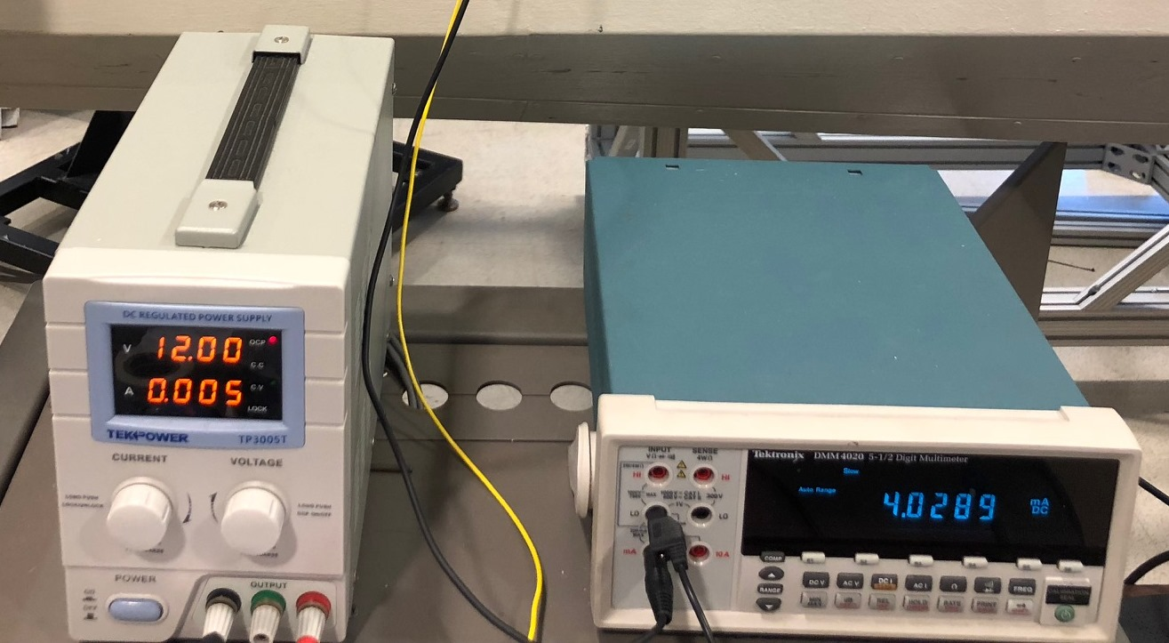
Figure 5. Power supply (left) and multimeter (right).

1.1. Mount a standard pitot-static tube (Figure 6) from the top of the wind tunnel using a vertical sting mount. Ensure that the probe is at the center of the test section and is aligned in the direction of the flow with the primary port facing directly into the flow.

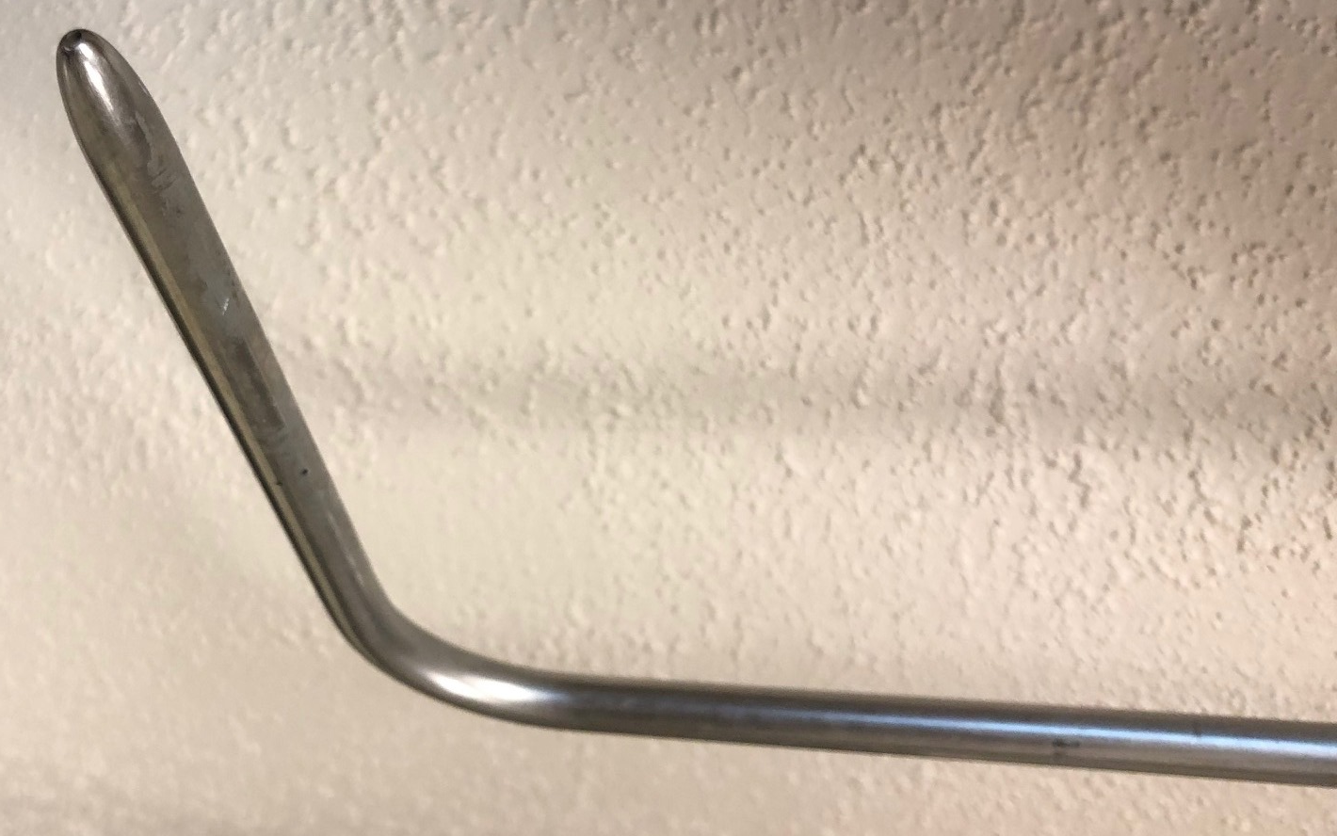
Figure 6. Pitot-static tube.

1.2. Align the top of the manometer fluid to the double O-ring marker on the glass tube. If the reading on the main scale (in brown, Figure 3) does not correspond to zero, choose a different reference point, align the manometer fluid to the new reference, and record the offset in height (h_{off}).
1.3. Connect the stagnation and static pressure outlets on the pitot-static tube to the corresponding ports on the U-tube manometer and the pressure transducer using flexible plastic tubing and T-channel connectors. Note that the pressure transducer can be mounted on any flat vertical surface as long as it is aligned in accordance with Figure 4.
1.4. Secure the wind tunnel doors and switch-on all the systems.
1.5. Take the reading for the no-air flow condition (zero reading).
1.6. Start the wind-tunnel and set the dynamic pressure in the test section to 1 psf.
1.7. Record the data corresponding to Table 1.
1.8. Increase the dynamic pressure setting in the wind-tunnel in steps of 1 psf up to a maximum setting of 20 psf and repeat step 1.7 at each dynamic pressure setting.
1.9. To check for transducer hysteresis, decrease the dynamic pressure in steps of 1 psf down to 0 psf and repeat step 1.7 at each dynamic pressure setting.
1.10. On completion of the test, shut down all systems.

Table 1. Data collected for the pressure calibration experiment
P_{transducer}  (psf) | h_{manometer}  (in) | I_{transducer}  (mA)
WT transducer | manometer | multimeter

REPRESENTATIVE RESULTS:
The following constants were used in the analysis: water density, &#961;_{water}: 61.04 lb/ft³; acceleration due to gravity, g: 32.15 ft/s²; and manometer off-set, h_{off} = 0.8 in. The variation in manometer data for increasing and decreasing dynamic pressures (with and without correcting for the instrument off-set) is shown in Figure 7. Figure 8 shows a plot of the transducer current readings against the manometer pressure, which was calculated using Equation 3.

In order to obtain the calibration curve for the pressure transducer, two linear curves are fitted through the increasing and decreasing data points, respectively. The corresponding linear fit equations are:

 | $${Increasing P_{dynamic}: P}_{manometer}=1.73{ I}_{transducer}-7.12$$ | (5)
 | $${Decreasing P_{dynamic}: P}_{manometer}=1.73{ I}_{transducer}-7.19$$ | (6)

The equations for the increasing and decreasing curves are almost similar, and the two curves line up right on top of each other, as observed in Figure 8. Therefore, it can be deduced that the pressure transducer does not have any hysteresis. A single calibration equation relating the current to the pressure (Equations 5 or 6) can be used for the transducer thereby removing the necessity of using the bulky U-tube manometer system for all future pressure measurements.

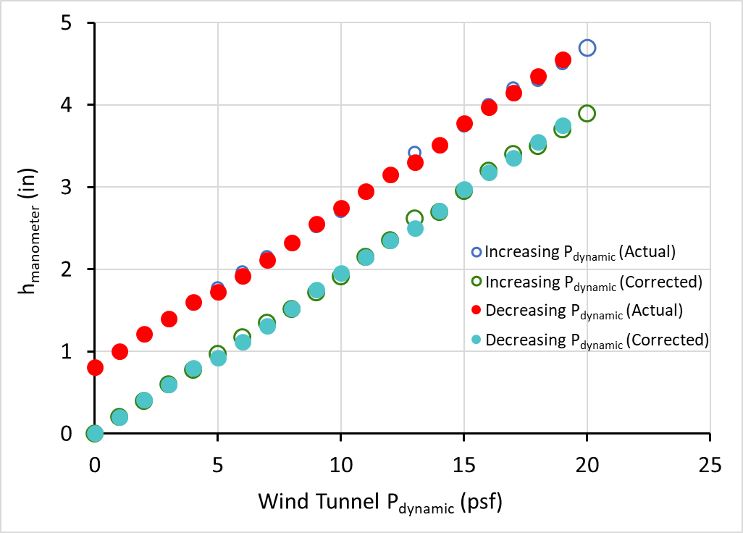
Figure 7. Variation of manometer fluid height with wind tunnel dynamic pressure.

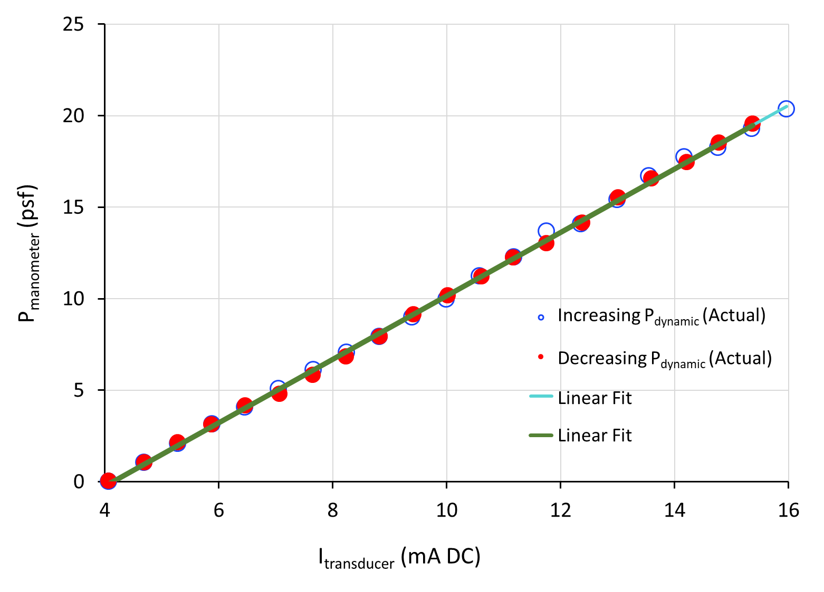
Figure 8. Calibration curves for the pressure transducer.

DISCUSSION:
Electromechanical transducers are popular replacements for some of the bulkier measurement systems. However, transducers need to be calibrated regularly using standardized measuring devices in order to be effective experimental tools. In this experiment, an off-the-shelf capacitive type electromechanical pressure transducer was calibrated by comparing the current signals generated by the transducer for a range of dynamic pressure conditions in a subsonic wind tunnel to the pressure measurements from a U-tube manometer. Results showed that a linear relationship exists between the transducer’s current signal and pressure with negligible sensor hysteresis. A single calibration equation relating the transducer current output to pressure was obtained.

Modern day electromechanical measurement systems provide a path to automating experimental data acquisition and can be used in real-time static and dynamic systems for data monitoring and analysis. However, proper calibration practices, like the one demonstrated in this experiment, are necessary to help users obtain accurate and repeatable data using said sensors.

DISCLOSURES:
ACKNOWLEDGMENTS:
REFERENCES:

