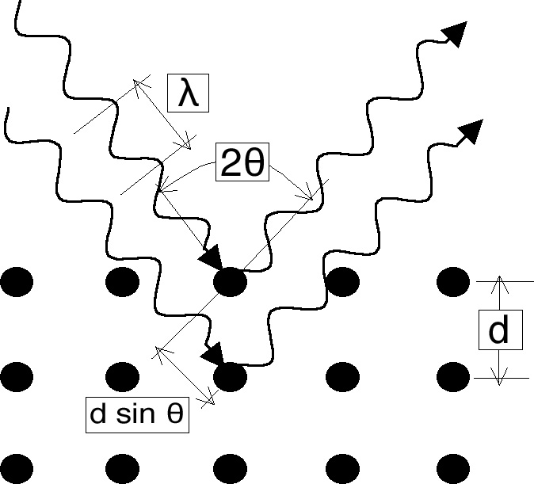
θ
X-ray source
X-ray detector

Figure 1: Illustration of Bragg's Law.

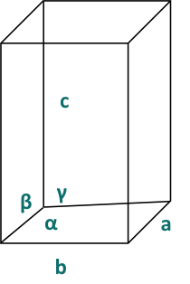
a = b ≠ c
α = β = γ = 90⁰

Figure 2: The tetragonal structure as one of the seven crystal classes.

1
1'
2
2'
3
3'
A
B
C
d
x
P
Q
R
S

Figure 3: Three diffraction ray paths, of which rays 11’ and 22’ satisfy the Bragg condition, while ray 33’ results from scattering by an atom (red circle) at an arbitrary position.

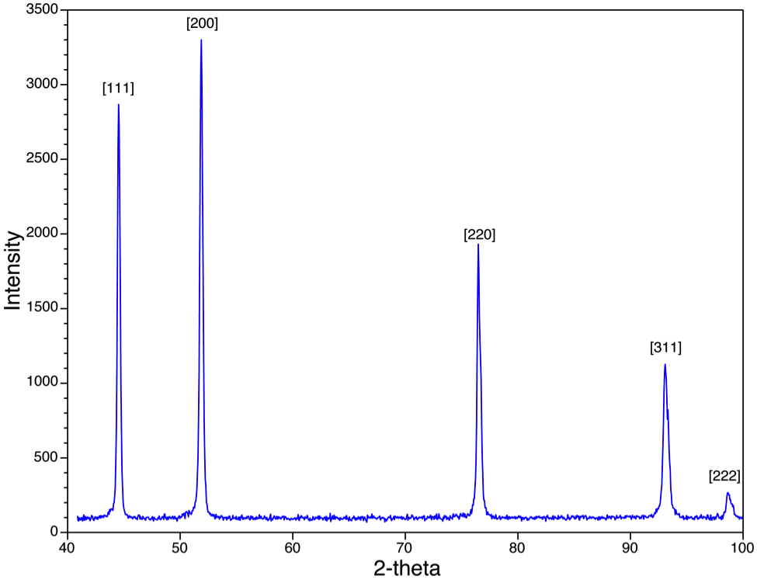

Figure 4: An XRD scan of Ni with a face-centered cubic structure is shown.

