Figure 1.
Figure 2.
Figure 3.
Figure 4.
Figure 5.
Figure 6.
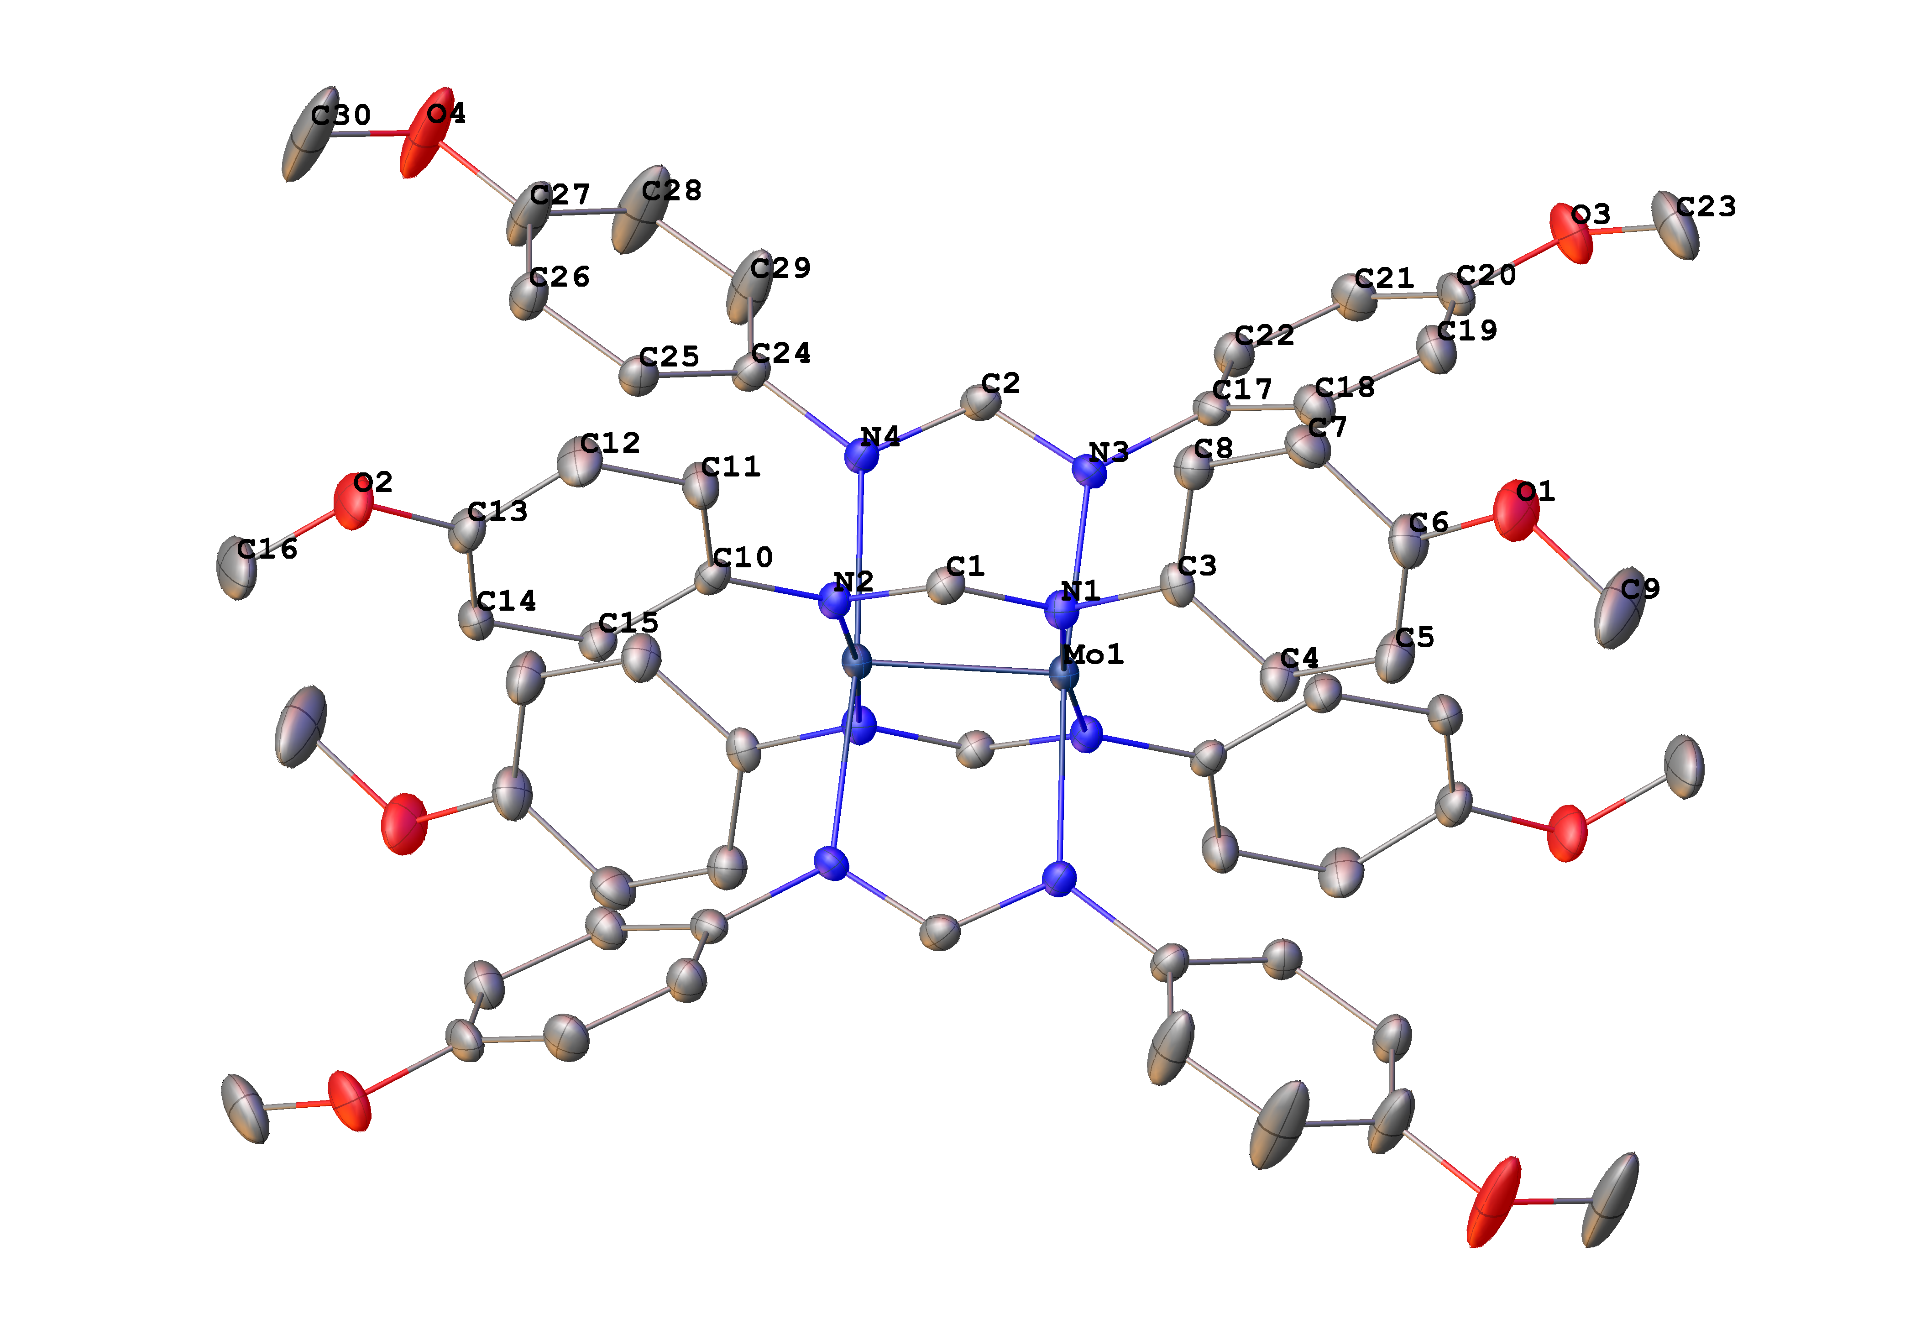
Figure 7.
Figure 8.
Figure 9.

