Overview

Source: David Powers and Tamara Powers, Department of Chemistry Texas A&M University, College Station, TX

Paddlewheel complexes are a class of compounds comprised of two metal ions (1st, 2nd, or 3rd row transition metals) held in proximity by four bridging ligands (most commonly formamidinates or carboxylates) (Figure 1). Varying the identity of the metal ion and the bridging ligand provides access to large families of paddlewheel complexes. The structure of paddlewheel complexes allows for metal–metal bonding, which plays a vital role in the structure and reactivity of these complexes. Due to the diversity of electronic structures that are available to paddlewheel complexes – and the corresponding differences in M–M bonding displayed by these structures – paddlewheel complexes have found application in diverse areas, such as in homogeneous catalysis and as building blocks for metal-organic frameworks (MOFs). Understanding the electronic structure of the M–M bonds in paddlewheel complexes is critical to understanding their structures and thus to application of these complexes in coordination chemistry and catalysis.

Figure 1. General structure of paddlewheel complexes, where M can be a 1st, 2nd, or 3rd row transition metal.

When two transition metals are held in close proximity the d-orbitals overlap, which can result in the formation of M–M bonds. Overlapping d-orbitals can form three types of bonds – σ, π, and δ – depending on the symmetry of the orbitals involved. If we assign the molecular z-axis to be coplanar with the M–M bond, a σ bond is formed by overlap of the $d_{z^{2}}$ orbitals and π bonds are formed by overlap of the $d_{xz}$ and $d_{yz}$ orbitals. δ bonds are generated by overlap of d-orbitals that have two planar nodes ($d_{xy}$ and $d_{x^{2}-y^{2}}$). As a result, all four lobes of the d-orbital overlap and the corresponding δ bond has two planar nodes (Figure 2). In theory, with the addition of δ bonds, paddlewheel complexes are capable of supporting quintuple bonds, or five bonds between metal atoms. In most complexes, the $d_{x^{2}-y^{2}}$ forms strong metal–ligand bonds and does not meaningfully contribute to M–M bonding. Thus, quadruple bonds are the maximum bond order in many complexes.

Figure 2. Visual representation of σ, π, and δ bonding MOs resulting from the linear combination of metal d-orbitals. The $d_{z^{2}}$ atomic orbitals have the best spatial overlap, followed by the $d_{xz}$ and $d_{yz}$ orbitals. The $d_{xy}$ atomic orbitals have the least amount of spatial overlap.

In this video, we will synthesize the dimolybdenum paddlewheel complex Mo₂(ArNC(H)NAr)₄, where Ar = p-(MeO)C₆H₄, which features a quadruple bond. We will characterize the compound by NMR spectroscopy and use X-ray crystallography to study the M–M bond.

Principles

We begin by constructing an MO diagram of the M–M bond within the general dimolybdenum complex Mo₂(ArNC(H)NAr)₄. First, we need to define our axes. Assuming the highest available symmetry, Mo₂(ArNC(H)NAr)₄ is in the point group D_{4h} (Figure 3). The z-axis is by definition assigned to the axis with highest rotational symmetry (primary axis), which in this case is a C₄ rotation axis that lies along the Mo–Mo bond. By convention, the x- and y-axis lie along the M–L bonds; in our specific case, this means that the x- and y-axes are collinear with the Mo–N vectors. According to our axis assignments, the $d_{x^{2}-y^{2}}$ orbital on each Mo atom is involved in metal–ligand bonding. That leaves the $d_{xy}$, $d_{xz}$, $d_{yz}$, and $d_{z^{2}}$ orbitals for M–M bonding.

The MO diagram that describes the M–M bond in Mo₂(ArNC(H)NAr)₄ is shown in Figure 4. Linear combination of the $d_{z^{2}}$ orbital on each M atom results in σ and σ* MOs. The $d_{xz}$ and $d_{yz}$ orbitals form π and π* MOs. Finally, linear combination of the $d_{xy}$ atomic orbitals gives rise to the δ and δ* MOs. The δ bond exhibits the least amount of spatial overlap between the atomic orbitals and, as a result, the relative energy of the bonding orbitals is σ < π < δ (Figure 2). This corresponds to bond strengths, where a σ bond is stronger than a π bond, which is stronger than a δ bond. We fill the corresponding MOs with the total number of d e– for both Mo center, which is 8 (Mo²⁺, d⁴). This leads to a bond order of 4, which is consistent with a quadruple bond.

In this video, we will use X-ray crystallography to observe the Mo–Mo bond length in the Mo₂(ArNC(H)NAr)₄ complex. With the Mo–Mo bond distance from solid state structure, we can find the formal shortness ratio (FSR), which is the normalized value of the M–M bond. The FSR is calculated for a bond A–B using Equation 1, which is simply the ratio of the bond distance observed in the solid state ($D_{A-B}$) to the sum of the atomic radii ($R_{1}^{A}$ and $R_{1}^{B}$) of the individual atoms.

${FSR}_{AB}=\frac{D_{A-B}}{R_{1}^{A}+R_{1}^{B}}$ (1)

The FSR value is normalized for atomic radius and thus provides a fast and convenient way to compare M–M bond distances, not only between different metal types, but also to bond distances between non-metal atoms.

Figure 3. Defined axes for the molecule Mo₂(ArNC(H)NAr)₄, assuming highest symmetry (D_{4h}).

Figure 4. MO diagram of the M–M bonding in Mo₂(ArNC(H)NAr)₄.

Procedure

- Synthesis of Ligand ArN(H)C(H)NAr, Where Ar = p-(MeO)C₆H₄ (Figure 5)

  - Combine 6.0 g (0.050 mol) of p-anisidine and 4.2 mL (0.025 mol) of triethylorthoformate in a 100 mL round bottom flask with a magnetic stir bar.

  - Attach a distillation head to the reaction flask.

  - With stirring, heat the reaction in an oil bath to reflux (120 °C). Once reflux is achieved, the byproduct ethanol should begin to distill from the reaction. Collect the ethanol in a beaker placed at the end of the distillation head.

  - Heat the reaction until the distillation of ethanol ceases (at least 1.5 h).

  - Remove the flask from the oil bath and allow the reaction mixture to cool to room temperature. A precipitate should form. If the product does not precipitate, place the flask in an ice bath and scratch the bottom of the flask with a spatula to encourage crystallization.

  - Recrystallize the product from a minimal amount of boiling toluene (for a more detailed procedure, please review the “Purifying Compounds by Recrystallization” video in the Essentials of Organic Chemistry series).

  - Collect the product by filtration through a fritted funnel and wash with 10 mL of hexanes.

  - Isolate the white product and allow it to dry in the air.

  - Collect a ¹H NMR of the solid using CDCl₃.

Figure 5. Synthesis of ArN(H)C(H)NAr, where Ar = p-MeOC₆H₄.

- Setup of the Schlenk Line

Note: For a more detailed procedure, please review the “Schlenk Lines Transfer of Solvent” video in the Essentials of Organic Chemistry series. Schlenk line safety should be reviewed prior to conducting this experiment. Glassware should be inspected for star cracks before use. Care should be taken to ensure that O₂ is not condensed in the Schlenk line trap if using liquid N₂. At liquid N₂ temperature, O₂ condenses and is explosive in the presence of organic solvents. If it is suspected that O₂ has been condensed or a blue liquid is observed in the cold trap, leave the trap cold under dynamic vacuum. Do NOT remove the liquid N₂ trap or turn off the vacuum pump. Over time the liquid O₂ will sublime into the pump; it is only safe to remove the liquid N₂ trap once all of the O₂ has sublimed.

  - Close the pressure release valve.

  - Turn on the N₂ gas and the vacuum pump.

  - As the Schlenk line vacuum reaches its minimum pressure, prepare the cold trap with either liquid N₂ or dry ice/acetone.

  - Assemble the cold trap.

- Synthesis of Mo₂(ArNC(H)NAr)₄ (Figure 6)¹

CAUTION: The molybdenum source used in the synthesis of Mo₂(ArNC(H)NAr)₄ is Mo(CO)₆, which is highly toxic and may be fatal if inhaled, absorbed through the skin, or swallowed. CO is generated during the reaction. Therefore, the synthesis must be conducted in a well-ventilated hood.

  - Use standard Schlenk line techniques for the synthesis of Mo₂(ArNC(H)NAr)₄ (see the “Synthesis of a Ti(III) Metallocene Using Schlenk line Technique” video).

  - Add 0.34 g (1.3 mmol) Mo(CO)₆ and 1.0 g (3.9 mmol) of ArN(H)C(H)NAr to a 100 mL Schlenk flask and prepare the Schlenk flask for the cannula transfer of solvent.

  - Add 20 mL of degassed o-dichlorobenzene to the Schlenk flask via cannula transfer.

  - Fit the Schlenk flask with a condenser connected to the N₂ gas line.

  - Reflux the reaction for 2 h (180 °C) in a silicone-oil bath.

Note: Mo(CO)₆ is volatile and will condense on the sides of the Schlenk flask during the reaction. To obtain higher yields, periodically re-dissolve any sublimed Mo(CO)₆ by pulling the flask out of the oil bath and gently swirling the solvent in the flask.

  - Remove the Schlenk flask from the oil bath and allow the mixture to cool to room temperature.

  - Filter the brown solution through a fritted funnel and wash the yellow precipitate with 10 mL of hexanes, followed by 5 mL of reagent grade acetone. The Mo₂(ArNC(H)NAr)₄ does decompose slowly in solution when O₂ is present. Therefore, the filtration should be done promptly once the reaction is removed from N₂.

  - Collect the solid yellow Mo₂(ArNC(H)NAr)₄ and allow it to air dry.

  - Using CDCl₃ measure the ¹H NMR spectrum of the product.

Figure 6. Synthesis of Mo₂(ArNC(H)NAr)₄, where Ar = p-MeOC₆H₄.

- Single Crystal Growth

Note: Mo₂(ArNC(H)NAr)₄ oxidizes slowly in solution. The crystallization solvent should be degassed before use, but rigorous air-free conditions are not necessary to obtain X-ray quality crystals for single crystal X-ray diffraction.

  - Degas 10 mL of dichloromethane (CH₂Cl₂) by bubbling N₂ gas through the solution for 10 min (see the “Synthesis of a Ti(III) Metallocene Using Schlenk line Technique” video for a more detailed procedure on purging liquids).

  - Make a saturated solution of Mo₂(ArNC(H)NAr)₄ by dissolving 20 mg of the solid in 2 mL of the degassed CH₂Cl₂.

  - Make a pipette Celite plug by inserting a small piece of Kimwipe into a pipette. Add a small amount of Celite to the pipette.

  - Filter the CH₂Cl₂ solution through the pipette Celite plug into a small 5 mL vial. Help to push the solution through the Celite using a pipette bulb.

  - Using tweezers, insert the 5 mL vial into a 10 mL scintillation vial.

  - In the outer scintillation vial, add 2 mL of hexanes.

  - Tightly cap the scintillation vial and place it on a shelf where it will be undisturbed.

  - Allow at least 24 h for single crystal growth (see the “X-ray Crystallography” video in the Essentials of Organic Chemistry series for a more detailed procedure on how to grow single crystals).

  - Collect single crystal X-ray data on the sample (see the “Single Crystal and Powder X-ray Diffraction” video for a more detailed procedure on how to collect X-ray data).

Results

Ligand ArN(H)C(H)NAr:
Yield: 3.25 g (53%). ¹H NMR (chloroform-d, 300 MHz, δ, ppm): 8.06 (s, 1H, NHC–HN), 6.99 (d, 4H, aromatic C–H, J = 8.7 Hz), 6.86 (d, 4H, aromatic C–H, J = 9.0 Hz) 3.80 (s, 6H, –OCH₃).

Mo complex Mo₂(ArNC(H)NAr)₄:
Yield: 450 mg (57%). ¹H NMR (chloroform-d, 300 MHz, δ, ppm): 8.38 (s, 4H, NHC–HN), 6.51 (d, 16H, aromatic C–H, J = 8.8 Hz), 6.16 (d, 16H, aromatic C–H, J = 8.8 Hz), 3.71 (s, 24H, –OCH₃).

Table 1. Crystal Data and Unit Cell Parameters

Empirical formula | C₆₀H₇₀Mo₂N₈O₈
Formula weight | 1223.12
Temperature (K) | 296.15
Crystal system | triclinic
Space group | P-1
a (Å) | 10.1446(4)
b (Å) | 10.3351(4)
c (Å) | 13.9623(6)
α (°) | 80.151(2)
β (°) | 75.251(2)
γ (°) | 82.226(2)
Volume (Å³) | 1388.3(1)

The ¹H NMR spectrum of Mo₂(ArNC(H)NAr)₄ exhibits two signals in the aromatic region, which is consistent with 4-fold symmetry. The solid-state structure (Figure 7) is consistent with the point group D₄ and features a short Mo–Mo bond (2.0925(3) Å). The atomic radii of Mo are 1.45 Å. Therefore, using Equation 1, the FSR value for the M–M bond in Mo₂(ArNC(H)NAr)₄ is 0.72. This value is lower than that observed for the Mo–Mo quadruply bonded complex Mo(hpp)₄ (hpp = 1,3,4,6,7,8-hexahydro-2H-pyrimido[1,2-a]pyrimidinate), which has an FSR value of 0.797, and is consistent with the presence of a M–M quadruple bond.

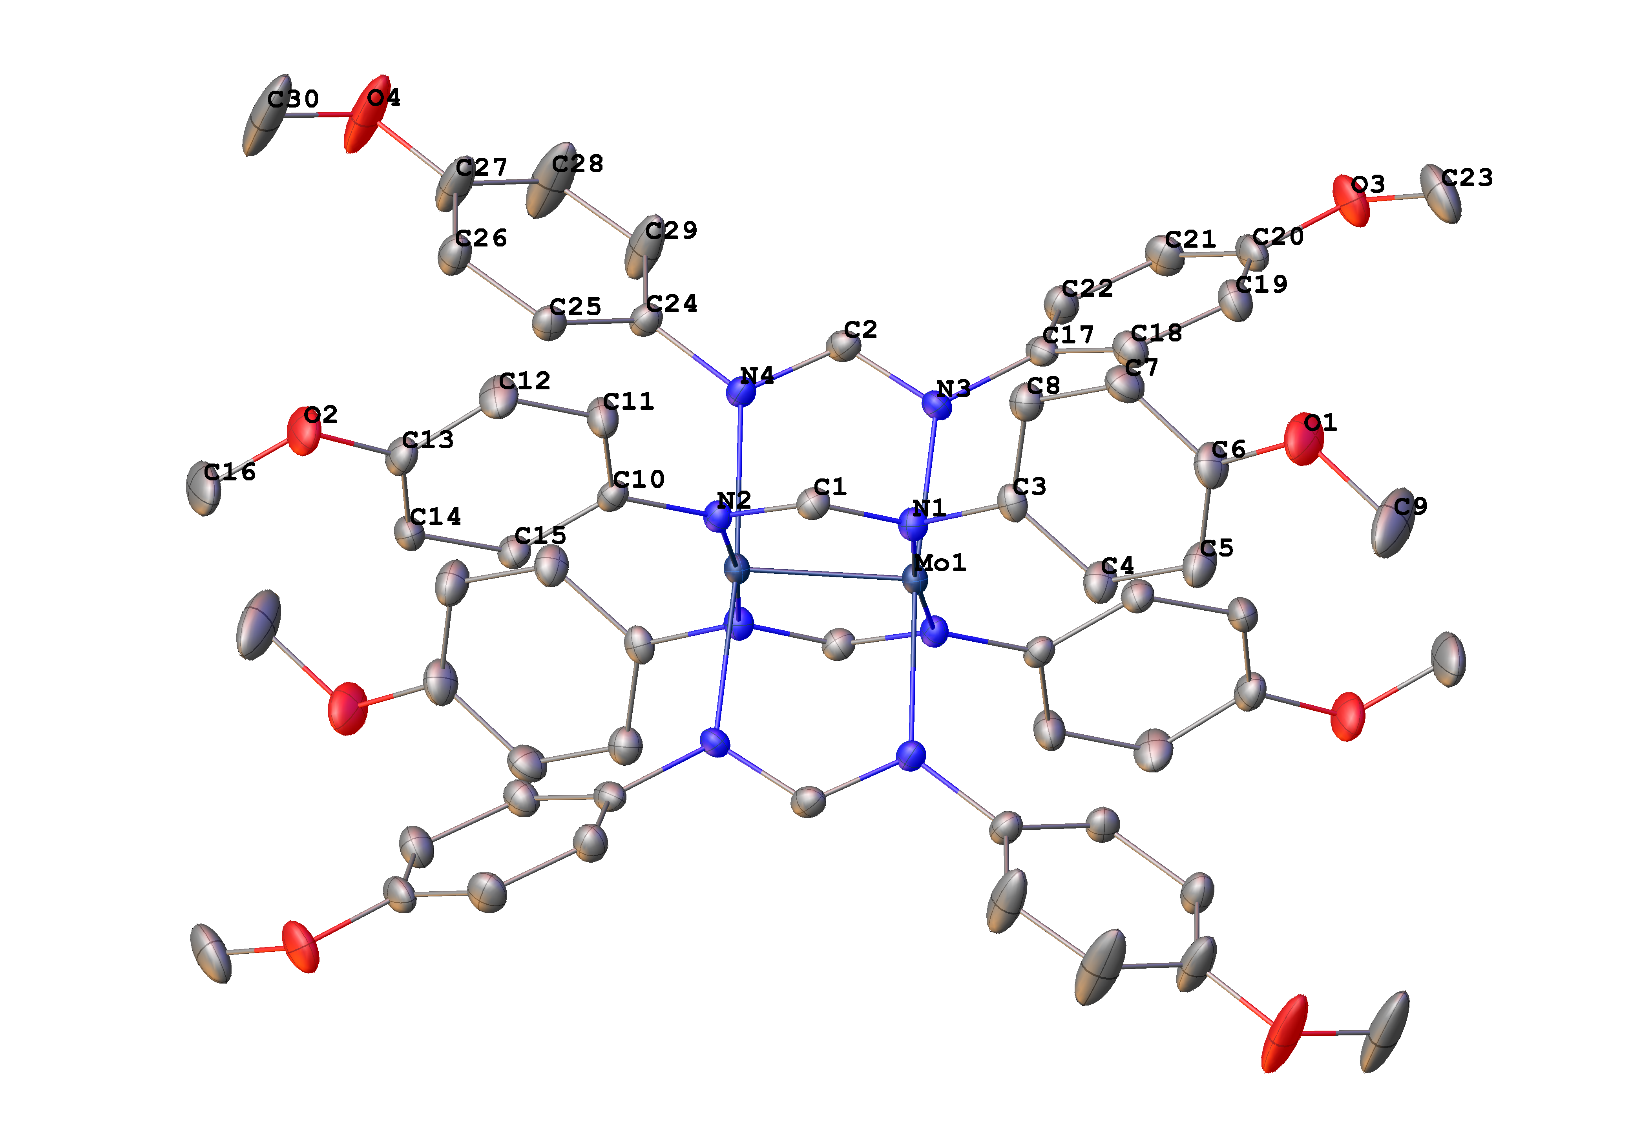
Figure 7. Solid-state structure for Mo₂(ArNC(H)NAr)₄ with the thermal ellipsoids set at the 50% probability level. Hydrogen atoms are omitted for clarity (Mo navy, N blue, C gray).

Applications and Summary

In this video, we learned about M–M bonding. We synthesized a dinuclear molybdenum complex featuring a quadruple bond. Quadruple bonds consist of three different bond types, including σ, π, and δ bonds. We collected single crystal X-ray diffraction data and observed a short Mo–Mo bond length consistent with a quadruply bonded compound.

Paddlewheel complexes, such as the Mo₂ complex prepared here, display a wide range of properties and thus find application in diverse areas of chemistry. For example, M–M bonds play an important role in catalysis: the dirhodium paddlewheel complex Rh₂(OAc)₄ is a known catalyst for C–H bond functionalization via carbene and nitrene transfer reactions (Figure 8). In a typical carbene transfer reaction, Rh₂(OAc)₄ reacts with a diazo compound to generate a Rh₂ carbene intermediate. Subsequent insertion of the carbene into a C–H bond generates the product of C–H functionalization and regenerates the Rh₂(OAc)₄ catalyst. The exceptional reactivity of Rh₂ catalysts in these reactions has been ascribed to Rh–Rh interaction via the M–M bond. The Rh–Rh bond in the resulting intermediate acts as an electron reservoir; while one metal serves as a binding site for substrate, the second metal center shuttles electron density to and from the active metal center during substrate activation. The d-orbital splitting diagram of the intermediate complex (Rh–Rh core bound to the carbenoid) shows that the frontier d-orbitals are non-bonding with respect to the active Rh center (Figure 9a). The electron density in both the σ and π non-bonding MOs is centered on the nucleophilic carbenoid carbon and the “spectator” Rh center, which is not directly bound to the carbenoid unit (Figure 9b).

Figure 8. C–H bond functionalization via a metal-carbenoid intermediate.

Figure 9. (a) d-orbital MO splitting diagram of the Rh–Rh core in paddlewheel complexes bound to a carbenoid substrate. Note that only orbitals involved in substrate binding are shown. (b) The resulting σ and π non-bonding MOs are filled with electrons. The electron density in those MOs is centered on the carbenoid carbon and the “spectator” Rh center.

Paddlewheel complexes have also been utilized as building blocks in MOFs. MOFs are porous coordination polymers that consist of metal complexes linked together by organic ligands. The resulting one-, two-, or three-dimensional superstructures can be used in a variety of applications ranging from gas absorption (including separation and purification) to catalysis.

References:

Nguyen, T., Sutton, A. D., Brynda, M., Fettinger, J. C., Long, G. J., Power, P. P. Synthesis of a stable compound with fivefold bonding between two chromium(I) centers. Science. 310(5749), 844-847 (2005).
Lin, C., Protasiewicz, J. D., Smith, E. T., Ren, T. Linear free energy relationship in dinuclear compounds. 2. Inductive redox tuning via remote substituents in quadruply bonded dimolybdenum compounds. Inorg Chem. 35(22), 6422-6428 (1996).
Cotton, F. A., Murillo, C. A., Walton, R. A. Eds. Multiple Bonds Between Metal Atoms, 3rd ed. Springer. New York, NY. (2005).
Nakamura, E., Yoshikai, N., Yamanaka, M. Mechanism of C−H Bond Activation/C−C Bond Formation Reaction between Diazo Compound and Alkane Catalyzed by Dirhodium Tetracarboxylate. J Am Chem Soc. 124 (24), 7181-7192 (2002).

