PI Name: Michael Benton
Science Education Title: Testing the Efficiency of Fins in a Finned-Tube Heat Exchanger
Overview
Goal: The goal for this experiment is to test the heat transfer efficiency of a finned-tube heat exchanger and compare it to the theoretical efficiency of a heat exchanger without fins.
Comparable Technology: Multiple classes of heat exchangers exist to fill different needs. Some of the most common types are shell and tube exchangers and plate exchangers¹. Shell and tube heat exchangers use a system of tubes through which fluid flows¹. One set of tubes contains the liquid to be cooled or heated, while the second set contains the liquid that will either absorb heat or transmit it¹. Plate heat exchangers use a similar concept, in which plates are closely joined together with a small gap between each for liquid to flow¹. The fluid flowing between the plates alternates between hot and cold so that heat will move into or out of the necessary streams¹. These exchangers have large surface areas, so they are usually more efficient¹.
Procedure: Experimental data will be measured for three different flow rates of monoethylene glycol (MEG) and two unique water flow rates for each MEG flow rate used. The Reynold’s number will be determined for flow with and without the fins and will be used to calculate the heat transfer coefficient, surface area, and fin efficiency for each unique trial run. This data will be used to evaluate if turbulent flow is possible without the fins and under which set of trial conditions the most heat transfer occurs.
Principles
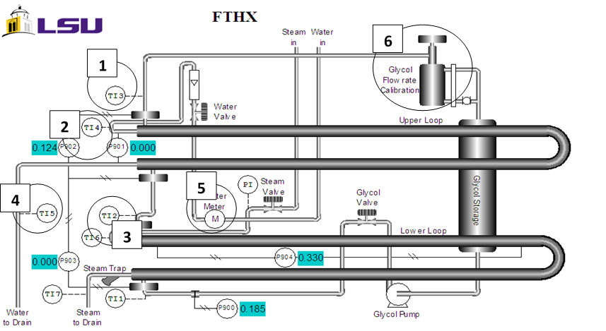
Finned Tube Heat Exchanger: The labels in the figure are denote as: 1) MEG outlet temperature 2) water inlet temperature 3) MEG inlet temperature 4) water outlet temperature 5) water meter used to determine water flow rate through the exchanger 6) MEG accumulation sight glass/cylinder used to determine MEG flow rate.

Heat exchangers transfer heat to or from a process in order to heat. The exchangers use fluid species which flow in a separate space from an opposing stream that is providing heat. Fins can be added to the flow area to facilitate more heat transfer, as they increase the surface area available for transference. The added fins will decrease the area through which the species flows and provide more surfaces on which boundary layers can form, resulting in flow that is less turbulent. The less turbulent a flow, the larger boundary layer it will have. A boundary layer inhibits heat transfer, so with less turbulent flow less heat is transferred.
The relationship between the area through which heat can flow and the heat transfer coefficient is used in calculating the total heat transferred. This relationship is calculated through Equation 1:
“q = h • A • n_{f} • (T_{bulk} –T_{surface})”
where q is heat transferred (Btu), h is heat transfer coefficient, A is area through which heat is transferred (ft²), n_{f} is fin efficiency, and T_{bulk} and T_{surface} are the temperatures of the bulk fluid flow and the temperature of the heat surface (°C), respectively.
The Reynolds Number is used in order to calculate the heat transfer coefficient.
Re = V p (D_{eq})/µ

Where V is the velocity of MEG (ft/s), ρ is the density of the MEG (lbm/ft3), Deq is the equivalent of the channel (equal to the area perpendicular to flow divided by the wetted perimeter), and μ is the viscosity of MEG (lbm/ft ·s).
The heat transfer coefficient is calculated by:
h = 0.332(k/x)Re^{1/2}Pr^{1/3} and Pr = µ Cp/k
Where k is the conductance of the chemical through which heat is flowing (Btu/ft/F), Re is the Reynolds number, Pr is the Prandtl number, µ is the viscosity of MEG, and Cp is the capacity value for MEG.
Fin efficiency is calculated as:
nf= tanh⁡(h)⁡h
Procedure
- Open the valve below the steam generator and drain any water inside.
- Close the drain value and open the charge valve. Add 4 liters of water, then close the valve.
- Start the unit, and allow 15 minutes to heat up. Wait for steam to begin forming.
- Calculate the flow of water by starting the stopwatch.
- Next, watch the gauge displaying the volume of water.
- Stop the watch at 30 seconds.
- Observe the total volume of water from the gauge.
- Divide the volume of water by the time to find the flow rate.
- Similarly, calculate flow rate of MEG using a stopwatch and a graduated sight glass.
- Observe the temperature from the thermocouples after the 30 seconds have passed and flow rates have been calculated, and record the values.
- Vary the flow rate of water between a high and low value and the flow rate of MEG between a high, middle, and low value. Previous experimenters used rates of 0.0439, 0.0881, and 0.1323 gal/sec for the low, medium, and high rates, respectively. Each flow rate of water should be used with each flow rate of MEG, totaling six unique runs.
- Calculate total heat transferred, q, with Equation 1 using the temperature difference read from the thermocouples (devices used to measure temperature) and the known physical dimensions of the heat exchanger (found in the user manual for the unit being operated). The temperature differences can be taken from the temperature readings of each run.
- Calculate the Reynolds number, surface area, and fin efficiency for each unique trial run, using the formulas cited above.
- Compare the calculate values to theoretical values of the heat exchanger without fins.

Representative Results
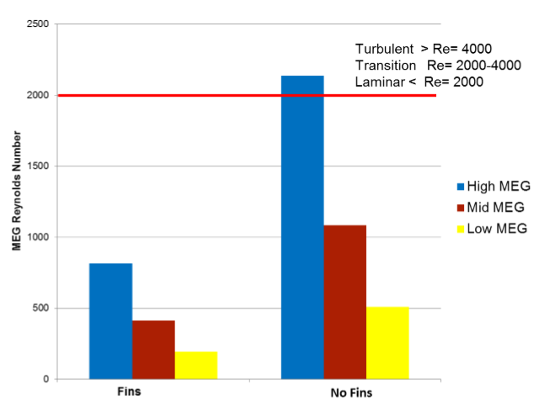
Figure 1: Representation of the calculated Reynolds numbers for each setting.
The finned tubes did not reach turbulent flow (Figure 1). The fins create additional surfaces on which boundary layers form, as known through laminar and turbulent flow theory, and if the fluid moving through them is not moving with sufficient velocity, the fluid will not reach turbulence. The boundary layers between fins will overlap in the laminar region, so the fluid will remain laminar.
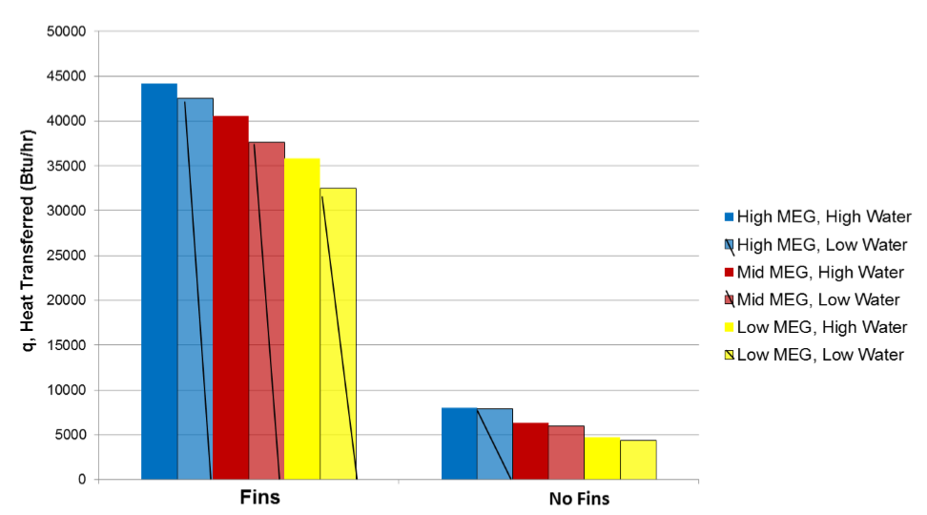
Figure 2: A depiction of the heat transferred between exchangers with and without fins at each flow rate.
The amount of heat transferred, q, in the tubes with and without fins at different flow rates of MEG was compared (Figure 2). The results showed that a fin tube will transfer more heat than a tube without fins at the same operating conditions. Fins clearly were better in this experiment for heat transfer. As expressed in the principles, heat transfer is more effective with more surface area for transfer to occur. These results supported this relationship, as the finned test transferred more heat (Figure 2), despite the lower Reynolds number observed for the finned tubes (Figure 1).
Summary
Heat exchangers are used in a variety of industries, including agriculture, chemical production, and HVAC. The goal for this experiment was to test the heat transfer efficiency of a finned-tube heat exchanger and compare it to the theoretical efficiency of a heat exchanger without fins. Experimental data was measured for three different flow rates of monoethylene glycol (MEG) and two unique water flow rates for each MEG flow rate used. The Reynold’s number was determined for flow with and without the fins and was used to calculate the heat transfer coefficient, surface area, and fin efficiency for each unique trial run. This data was used to evaluate if turbulent flow is possible without the fins and under which set of trial conditions the most heat transfer occurs. The finned tubes did not reach turbulent flow. The results showed that a fin tube will transfer more heat than a tube without fins at the same operating conditions because the flow of MEG through the heat exchanger will not reach turbulence.
Applications
Heat exchangers are used in a variety of industries. In the agriculture industry, heat exchangers are used in the processing of sugar and ethanol². Both of these products are processed into a juice, which must be heated to be further processed². Heat exchangers are used in heating the juices for clarification². Once the juices have been processed into even syrups, further heating with exchangers is necessary to continue processing and form molasses². Molasses is cooled using heat exchangers, after which it can be stored for later processing².
Heating, ventilation, and air conditioning systems, together known as HVAC, all make use of heat exchangers³. Household air conditioning and heating units make use of heat exchangers³. In larger settings, chemical plants, hospitals, and transportation centers all make use of similar heat exchanger HVAC, on a much larger scale³. In the chemical industry, heat exchangers are used for heating and cooling a large variety of processes⁴. Fermentation, distillation, and fragmentation all make use of heat exchangers⁴. Even more processes like rectification and purification require heat exchangers⁴.
Sources
- "Types of Heat Exchangers." Types of Heat Exchangers. N.p., n.d. Web. 19 Jan. 2017.
- "Heat exchangers for sugar factories and distilleries." Heat exchanger for sugar and ethanol industry. N.p., n.d. Web. 19 Jan. 2017.
- "Biotechnology and green chemistry heat exchangers." Heat exchanger for green chemical industry. N.p., n.d. Web. 19 Jan. 2017.
- "Heat exchangers for heating and cooling." Heat exchangers for district heating, cooling and HVAC. N.p., n.d. Web. 19 Jan. 2017.

