Title: Solving for the Mass Transfer Coefficient of a Gas Absorber
Overview
Source: Michael Benton, Department of Chemical Engineering, Louisiana State University, Baton Rouge, LA
Gas absorbers are used to remove contaminants from gas streams. Multiple designs are used to accomplish this objective¹. A packed bed column uses gas and liquid streams running counter to each other in a column packed with loose packing materials such as ceramics, metals, and plastics; or designed structure packing¹. The packed bed uses surface area created by the packing to create a maximum amount of efficient contact between the two phases¹. The systems are low maintenance and can handle corrosive materials with high mass transfer rates¹. Spray columns are another type of absorber, which uses constant direct contact between the two phases, with gas moving up and liquid being sprayed down into the gas flow¹. This system only has one stage and poor mass transfer rates, but is very effective for solutes with high liquid solubility¹.
The goal of this experiment is to determine how variables including gas flow rate, water flow rate, and carbon dioxide concentration affect the overall mass transfer coefficient in a gas absorber. Understanding how these parameters affect CO₂ removal enables contamination removal to be optimized. The experiment uses a randomly packed water counter-flow gas absorption column. Eight runs with two different gas flow rates, liquid flow rates, and CO2 concentrations were used. During each run, the partial pressures were taken from the bottom and top of the column unit and equilibrium partial pressures were calculated. These pressures were then used to find the mass transfer coefficient, and the mass transfer coefficients were compared to theoretical values.
Principles
A gas absorption unit (Figure 1) uses contact with a liquid to remove a substance from a gas mixture. Mass is transferred from the gas mixture to the liquid in absorption. The two phases near equilibrium in the apparatus, then the separation of the gas-liquid phase occurs. The overall mass transfer coefficient is the rate at which the concentration of one species moves from one fluid to the other (Equation 1).
$K_{G}= \frac{s}{a x z}\int_{Y_{A2}}^{Y_{A1}}{\frac{dY_{A}}{(p_{AG}-p_{A}^{*})}}$ (1)
In equation 1, K_{G} is the overall mass transfer coefficient, p_{AG} is the partial pressure of CO₂, p*_{A} is the equilibrium pressure from Henry’s Law, a is the interphase mass transfer effective area, and z is the height of the packing. Mass transfer depends on the mass transfer coefficients in each phase and the amount of interfacial area available in the absorber. Henry’s Law and Raoult’s Law are applied to approximate the partial pressures. They are two laws that describe the partial pressure of a component in a mixture, and are used together in order to fully describe the behavior of the mixture at the limits of the vapor-liquid equilibrium relationship. The objective of a gas absorption column is to control effluent. The column counter-flows a liquid with the flue stream to remove gas species through convective mass transfer and molecular diffusion. The overall mass transfer of a water counter-flow packed column is measured in this study to determine the effects of water flow, gas flow, and CO₂ gas concentration. The coefficients will then be compared to theoretical values.
Procedure
The experiment uses a randomly packed water counter-flow gas absorption column. The column is packed with 34 cm of 13 mm berl saddles with 465 m²/m³ surface area. The pressure entering the system is about 1.42 bar with a temperature of about 26 ⁰C, and valves at the entrance and exit of the column allow gas to escape. An “Oxy Baby” Infra-red spectrometer, directly connected to the tank, measures gases leaving the tank and tanks of pure gas are used for calibration.
- Operating the Gas Absorber
  - Turn on the master switch and close the adjusting valve used to control the amount of water in the column
  - Open the air flow valve completely and the adjusting valve for column pressure.
  - Set the air flow rate to the desired level (use a minimum of 20 L/min and increase as needed), and set the column pressure to ~ 1.4 bar and 25⁰C using the adjusting valve for pressure.
  - Start the carbon dioxide flow rate at ~ 4 L/min.
  - Set the water flow at ~ 75 L/h, and adjust the water level to maintain a constant height. Tweak if necessary while running to ensure constant height.
  - Sample the pressure as desired at the base, center, and head of column using the in-line pressure gauges.
  - Perform eight different runs, using two different gas flow rates, liquid flow rates, and CO₂ concentrations. This will enable determination of the most important variables.
  - Allow the system to achieve steady-state when any flow rate is altered. This typically takes 30 - 45 min.
Representative Results
Partial pressures were taken from each trial run. Mass transfer coefficients were calculated from these and compared to predicted values (Figure 1). The predicted values arise from mass balances and represent the operating line for the absorption process (see reference 2 for an in-depth discussion of the operating line. Solid lines represent the operating line, while triangles represented the experimental mass transfer coefficient values. Confidence intervals for the model values and the mean mass transfer coefficient were plotted with dashed lines. These values were compared to determine how gas flow rate would affect mass transfer coefficient. There was no deviation between the operating line and experimental values, showing that only liquid had a significant statistical effect on mass transfer when compared to the confidence interval for the given conditions.
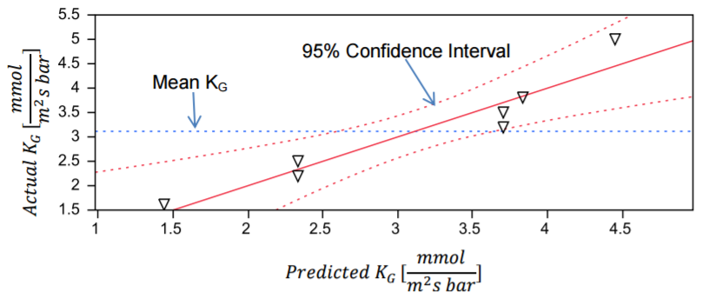
Figure 1: Model of the predicted and actual values of the mass transfer coefficient.
The same approach was used to calculate mass transfer coefficient under the same operating conditions. These values were compared to experimental values (Figure 2). The theoretical values showed similar trends to the experimental data. Whether the gas rate was high or low, the model and experiment behaved the same, showing that gas had little or no effect on the mass transfer coefficient. Based on these results, gas flow rate has a negligible effect on mass transfer coefficient. The theoretical values showed some variation from the experimental values, however the values followed the same overall trend and were found to be of the same order of magnitude. The variation shown is attributable to minor experimental error.
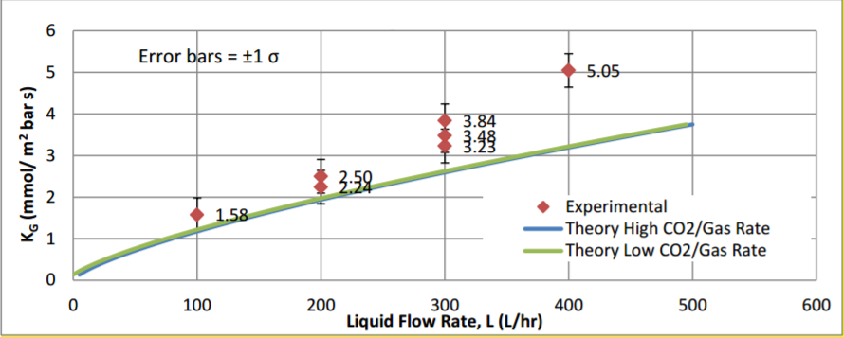
Figure 2: A graphical depiction of experimental value compared to theoretical values.
Applications and Summary
The goal of this experiment was to use factors of gas flow rate, water flow rate, and carbon dioxide concentration to determine the overall mass transfer coefficient in a gas absorber. The experiment used a randomly packed GUNT CE 400 water counter-flow gas absorption column. Eight runs with two different gas flow rates, liquid flow rates, and CO2 concentrations were performed. Partial pressures were taken from the bottom and top of the column unit, and these pressures were then used to find the mass transfer coefficient.
The model showed that only liquid had a significant statistical effect on mass transfer when compared to the confidence interval for the given conditions. Based on these results, gas flow rate has a negligible effect on mass transfer coefficient. When running experiments on the gas absorption column with CO₂, the liquid flow rate will be a significant factor of mass transfer. This process is liquid controlled. Gas-related factors such as CO₂ concentration and gas flow rate will have little to no significance.
Gas absorption is an important mechanism for safety in the production of chlorine³. During normal operation, gas absorbers treat any consistently occurring leaks³. The start-up of a chlorine operation must be treated until it produces a gas-free product³. In the event of a breakdown in the process, absorbers must be used to treat the gas that has been produced³. Additionally, when new leaks form, the main emergency response unit is the standby gas absorbers³. Treatment units are vitally important in these operating conditions, as they help create a safe environment when dealing with a dangerous product³.
When refining natural gas, absorption towers are used to remove natural gas liquids from the gas phase⁴. An absorbing oil with an affinity to natural gas liquids removes the liquid from the gas phase, purifying the product⁴. The oil with natural gas liquids is then further purified to recover the liquids, such as butane, pentanes and other molecules⁴. The oil can then be used again for treatment⁴.
In the food industry, gas absorption is used to purify fats and oils⁵. Unwanted flavors can be removed and the products can be treated effectively⁵. Fats and oils are processed by being heated into steam, then brought into contact with the liquid fat or oil⁵. The contact between streams removes the undesired components and leaves the desired product⁵. These products can be blended into food products like margarine or directly made from cream into butter⁵.
References
- "ENCYCLOPEDIA OF CHEMICAL ENGINEERING EQUIPMENT." Absorbers - Separations: Chemical - MEL Equipment Encyclopedia 4.0. N.p., n.d. Web. 28 Jan. 2017.
- Welty, James R., Rorrer, Gregory L., and David G. Foster. Fundamentals of Momentum, Heat, and Mass Transfer. 6th ed. John Wiley & Sons, Inc., Hoboken, NJ, 2015

- "Chloric Gas Absorption." GEA engineering for a better world. N.p., n.d. Web. 28 Jan. 2017.
- "NaturalGas.org." NaturalGasorg. N.p., n.d. Web. 28 Jan. 2017.
- "Unit Operations in Food Processing - R. L. Earle." Unit Operations in Food Processing - R. L. Earle. N.p., n.d. Web. 28 Jan. 2017.

