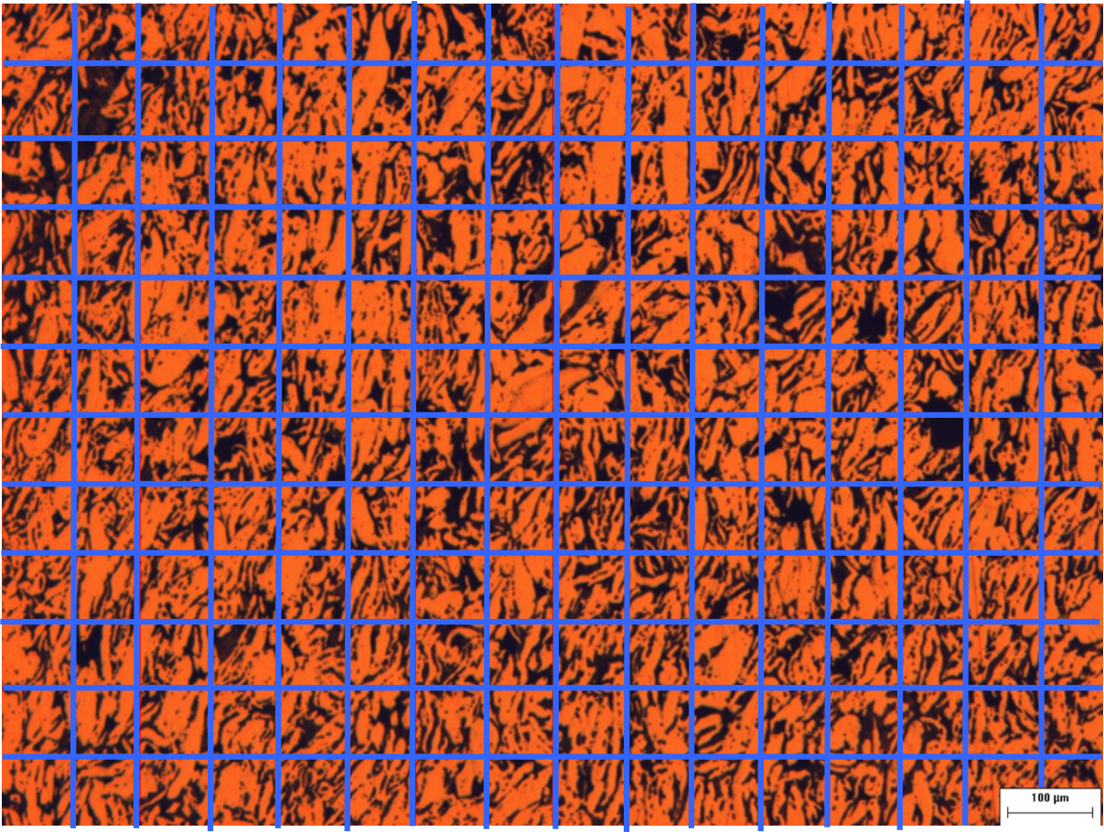
Figure 1: Materialographic image with a superimposed grid. The intersection points on the grid are used for analysis.

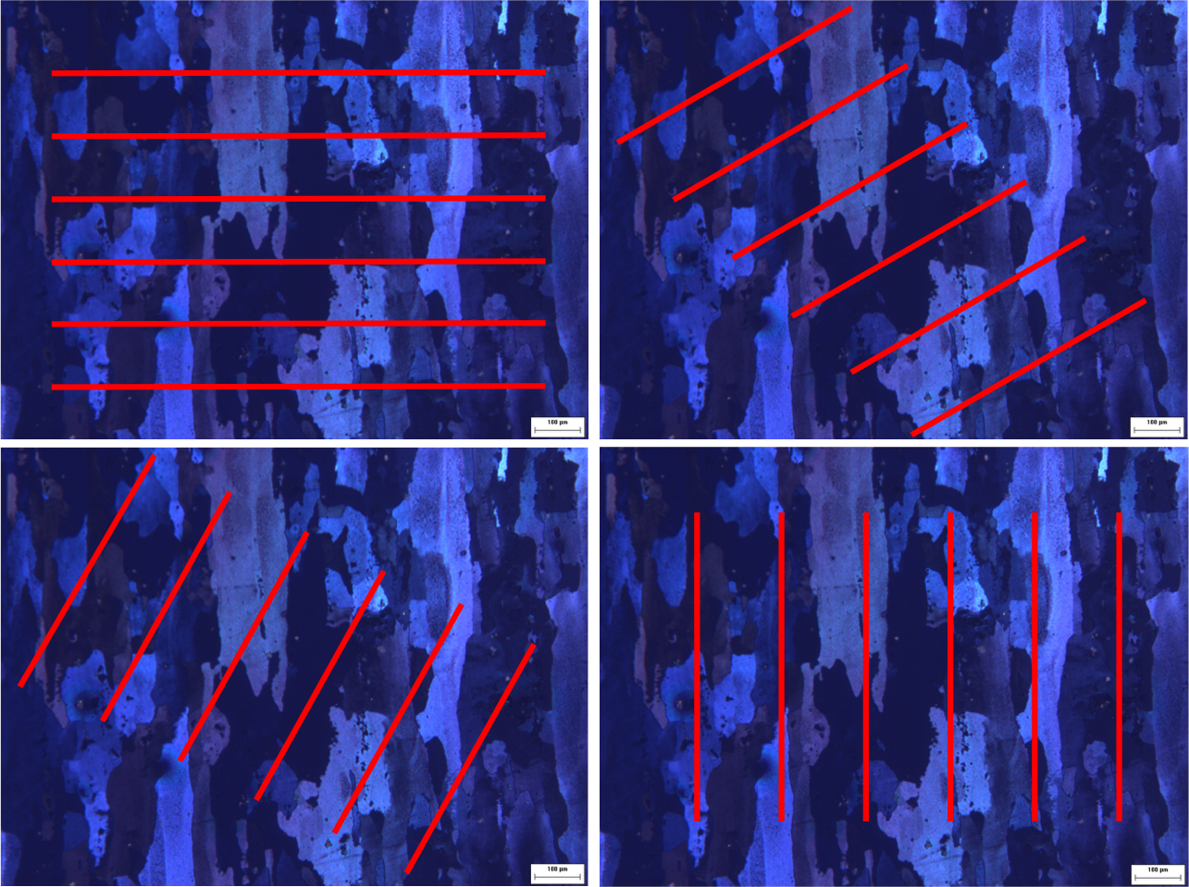
d
c
b
a
Figure 2: Grains size measurements using lines at a) 0, b) 30, c) 60 and d) 90 degrees orientation. The grains are obviously anisotropic in shape (longer in one direction than the other). This anisotropy results from the nonuniform forces acting on the samples during processing through which the grains become “squashed”.

