Overview

Source: Tamara Powers, Department of Chemistry Texas A&M University, College Station, TX

Bioinorganic chemistry is the field of study that investigates the role that metals play in biology. Approximately half of all proteins contain metals and it is estimated that up to one third of all proteins rely on metal-containing active sites to function. Proteins that feature metals, called metalloproteins, play a vital role in a variety of cell functions that are necessary for life. Metalloproteins have intrigued and inspired synthetic inorganic chemists for decades, and many research groups have dedicated their programs to modeling the chemistry of metal-containing active sites in proteins through the study of coordination compounds.

The transport of O₂ is a vital process for living organisms. O₂-transport metalloproteins are responsible for binding, transporting, and releasing oxygen, which can then be used for life processes such as respiration. The oxygen-carrying cobalt coordination complex, [N,N'-bis(salicylaldehyde)ethylenediimino]cobalt(II) (Co(salen)) has been studied extensively to gain understanding about how metal complexes reversibly bind O₂.

In this experiment, we will synthesize Co(salen) and study its reversible reaction with O₂ in the presence of dimethylsulfoxide (DMSO). First, we will quantify the amount of O₂ consumed upon exposure of Co(salen) to DMSO. We will then visually observe the release of O₂ from the Co(salen)–O₂ adduct by exposing the solid to CHCl₃.

Principles

There are two solid polymorphs of Co(salen) (active and inactive), which can be isolated from different reaction conditions. Active and inactive Co(salen) vary in their color (brown and red, respectively), structure, and reactivity. Both polymorphs consist of dimeric units. In the case of active Co(salen), the Co-centers in each of the two Co(salen) molecules are in close proximity, forming a very weak van der Waals interaction between the metal centers (Figure 1). While the active form does exhibit a weak Co–Co interaction, the separation between the dimeric units provides space for O₂ to react with the Co centers; as a result, the active form of Co(salen) reacts with O₂ in the solid state.

In the so-called inactive form of Co(salen), there is a dative interaction between the Co center of one molecule and an oxygen atom from the other (Figure 1). The two Co(salen) units are closer together compared to the active form and, as a result, the inactive form is stable in air in the solid state and only reacts with O₂ in the presence of a coordinating solvent (such as DMSO), which disrupts the dimeric unit and stabilizes the Co(salen)–O₂ adduct. Inactive Co(salen) is easier to handle and study, since the solid can be isolated without using air-free techniques. Therefore, in this experiment we will synthesize inactive Co(salen) and study its reaction with O₂ in the presence of DMSO.

There are several ways that O₂, a diatomic molecule, can coordinate to metal center(s) (Figure 2). End-on binding results in a metal–oxygen bond to one of the oxygen atoms in O₂. In side-on binding, both oxygen atoms form bonds to the metal center. In some cases, the O₂ unit bridges two metal complexes where end-on and side-on binding are also observed.

Inactive Co(salen) forms a 2:1 cobalt to O₂ adduct in the presence of the coordinating solvent, DMSO. The O₂ unit bridges the two cobalt centers in an end-on fashion (Figure 3) and coordinated DMSO molecules complete the octahedral coordination sphere of each of the Co centers. If we consider the MO diagram of O₂ and d-orbital splitting diagram for Co(salen), we can understand why the 2:1 O₂ adduct is favored (Figure 4). O₂ displays a triplet ground state with two unpaired electrons in the π* MOs. Co(salen) is paramagnetic, with one unpaired electron in its $σ_{{dz}^{2}}^{*}$ MO (assuming square planar (D_{4h}), Co²⁺, 7 de–). The binding of O₂ to Co(salen) is a redox reaction, where two Co(salen) molecules are oxidized by 1 e– each to a final oxidation state of 3+ at cobalt, and the O₂ molecule is reduced by 2 e–, resulting in the formation of peroxide (O₂^{2–}). The 1:1 adduct is not favored in this case because Co(III) is d⁶ and, therefore, does not want to give up another electron (For a review on MO theory/d-orbital splitting, see the video on Group Theory and MO Theory of Transition Metal Complexes).

In this video, we will experimentally determine the Co:O₂ ratio upon reaction of inactive Co(salen) with O₂ in the presence of DMSO by measuring the volume of O₂ lost in a closed system. We can use the ideal gas law (Equation 1) to calculate the number of moles of O₂ consumed.

$PV=nRT$ (Equation 1)
$$P=prssure=1 atm$$
$$V=volume \left(L\right)$$
$$R=0.082 L atm mol^{-1}K^{-1}$$
$$T=temperature \left(K\right)$$
$$n=moles$$

We will then study the reversibility of O₂ binding by exposing the resulting solid [Co(salen)]₂O₂(DMSO)₂ to chloroform (CHCl₃). Addition of CHCl₃ (a non-coordinating solvent that cannot stabilize the Co(salen)–O₂ adduct) leads to a decrease in the concentration of DMSO. Le Châtelier's principle can explain that upon a decrease in concentration of DMSO, the equilibrium shown in Figure 3 will shift towards the reactants, resulting in liberation of O₂ gas.

Figure 1. Active and inactive forms of Co(salen).

Figure 2. Coordination modes of O₂ to metal center, M.

Figure 3. Reversible reaction of O₂ with Co(salen).

Figure 4. MO diagram of O₂ and d-orbital splitting diagram of Co(salen) (derived from Group theory, assuming square planar geometry).

Procedure

- Synthesis of Inactive Co(salen)

  - Charge a 250 mL 3-neck round-bottom flask with 120 mL of 95% EtOH and 1.10 g (0.096 mL, 0.009 mol) of salicylaldehyde.

  - Fit the center neck with a condenser connected to N₂. Fit the other two necks with a rubber septum and an addition funnel fitted with a rubber septum.

  - Stir the reaction in a water bath and heat the solution to reflux (80 °C).

  - Add ethylene diamine (0.52 g, 0.58 mL, 0.0087 mol) via syringe through the round-bottom flask septum.

  - In a 50 mL round-bottom flask, prepare a solution of cobalt(II) acetate tetrahydrate (2.17 g, 0.0087 mol) in 15 mL of distilled water. Heat the solution in the same water bath containing the 3-neck flask to ensure that all of the cobalt acetate dissolves.

  - Add the cobalt acetate solution to the addition funnel.

  - Degas the cobalt acetate solution by bubbling N₂ through the liquid in the addition funnel for 10 min (see “Synthesis of a Ti(III) Metallocene Using Schlenk Line Technique” video for a more detailed procedure on purging liquids). The condenser N₂ adapter may need to be closed to allow the N₂ to bubble through the cobalt acetate solution.

Note: Never heat a closed system! Make sure to vent the system during degassing.

  - Slowly add the cobalt(II) acetate solution (~ 1 drop/s), while vigorously stirring the ethanol mixture. Without sufficient stirring, a chunky precipitate will form that can jam the stir bar.

  - Once all of the cobalt acetate has been added, stir the reaction at reflux for 1 h.

  - Turn off the hot plate and remove the 3-neck round-bottom flask from the water bath.

  - Remove the condenser and addition funnel from the flask. Submerge the flask in an ice bath to facilitate precipitation of the Co(salen).

  - Filter the solution under vacuum to isolate the solid and wash the resulting red solid with cold ethanol.

  - Isolate the solid. Calculate the yield of the reaction and collect an IR of the Co(salen). Make sure that the Co(salen) is dry before using it in the O₂ uptake reaction.

- Apparatus Setup for O₂ Uptake (Figure 5)¹

Note: It is very important that the system does not leak. A leak in the system will lead to a lower than expected Co:O₂ ratio.

  - Connect a needle to an O₂ (ultra-high purity) gas cylinder with Tygon tubing. Gently bubble O₂ through 5 mL of DMSO for at least 10 min.

  - While the DMSO is being saturated with O₂, fit the two ends of a graduated 10 mL glass pipette with Tygon tubing (each 1.5 ft in length).

  - Attach a glass funnel to one of the Tygon tubing pieces.

  - Clamp the glass pipette and the funnel to a ring stand so that the funnel is facing up and the tubing forms a U shape (Figure 5).

  - Fill the pipette and funnel with mineral oil. Add the oil through the funnel, making sure that the oil also fills the tubing connected to the pipette. Continue to add the oil until the funnel is filled about half way up the funnel. Don’t let the oil get too close to the top of the funnel, as the O₂ bubbling through the funnel can cause splashing if the funnel is too full.

  - To the open end of the tubing, attach a side-arm test tube (test tube A).

  - Add 50 mg (0.077 mmol) of the inactive [Co(salen)]₂ to the side-arm test tube A connected to the glass pipette.

  - Add 2 mL of the DMSO saturated with O₂ to a 3 mL test tube (test tube B).

  - Use a pair of tweezers to gently lower test tube B into test tube A, being careful not to spill any of the DMSO. It is important to not expose the Co(salen) to the DMSO at this point.

  - Seal test tube A with a rubber septum. Wire the septum to prevent leaks.

  - Insert the needle connected to the O₂ gas tank into the septum and purge the system with O₂ for 10 min.

  - Remove the O₂ needle and grease the top of the rubber septum to prevent leaks.

  - Some of the pressure within the setup may need to be released to get oil into the glass pipette. To do this, insert a free needle into the rubber septum on test tube A. Cover the opening with a finger and slowly release the pressure within the setup. Do not forget to cover the new hole with grease to prevent leaks.

  - Move the glass pipette and funnel so that the oil levels line up in both pieces of glassware.

  - Record the volume level of oil within the glass pipette.

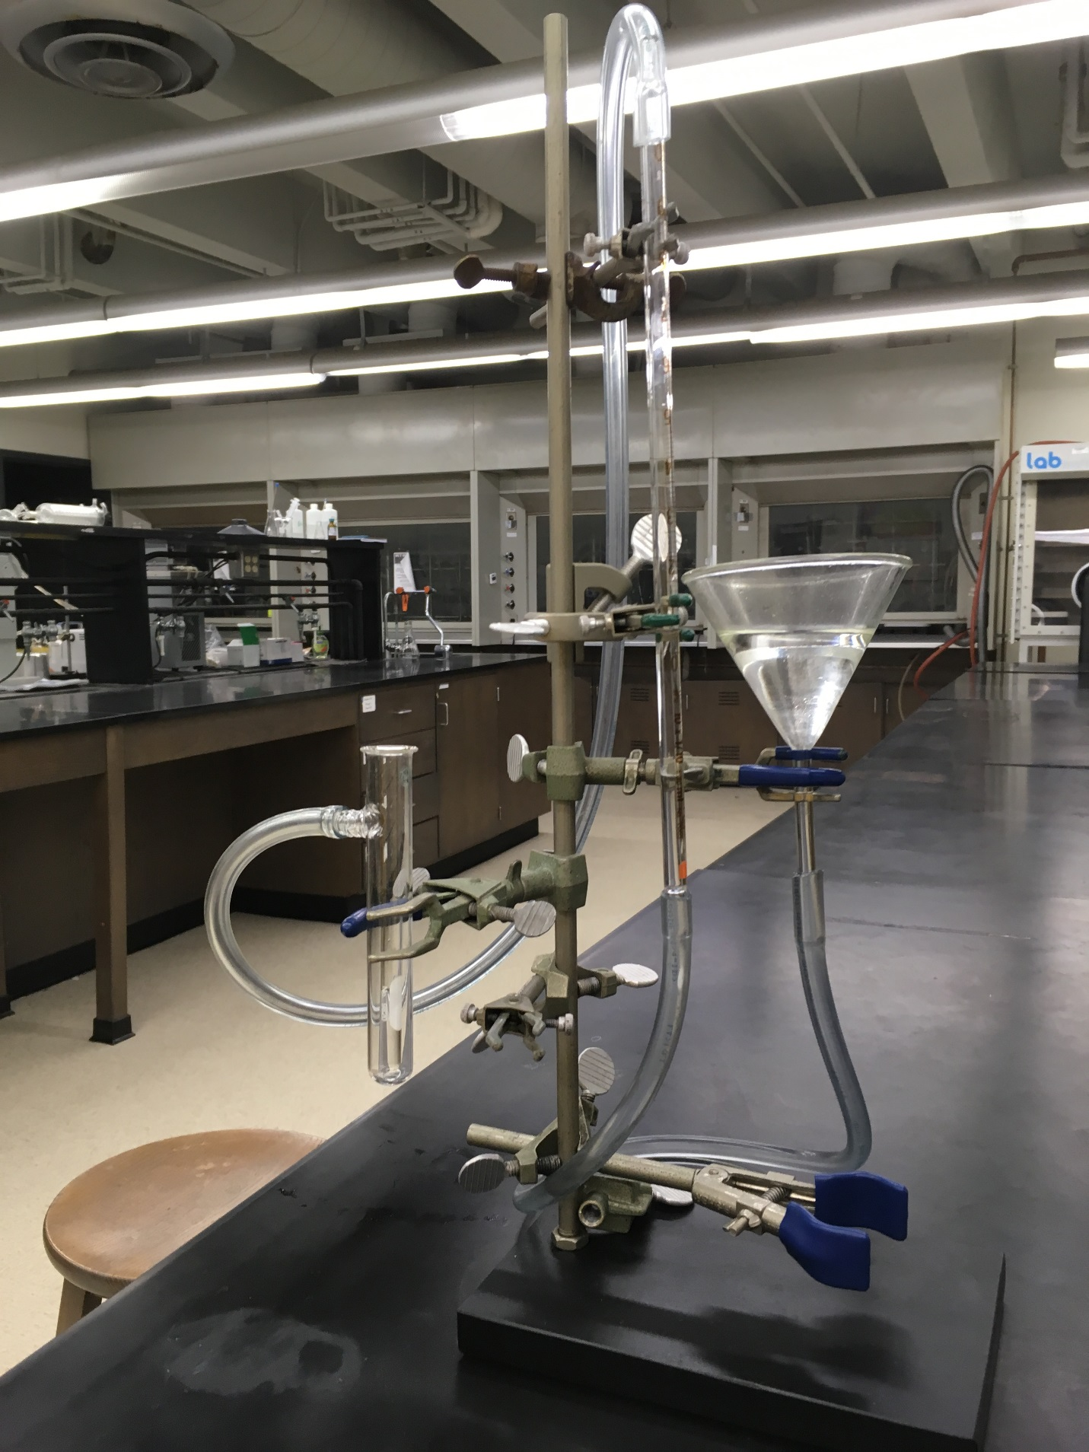
Figure 5. O₂ uptake apparatus setup.

- O₂ Uptake Reaction

  - Add the DMSO to the solid Co(salen) by gently tipping the test tubes, making sure that none of the solution enters the side-arm of test tube A.

  - Once all of the DMSO has been added, hold the top of the test tube and gently mix the solution by shaking the test tube back and forth.

Note: Do not use an up and down shaking motion. Banging the two test tubes together too violently can lead to the breaking of test tube A.

  - Continue to gently shake the test tubes by hand until the oil level in the pipette stops rising (about 15–20 min).

  - Once O₂ consumption ceases, move the pipette and funnel so that the oil levels line up.

  - Record the new volume level of the oil in the glass pipette. The volume difference is the volume of O₂ consumed during the reaction at atmospheric (1 atm) pressure.

  - Record the temperature of the room.

- O₂ Liberation from Co(salen)–O₂ Adduct

  - Transfer the resulting DMSO solution from step 3 to a 15 mL centrifuge tube.

  - Fill a second test tube with an equivalent amount of water.

  - Insert the test tubes across from each other into a centrifuge.

  - Centrifuge the sample for at least 15 min. The resulting solid pellet quality improves with increasing centrifuge time.

  - Gently remove the test tube with the Co(salen)–O₂ adduct sample, so not to disturb the pellet.

  - Carefully decant the DMSO solution above the pellet.

  - Holding the centrifuge tube at a 45 ° angle with the pellet facing up, slowly add 1 mL of CHCl₃ with a pipette, by allowing the solution to drip down the side of the centrifuge tube. Take extreme care to not disturb the solid Co(salen)–O₂ adduct.

  - Observe any physical changes that occur.

Results

Characterization of Inactive Co(salen):

Yield: 2.4 g (85%). IR (KBr pellet): 1,628 (s), 1,608(vs), 1,545 (m), 1,532 (s), 1,472 (m), 1,452 (vs), 1,434 (m), 1,398 (vw), 1,386 (w), 1,350 (m), 1,333(m), 1,308 (m), 1,290 (m), 1,258 (vw), 1,249 (vw), 1,236 (m), 1,221 (m), 1,206 (m), 1,197 (m), 1,150 (w), 1,140 (m), 1,126 (s), 1,087 (m), 1,052 (m), 1,025 (m), 974 (w), 968 (w), 952 (w), 945 (w), 922 (vw), 903 (m), 851 (m), 845 (w), 792 (w), 757 (m), 751 (s), 748 (s), 740 (m), 730 (s).

O₂ Uptake:

53 mg (0.081 mmol) of [Co(salen)]₂ consumed 0.0016 L of O₂. Using standard pressure and the temperature recorded in step 3.6, the number of moles of O₂ consumed was:

$$n= \frac{PV}{RT} = \frac{(1 atm)(0.0016 L)}{(0.082 L atm {mol}^{-1}K^{-1})(298 K)}= 0.000065 mol=0.065 mmol O_{2}$$

The calculated moles of Co in 0.081 mmol of [Co(salen)]₂:

$0.081 mmol {[Co\left(salen\right)]}_{2} × \frac{2 mol Co}{1 mol {[Co\left(salen\right)]}_{2}}=0.162 mmol Co$

Therefore, the Co:O₂ ratio was:

0.162 mmol Co:0.065 mmol O₂

which is equivalent to a 2:0.8 ratio of Co to O₂.

Addition of CHCl₃ to Co(salen)–O₂ Adduct:

Upon addition of CHCl₃, the CHCl₃ solution turned red and a stream of bubbles was liberated from the solid, indicating the release of O₂ gas and formation of inactive Co(salen).

Applications and Summary

In this video, we explained the different ways that diatomic oxygen can coordinate to metal center(s). We synthesized the oxygen-carrying cobalt complex Co(salen) and studied its reversible binding with O₂. Experimentally we demonstrated that inactive Co(salen) reversibly binds O₂ and forms a 2:1 Co:O₂ adduct in the presence of DMSO.

All vertebrates depend on hemoglobin, a metalloprotein found in red blood cells, to transport oxygen to respiratory organs as well as other tissues. In hemoglobin, oxygen reversibly binds to a heme group that features a single Fe center coordinated to a heterocyclic ring called a porphyrin (Figure 6a). Hemoglobin is not the only oxygen-carrying and storage metalloprotein. For example, mollusks possess a protein called hemocyanin, which features a dicopper active site that is responsible for oxygen transport (Figure 6b).

Using synthetic molecular species to model active sites in metalloproteins is challenging due to the distinct differences in electronic structure of a simple coordination compound compared to that of a metal surrounded by a protein superstructure. As a result, it is often difficult to precisely replicate the structure of the active site in metalloproteins. While there are examples of model complexes that structurally mimic metal active sites, there are fewer examples of structurally similar model complexes that exhibit reactivity inherent to the native metalloenzyme.

Figure 6. (a) The Fe center in hemoglobin binds to O₂ in an end-on fashion, while (b) the copper containing active site in hemocyanin binds to O₂ in a bridging side-on orientation.

References:

Niederhoffer, E. C., Timmons, J. H., Martell, A. E. Thermodynamics of Oxygen Binding in Natural and Synthetic Dioxygen Complexes. Chem Rev. 84, 137-203 (1984).
Appleton, T. G. Oxygen uptake by cobalt(II) complex. An undergraduate experiment. J Chem Educ. 54 (7), 443 (1977).
Ueno, K., Martell, A. E. Infrared Studies on Synthetic Oxygen Carriers. J Phys Chem.60, 1270–1275 (1956).

