Figure 1. Example phase diagram. The colored lines represent the pressure and temperature requirements for phase transitions. Distillation of a solid will occur at pressures and temperatures above the triple point. The blue line represents the temperature and pressure conditions where sublimation would occur.
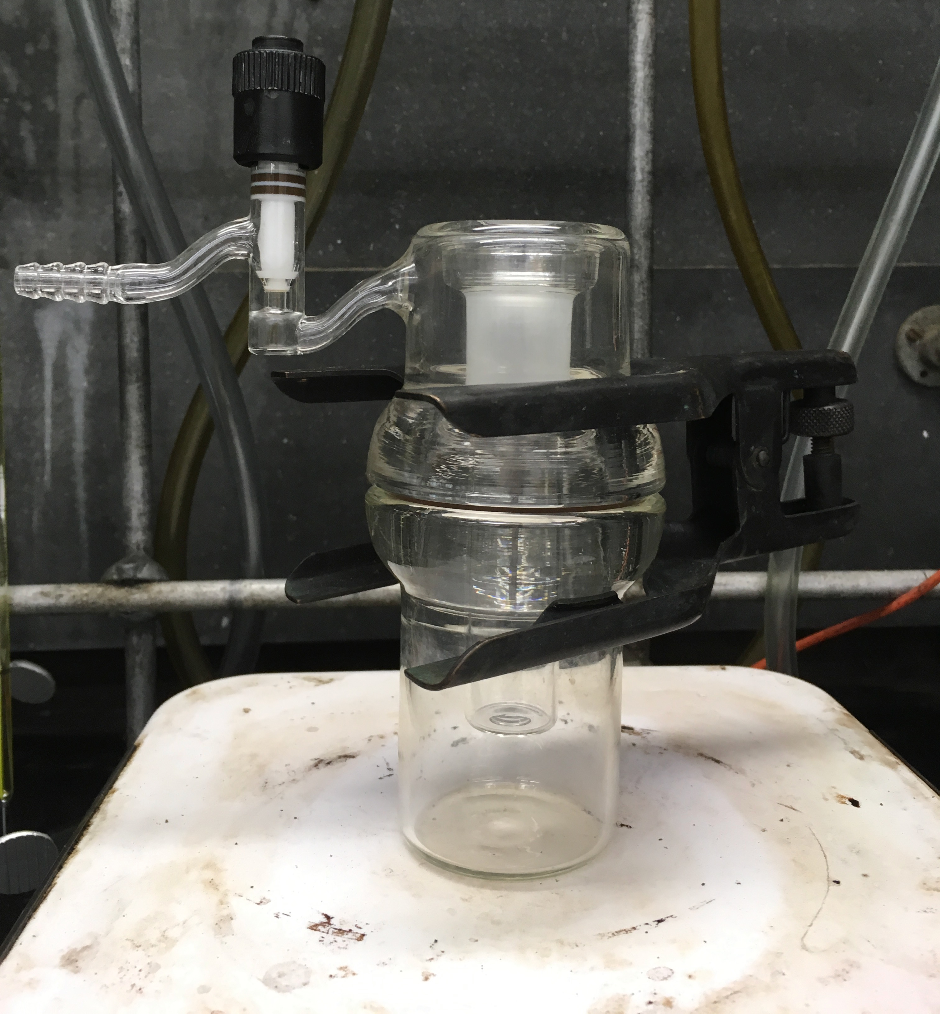
Figure 2. A sublimation chamber designed for low pressure sublimation.

