Title:
Keywords:
Authors:
Corresponding Author:
Short Abstract:
Long Abstract:
Source: Tamara Powers, Department of Chemistry Texas A&amp;M University, College Station, TX

Sublimation, the direct phase transition of a solid into a gas without first becoming a liquid, takes place at temperatures and pressures lower than that of the compound’s triple point (Figure 1). The process of sublimation can be utilized to purify both organic and inorganic solids. During the purification technique, a solid is heated directly into the gas-phase. All non-volatile impurities are left behind while the vaporized compound is then collected (deposition) as a solid on a cold surface. Here, we will use sublimation to purify ferrocene, an inorganic solid with a triple point temperature of 183 &#176;C.

Figure 1. Generic phase diagram. The colored lines represent the pressure and temperature requirements for phase transitions. Distillation of a solid will occur at pressures and temperatures above the triple point. The blue line represents the temperature and pressure conditions where sublimation occurs.

Introduction:
Many inorganic compounds are solids and therefore it is important to understand the methods for purification of solids. Some of the techniques for the purification of solids are similar to those used for the purification of liquids. For example, distillation is a useful purification technique for low-melting solids, which melt before they vaporize. On a phase diagram, note that distillation can be accomplished at pressures that are above the triple point of a compound (Figure 1). After initially melting to yield a liquid (red line, Figure 1), distillation proceeds as it would for any other liquid-phase compound.

Sublimation is related to distillation, but does not involve the intermediate phase transition to the liquid phase. Sublimation only occurs at specific temperatures and pressures that lie below the triple point of a compound in its phase diagram (Figure 1). Sublimation is a purification technique where a solid is heated (sometimes under vacuum) resulting in a phase transition directly from the solid-phase to the gas-phase. Deposition of the vaporized compound on a cold surface results in isolation of the sublimed material. Non-volatile impurities are left behind after the sublimation is complete. Common examples of substances that readily undergo sublimation at atmospheric pressure are ice (at temperatures below 0 &#176;C) and CO₂.

Depending on the volatility of the solid being sublimed, various apparatuses can be used. For highly volatile solids (compounds with a triple point at a high pressure and low temperature), it is possible to make a simple sublimation chamber using a beaker and watch glass. Such an apparatus is appropriate for compounds that sublime at or near atmospheric pressure and ambient temperature. If vacuum and/or inert gas are needed, glassware specifically designed for sublimation (i.e., a sublimation chamber) can be used. The sublimation chamber (Figure 2) allows for sublimation under vacuum or under an inert atmosphere. It is comprised of two glass pieces: the solid is put at the bottom of the main chamber and upon sublimation the purified material is collected on the long cylinder in the center of the chamber called a cold finger, which can be filled with ice-water, dry and ice acetone, or some other cryogen. The base and the cold finger are sealed with an O-ring and secured with a clamp. Upon completion of the sublimation, the chamber can be dissembled (in the air for non-air sensitive compounds or in the glove box for air-sensitive materials) and the purified solid can be scraped off of the cold finger. All non-volatile impurities should remain at the bottom of the sublimation chamber.
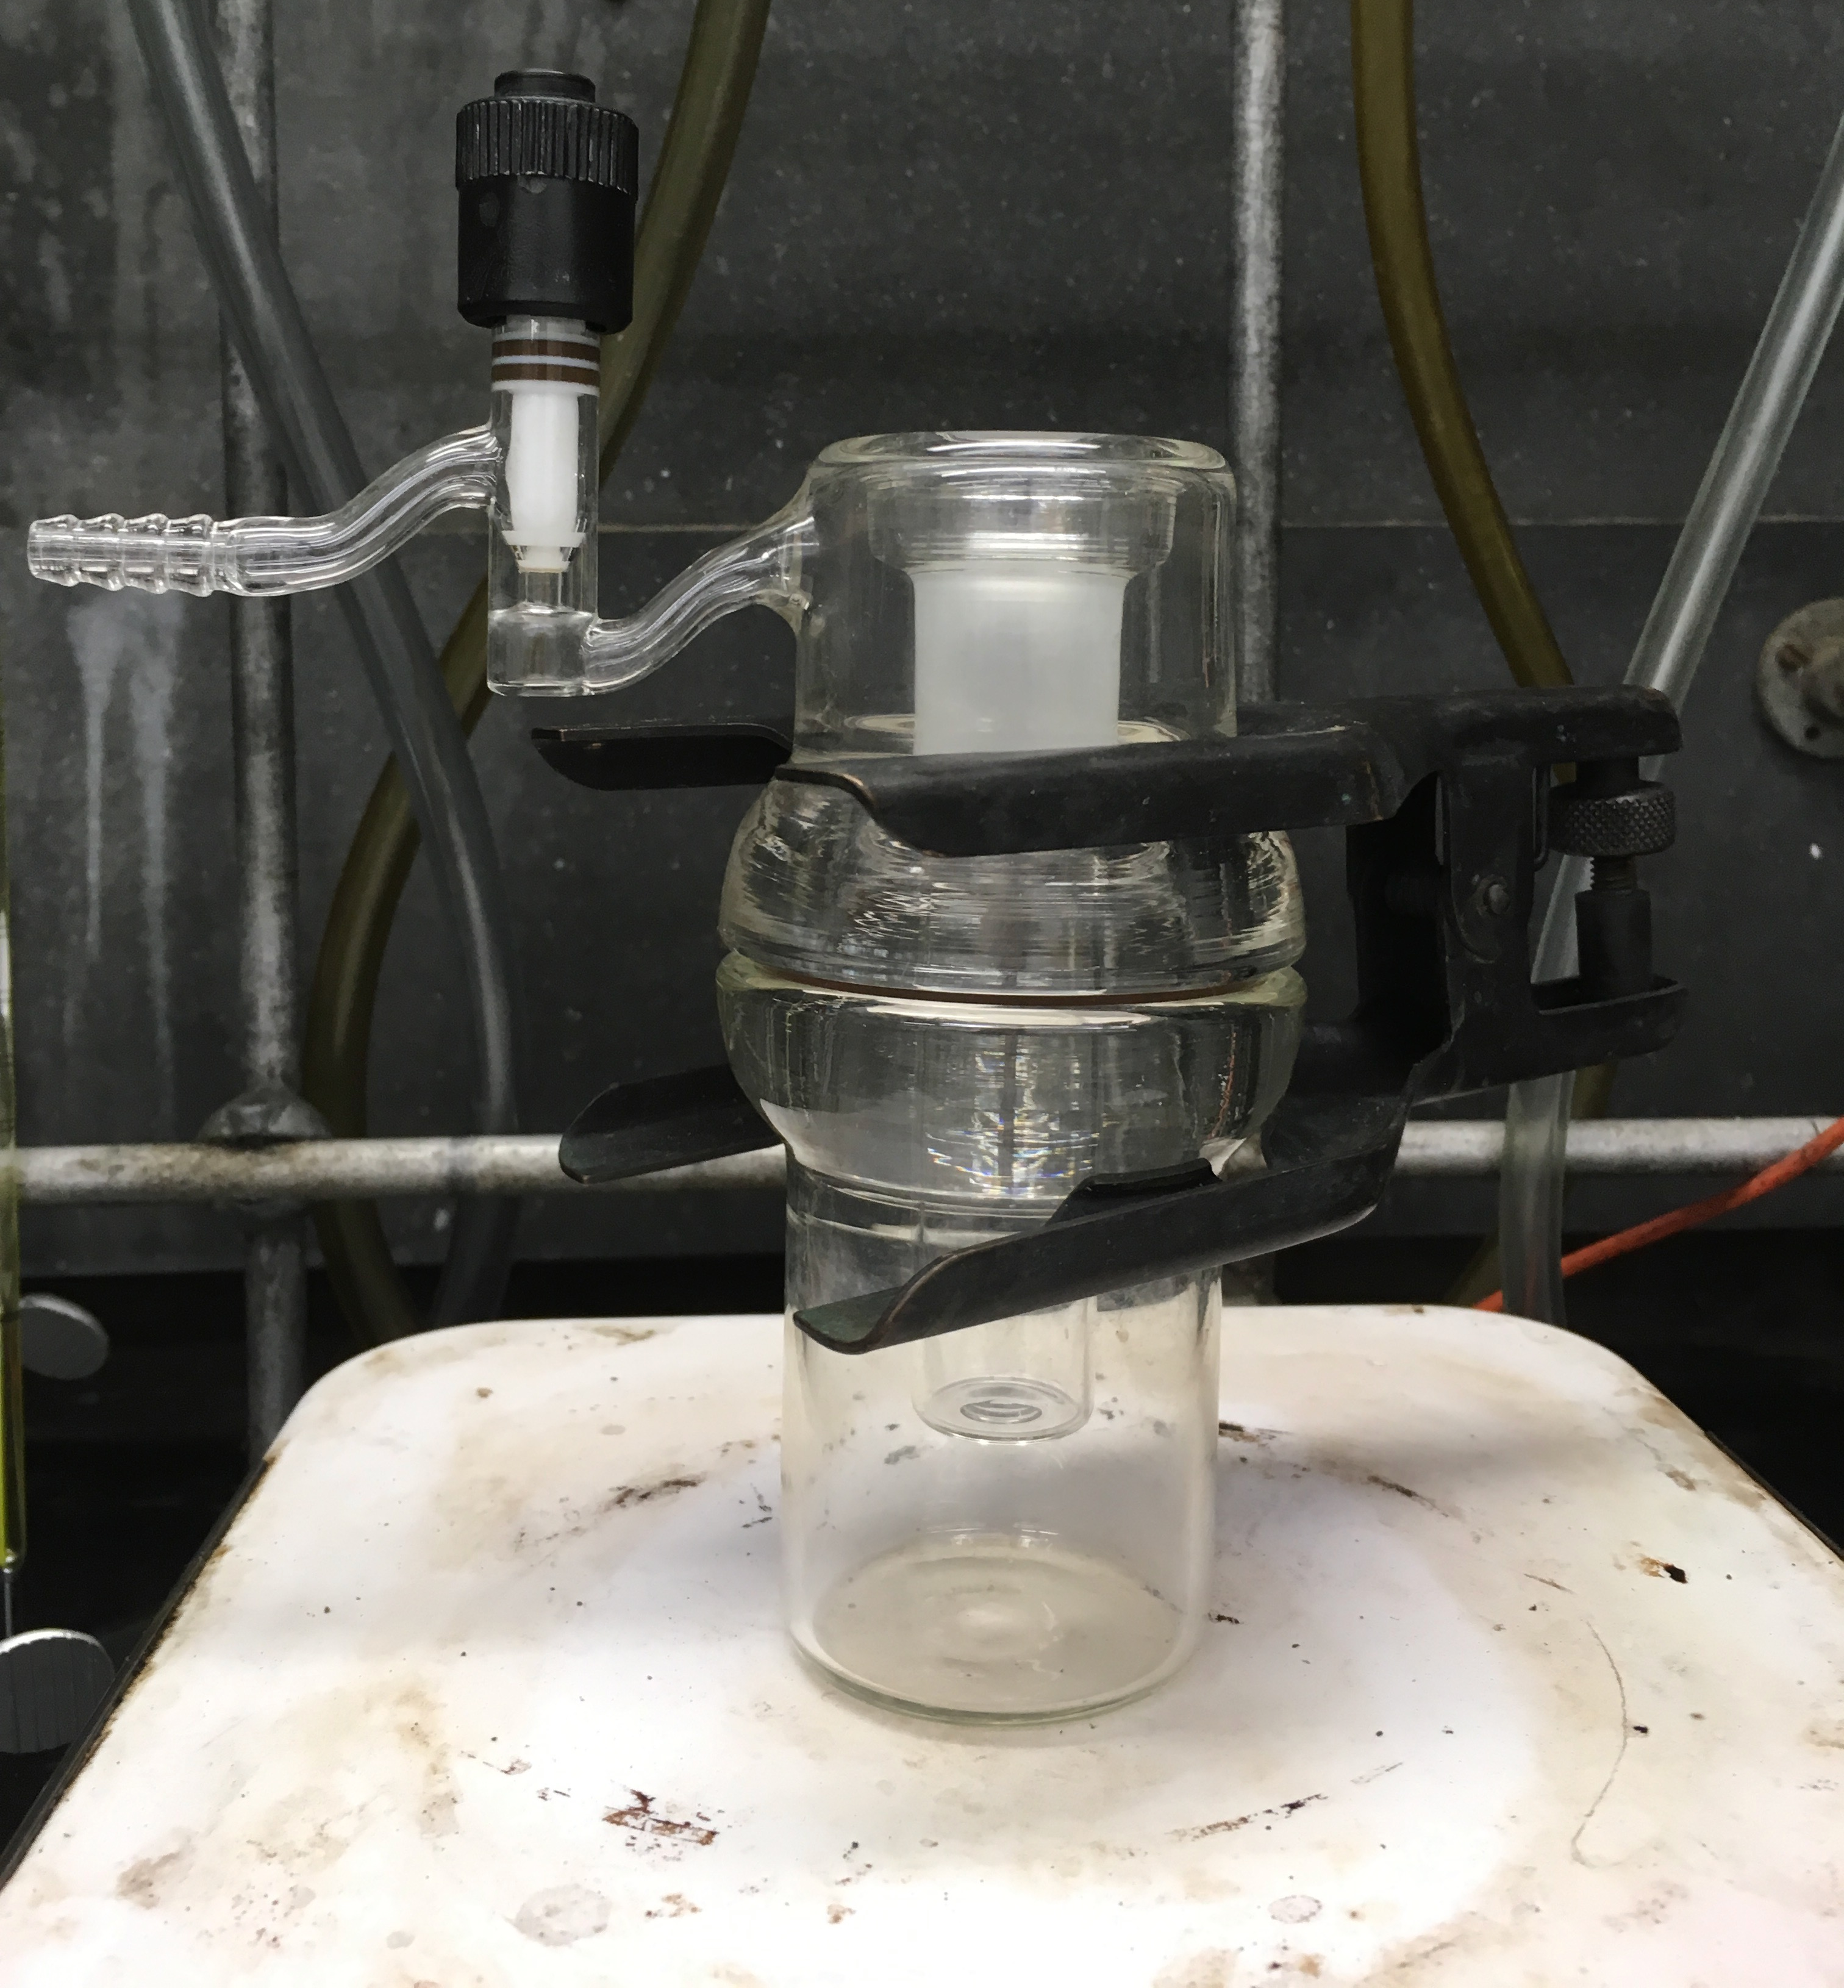
Figure 2. A sublimation chamber designed for low pressure sublimation.

Protocol:
1. Setup of the Schlenk Line

For a more detailed procedure, please review the “Schlenk Lines Transfer of Solvent” and “Degassing Liquids” videos in the Essentials of Organic Chemistry series). Schlenk line safety should be reviewed prior to conducting this experiment. Glassware should be inspected for star cracks before use. Care should be taken to ensure that O₂ is not condensed in the Schlenk line trap if using liquid N₂. At liquid N₂ temperature, O₂ condenses and is explosive in the presence of organic solvents. If it is suspected that O₂ has been condensed or a blue liquid is observed in the cold trap, leave the trap cold under dynamic vacuum. Do NOT remove the liquid N₂ trap or turn off the vacuum pump. Over time the liquid O₂ will sublime into the pump—it is only safe to remove the liquid N₂ trap once all of the O₂ has sublimed.

1.1. Close the pressure release valve.
1.2. Turn on the N₂ gas and the vacuum pump.
1.3. As the Schlenk line vacuum equilibrates, prepare the cold trap with either liquid N₂ or dry ice/acetone.

1.4. Assemble the cold trap.

2. Add 500 mg (2.7 mmol) of ferrocene to the base of the sublimation chamber.
3. Assembly of the Sublimation Chamber
3.1. Place the O-ring in the groove of the chamber base.

3.2. Gently place the cold finger into the chamber base and make sure that the O-ring fits into the groove of the glassware.

3.3. Secure the two pieces of the sublimation chamber using a clamp.
4. Connect the sublimation chamber to the Schlenk line and open the chamber to vacuum for 1 min. Close the vacuum valve on the sublimation chamber. The sublimation will be carried out under static vacuum.

5. Fill the cold finger with an ice bath.

6. Place the base of the sublimation chamber into a water bath heated to 80 &#176;C.
7. After the sublimation is complete, remove the sublimation chamber from the bath.
8. Close the stopcock on the Schlenk line.
9. Remove the Schlenk line tube from the sublimation chamber and repressurize the sublimation chamber by slowly opening the valve. Be careful! If the chamber is repressurized too quickly it will disturb the purified crystals on the cold finger.
10. Unclamp the sublimation chamber and remove the water from the cold finger with a pipette.

11. Carefully lift the cold finger out of the sublimation chamber.
12. Scrape the purified ferrocene from the cold finger and transfer to a vial. Record the weight of the purified product. If the compound being sublimed is air-sensitive, the entire apparatus should be brought into an inert-atmosphere glove box prior to opening the sublimation chamber.

Representative Results:
Ferrocene (99%) was purchased from Alfa Aesar. Sublimation of 500 mg as described resulted in 493 mg isolated product. The purified ferrocene was analyzed by ¹H NMR.

¹H NMR (chloroform-d, 300 MHz, δ, ppm): 4.15 (s).

Discussion:
Sublimation is a technique used in the purification of solids. Solids that sublime at low pressure and temperature are good candidates for purification by sublimation. Here, we have demonstrated how to use a sublimation chamber to sublime ferrocene under static vacuum at 80 &#176;C.

In a laboratory setting, sublimation is a useful technique that can be applied to the purification of solids in a variety of situations including in the purification of starting materials or synthesized products. In this example, the purified solid is collected on the cold finger, while the impurities are left at the bottom of the sublimation chamber. However, one may want to remove a solid impurity that can be sublimed from a non-volatile solid. In this case, the desired material remains at the bottom of the sublimation chamber.

Sublimation is also used in freeze-drying, called lyophilization. Lyophilization is a process to dry materials used in both pharmaceutical and food industries, as well as in research laboratories. In the lyophilization process, a material is first frozen, followed by reduction of the surrounding pressure, which allows the water (or other solvent) to be removed by sublimation.

Disclosures:
Acknowledgements:
References:

Kaplan, L., Kester, W. L., Katz, J. J. Some properties of iron biscyclopentadienyl. J Am Chem Soc. 74, 5531-5532 (1952).

