Figure 1. Synthesis of Ti(III) metallocene compound (3) and it’s reaction with O₂.
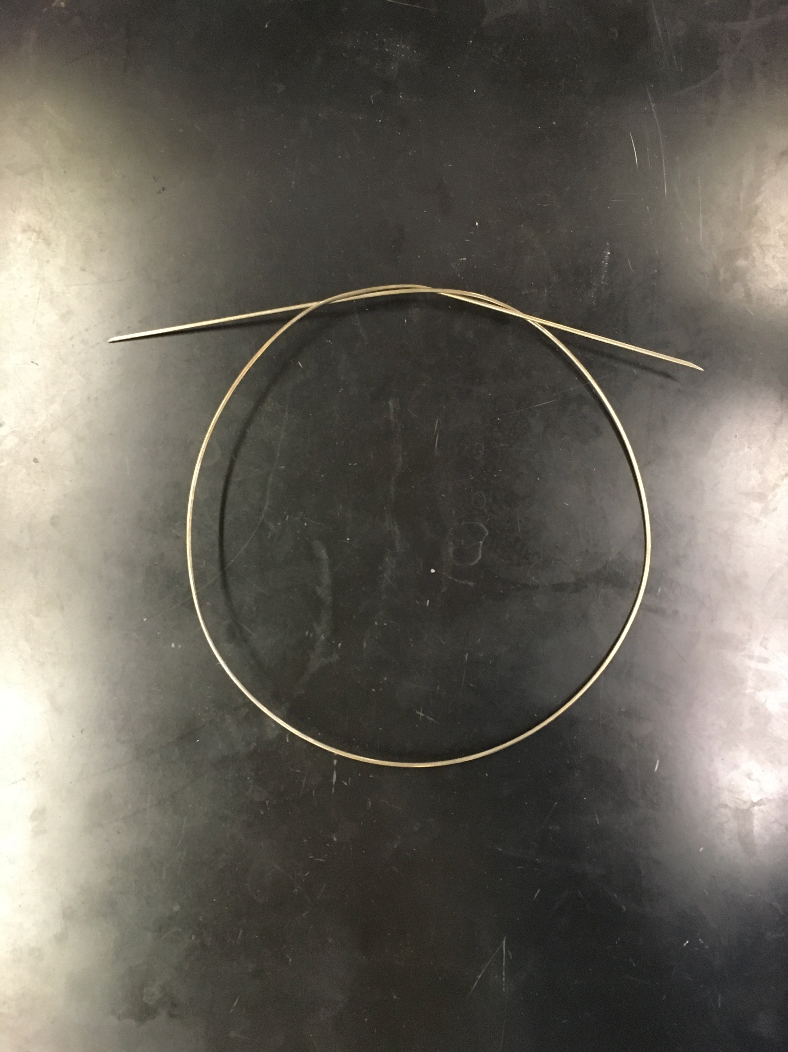
Figure 2. Cannula
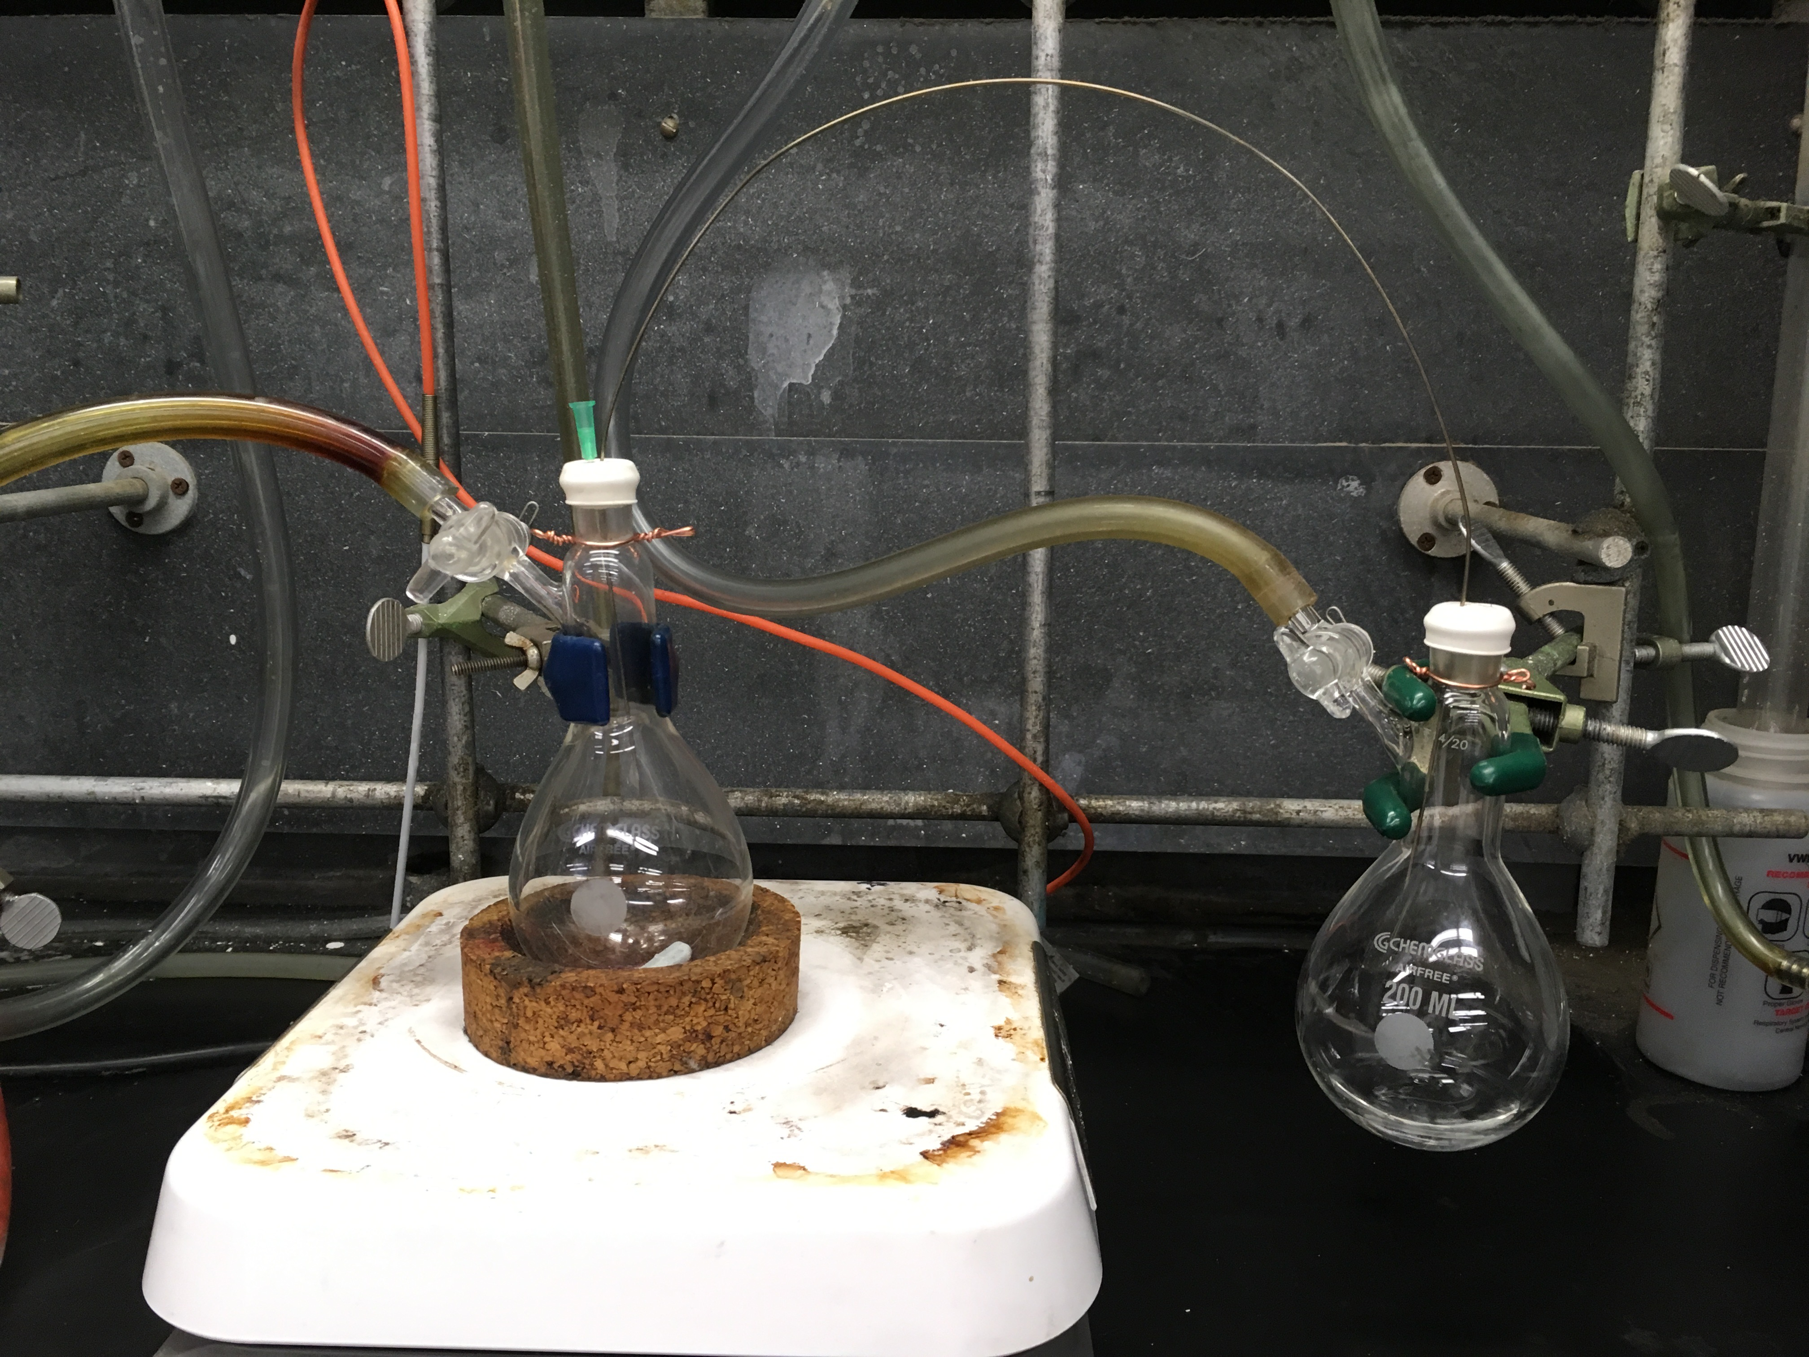
Figure 3. Basics of cannula transfer. Schlenk flask A (the receiving flask, left) contains the solid reactants and Schlenk flask B (the donor flask, right) contains the degassed acetonitrile.
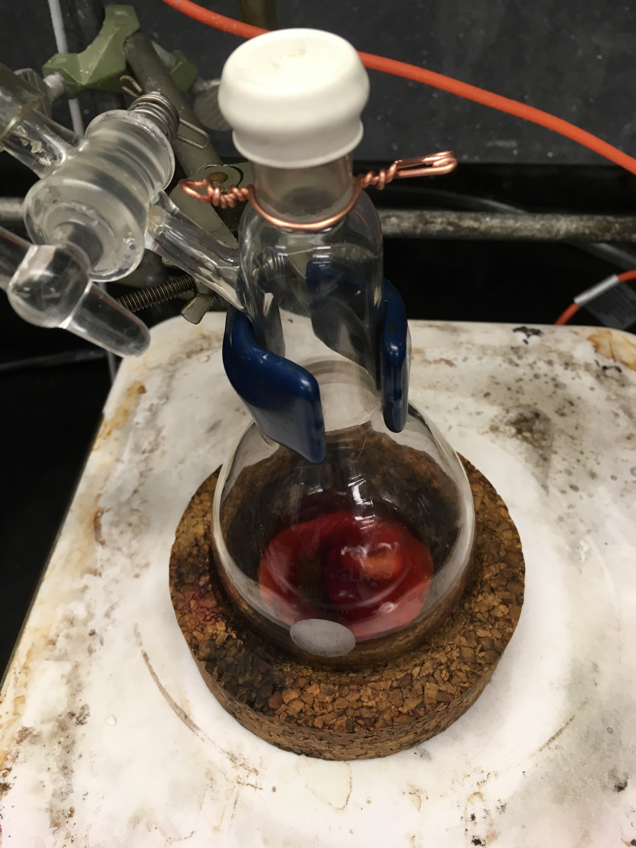
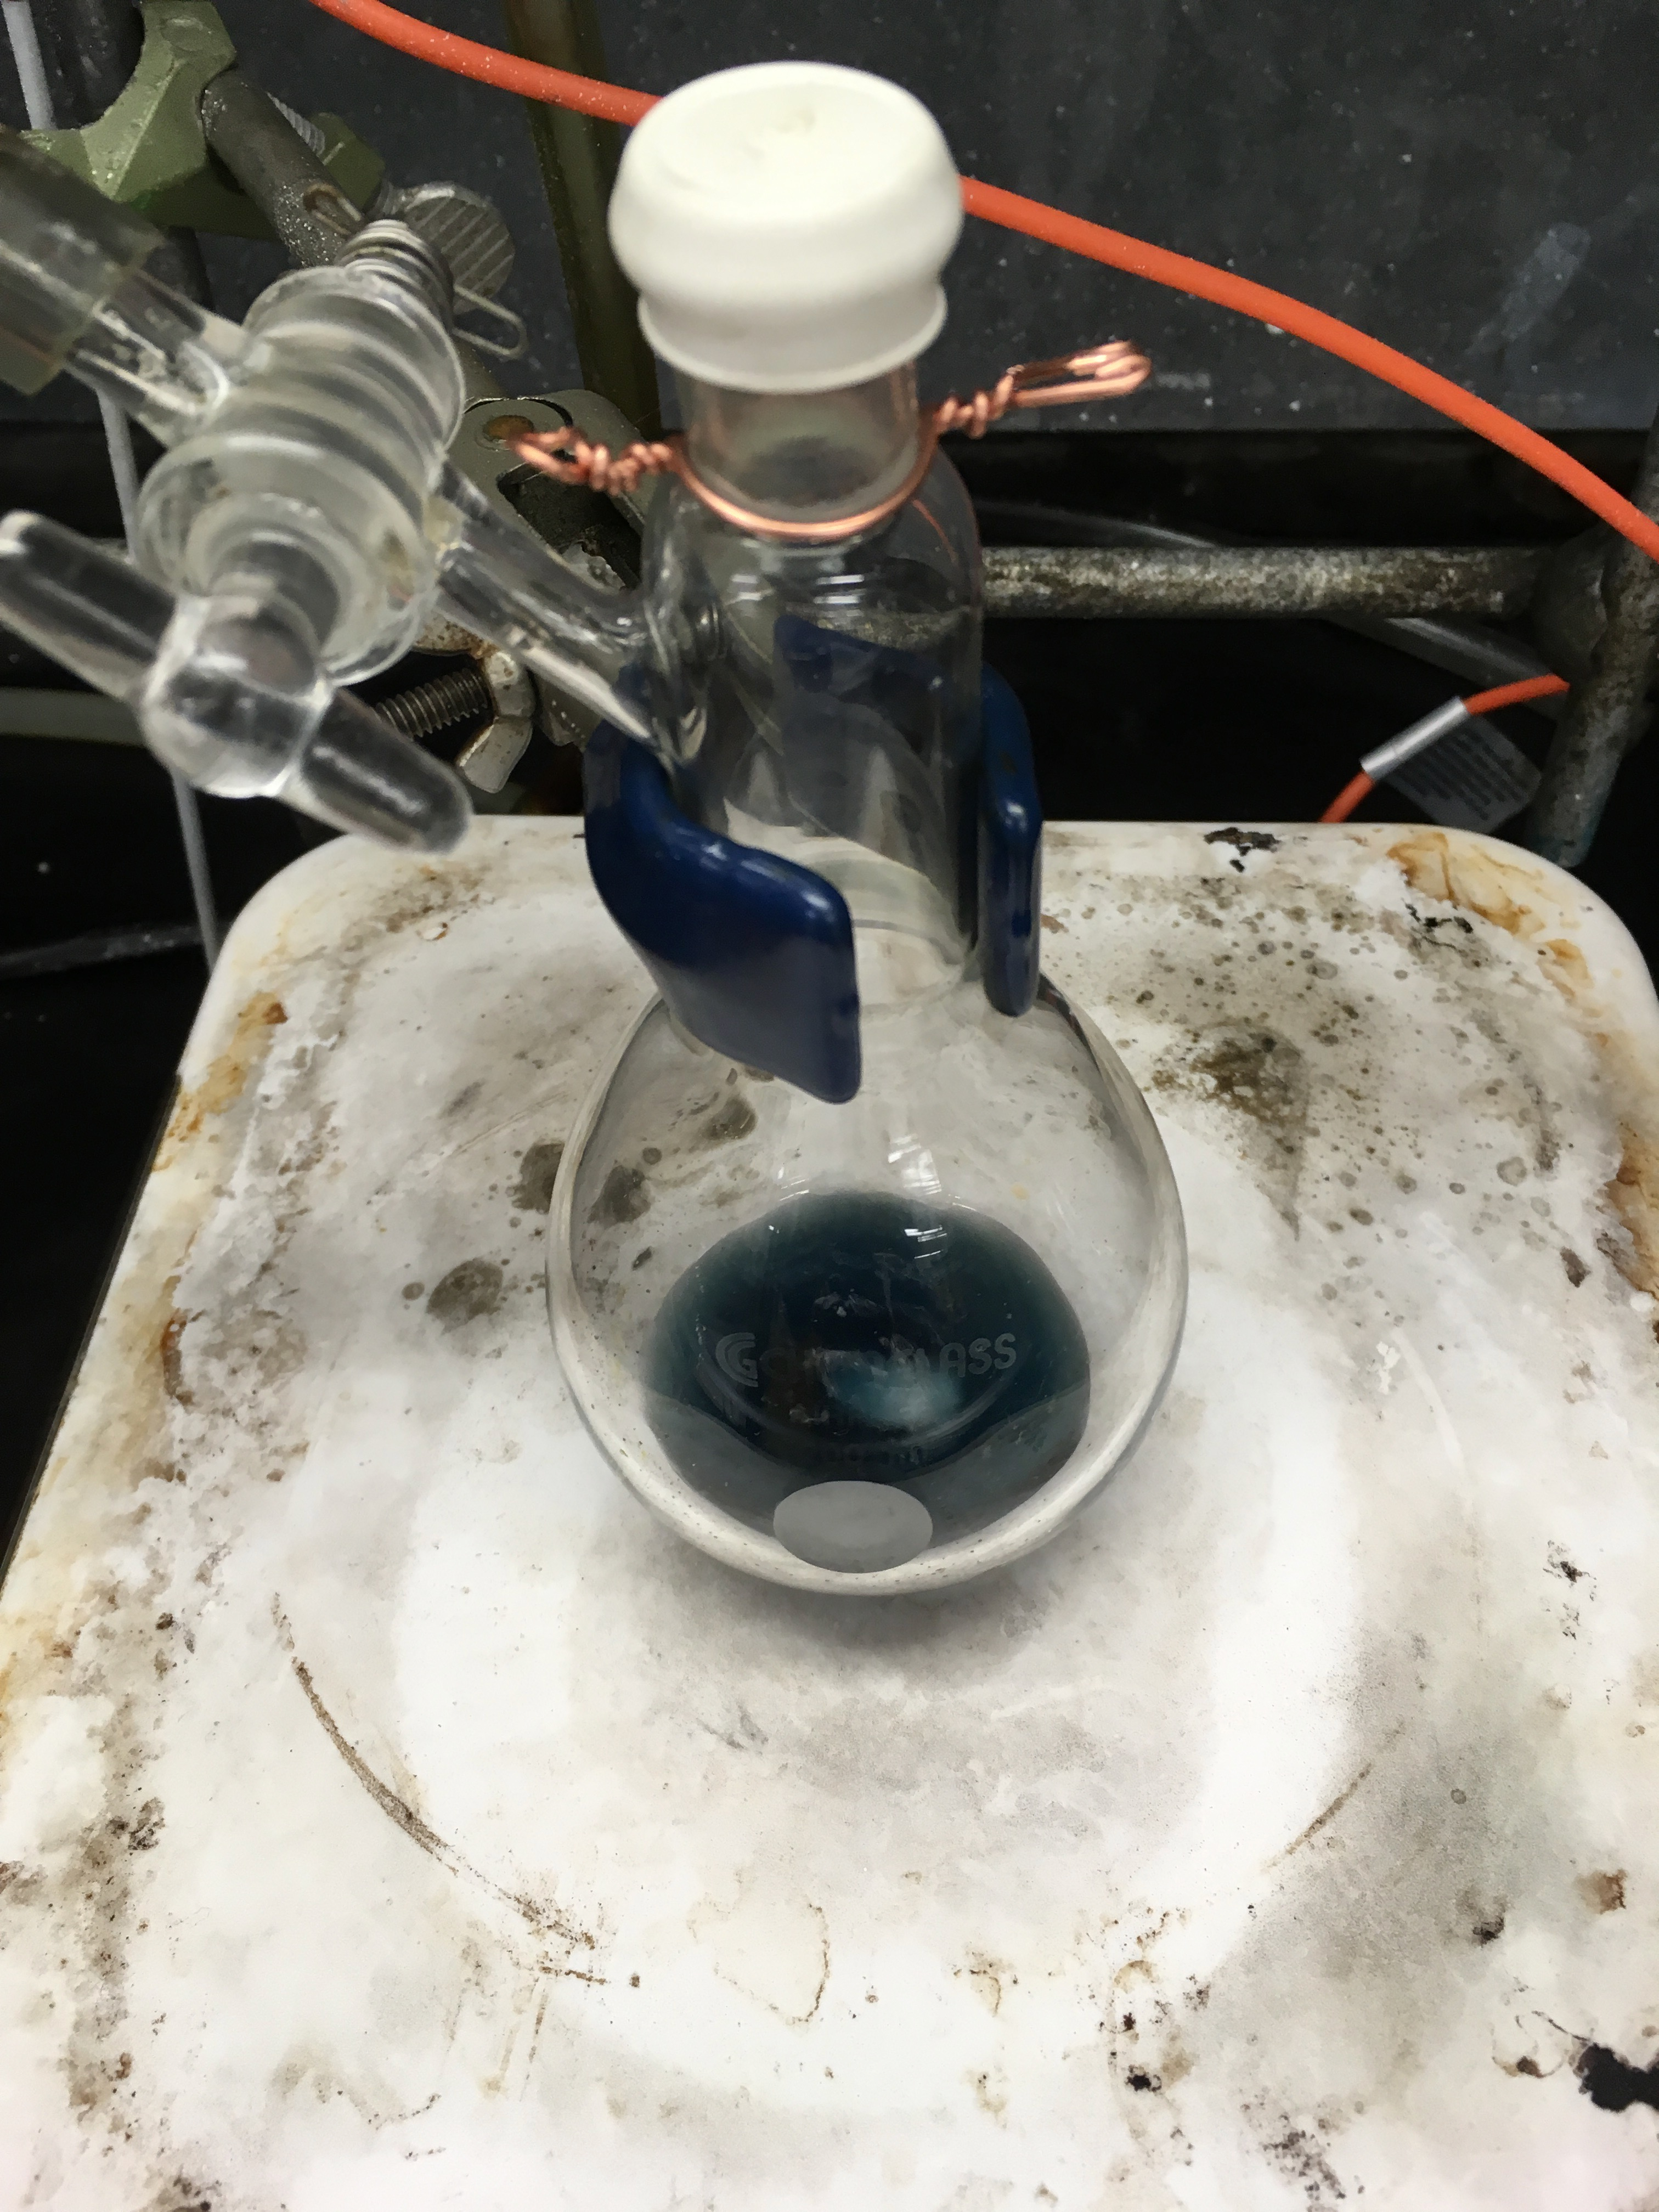
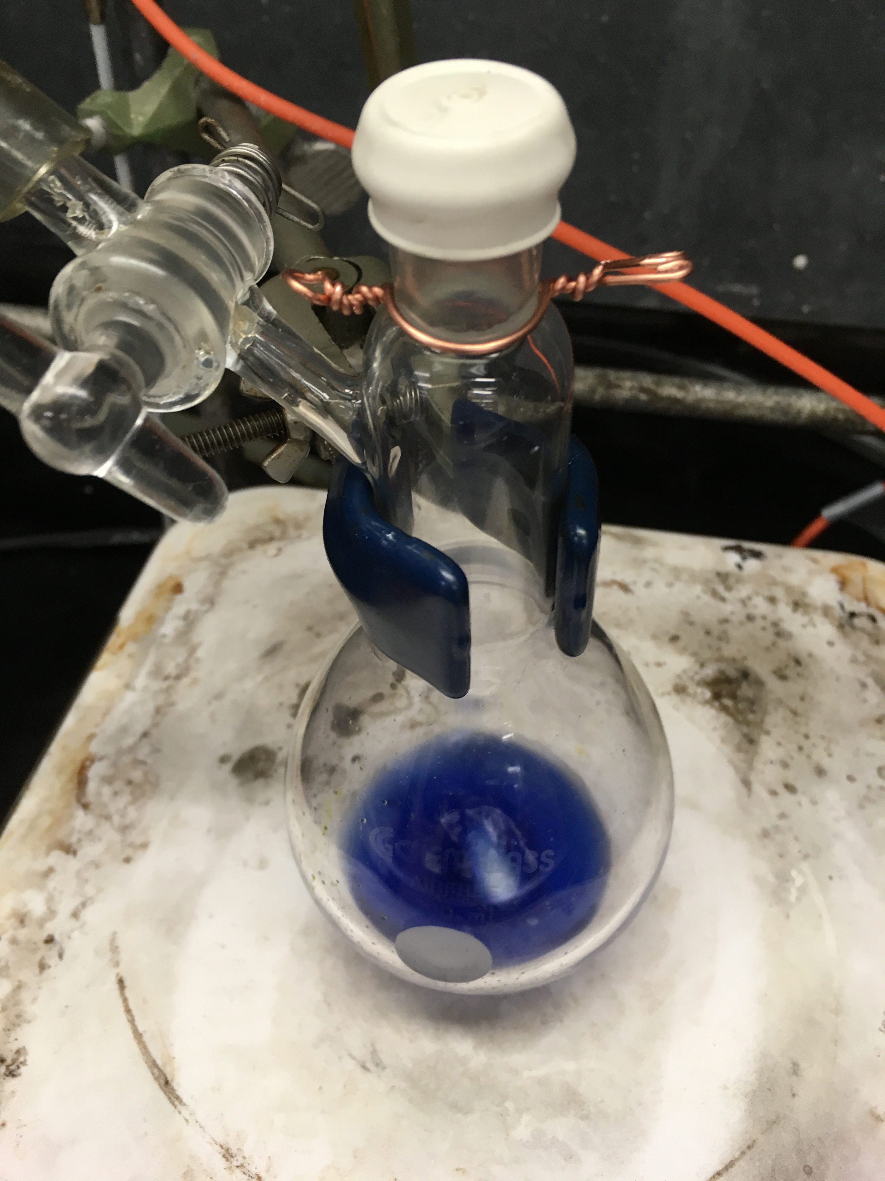
Figure 4. Three color stages during the synthesis of Ti(III) metallocene compound (3).

