Overview

Source: Tamara Powers, Department of Chemistry Texas A&M University, College Station, TX

Inorganic chemists often work with highly air- and water-sensitive compounds. The two most common and practical methods for air-free synthesis utilize either Schlenk lines or glove boxes. This experiment will demonstrate how to perform simple manipulations on a Schlenk line with a focus on solvent preparation and transfer. Through the synthesis of a reactive Ti(III) metallocene complex, we will demonstrate a new, simple method to degas solvent as well as how to transfer solvent by cannula and by syringe on a Schlenk line.

The synthesis of a Ti(III) metallocene compound 3 is shown in Figure 1. Compound 3 is highly reactive with O₂, (see oxidation of compound 3 to Ti(IV) metallocene 4 shown in Figure 1). Therefore, it is important to run the synthesis under anaerobic conditions. The synthesis of target compound 3 can be monitored visually and progresses through one additional color change before arriving at the desired product, which is blue in color. If during the experiment there is an observed color change from blue to yellow (or green = blue + yellow), this is an indication that O₂ entered the flask and that undesired oxidation of compound 3 to the Ti(IV) analog (compound 4) has occurred.

Figure 1. Synthesis of Ti(III) metallocene compound 3 and it’s reaction with O₂.

Principles

Schlenk line technique uses positive pressure of inert gases to keep air out of a system when handling air- and water-sensitive reagents. An introduction to Schlenk line technique can be found in the “Schlenk Lines Transfer of Solvent” video in the Essentials of Organic Chemistry series. In this module, two experimental techniques using the Schlenk line will be explored: solvent degassing and air-free solvent transfer.

Anaerobic synthesis requires removal of air that is dissolved in reaction solvents (i.e., degassing the solvent). The solubility of a gas in a liquid is dependent on the identity of the gas and the solvent, as well as the temperature of the system and the partial pressure of the gas above the liquid. Henry’s law states that at a given temperature, the amount of gas dissolved in a specific volume of liquid is directly proportional to the partial pressure of that gas in the system. To degas a solvent, the air above the liquid is removed or replaced with an inert gas, such as N₂ or Ar. By reducing or removing the pressure of air above the liquid, the amount of air dissolved in that liquid decreases. The process of degassing ultimately results in the removal of all of the air dissolved in the solvent.

There are several methods that can be used to degas solvent, including freeze-pump-thaw and bubbling inert gas through the solvent (purging). While the freeze-pump-thaw method is the more rigorous of the two methods for removing dissolved O₂ (see the “Degassing Liquids” video in the Essentials of Organic Chemistry series), purging is useful when using smaller volumes of liquid and when the reactants and/or products are not water sensitive. Here we demonstrate how to degas solvent by purging. It is important to remember that degassing solvent does not remove water.

The most common methods to add solvent to a reaction using a Schlenk line include transfer by syringe or by cannula (a long double pointed needle, Figure 2). Syringes are used when a specific volume of liquid needs to be added to the reaction (i.e., adding a liquid reagent). Cannula transfers can be used to transfer an exact volume into a dropping funnel, or an approximate volume if transferring solvent to the reaction. Cannula transfer relies on a pressure difference between two flasks to transfer solvent from one vessel (donor flask) to another (receiving flask) (Figure 3), and the pressure differential can be achieved by either application of vacuum or pressure. Vacuum-based cannula transfer is conducted by putting the receiving flask under static or dynamic vacuum, while the donor flask is connected to positive N₂ pressure. In pressure-based cannula transfer, the receiving flask is vented while positive N₂ pressure is fed into the donor flask. In both cases, the lower pressure in the receiving flask results in solvent flowing through the cannula from the donor flask to the receiving flask. Here we demonstrate how to use the pressure method for cannula transfer.

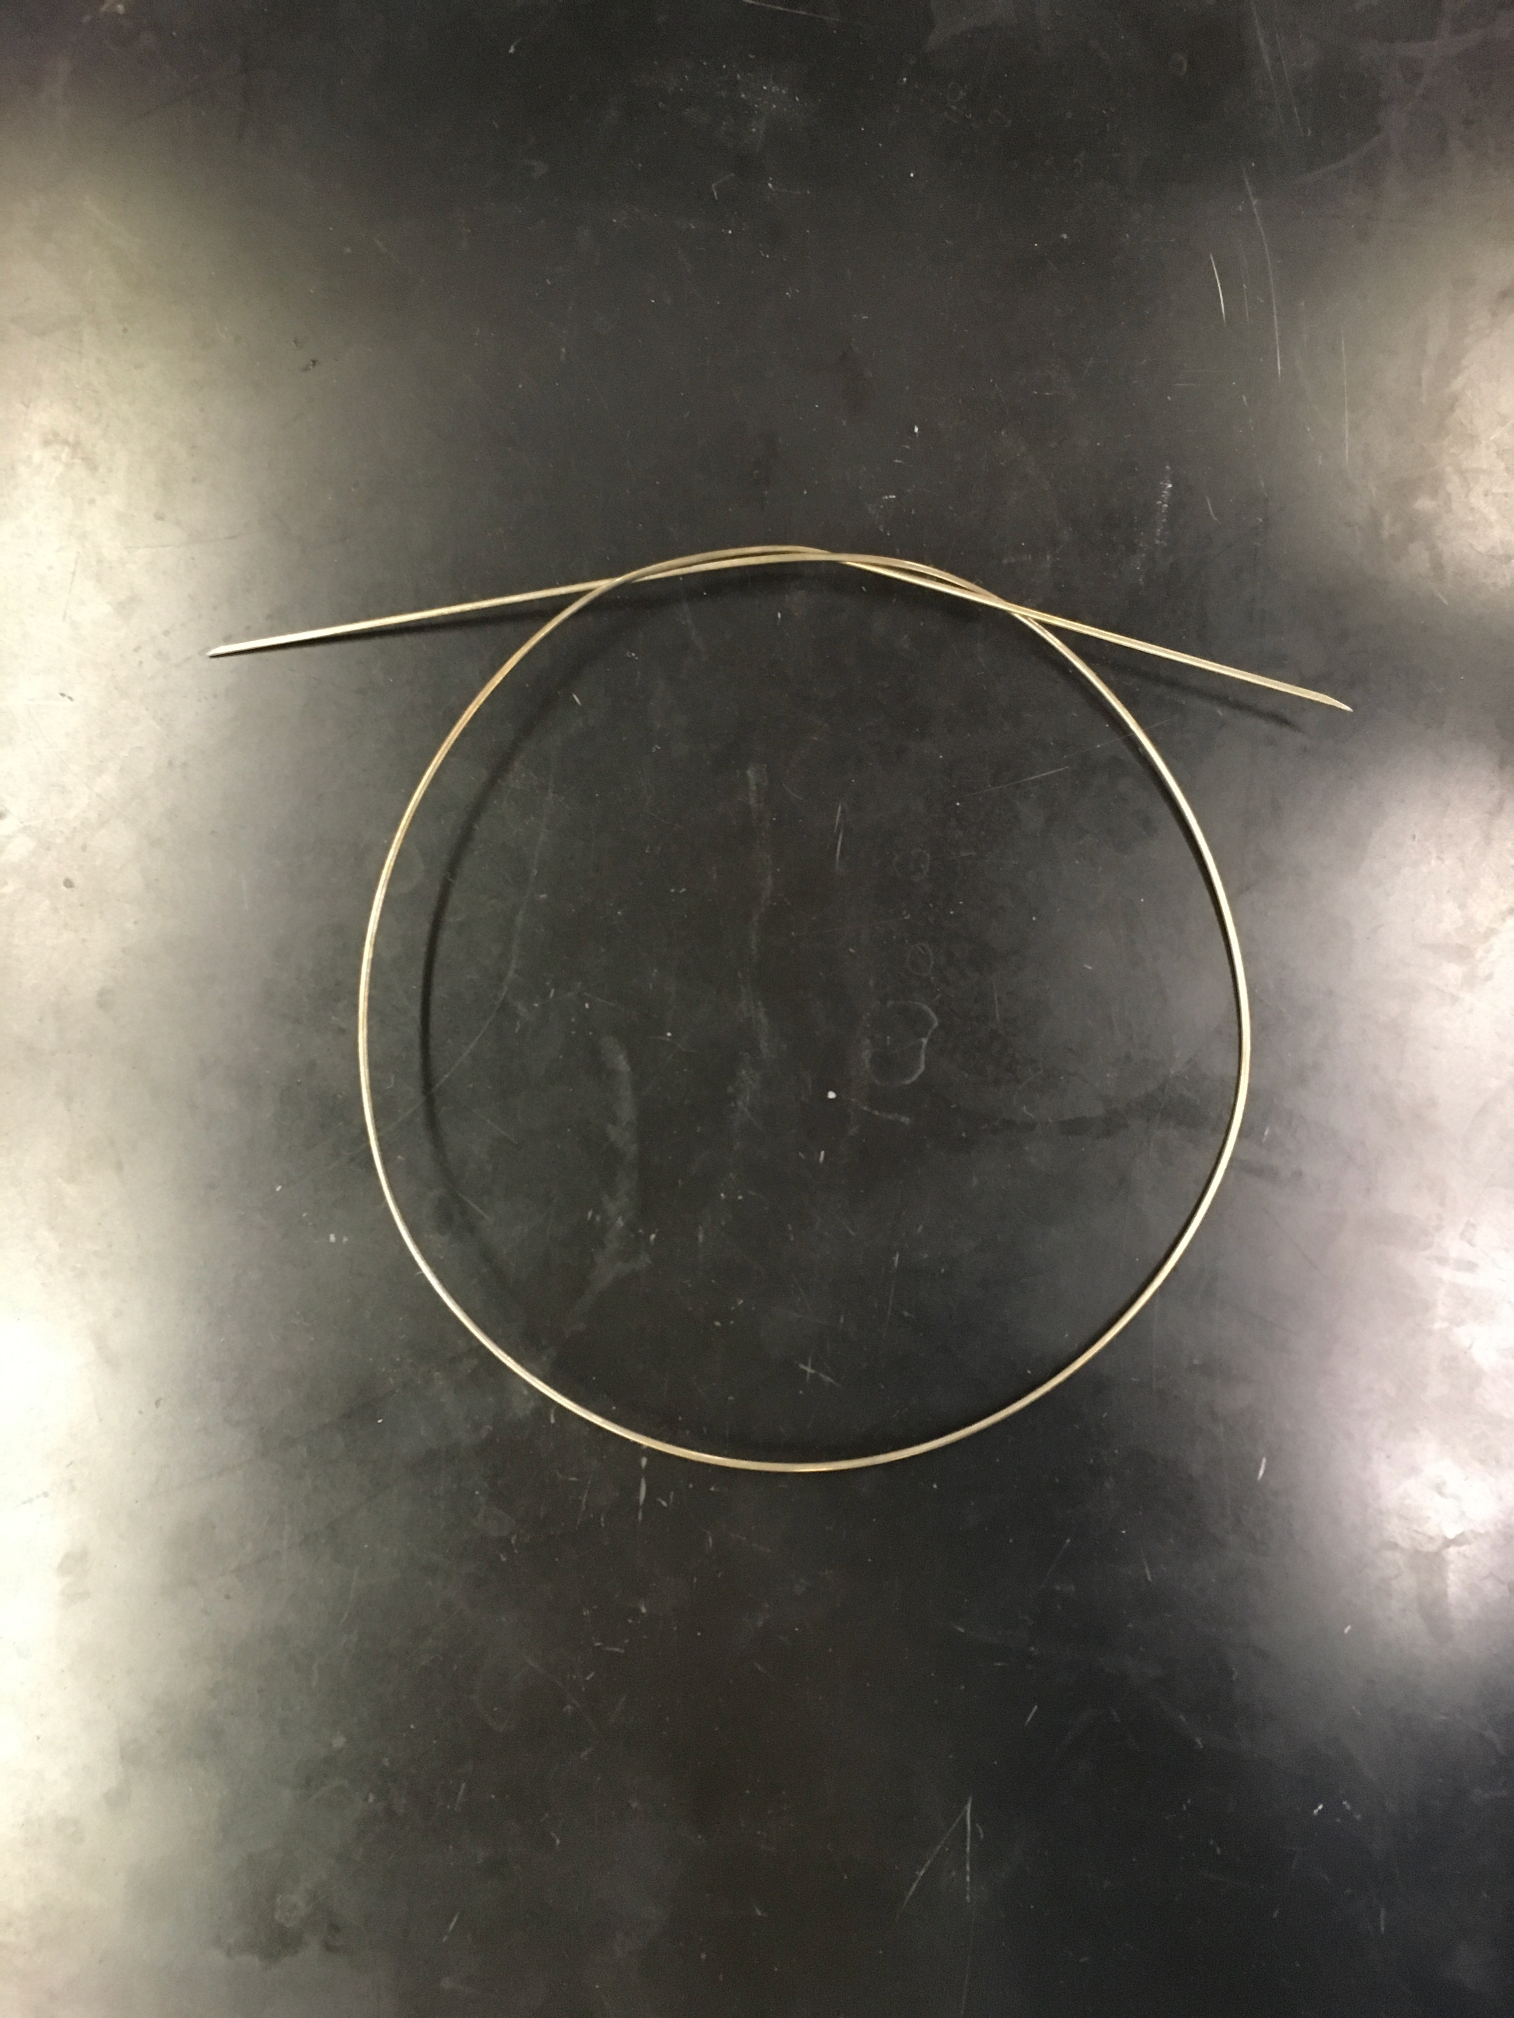
Figure 2. Cannula.

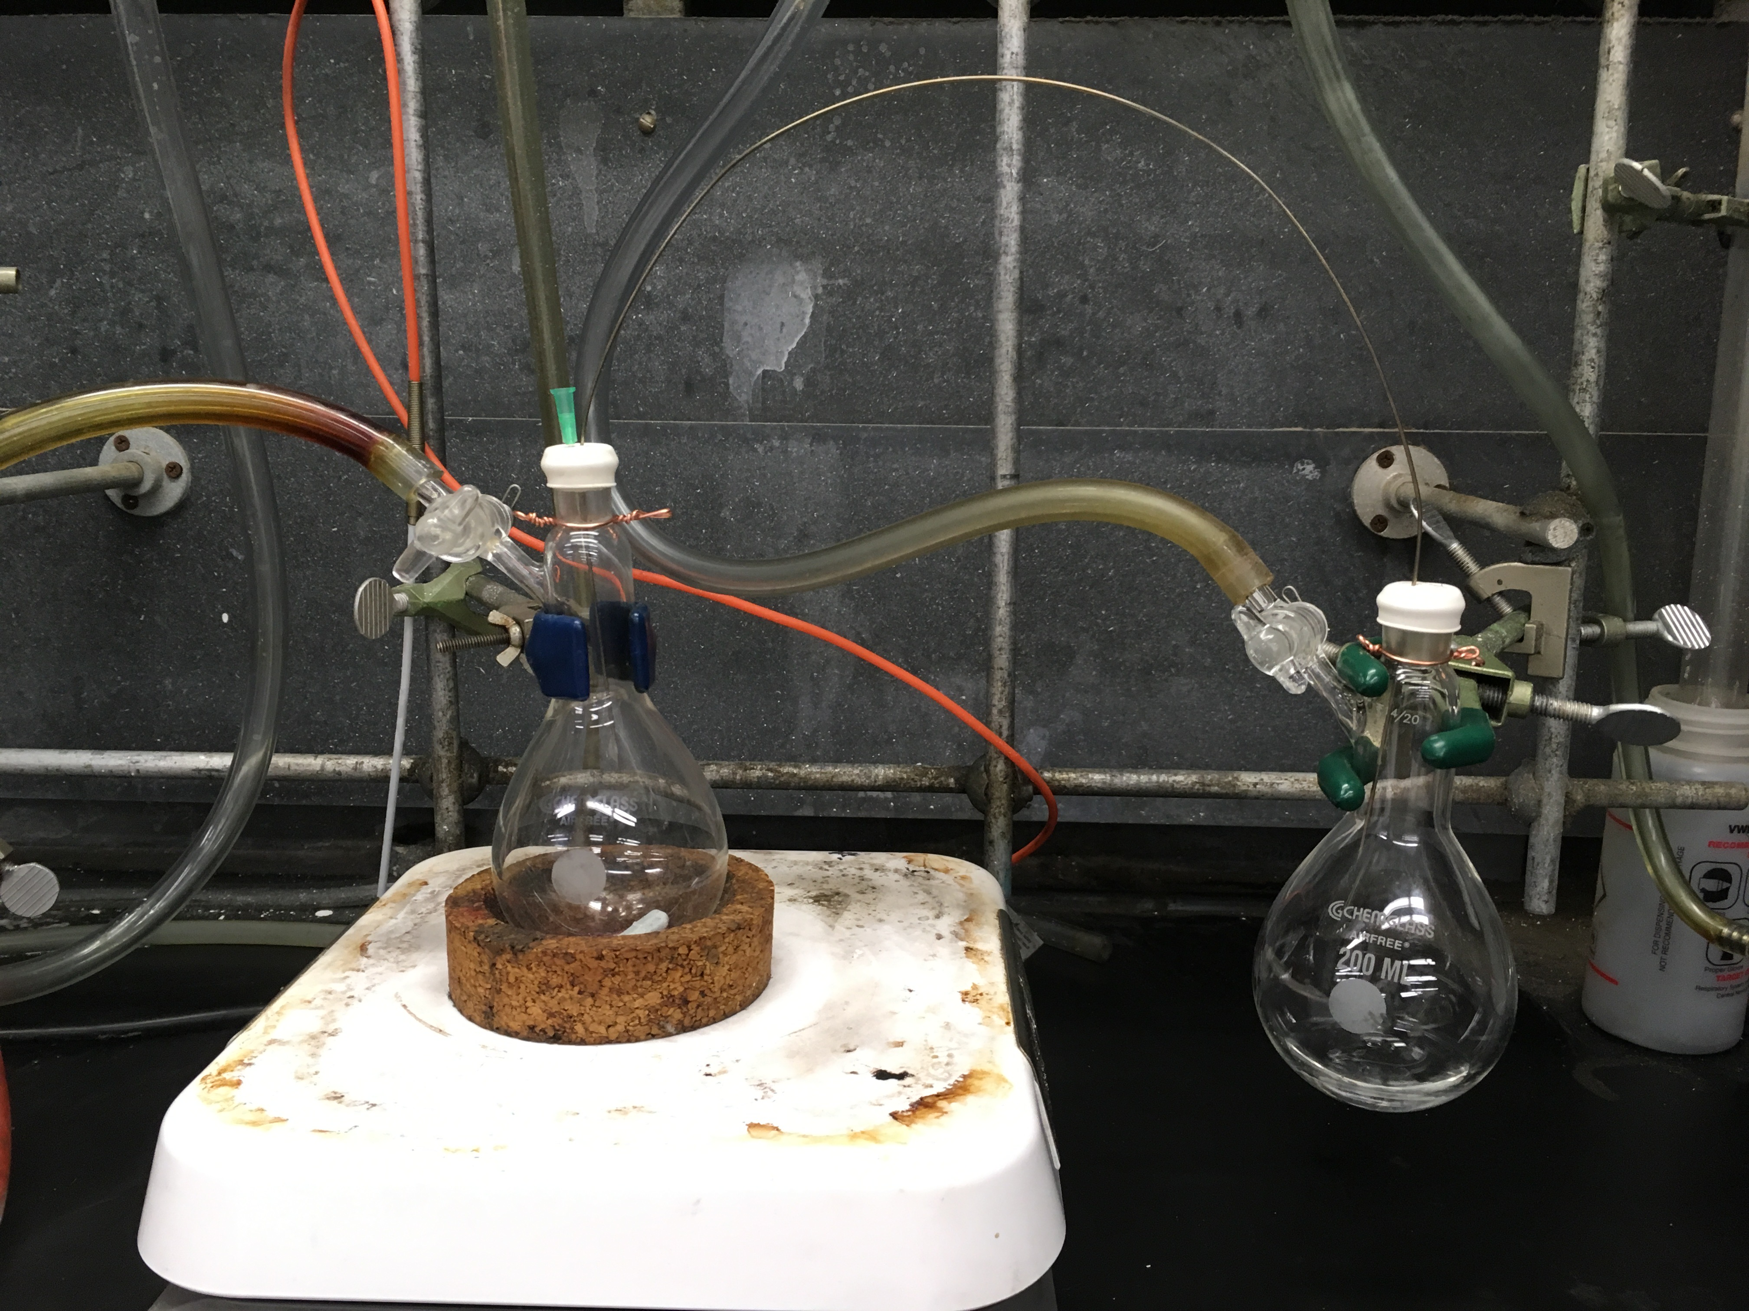
Figure 3. Basics of cannula transfer. Schlenk flask A (the receiving flask, left) contains the solid reactants and Schlenk flask B (the donor flask, right) contains the degassed acetonitrile.

Procedure

- Setup of the Schlenk Line

For a more detailed procedure, please review the “Schlenk Lines Transfer of Solvent” video in the Essentials of Organic Chemistry series. Schlenk line safety should be reviewed prior to conducting this experiment. Glassware should be inspected for star cracks before use. Care should be taken to ensure that O₂ is not condensed in the Schlenk line trap if using liquid N₂. At liquid N₂ temperature, O₂ condenses and is explosive in the presence of organic solvents. If it is suspected that O₂ has been condensed or a blue liquid is observed in the cold trap, leave the trap cold under dynamic vacuum. Do NOT remove the liquid N₂ trap or turn off the vacuum pump. Over time the liquid O₂ will sublime into the pump—it is only safe to remove the liquid N₂ trap once all of the O₂ has sublimed.

  - Close the pressure release valve.

  - Turn on the N₂ gas and the vacuum pump.

  - As the Schlenk line vacuum reaches its minimum pressure, prepare the cold trap with either liquid N₂ or dry ice/acetone.

  - Assemble the cold trap.

- Preparation of the Solid Reactants

  - Weigh 100 mg (0.40 mmol) of solid dicyclopentadienyltitanium(IV) dichloride (compound 1, Figure 1) and 78 mg (1.2 mmol) zinc dust into a Schlenk flask (Schlenk flask A).

  - Fit Schlenk flask A with a greased glass stopper and attach the Schlenk flask side arm to the Schlenk line with Tygon tubing.

  - Open the stopcock of the Schlenk line tube attached to Schlenk flask A to vacuum. Slowly open the stopcock on Schlenk flask A. Evacuate Schlenk flask A for 5 min.

  - Repressurize Schlenk flask A with N₂ by first closing the stopcock on the Schlenk flask. Slowly repressurize the Schlenk line tubing with N₂ by turning the Schlenk line stopcock to N₂. Make several (at least 5) quick 180 ° turns on the Schlenk flask stopcock, making sure the stopcock is closed after each turn. Slowly open the stopcock to finish filling Schlenk flask A with N₂.

  - Close the Schlenk flask A stopcock.

  - Repeat steps 2.3–2.5 two more times. On the last cycle, leave the stopcock to the Schlenk flask A open.

- Preparation of the Solvent

Note: Since the reaction is not water sensitive, glassware and solvents do not need to be dried. However, if the preparation is for use in the glove box, all glassware and solvents should be appropriately dried.

  - Measure 15 mL of acetonitrile and transfer the solvent to a new Schlenk flask (Schlenk flask B). Fit Schlenk flask B with a septum.

  - Connect Schlenk flask B to the Schlenk line using Tygon tubing. Evacuate the tubing for 5 min and refill the tubing with N₂ (the stopcock to the Schlenk flask should remain closed). Repeat the evacuation/refill cycles two more times. Leave the tubing under N₂.

  - Purge one of the unused Tygon tubes on the Schlenk line with N₂, fitted with a long needle.

  - Insert the needle into the septum of Schlenk flask B and lower the needle into the acetonitrile.

  - Insert a second needle (not attached to the Schlenk line) into the septum of Schlenk flask B. This is the vent needle. Upon insertion of the vent needle, N₂ should start bubbling through the acetonitrile.

  - Allow the acetonitrile to degas for 15 min.

  - Open the stopcock to Schlenk flask B.

  - Remove the vent needle, followed by the needle connected to the Schlenk line. Close the stopcock on the Schlenk line that is connected to the long needle.

- Addition of Solvent via Cannula (Figure 3)

  - Make sure that the stopcocks to both of the Schlenk flasks (A & B) are open to N₂.

  - Replace the glass stopper on Schlenk flask A with a rubber septum.

  - Insert one end of the cannula through the septum on Schlenk flask B (the donor flask). Do NOT put the needle into the acetonitrile.

  - Ensure N₂ is flowing through the cannula by putting the opposite end of the cannula close to the skin of the arm.

  - Insert the other end of the cannula into Schlenk flask A (the receiving flask).

  - Close the stopcock to Schlenk flask A.

  - Lower the cannula in Schlenk flask B so that the tip reaches the bottom of the acetonitrile.

  - Insert a vent needle in the septum of Schlenk flask A. Solvent should begin to flow. If no solvent is flowing, try increasing the N₂ flow or raising the solvent flask above the height of the receiving flask.

  - Transfer all 15 mL of the acetonitrile from Schlenk flask B to A. If only a portion of the solvent is desired, simply remove the cannula tip from the solvent in Schlenk flask B to stop the flow of liquid.

  - Remove the vent needle from the septum and open the stopcock to Schlenk flask A.

  - Remove the cannula from Schlenk flask A.

  - Remove the cannula from Schlenk flask B.

- Synthesis of Ti(III) Metallocene (Compound 3)

  - Vigorously stir the solution for 15 min (or until the reaction mixture turns blue).

  - If a green color persists, add more zinc dust (1–2 additional equivalents). To add more zinc dust to the system without introducing O₂, make sure that the Schlenk flask stopcock is open to positive N₂ pressure. Remove the rubber septum and add the solid to the flask. Re-attach the rubber septum. If the addition of excess zinc dust does not effect the desired color change to blue, O₂ was likely introduced into the system.

- Addition of Solvent via Syringe

  - Degas 10 mL of acetonitrile as described in step 3 in Schlenk flask B.

  - Make sure that both Schlenk flask A & B stopcocks are open to N₂ and are fitted with rubber septa.

  - Insert the syringe needle into either flask and pull N₂ gas into the syringe.

  - Remove the needle and eject the N₂ into the hood.

  - Repeat steps 6.3–6.4 two more times.

  - Insert the syringe needle fitted to a 10 mL syringe into Schlenk flask B and pull up the desired volume of solvent (5 mL).

  - Remove the needle from the solvent but leave the needle in the Schlenk flask. Bend the needle so that the syringe is pointing up (the needle should form an arch) and pull ~1 mL of N₂ gas into the needle. There should be a gas “bubble” at the top of the syringe.

  - While keeping the needle arched, remove the needle from Schlenk flask B. The syringe should still be pointed up with the bubble of N₂ at the tip of the syringe where the needle is attached. The N₂ bubble will prevent acetonitrile from leaking out of the syringe.

  - With the needle still arched and the syringe pointing up, insert the needle into the septum of Schlenk flask A.

  - Slowly add acetonitrile to Schlenk flask A. At this point, the position of the syringe is irrelevant.

  - When solvent addition is complete, remove the syringe needle from Schlenk flask A.

Results

Upon addition of the acetonitrile in step 4, the solution should change color from orange, to green, to blue (Figure 4). Failure to obtain the blue color indicates a leak in the system. Addition of acetonitrile by syringe in step 6 should result in no color change if anaerobic conditions are maintained. If oxygen is present, the solution will turn from blue, to green, to orange.

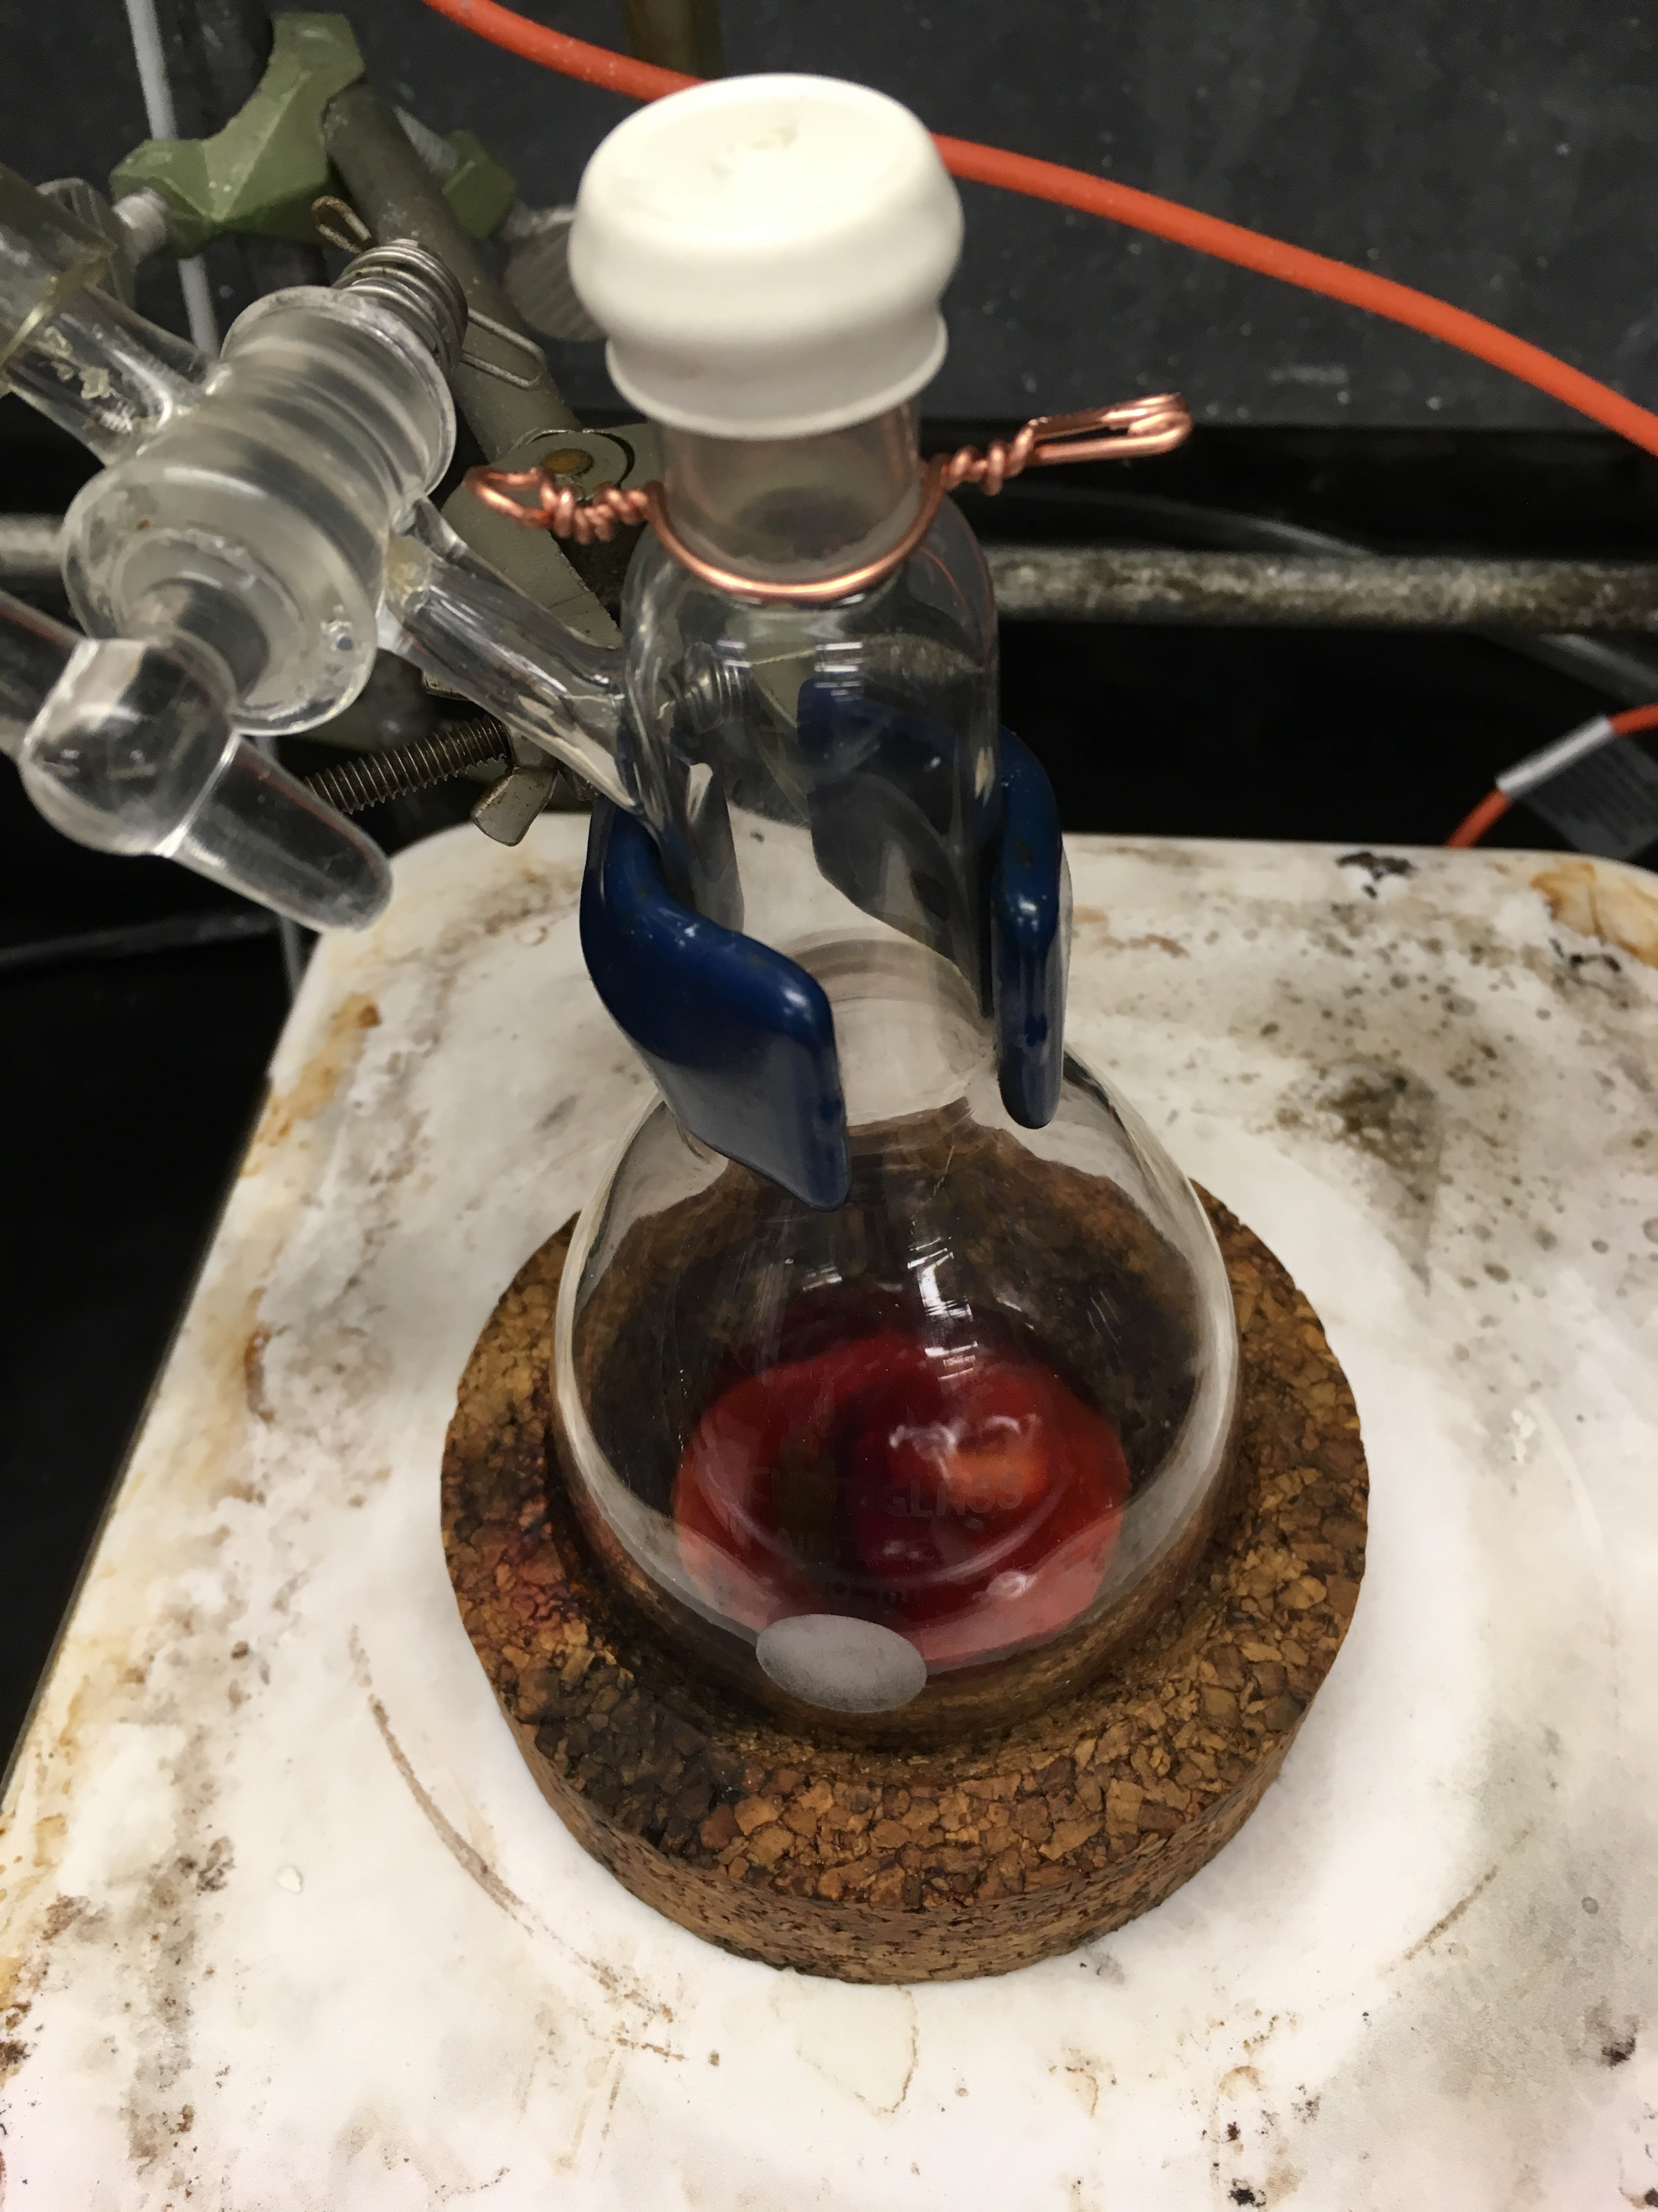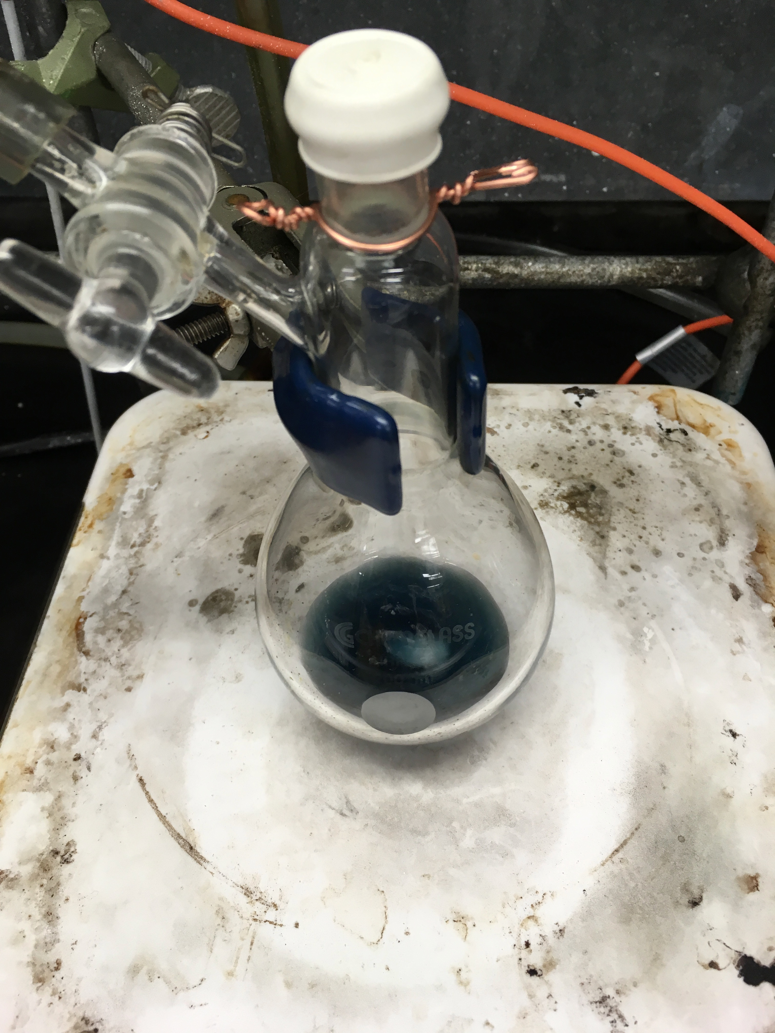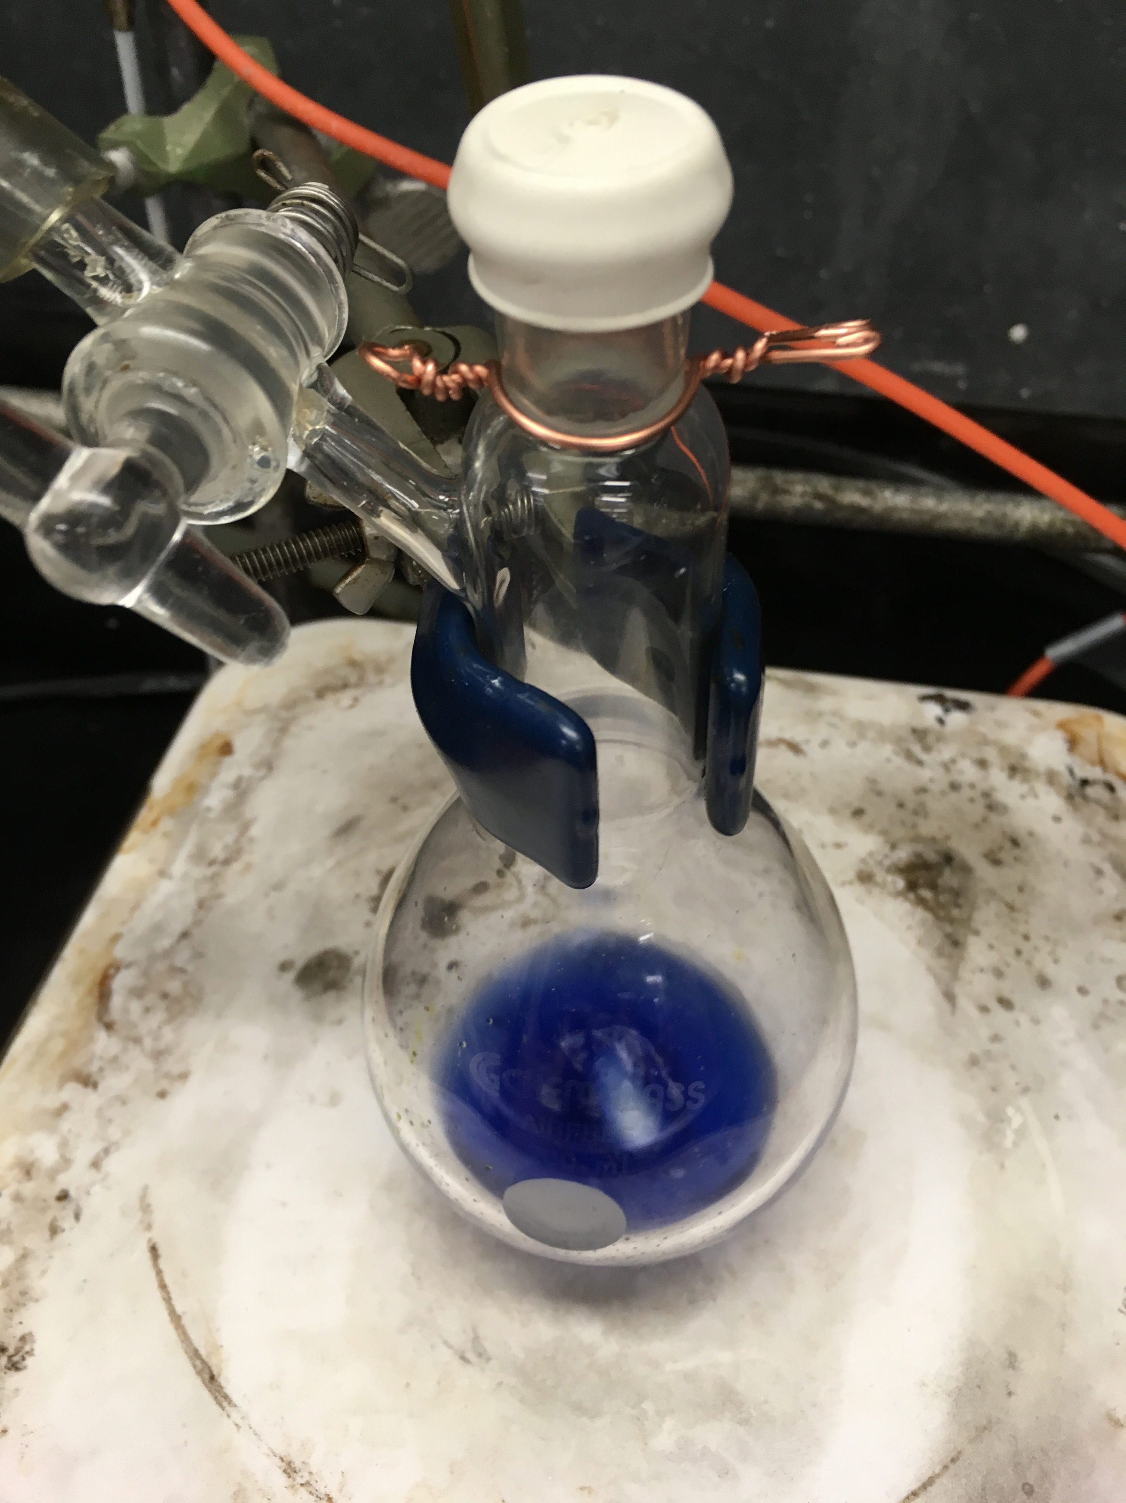
Figure 4. Three color stages during the synthesis of Ti(III) metallocene compound 3.

Applications and Summary

Here, we demonstrated standard Schlenk line technique to synthesize an air-sensitive Ti(III) metallocene complex. The solvent was degassed by bubbling N₂ through the liquid in a Schlenk flask. We also demonstrated how to set up a reaction under anaerobic conditions on the Schlenk line and transfer solvent anaerobically by cannula transfer as well as by syringe.

Inorganic chemists use Schlenk line technique in the synthesis of air- and water-sensitive compounds. The solvent used in the synthesis of highly-reactive materials can be prepared using the Schlenk line. Air-sensitive reactions can also be set up and worked up using a Schlenk line. The Schlenk line technique is a powerful method for air-free manipulations used in synthesis, purification (i.e., distillation, sublimation, and crystallization), catalysis, and gas reactions. In the next module, we will demonstrate how to use a glove box for air-free synthesis. While some air-free manipulations are easier to perform in a glove box, there are certain situations when one cannot use a glove box and must rely on Schlenk line technique (such as heating a reaction). Some metallocene complexes (metal compounds featuring typically two cyclopentadienyl anions (Cp, C₅H₅–)) exhibit catalytic properties. For example, titanocene is a catalyst used in olefin metathesis.

The Ti(III) metallocene synthesized herein can be used on the Schlenk line or in the glove box as an atmospheric test. Oxidation of the Ti(III) metallocene by O₂ on the Schlenk line or in the glove box would result in a color change and would provide a visual indication that the atmosphere contains O₂.

References

Burgmayer, S. N. Use of a Titanium Metallocene as a Colorimetric Indicator for Learning Inert Atmosphere Techniques. J Chem Educ. 75, 460 (1998).

