Title: Catalytic Reactor: Hydrogenation of Ethylene

Overview

Source: Kerry Dooley, Department of Chemical Engineering, Louisiana State University, Baton Rouge, LA
The hydrogenation of ethylene (C₂H₄) to ethane (C₂H₆) has often been studied as a model reduction reaction in characterizing new metal catalysts.¹⁻² While supported nickel is not the most active metal catalyst for this reaction, it is active enough that reaction can take place at < 200°C.
The reaction typically involves adsorbed, dissociated hydrogen (H₂) reacting with adsorbed ethylene. In other words, both hydrogen-atoms and ethylene molecules form bonds with a metal site (here denoted "S"). The strong bonding of ethylene with S weakens the double bond sufficiently to allow hydrogen atoms to add to ethylene, forming ethane, which is not adsorbed.
The purpose of this experiment is, first, to convert raw composition measurements to limiting reactant fractional conversions.³ These conversions can then be used in a plug-flow reactor (PFR) to fit the data to a standard power-law kinetics model by the “Integral Method”.³ A comparison of the experimental orders of reaction for both ethylene and hydrogen with the theoretical orders reveals in this case that the reaction is kinetically controlled rather than mass-transfer controlled.
Principles
A mechanism for the reaction (letting A = ethylene, E = ethane and S = a metal site) can be written as:²
A + S $⇌$ AS (1)
H₂ + 2 S $⇌$ HS + HS (2)
AS + HS $⇌$ AHS + S (3)
AHS + HS $⇌$ E + S + S (4)
If we assume the third reaction is the rate-limiting step, and that the total amount of S sites is constant (S_{o}), we can use an approximate mass balance:
(S_{o}) ~ (S) + (AS) + (HS) (5)
and the quasi-equilibrium assumption on steps (1) - (2) to obtain a theoretical kinetics expression:
r = k (H₂)^{1/2} (A) (S_{o})² [1 + K₁ (A) + K₂^{1/2} (H₂)^{1/2}]⁻² (6)
where k is a rate constant, K is an equilibrium constant, ”1” represents for the first reaction, “2” for second reaction, and (H₂), (A) and (S_{o}) are the concentrations of each of the components. Note that in the approximate mass balance we assume that (S), (HS) and (AS) >> (AHS). Also note that (S_{o}) is a constant as long as the total number of metal sites remains the same. When the number of metal sites decreases with respect to time, we say the catalyst "deactivates"; when it increases, the catalyst "activates". In this reaction, deactivation can be caused by a side reaction with this stoichiometry:
a C₂H₄ $⇌$ (CH)_{2a} + a H₂ (7)
The polymer product (CH)_{2a} ("coke") is too heavy ("a" is large) to desorb from the metal sites, and so these metal sites are effectively removed from the catalyts.⁴ However, subsequent reaction conditions may cause the coke to break down, thus "reactivating" the catalyst.
For these kinetics, it is evident that for low concentrations of ethylene the rate is first-order in ethylene, whereas for high concentrations of ethylene, the reaction rate is -1 order. The comparable values for the hydrogen order are 0.5 to -0.5. Rate expressions of this type (also common in enzyme-catalyzed reactions) are called "Langmuir-Hinshelwood". Since the equilibrium constant K₁ is temperature-dependent, this rate expression tells us that the order m for ethylene in a "power-law" rate expression of the type:
r = k (A)^{m} (H₂)^{n} (8)
will change with temperature. Most rate expressions regressed from experimental data are of the "power-law" type, as seen in standard textbooks on chemical kinetics.⁵
A simplified schematic of the reactor system (Fig. 1) is shown below. Many of the valves and components are labeled on the reactor. The reactor is a steel tube contained within a sandbath. The sandbath is fluidized using air and heated by metal resistance heaters. A large amount of heat can be transferred rapidly to the pilot-plant reactor.

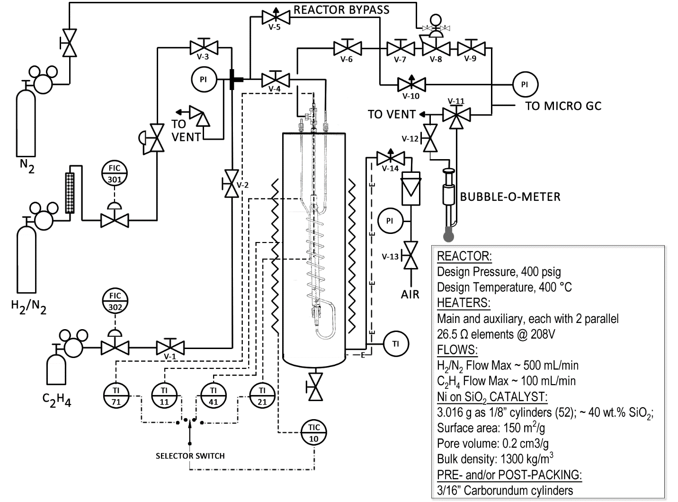
Figure 1: Schematic of Catalytic Reactor System

Precautions have been taken to make this a safe system. There are relief valves on the system, a high temperature shutdown, and only diluted hydrogen (see spec sheet on the cylinder) is used. However, with any reacting system, strict adherence to safety procedures is necessary. The lower explosion limit of hydrogen in air is 4.0 vol%.⁶ For this reason, it is important to ensure that the reactor is not leaking hydrogen into the surrounding sandbath. A CGD900 Combustible Gas Leak Detector is available for this purpose.
The catalyst used in this demonstration (2.0 g) uses nickel as the active component but is approximately 40 wt% silica (SiO₂). The silica is called a "support" for the nickel, and its purpose is to provide a large surface area for the nickel to cover. An inert material, silicon carbide (SiC), is used to fill up the rest of the reactor. The catalyst has surface area = 150 m²/g, pore volume = 0.2 cm³/g, and a bulk density of ~1300 kg/m³.
The closest ideal reactor to a packed bed catalytic reactor is a PFR. Nonideal reactor analysis is beyond the scope of this experiment. The PFR mass balance using catalyst weight as the independent variable and fractional conversion as the dependent variable becomes:
$\int_{0}^{f_{Af}}{\frac{df_{A}}{r'}} = \frac{W}{F_{Ao}}$ (9)
where f_{A} is the fractional conversion of the limiting reactant, “f” stands for final (exit) conditions, W is the catalyst weight, F_{Ao} the feed molar flow rate of A, and r’ is the rate expression on a per wt basis. How to put r’ in terms of f_{A} only for an ideal gas is covered in any of the standard kinetics references.³ Note that there will be two classes of data, one class with ethylene limiting and the other with hydrogen limiting, but there can only be one common rate expression. The fractional conversion can be found by analyzing both the feed and product gas with a gas chromatograph. Through closing the mass balance, the rate of the reaction can be found and compared to the nominal activation energy for this type of catalytic reaction. One can also compare the orders of the reaction.

Procedure

The system is controlled through a commercial distributed control system; there is only one operator interface.
- Reactor Startup
  - To start up the real-time process history view, navigate to Start > DeltaV > Operator > Process History View, and then open CATUnitOverview. Chart scales can be compressed or expanded by clicking those buttons on the menu bar. Procedures to download data from the control system to an Excel spreadsheet are available on the computer.
  - Be certain the air to the sandbath is on. The rotameter should read ≈5 or higher and be held constant from run to run to provide consistent heating.
  - Enable main power to the sandbath heater by pushing the black-colored START button on the CAT unit’s panel board.
  - Set temperature controller (TIC-10, for the sandbath) to desired initial set point, mode to AUTO. To use rapid heating at the beginning of the experiment, refer to Appendix.
  - The temperatures can be monitored on the chart. The reactor effluent flow rate should be checked periodically. If problems, such as loss of flow or runaway temperature develop, shut off both reactant flows using appropriate shutoff valves and turn all heaters off. Leave sandbath air on.
- Set Flow Rates
Set flow rates prior to heating. Calibrations for the two flow controllers – FIC-301 for the hydrogen-nitrogen mixture and FIC-302 for ethylene – will be provided.
  - Set the digital value on the interface that designates whether the computer or the panel board will be used to 1 in order to indicate computer use.
  - Block the GC sample line.
  - Determine the volumetric flow rate by timing the rate of rise of a single bubble between two volumes in a bubble meter. A bubble meter is a glass buret with graduated volumes. Make sure the GC sample line is blocked when the bubble meter is being actively used to measure flow (calibration, checking exit flow rate).
  - Take at least one sample of the feed through the bypass (a blank sample) to check its composition. It's OK to change flow rates on the fly without bypassing the reactor. Changing the flow rates also changes the relative concentrations of the feed (the pressure being constant), so flow rates will need to be changed often.
  - Unblock the GC sample line and flow the reactants through the reactor bypass and into the GC inlet port.
  - Use a gas chromatograph to analyze the gas product composition. Further instructions are included in Appendix B on how to operate the GC and determine composition.
- Reactor Shutdown
  - Shutdown main power to the sandbath heater by pushing the red EMERG. STOP button on the CAT unit’s panel board.
  - Place TIC-10 in MAN mode and set the output to 0%. Set auxiliary power (if on) to 0%.
  - Set ethylene flow to 0% by putting the controller in MAN and setting the output to 0%.
  - Shut off both ethylene block valves before the mixing tee and shutoff the main gas cylinder valve.
  - Let hydrogen/nitrogen flow for ~2 min before shutting off; this will prolong the life of the catalyst.
  - Block both valves before the mixing tee. Then shut off the main valve for the hydrogen/nitrogen mixture.
  - Leave the air to the fluidized bed on.
Representative Results
Nonlinear regression to obtain best estimates (using Eqs. 8 - 9) of the reaction orders m and n, and the rate constant k, can be tedious. Such a solution algorithm requires one numerical integration per data point per iteration of m and n, leading to many thousands of numerical integrations. An alternative technique that is almost as good, but much less computationally expensive, is to formulate trial pairs of m, n based on the structure of Eq. 6. Any values within the range of the theoretical orders is certainly possible. Then formulate an objective function of the type:
$O.F. ={\{\int_{0}^{f_{Af}}{\frac{df_{A}}{r^{'}}}- \frac{W}{F_{Ao}}\}}^{2}$ (11)
This objective function for each m, n pair can be calculated, and the best fit determined using its minimum or near-minimum along with other standard fit criteria, such as the randomness of the errors in Eq. 11 as a function of the partial pressures. Also note that Eq. 9 predicts that a plot of the left-hand side integral (call it “Y”) vs. 1/F_{Ao} (call it “X”) should be linear at the optimal m, n. Checking the degree of linearity and the randomness of the errors of this formulation is also a valid method to determine goodness of fit.
Some data taken at P = 1 atm, T = 80°C, P_{C2H4} = 0.17-0.42 atm, P_{H2} = 0.23-0.33 atm (nitrogen as diluent) were analyzed as described above. The linear plot of the “best fit” kinetics is shown in Figure 2. Several other m, n pairs were also examined in like manner and found to give poorer linear fits. The best fit values of m and n suggest that ethylene is weakly adsorbed on the nickel catalyst (no inhibition in the denominator of Eq. 6), while hydrogen is strongly adsorbed (the negative order denotes inhibition). For most catalytic reactions, too strong an adsorption is just as bad as too weak an adsorption, although “too strong” is reflected in a negative reaction order, while “too weak” is reflected in low conversions and a small rate constant k.

Figure 2. Kinetics analysis of ethylene hydrogenation at 80°C, 1 atm for 60 wt% Ni catalyst. The “a” denotes data where C₂H₄ is the limiting reactant, while “b” denotes H₂ as the limiting reactant.
Both best fit values of m and n are within the range of expectations based on Equation (6). The value of “m” is at its maximum, therefore the reaction is not diffusion-controlled. For a diffusion-controlled reaction both “m” and “n” would be close to zero. The experimental orders can sometimes answer the question of kinetically-controlled vs. diffusion-controlled, but if both orders were near zero nothing could be proven, because zero is within the range of possible orders based on Equation (6). A proof of the above statements is beyond the scope of this experiment.
Applications and Summary
The method described here is called the “Integral Method” in most books on kinetics and reactor design.³ While it is mathematically far more difficult to apply than differential methods, it is also better adapted to analyze the kinds of data that are easy to obtain in most pilot-scale reactor systems, where the reactant and product partial pressures and fractional conversions can vary over wide ranges. Because we are not relying upon batch reactors or low reactant conversions, such “integral data” are also more accurate and relevant for scaleup. The first part of the method is to convert the raw data of flow and composition measurements into fractional conversion vs. space time (the right-hand side of Equation 9 is often called the space time). The next step is to postulate reasonable reaction orders for the reactants (and sometimes products) that affect the rate. The final step is to compare as many sets of orders as possible using Equation (11), or the linearity relationship in Equation (9), and pick the set giving the best fit to all the data.
Almost any supported metal catalyst can catalyze the hydrogenation of ethylene over some temperature range, and the catalyst activity, selectivity (to ethane) and stability (coking resistance) are important descriptors of a potential metal catalyst’s utility. The kinetic orders of the reaction are also important descriptors. They indicate the relative adsorptive strengths of a hydrocarbon vs. hydrogen, and whether the catalyst’s rates might be limited by reactant or product diffusion (in which case, orders near zero are found). The orders can also suggest if the assumptions made in deriving Equation 6 (e.g., a single rate-limiting step that is the surface reaction) are even correct in the first place. Usually knowing the experimental rate expression is insufficient to determine the correct mechanism by itself, but if the experimental rate expression is inconsistent with a proposed reaction mechanism, then the latter is certainly incorrect. In the example given here, the observed kinetics are consistent with the proposed mechanism and rate-limiting step, lending some credence to the mechanism.
With only slight adaptation, the “integral methods” described here have been used to determine the rate expressions for many important industrial catalytic reactions. These rate expressions have then been used to scale up these processes to tonnage scales. Some well-known examples include the steam reforming of methane to generate H₂, the oxidation of o-xylene to phthalic anhydride, and ammonia synthesis.⁶ In such cases, the rate expressions for hundreds of candidate catalysts might be computed, often at multiple temperatures.
As for catalytic reactions on supported metals, they constitute some of the most important industrial catalytic reactions, including automotive exhaust catalysis (a combination of carbon monoxide oxidation, unburnt hydrocarbon oxidation, and nitric oxide reduction), the reforming of linear to branched-chain hydrocarbons to increase the octane number of various fuels, and steam reforming. For the first of these the active metal is usually a platinum-paladium alloy, for the second it is platinum or a platinum alloy such as platinum-rhenium, and for the third it is nickel.⁷ Other metals such as copper, silver, gold and rhodium also find application, either by themselves or as alloys with other metals.

References

- O. Beeck, Discuss. Faraday Soc. 8, 118 (1950).
- J.B. Butt, AIChE J 22, 1 (1976).
- H.S. Fogler, “Elements of Chemical Reaction Engineering,” 4th Ed., Prentice-Hall, Upper Saddle River, NJ, 2006, Ch. 2-4; O. Levenspiel, “Chemical Reaction Engineering,” 3rd Ed., John Wiley, New York, 1999, Ch. 4-6; C.G. Hill, Jr. and T.W. Root, “Introduction to Chemical Engineering Kinetics and Reactor Design,” 2nd Ed., John Wiley, New York, 2014, Ch. 8.
- B. Peri, Discuss. Faraday Soc., 41, 121 (1966).
- Basic chemical kinetics – Fogler, Ch. 3, Levenspiel, Ch. 2, Hill and Root, Ch. 3.
- N. Bartknecht, "Explosions: Course, Prevention, Protection", Springer-Verlag, 1981.
- G.F. Froment, K.B. Bischoff and J. De Wilde, “Chemical Reactor Analysis and Design,” 3rd Ed., John Wiley, Hoboken, Ch. 11.
- J.R.H. Ross, “Heterogeneous Catalysis: Fundamentals and Applications,” Elsevier, Amsterdam, 2012, Ch. 8.

APPENDIX A – Auxiliary Heater Instructions
For rapid heating, turn the auxiliary heater on (output ≤ 90%), but be sure to turn it off when the skin or outer wall temperature nears the desired reactor temperature; the auxiliary heater is not controlled at this time and cooling (≈10 °C/hr) takes much longer than heating. The reactor temperature can lag the heater temperature significantly. The skin thermocouple can be selected as the input to TIC-10. The highest temperature to be used in any experiment is 200°C. A "CRITICAL" warning light alerts the user to high temperature. The control system monitors both the sandbath and reactor temperatures and both are programmed to alarm and shut off the heaters when too high.
APPENDIX B – Chromatograph Operating Instructions
The MicroGC is computer controlled. The default GC method is “cooling-1.” For the experiments, load method “PH-CAT4”. Click Control → Download Method. Display the Instrument Status by clicking on Control → Instrument Status. A run cannot be performed until all parameters in Instrument Status are near their set points.
When ready to perform a run, click Control → Single Run. A popup menu will prompt to enter a Sample ID, Data File and Result Name. For “Data File”, click the arrow head to the right and select Date and Time. After doing so, the screen will be in the field, and the date and time will be attached to the file names. For “Results”, click the arrow head to the right and select Sample ID, then repeat selecting Date and Time, then repeat selecting Increment Number. Return to the field and insert a single blank space between the first and second item and the second and third item. For “Number of reps’ enter the number of sequential repeated analyses desired. Now click “Start”. Live plots for both Channels A and B will appear, showing the chromatograms as they are generated. H₂ and N₂ are detected on channel A, while H₂, CH₄, C₂H₄, and C₂H₆ are detected on channel B. Currently, however, the method has only been calibrated for ethylene and ethane. When all reps are complete, DO NOT SAVE THE METHOD. The Result Sequence window will open, allowing access to the results.
To view the results, select the Result Sequence window, right click (e.g.) the first run number cell, choose Select Record. On the top menu select Reports → View → Area %. A report with the known compounds will pop up.
The GC will record in Area%. To calculate conversion (A = area%):
$f_{A}= \frac{A_{C2H6}}{A_{C2H4} x 0.535+ A_{C2H6}}$ (10)
It is also possible to compute the conversion by measuring the product flow rate with the bubble meter, and this can serve as a check on the GC results. Assuming an ideal gas and no reactions other than ethylene hydrogenation, the following equation can be derived using a stoichiometric table:³
$f_{A}= \frac{F_{T0}-F_{T}}{F_{T0} x_{j0}}$ (11)
Where F_{T0} is the total volumetric flow rate of feed, F_{T} is the total volumetric flow rate of the product stream as measured by the bubble meter, and $x_{j0}$is the mol or volume fraction of whichever is the limiting reactant.

