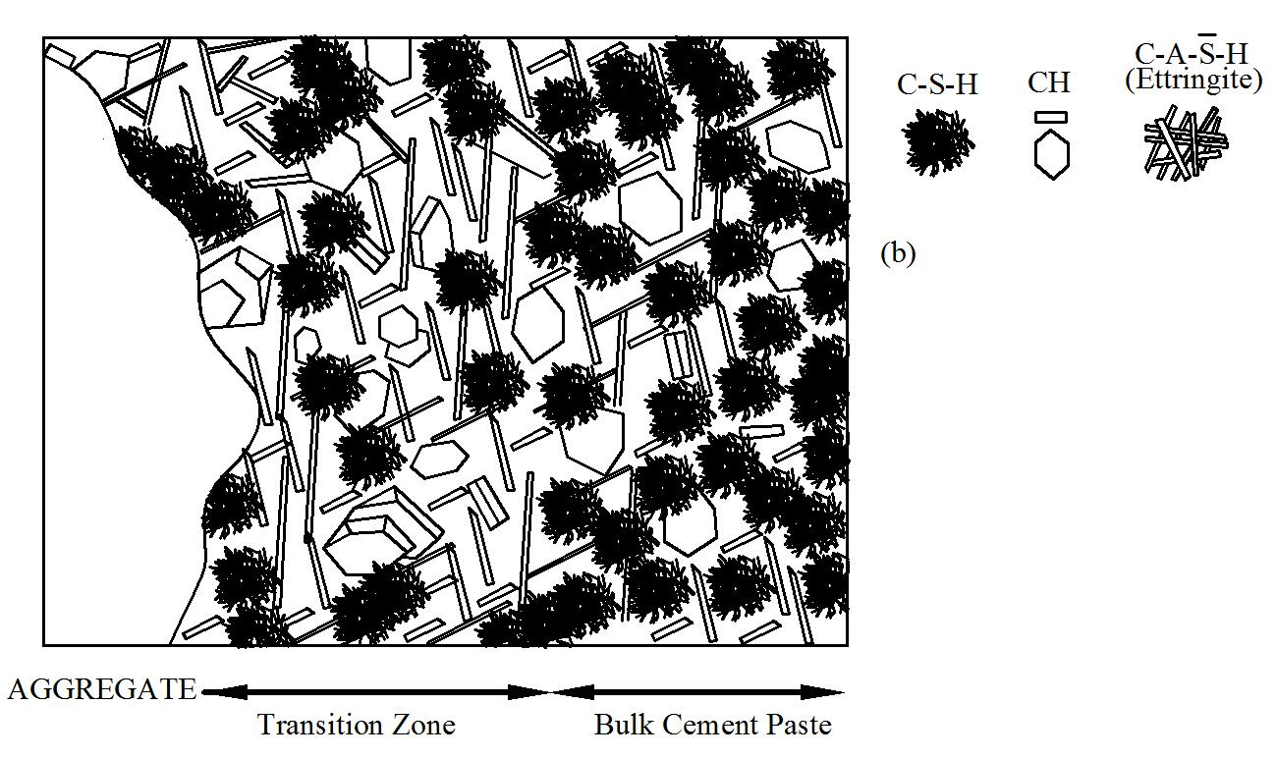

Figure 1 – Interface transition zone (adapted from Mehta, P.K. and Monterio, P.J.M., Concrete: Structure, properties and Materials, 2nd Ed., Prentice Hall, 1993)

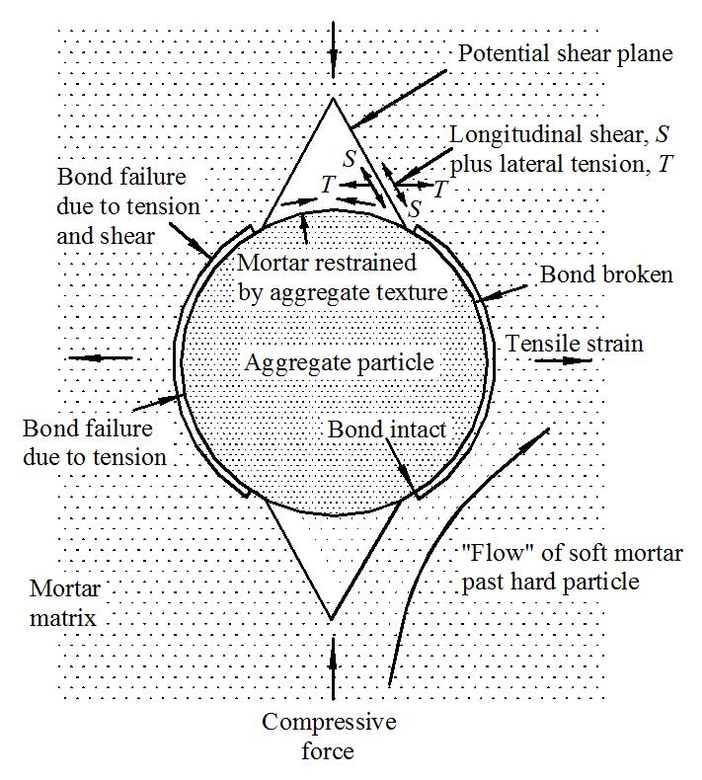

Figure 2 – Idealization of the state of stress around aggregate particles (adapted from Mindess, S., Young, F.J., and Darwin, D., Concrete, 2nd Ed., Prentice Hall, 2003)

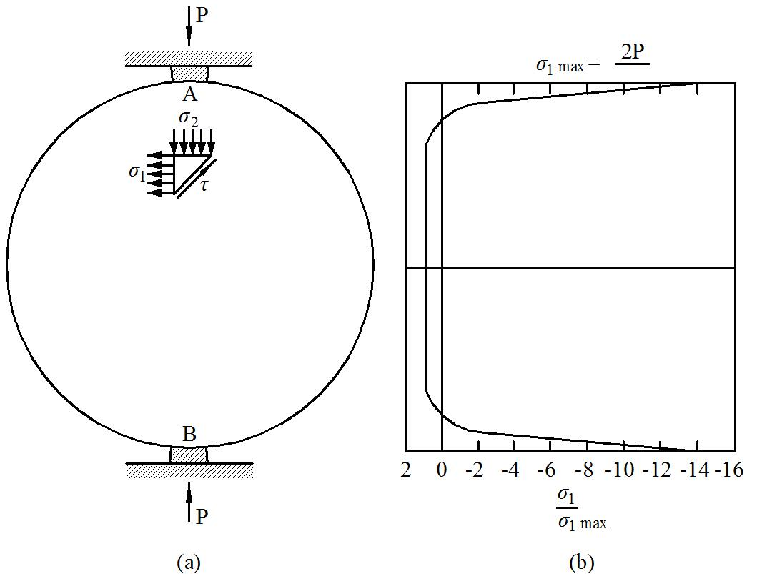

Figure 3 – Stress distribution over the diameter of a cylinder loaded in compression (adapted from Mindess, S., Young, F.J., and Darwin, D., Concrete, 2nd Ed., Prentice Hall, 2003)

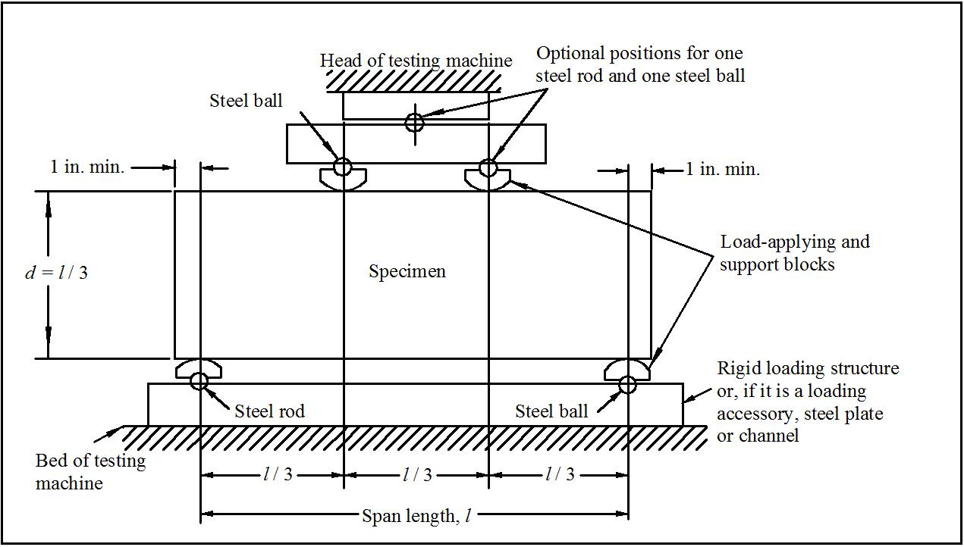

Figure 4 – Typical beam test configuration for determining tensile capacity of concrete (adapted from Mehta, P.K. and Monterio, P.J.M., Concrete: Structure, properties and Materials, 2nd Ed., Prentice-Hall, 1993)

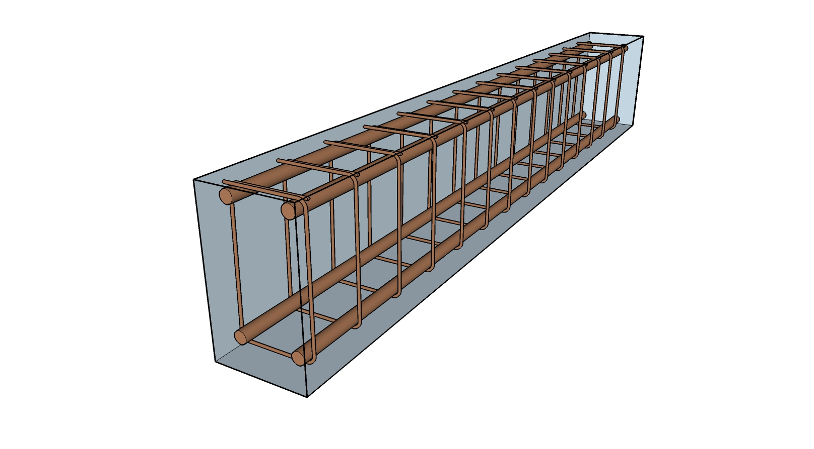

Figure 5 – Typical reinforcement in a concrete beam
.

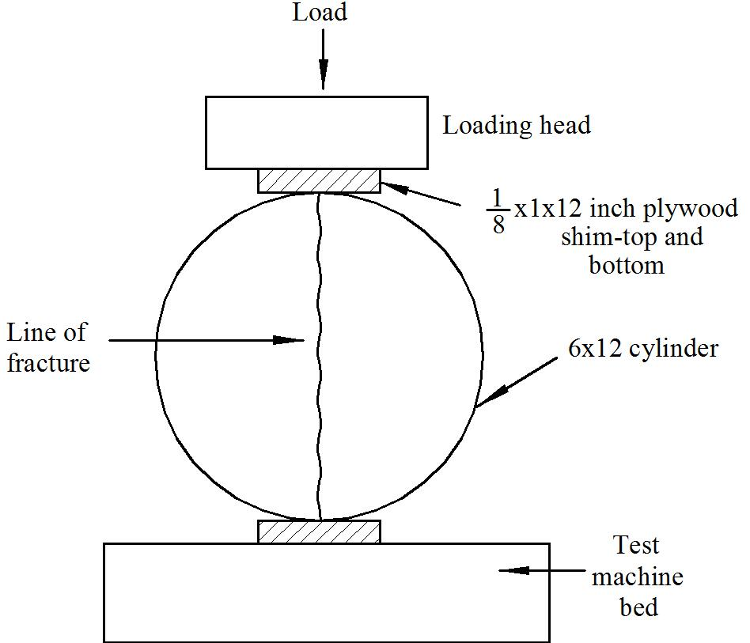

Figure 6 – Placement of specimen for split tension test (adapted from Mehta, P.K. and Monterio, P.J.M., Concrete: Structure, properties and Materials, 2nd Ed., Prentice-Hall, 1993)

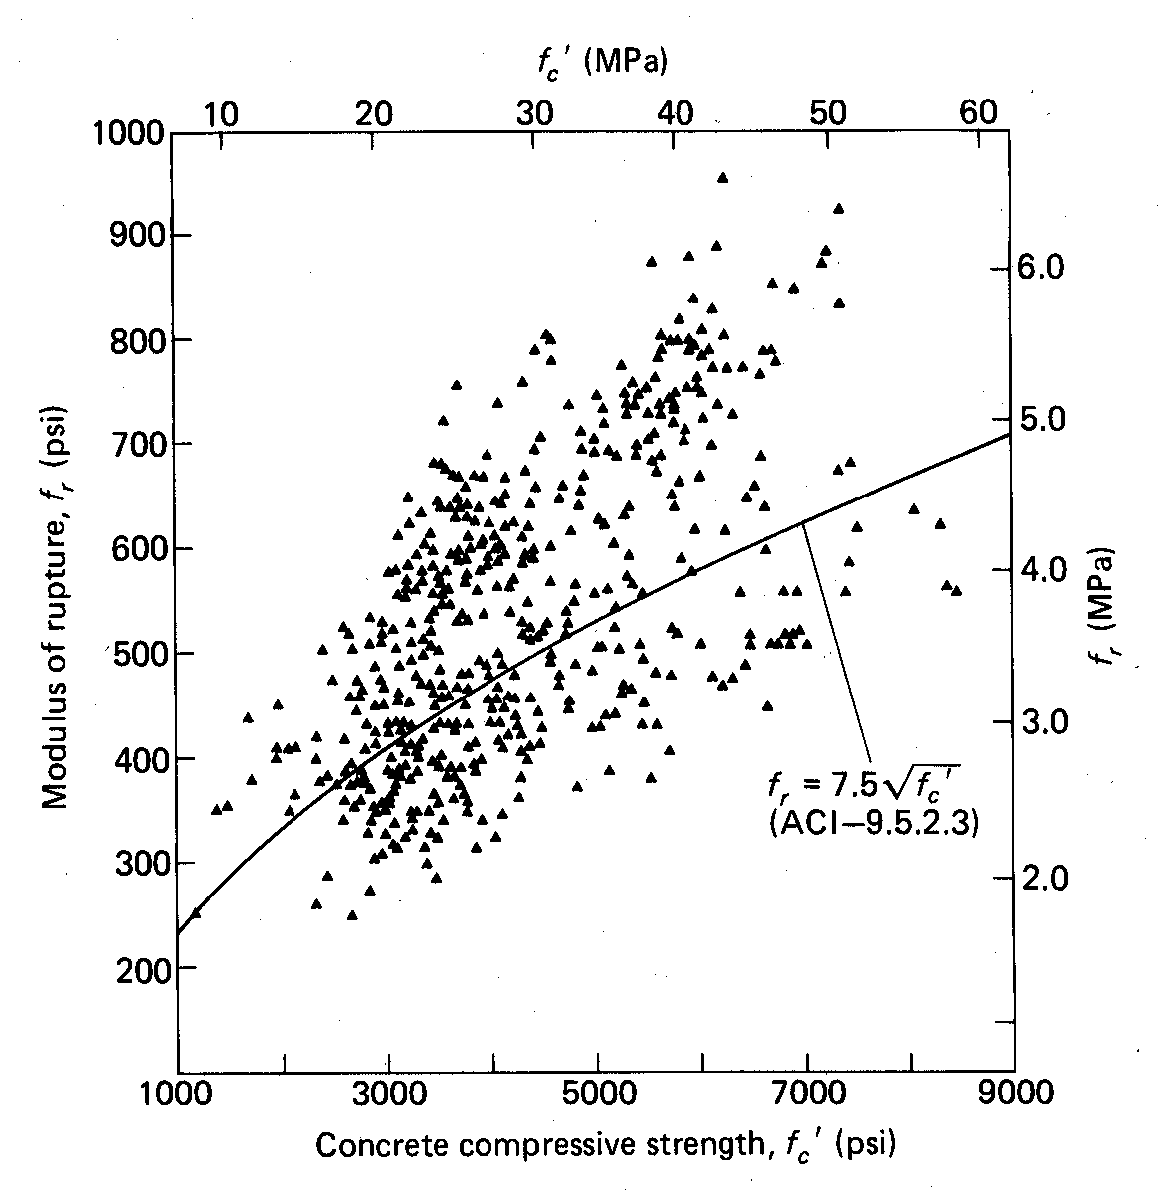

Figure 7 – Scatter in tensile strength results from beam tests as a function of compressive strength

Figure 8 – Comparison of load-deflection curves for unreinforced and reinforced concrete beams.
(to be added when the tests are filmed)

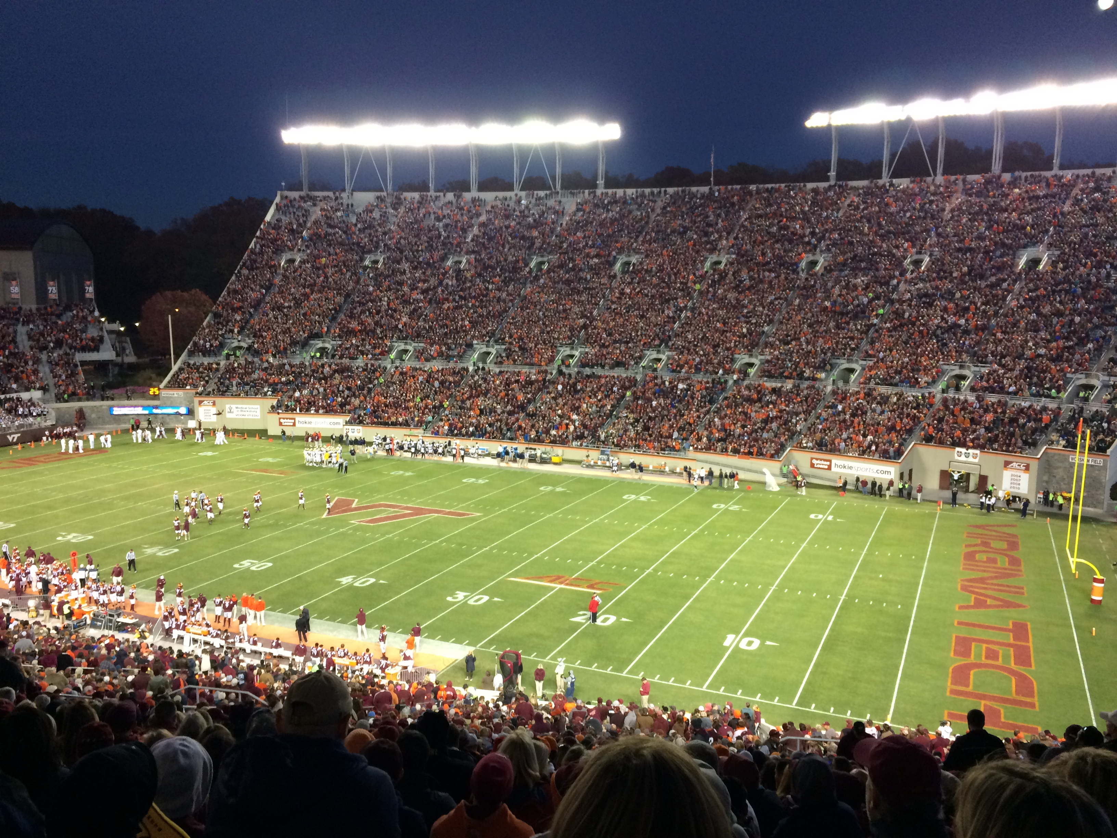

Figure 9 – Virginia Tech Stadium (Blacksburg, VA)

