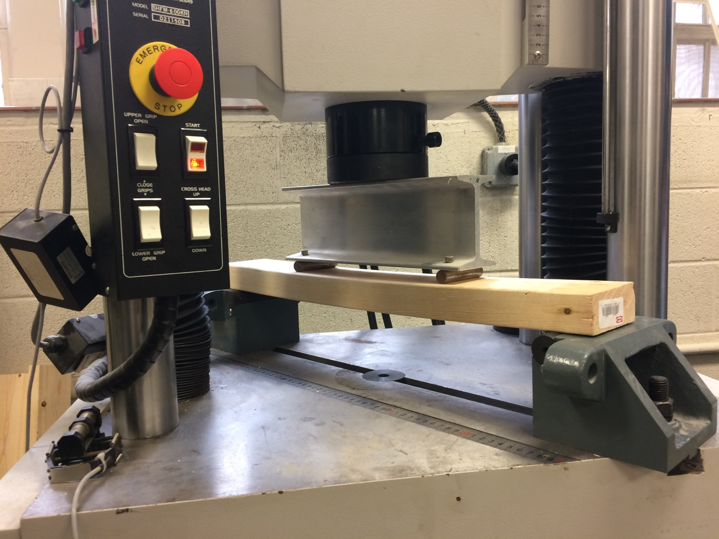

Figure 1 – Four-point bending apparatus

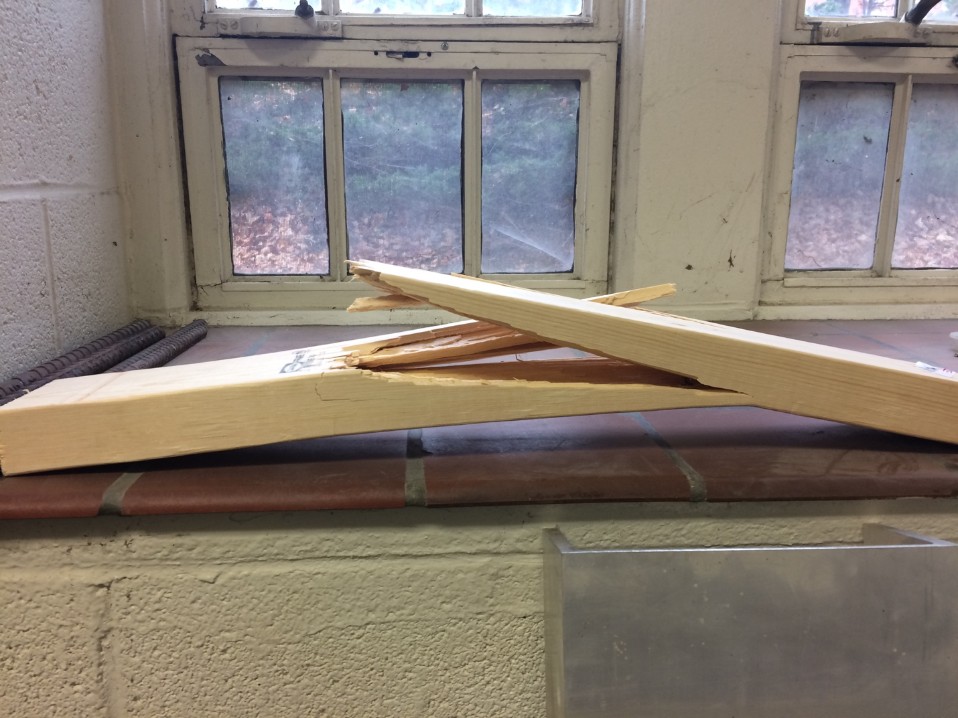

Figure 2 – Wood beam flexural failure

