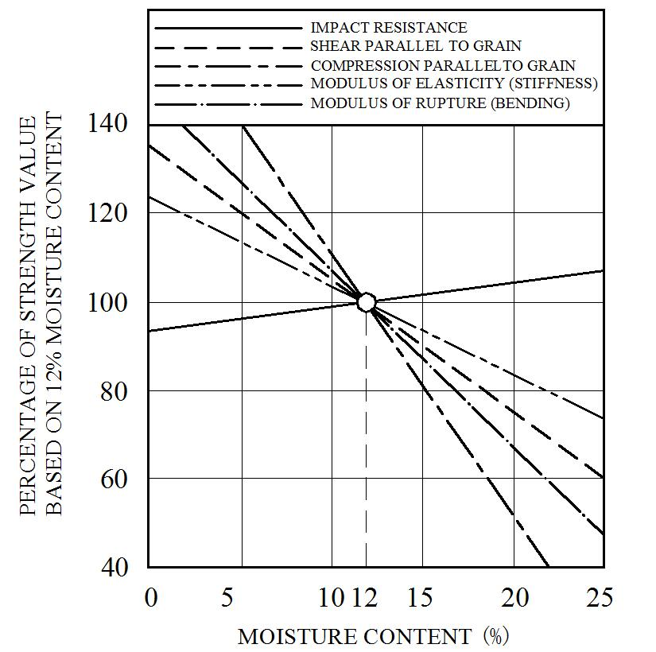
Figure 1 – Engineering properties of wood as a function of moisture content

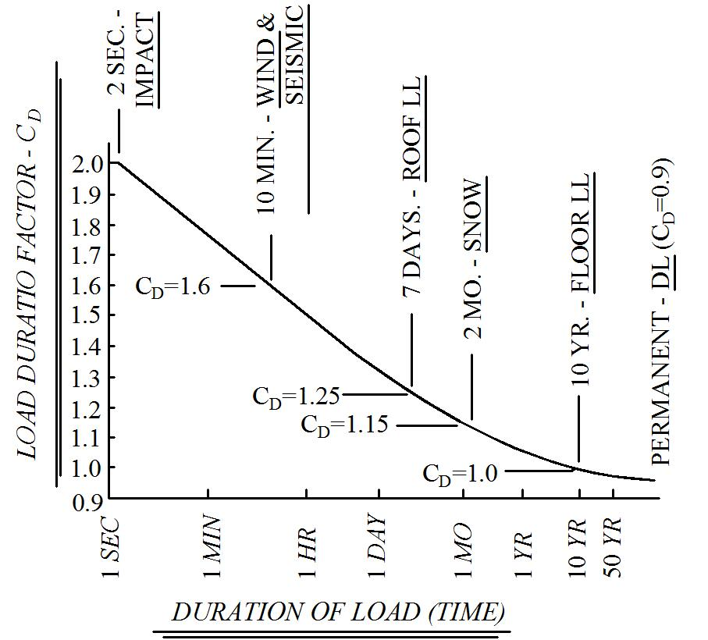

Figure 2 – Duration of load effects (redrawn from Breyer, D., Design of Wood Structures, McGraw-Hill, 1988)

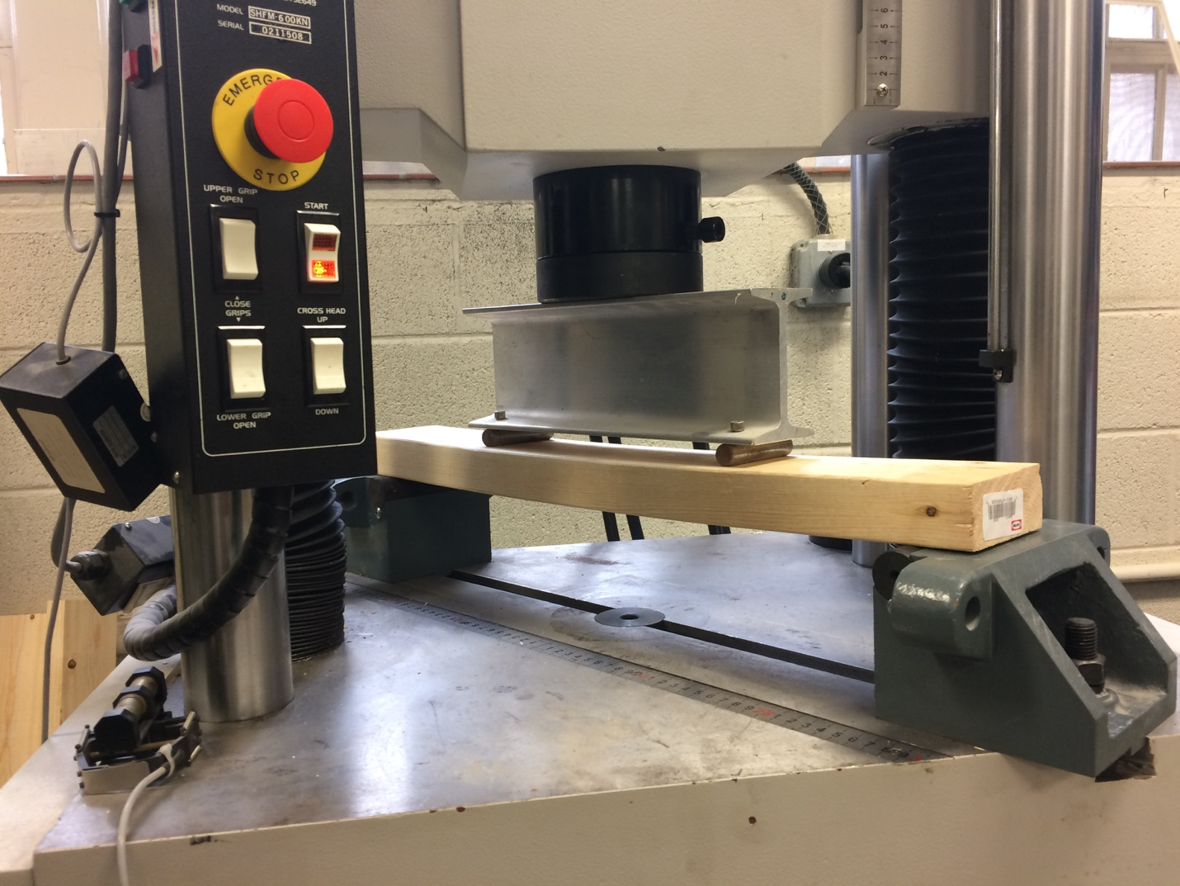

Figure 3 – Four-point bending apparatus

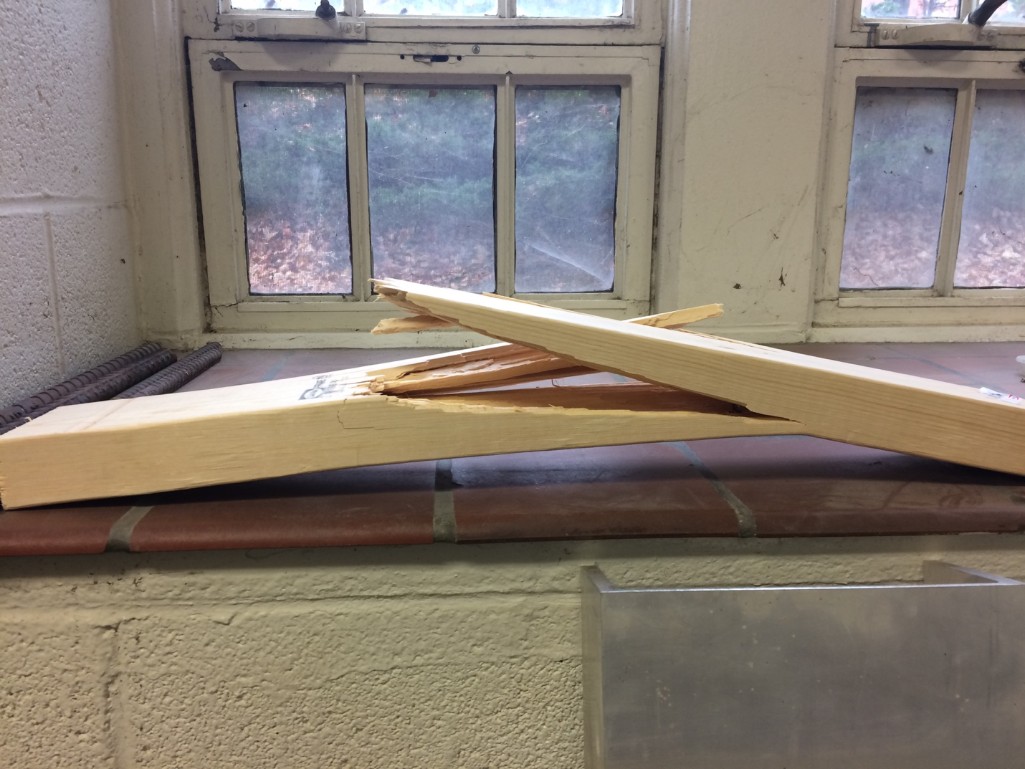

Figure 4 – Wood beam flexural failure

