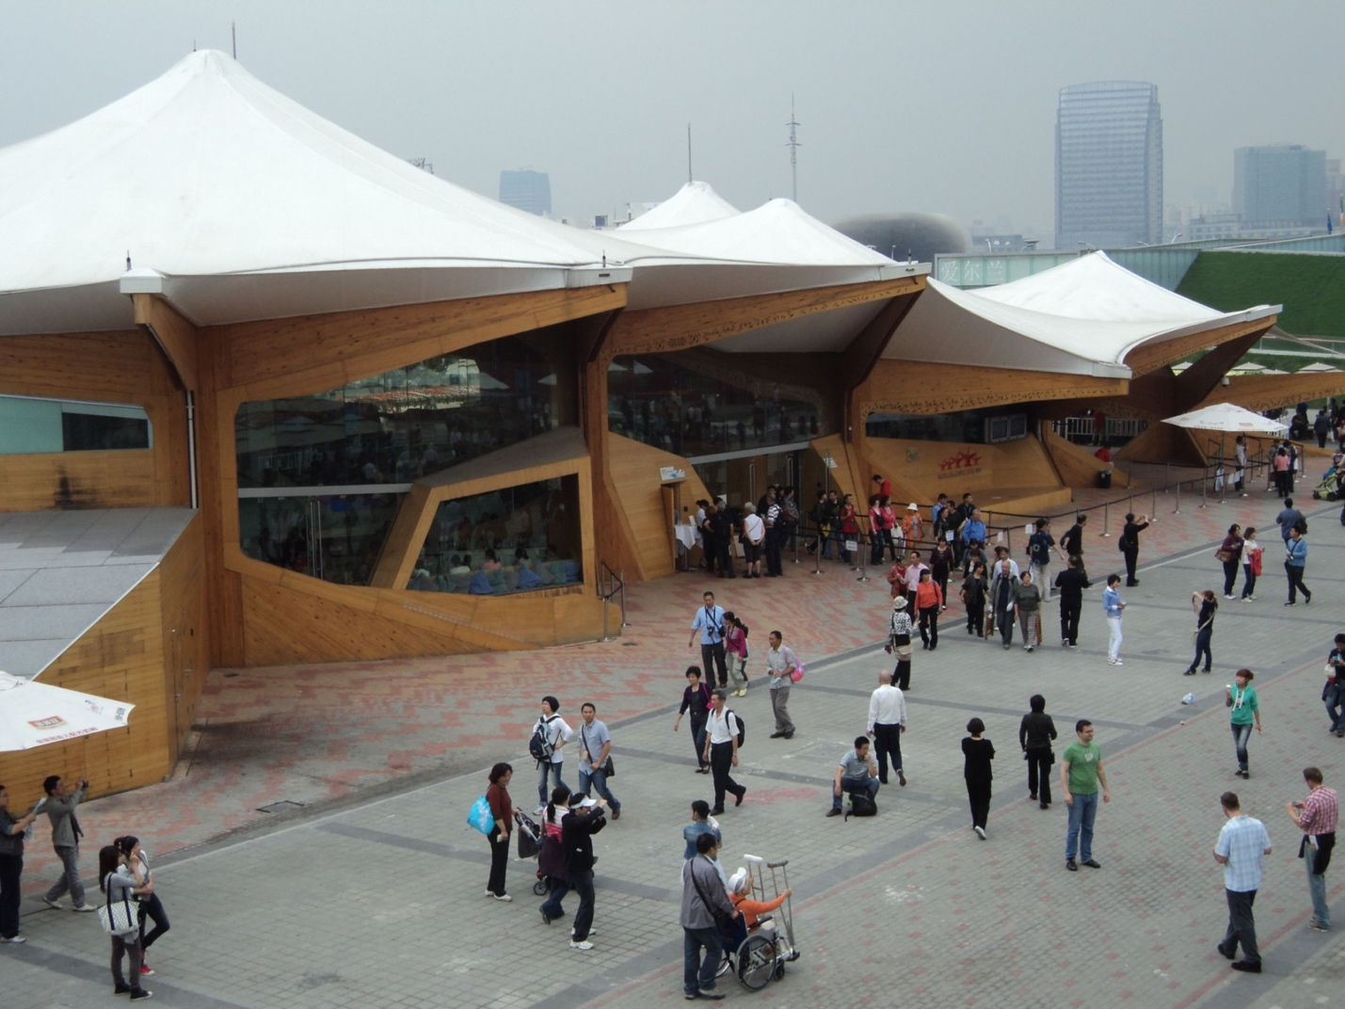

Figure 1 – Norwegian Pavilion at the Shanghai 2010 World Exposition

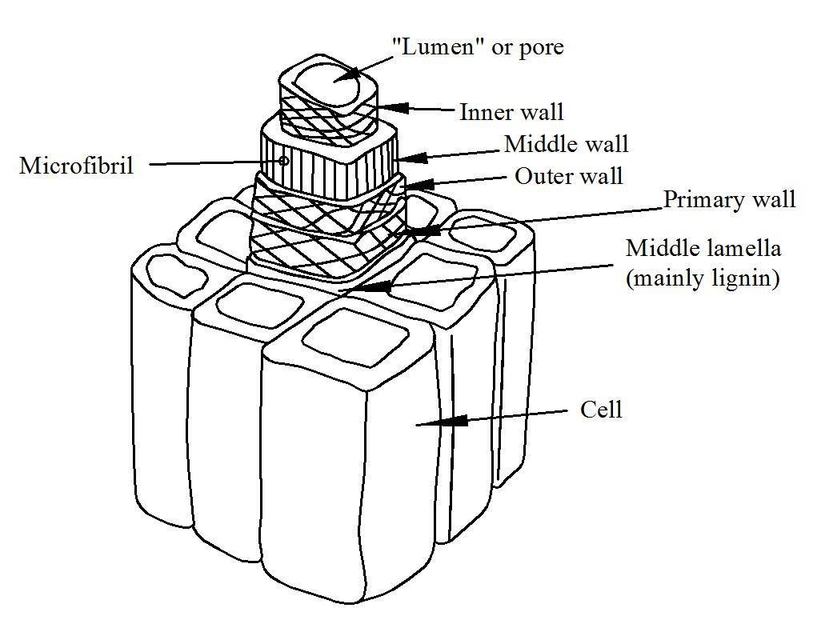
Figure 2 – The structure of wood (adapted from Young, J.F et al., The Science and Technology of Civil Engineering Materials, Prentice-Hall, 1999)

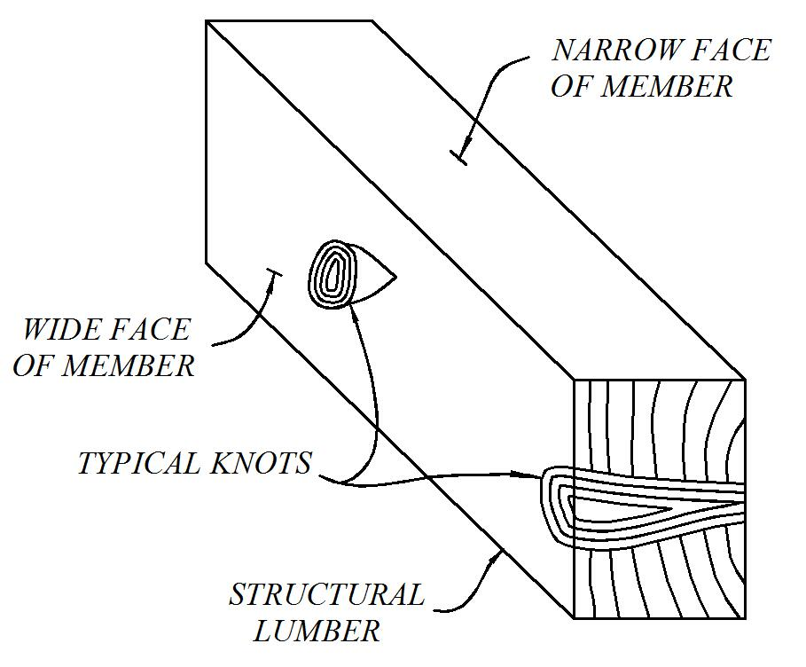

Figure 3 – Defects (knots) on a typical wood structural member (redrawn from Breyer, D., Design of Wood Structures, McGraw-Hill, 1988)

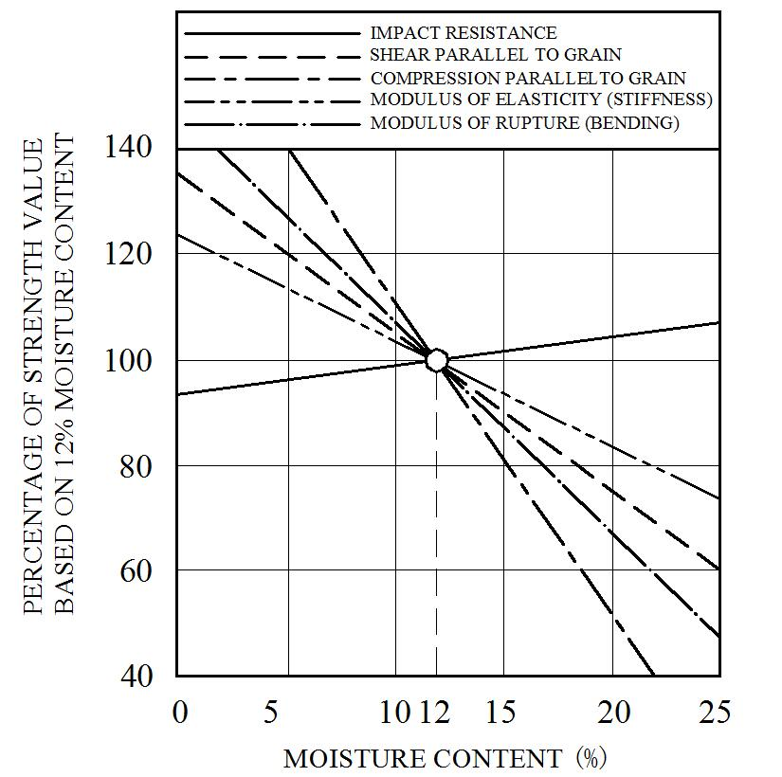
Figure 4 – Engineering properties of wood as a function of moisture content

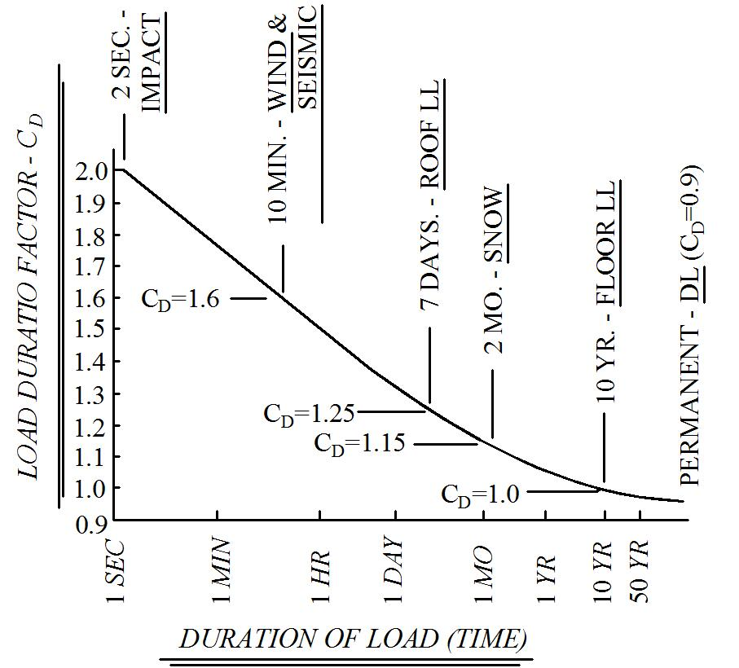

Figure 5 – Duration of load effects (redrawn from Breyer, D., Design of Wood Structures, McGraw-Hill, 1988)

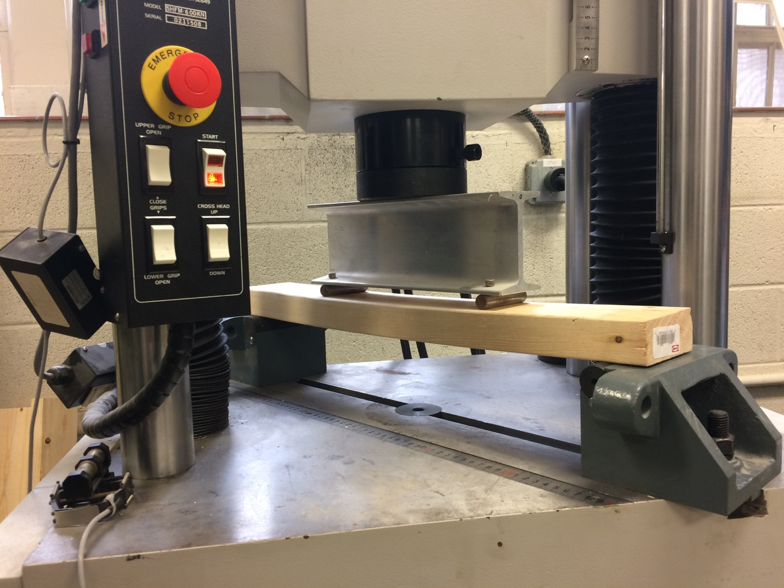

Figure 6 – Four-point bending apparatus

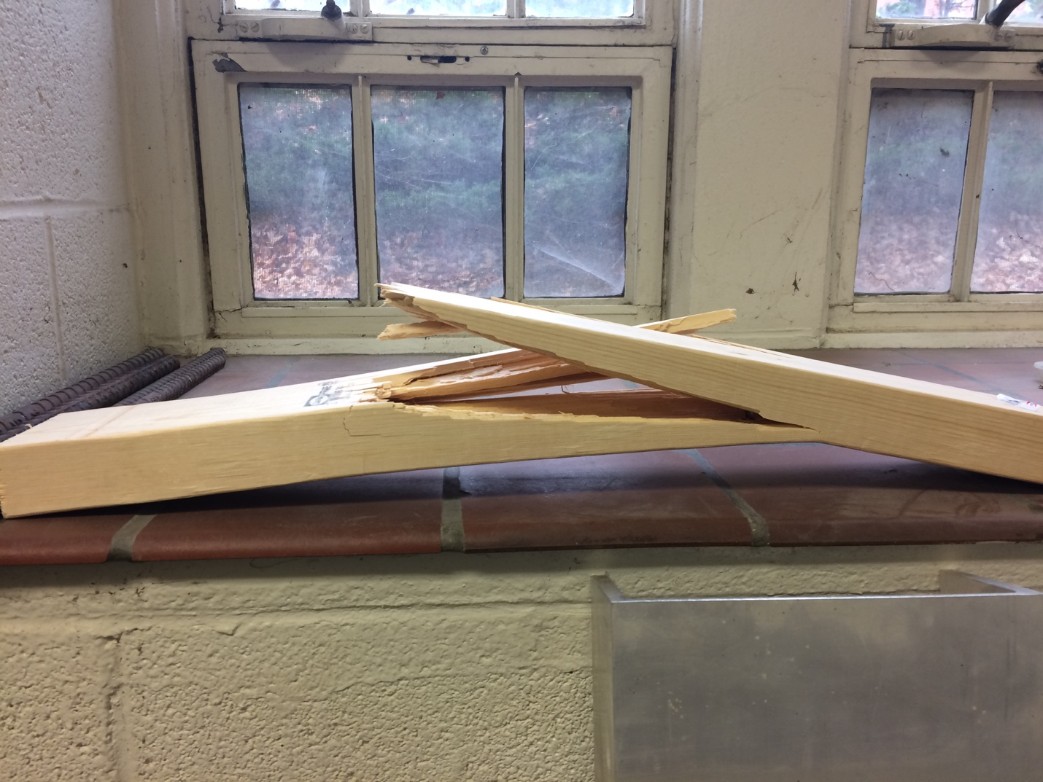

Figure 7 – Wood beam flexural failure

Figure 8 – Multi-story wood building

