PI Name: Roberto Leon
Science Education Title: Tests on Wood
Overview:
Wood is a ubiquitous material that has been used in construction from the earliest times. Wood is a renewable, sustainable material with great aesthetic value (Figure 1). Today, there are probably more buildings constructed with wood than any other structural material. Many of these buildings are single-family residences, but many larger apartment buildings, as well as commercial and industrial buildings, also use wood framing.
Figure 1 – Norwegian Pavilion at the Shanghai 2010 World Exposition
The widespread use of wood in construction has appeal from both an economic and aesthetic basis. The ability to construct wood buildings with a minimal amount of equipment has kept the cost of wood-frame buildings competitive with other types of construction. On the other hand, where architectural considerations are important, the beauty and warmth of exposed wood is difficult to match with other materials.
The objectives of this experiment are to conduct tensile and compressive tests on three types of wood to investigate their stress-strain behavior, and to conduct a four-point bending test on a wood beam to ascertain its flexural performance. In a four-point bending test, a simply-supported beam is loaded with two equal point loads at its third points, resulting in a central portion with constant moment and zero shear. This is an important test because wood structural elements are often used in floor systems and are thus primarily loaded by bending stresses.

Principles:
Wood is composed of elongated, round, or rectangular tube-like cells (Figure 2). These cells are much longer (2-4 mm) than they are wide (20-40 μm), with the length of the cells often related to the length of the tree. Cell walls are made of cellulose (a polymer), with polymeric chains aligned in distinct directions in each of the layers that form the cell wall. In Figure 2, the lines on the different components of the cell walls show approximate chain (or microfibil) alignment in each layer. The middle wall, with its chains aligned along the longer dimension of the cell, provides most of the strength to the cell, while the inner and outer wall’s diagonal chains provide stability. The cell wall structure is semi-crystalline, with crystalline structures of 30-60 μm length followed by short amorphous sections. The chains and the cells are bound together by a material known as lignin. Each cell is relatively weak, but the bundling effect of many cells together provided by the lignin results in a very strong and useful construction material. A good analogy for this is the resistance of a single drinking straw versus that of many straws glued or bound together.
Figure 2 – The structure of wood (adapted from Young, J.F et al., The Science and Technology of Civil Engineering Materials, Prentice-Hall, 1999)
The sheer fact that wood is a biological material makes it very susceptible to environmental decay and attack by pests if it is exposed to the elements. Thus, much of the wood used today is pretreated with chemicals to protect it from the environment and insect attack. That wood is a biological material also means that there is a large variation in the engineering properties between wood pieces, even within the same tree species. A large number of imperfections will inevitably be present, making wood an inhomogeneous material. These defects are the result of knots, where a portion of a branch or limb has been incorporated into the main body of the tree (Figure 3). Consequently, large factors of safety, or ratios of design strength to actual ultimate strength, are used in wood design. Typical values for factors of safety in wood are 2.5 for members in bending, and design codes are calibrated such that 99% of the members will have at least a 1.25 factor of safety.
Figure 3 – Defects (knots) on a typical wood structural member (redrawn from Breyer, D., Design of Wood Structures, McGraw-Hill, 1988)
The cellular makeup of wood makes it an orthotropic material. Thus, the properties will be different if the material is loaded parallel or perpendicular to the long side of cells. This property means that the usual theory of elasticity cannot be used directly as the material is not isotropic (same properties in all three directions) but orthotropic (distinct properties in two directions: longitudinal and transverse to the longer cell direction). The cellular makeup also means that the moisture content of the wood is a key parameter in determining its strength. Both of these factors would be too complex for use in everyday design, so the design of wood for structural purposes is based on linear theory and allowable stresses determined by the following approach:
- A statistical analysis of a large number of ultimate clear-wood (or defect-free) strength values for the various commercial species is performed. The nominal stresses are based on 95% of the values being greater, and 5% being lower than the nominal ultimate strength.
- The values are corrected to account for moisture content, as this factor greatly affects most engineering properties of wood (Figure 4). The moisture in wood consists primarily of free water in the cell cavities and water bound in the cell walls. When wood is dried, it is easy to remove free water, but much harder to remove bound water. The moisture content at which water begins to be removed from the cell wall is called the fiber saturation point (FSP). In general, reductions in moisture result in increases in strength, particularly as the level drops below the FSP. Wood in its green condition (or freshly cut) will have a large moisture content (over 100% for species like balsa) and will not begin to gain significant strength until its moisture content drops below the FSP, which ranges from 22% to 30% for most species. Lumber is considered to have been surfaced green (or cut in a wet condition) when its moisture content is above 19%, and surfaced dry if below that limit. Air-dried wood will have a moisture content of around 12%-15%, while kiln dried wood is below 10%. Wood is only kiln dried if needed for special applications such as furniture; for most common structural applications air drying is sufficient.
Figure 4 – Engineering properties of wood as a function of moisture content
- Strength ratios are next used to adjust the clear-wood values in order to account for the strength-reducing defects permitted in a given stress grade. Stress grades, a measure of engineering wood quality, are generally assigned based on a quick visual inspection, or from bending tests run in the production line. In the latter case, the stiffness is proportional to the modulus of elasticity, and that is then correlated to strength. Table 1 lists typical grades for Southern white pine, ranging from stud (lowest quality, like a cheap 2x4 that can be found at material supply stores) all the way to a dense select structural grade. The difference in bending strength is more than a factor of 3 over this stress grade range. In addition, as noted earlier, the value for the dense select structural grade already has a factor of at least 2.5 on it, so the bending value obtained in a laboratory test could easily exceed 8000 psi.
As shown in Table 1, the properties commonly given for most woods are allowable bending stress (F_{b}), horizontal shear (F_{v}), compression parallel to grain (F_{c}), compression perpendicular to grain (F_{c_}), and the modulus of elasticity (E). In addition to the basic orientation-specific properties of a species of wood, it should be evident that not all woods behave the same way under load. Softer woods, such as spruce, pine, or fir, are relatively inexpensive and therefore are used predominantly for structural purposes in light-frame structures. Harder woods, such as oak or hickory, have a different growth rate and pattern, making the woods harder to replenish, while also giving them superior characteristics for certain construction applications.
It is important to note that large volumetric changes are associated with reductions in moisture content. The shrinkage that results from drying is also not uniform. For example, for Douglas fir, the radial shrinkage is 4.8%, the tangential shrinkage is 7.6%, and the volumetric shrinkage is 12.4%. As wood is a polymeric material, it is also prone to creep, or to continuous viscous-like deformation under constant load. As a result, wood can generally support much higher stresses if the duration of loading is short. A load duration factor is used to account for this behavior (Figure 5). If the load durations are short, such as 10 minutes or less for the case of earthquake loads and large wind storms, the design values can be multiplied by 1.6 because the load duration is short enough that no appreciable creep can occur.
Other correction factors commonly used are the size factor, the repetitive member factor, and the form factor. The size factor accounts for the fact that most wood data is generated from shallow beam tests, less than 12 in. in depth, and it is well-known that the average strength decreases as the size of the member increases due to the presence of defects (the so-called size effect). The repetitive factor is used to account for the fact that wood members are often used in close proximity to one another and are tied together by floor diaphragms and collectors, so the weakness or failure of an individual member does not lead to a disproportionate collapse (i.e., failures will be localized). Finally, the aspect ratio (depth/thickness) of a member also affects test results. All of these correction factors are basically empirical, but justified based on statistics of laboratory tests results and performance experience in the field.
The orthotropic properties of wood can be ameliorated by creating laminates, such as plywood, where layers with fibers aligned in perpendicular directions result in an isotropic material. In a similar manner, members made of thin strips of fibers aligned in the same direction and glued under pressure, or glue laminated (glulam), derive their strength from distributing defects.
Figure 5 – Duration of load effects (redrawn from Breyer, D., Design of Wood Structures, McGraw-Hill, 1988)

Table 1 – Design values for Southern wide pine
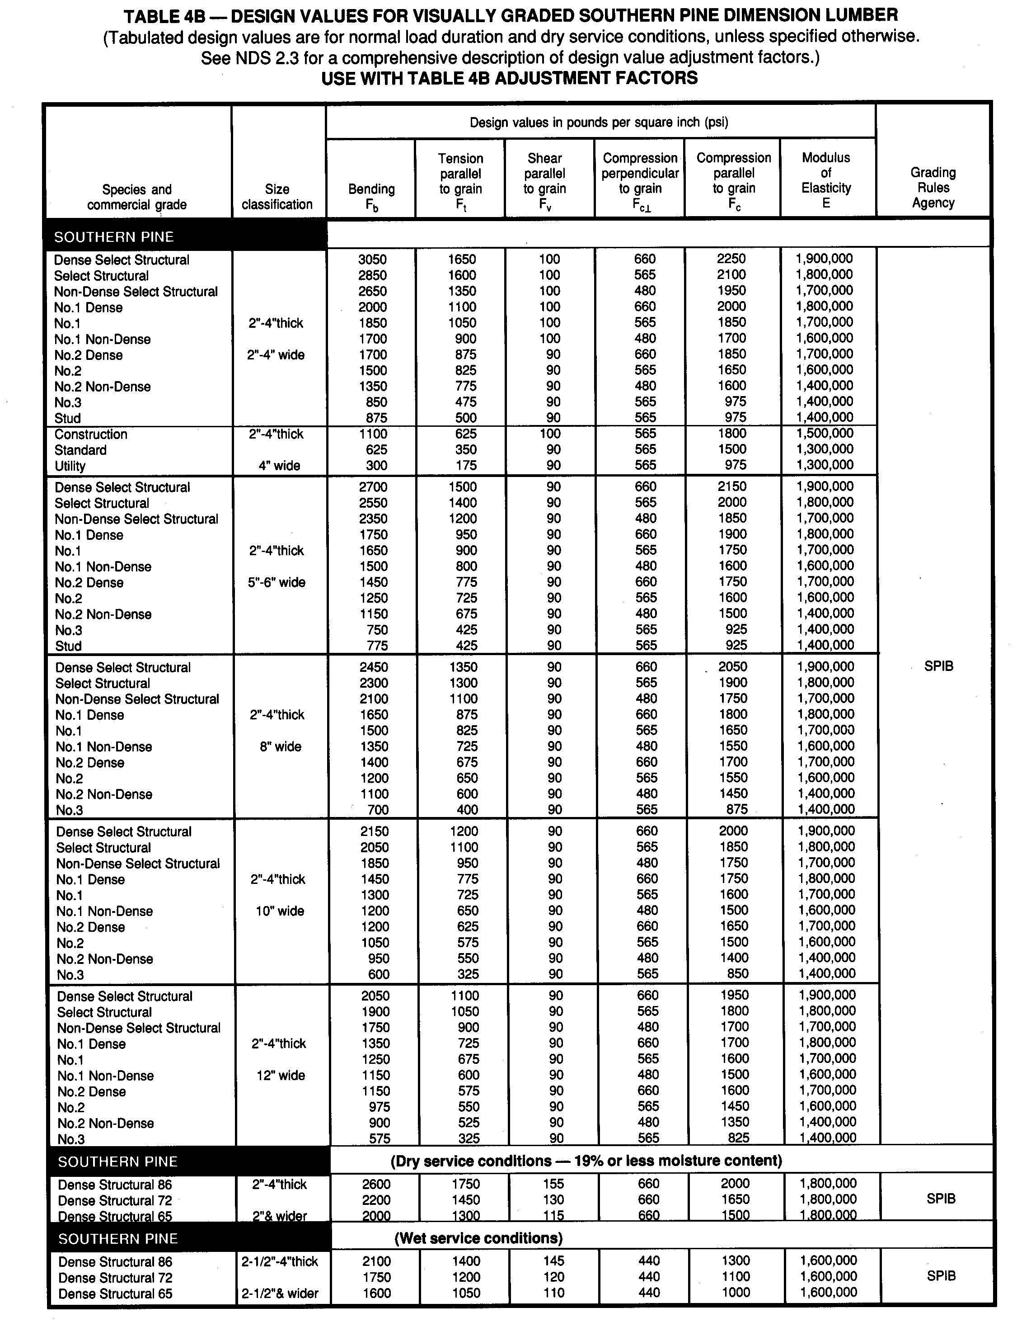

Procedure:

Compression Test
- Obtain nominal 3-1/2” compression cube specimens of three different woods (Southern pine, spruce, and oak for example). The cubes can be cut from a 4x4 section but should be clear wood. Ensure that the surfaces are to be parallel to one another. One set of specimens should be tested with the load applied parallel to the grain, and the other set of specimens should be tested with the load applied perpendicular to the grain. The number of test repetitions within a set depends on the desired confidence limits. Only one test per set will be run as part of this laboratory, as its objectives are to demonstrate the techniques and not to develop large robust data sets for engineering design.
- Measure the cross-sectional dimensions (width and thickness) of each test specimen to the nearest 0.002 in. using a caliper. Measure the total length (in the direction of loading) for the compression specimens. As the specimens may vary slightly in dimensions throughout their length, take several measurements, and record the approximate average for each measured dimension.
- After setting up the universal testing machine (see first manuscript on this series: Materials Constants), carefully center the specimen on the compression platen and lower the crosshead until a slight load is applied. Use the fine controls to back the load off to as close to zero as possible.
- Apply the compressive load slowly with a loading rate between 20 psi to 50 psi per second.
- The compression test may continue for several minutes with the load continually increasing and with significant strain seen in the specimen. Continue the test until a maximum load is obviously reached.
- Record the maximum load from the screen.
- Repeat for all specimens, both with specimens parallel and perpendicular to the grain.

Tension Test
- Obtain dog-bone specimens of three different woods (Southern pine, spruce, and oak for example). One set of specimens should be tested with the load applied parallel to the grain, and the other set of specimens should be tested with the load applied perpendicular to the grain. Note that these are not the specimen type required for ASTM tests on wood, as the intent is to demonstrate tensile behavior and not to develop a database for design.
- Proceed as normal with the usual tension test machine (see second manuscript on this series: Tensile Tests on Steel).

Bending Test
- Obtain a 2x4 about 24 in. long of dense Southern pine.
- Install a four-point bending test apparatus on the universal testing machine (Figure 6).
Figure 6 – Four-point bending apparatus
- Start the testing machine and associated software. Make sure the software is set to capture the maximum load and record the loads and cross-head values.
- Install the 2x4 into the apparatus and lower the upper crosshead until the apparatus just begins to make contact with the wood beam.
- Apply the load slowly (around 2000 lbs per minute) until the beam fractures (Figure 7).
Figure 7 – Wood beam flexural failure
- Record the failure load.

Results:
The compression, tension, and bending test results are summarized in Table 2. As shown consistently by all results, oak is the strongest wood, followed by spruce and southern pine. For the Southern pine, it is instructive to compare some of these values to those in Table 1. The comparisons will be made for a construction stress grade as the wood was obtained from a large hardware and material store. For bending, the ratio between the actual strength (7423 psi) and the allowable design (1100 psi) results in a factor of safety of about 6.7; for compression parallel to the grain, the ratio is about 3.0 (5437/1800). It is interesting to note that for bending the factor of safety would be about 2.4 even if we assumed the strongest available stress grade for Southern pine (dense select structural). This points out that very large factors of safety are used in wood for strength design. Generally wood structures will be governed by other design limits, including short and long term deformations, local crushing, and buckling during construction.
Table 2 – Wood testing summary
 | Compression Parallel (psi) | Compression Perpendicular (psi) | Tension Parallel (psi) | Tension Perpendicular (psi) | Bending (psi)
Oak | 7382 | 2045 | 4780 | 547 | 8902
Spruce | 6342 | 1534 | 3451 | 412 | 7834
Southern pine | 5437 | 1254 | 2756 | 327 | 7423
Table 3 – Normalized data
 | Compression Parallel (psi) | Compression Perpendicular (psi) | Tension Parallel (psi) | Tension Perpendicular (psi) | Bending (psi)
Oak | 1.00 | 1.00 | 1.00 | 1.00 | 1.00
Spruce | 0.86 | 0.75 | 0.72 | 0.75 | 0.88
Southern pine | 0.74 | 0.61 | 0.58 | 0.60 | 0.83
Table 3 presents the same data as in Table 2 but normalized to the strength of the oak material. For the two most important properties, bending strength and compression parallel to the grain, the spruce seems to be roughly about 87% and the southern pine roughly 78% as strong as the oak. Given the very large price differential between woods, it would appear that southern pine, as the cheapest of them, is a very efficient choice.

Summary:
Wood is a sustainable, natural material that exhibits orthotropic properties. In other labs, materials such as metals, polymers, and concrete have been tested in tension or compression with the assumption that the material acts isotropically, meaning that its resistance to a particular load is the same regardless of the orientation of the material. Steel, for example, has a myriad of randomly oriented grains at the micro scale, giving it homogenous and isotropic properties at the macro scale. However, wood, with its easily identifiable grain direction, does not act isotropically. Thus, a designer must carefully consider the anticipated loadings on a wood member or structure to ensure maximum effectiveness of the material. Additionally, due to its natural origin, wood has mechanical properties tied to the individual species of tree, the moisture content, and the size of the test specimen.

Applications:

Until recently, wood structures were limited to three or four stories in an apartment or small office building. Developments of cross-laminated timber, wood panels consisting of layers oriented at right angles to one another and then glued, have resulted in the development of structural systems capable of reaching 8 or more stories (Figure 8). Much taller buildings, in the order of 20 stories, are still under development.
Figure 8 – Multi-story wood building

