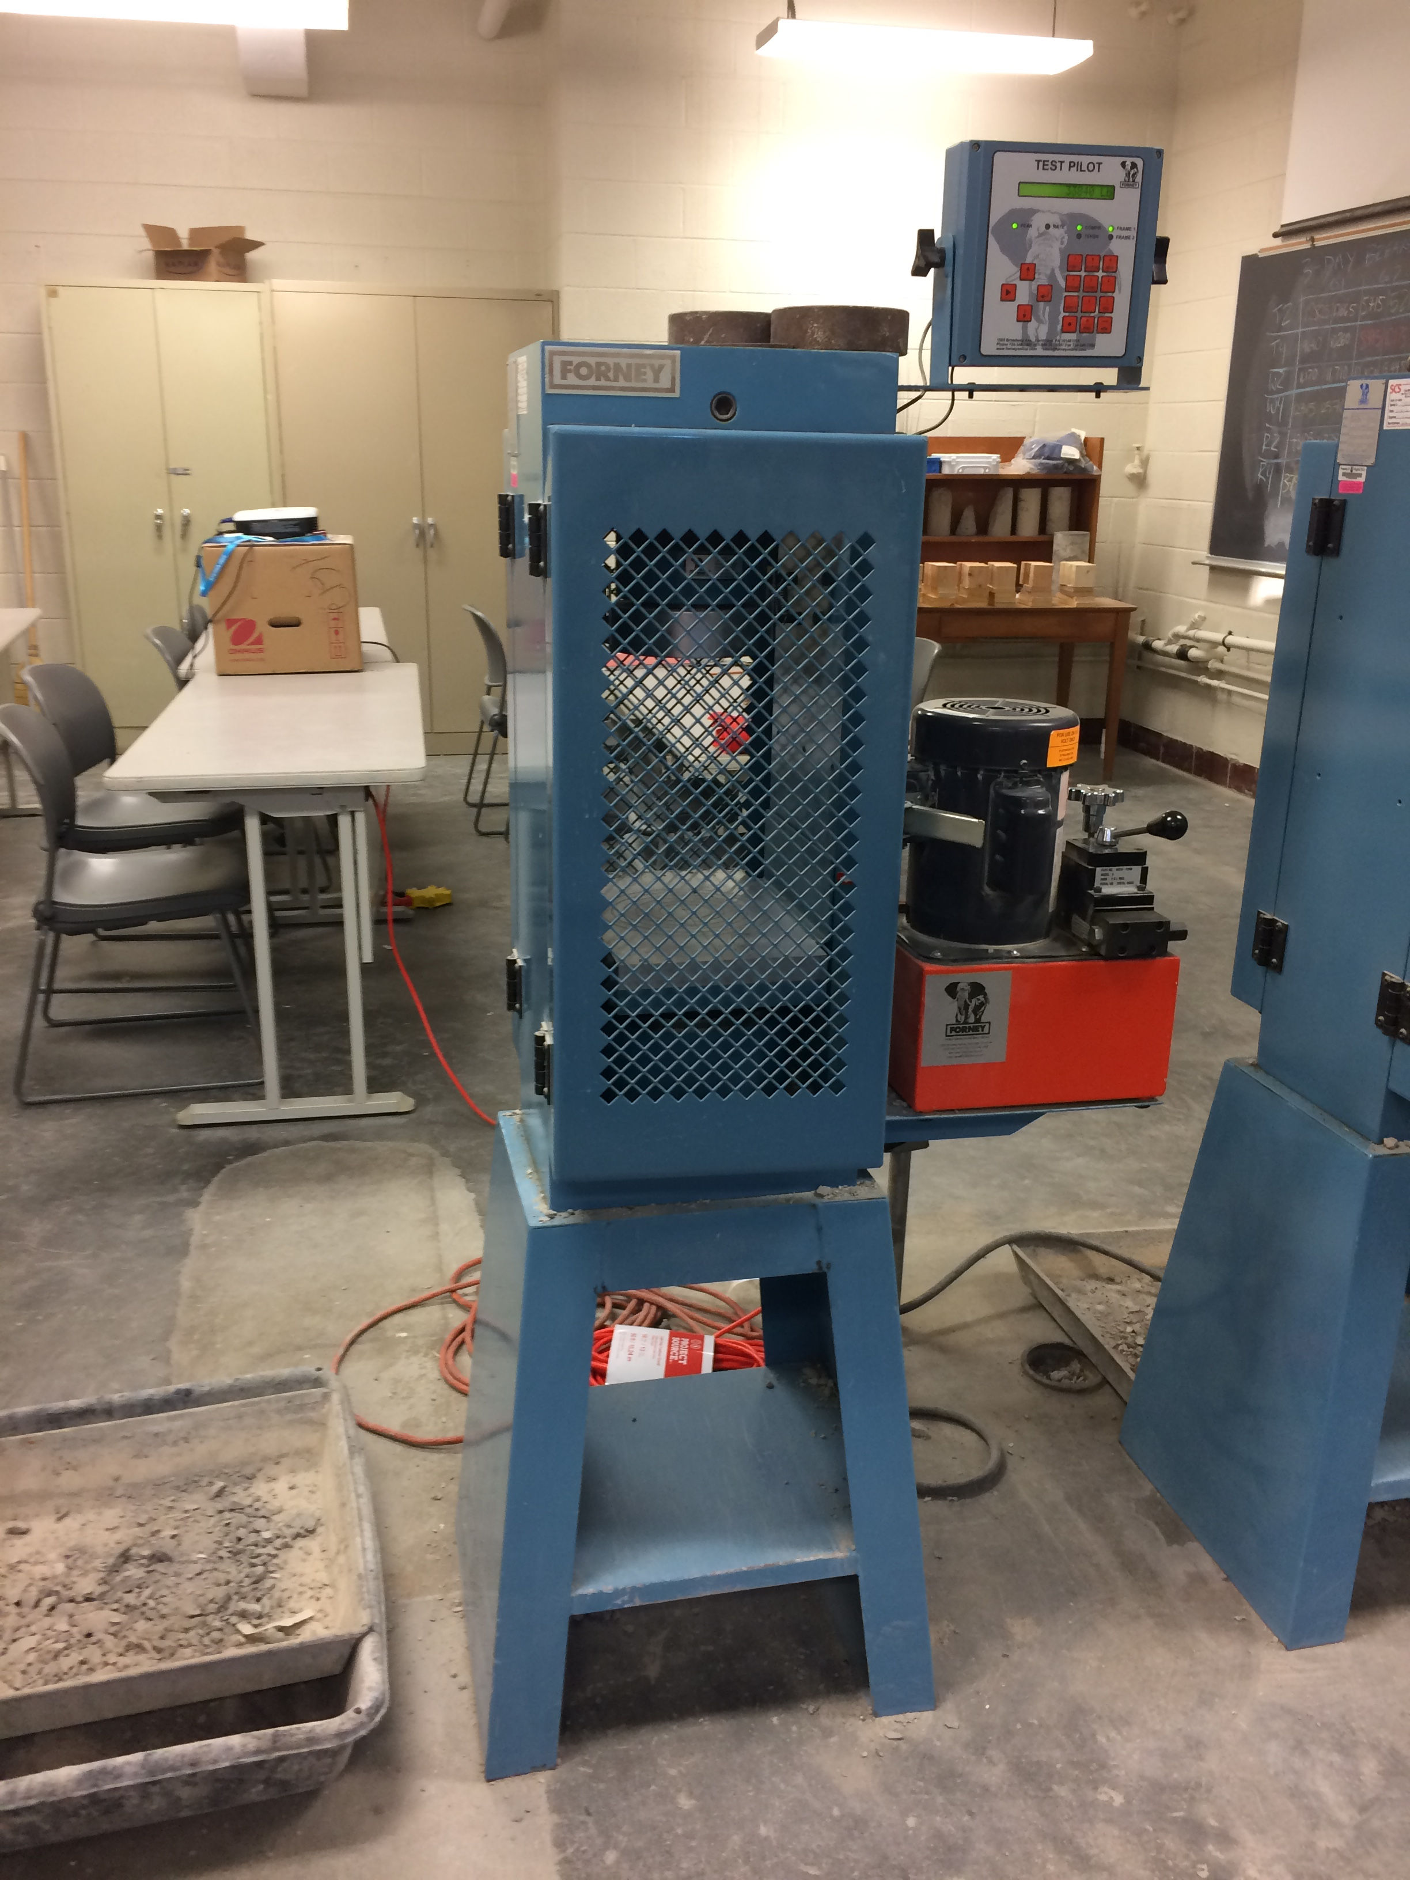

Figure 1 – Typical concrete cylinder testing machine

Figure 2 –Compressometer

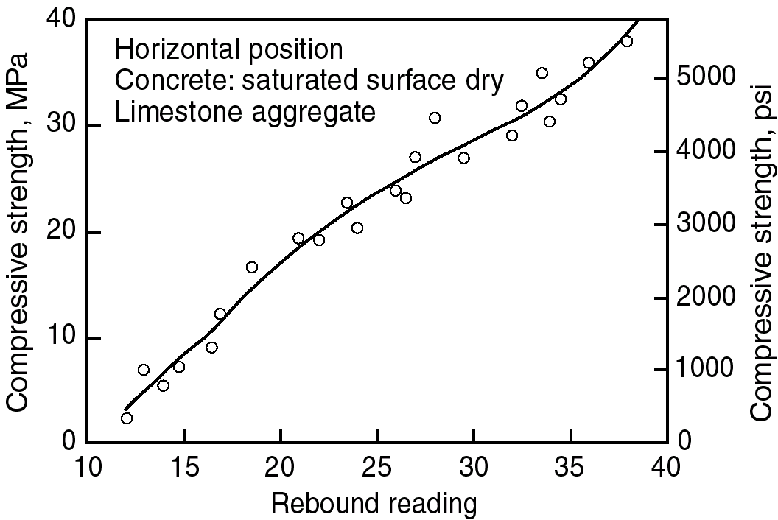
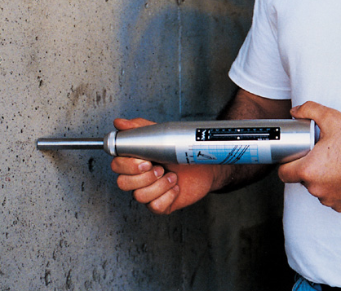

Figure 3 – Schmidt hammer and typical calibration curve

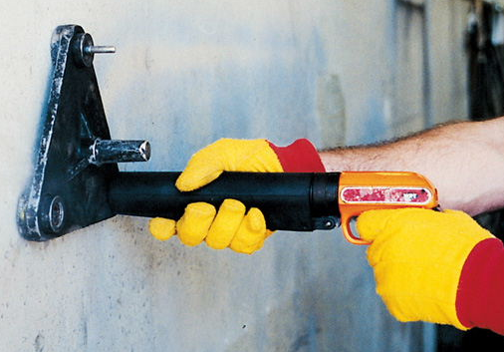
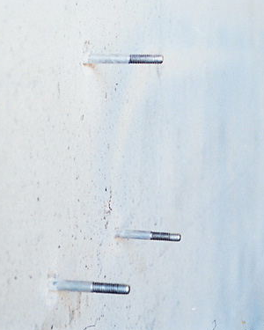

Figure 4 – Windsor probe

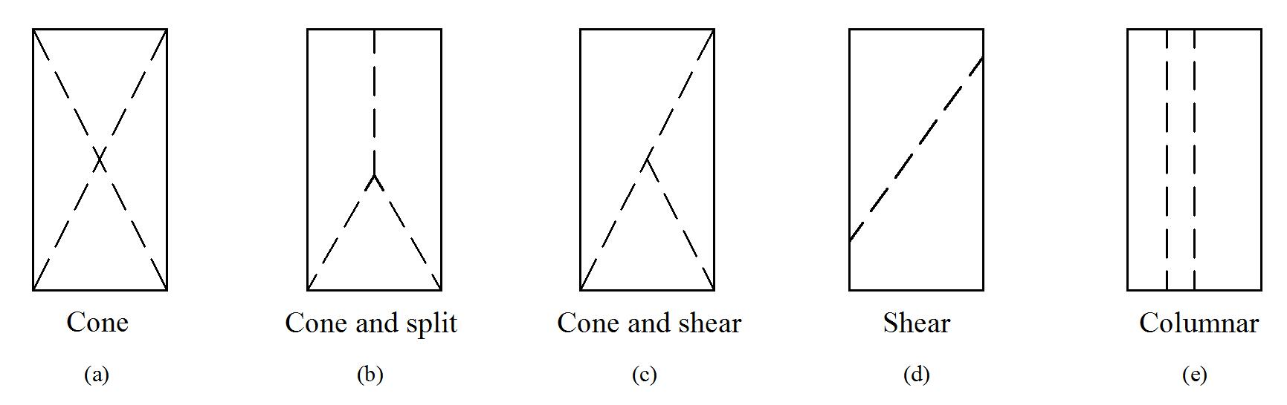

Figure 5 – Fracture modes in concrete cylinders under compression

