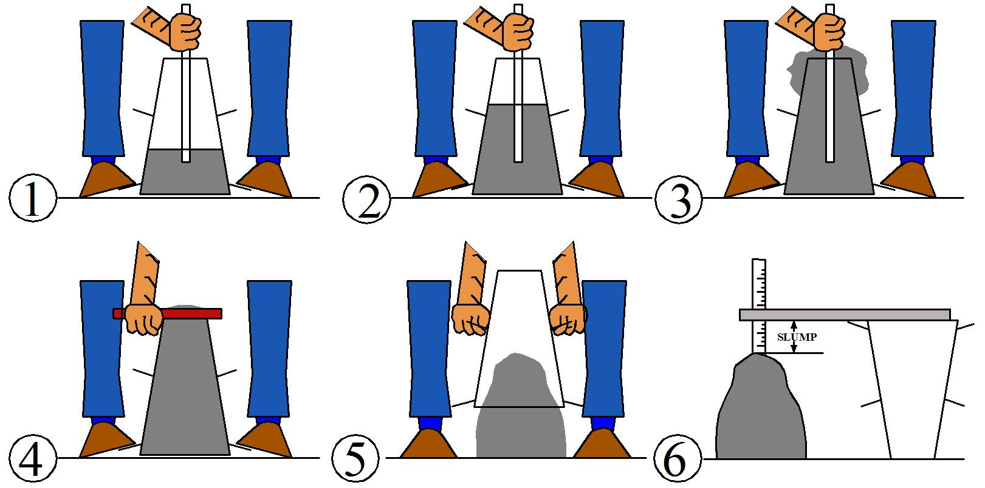

Figure 1 – Slump cone test: (1)-(3) Filling and rodding three layers; (4) Striking concrete level flush with top of the cone; (5) Lifting cone; (6) Measuring slump.

Figure 2 – Air entrainment test.

Figure 3 – Flow table test.

