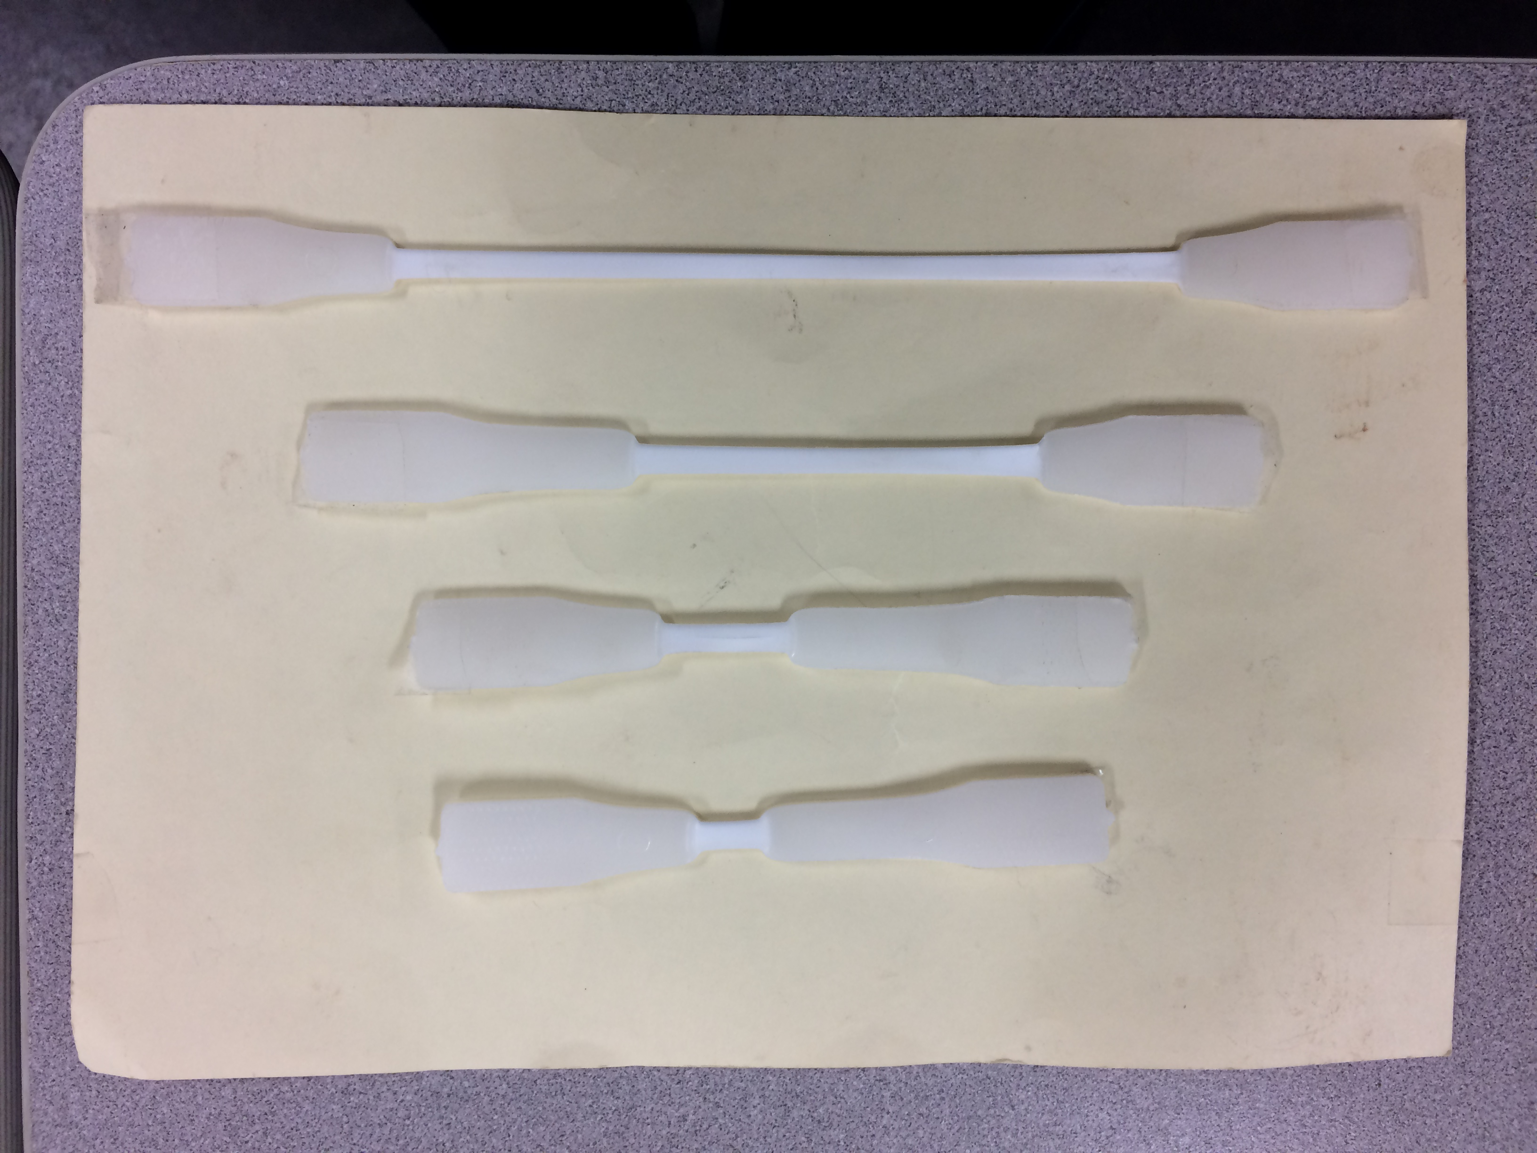
Figure 1A: Progression of necking in a short HDPE specimen
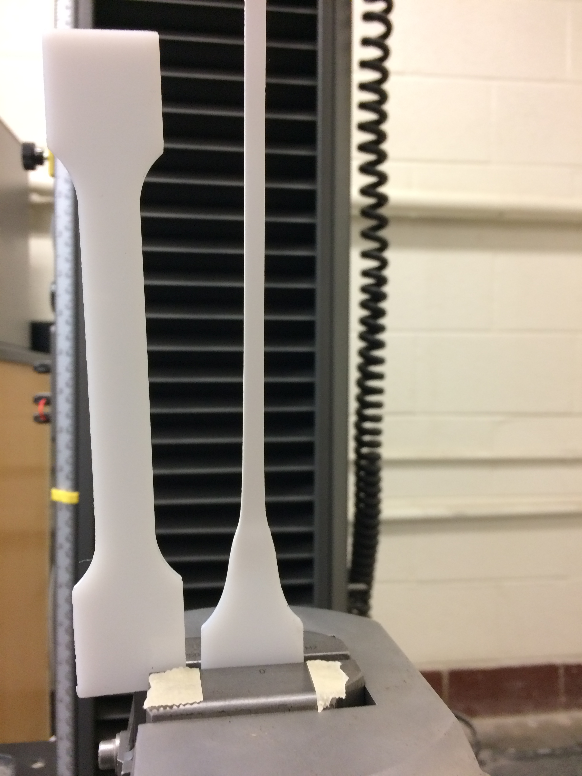

Figure 1B: Close up of necking near grip, showing comparison to original specimen

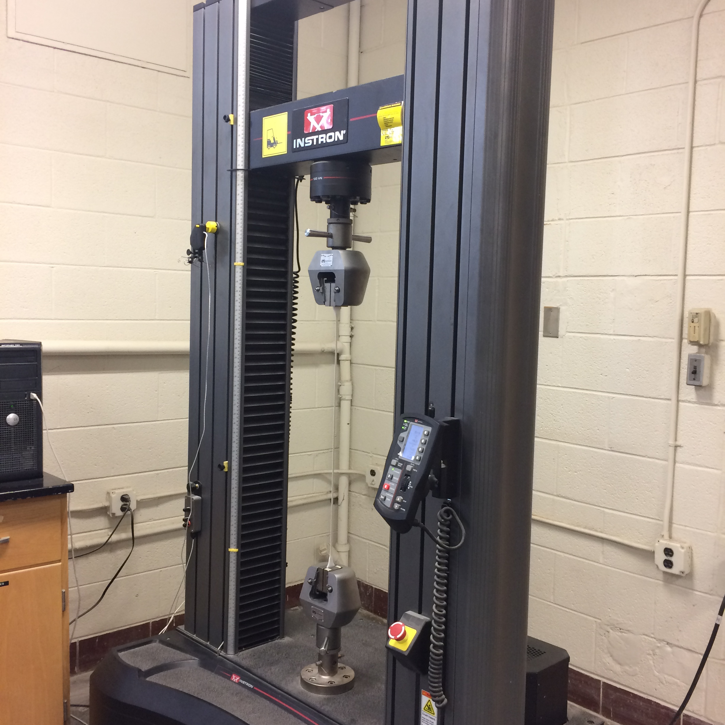

Figure 2 – Large deformations possible in a HDPE loaded slowly. The photo shows the entire specimen whose end is shown in Figure 4B

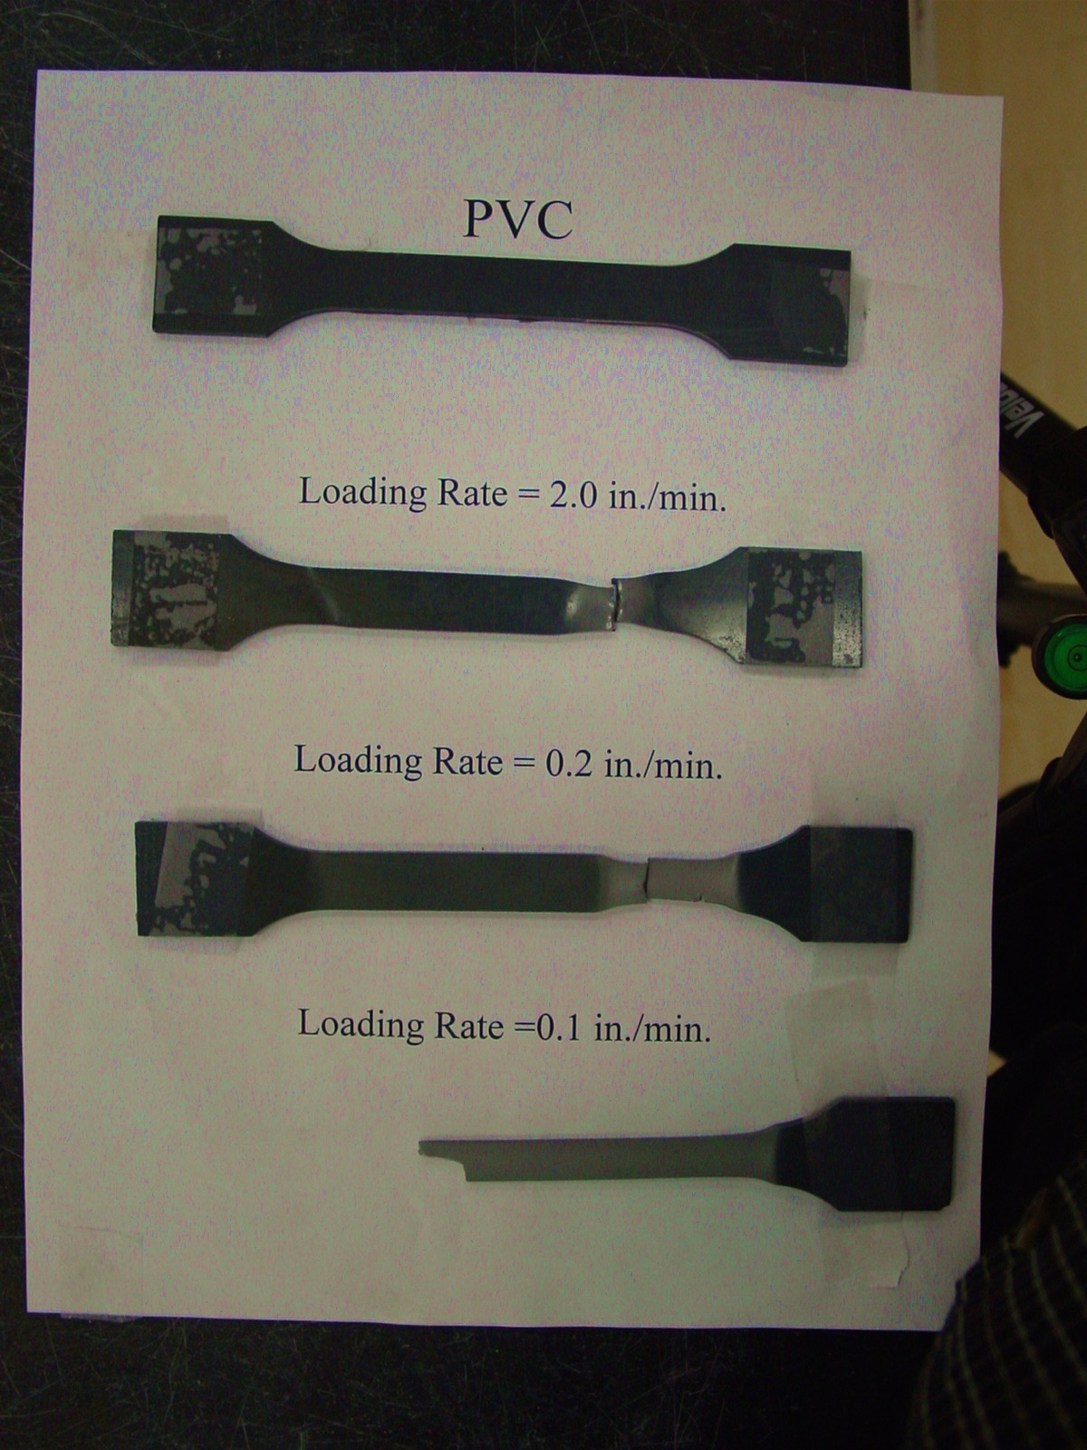
Figure 3 – Failure in a PVC specimen showing strain rate effects

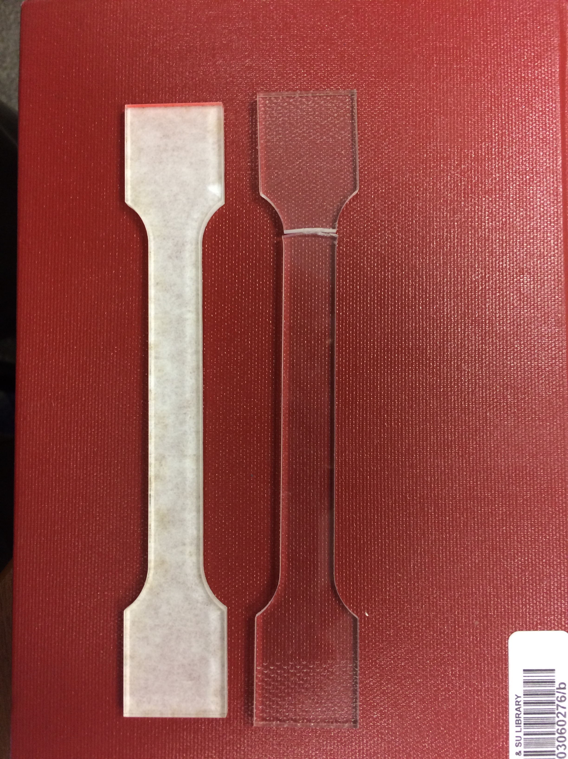

Figure 4 – Acrylic specimen with white backing and fractured acrylic specimen

Figure 5 – Stress-strain curve for HDPE

Figure 6 – Stress-strain curve for PVC

Figure 7 – Stress-strain curve for nylon

Figure 8 – Stress-strain curve for an acrylic

Figure 9 – Comparison of stress-strain curves up to 50% strain

