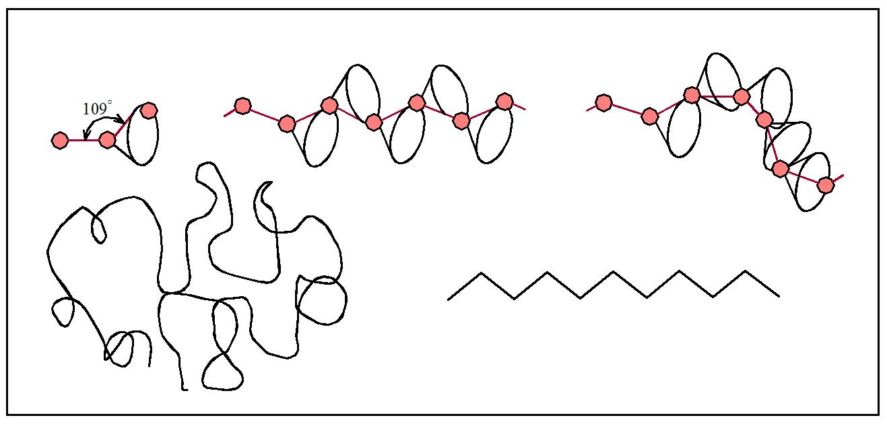
Figure 1 – Tetrahedral carbon bonding and resulting chains

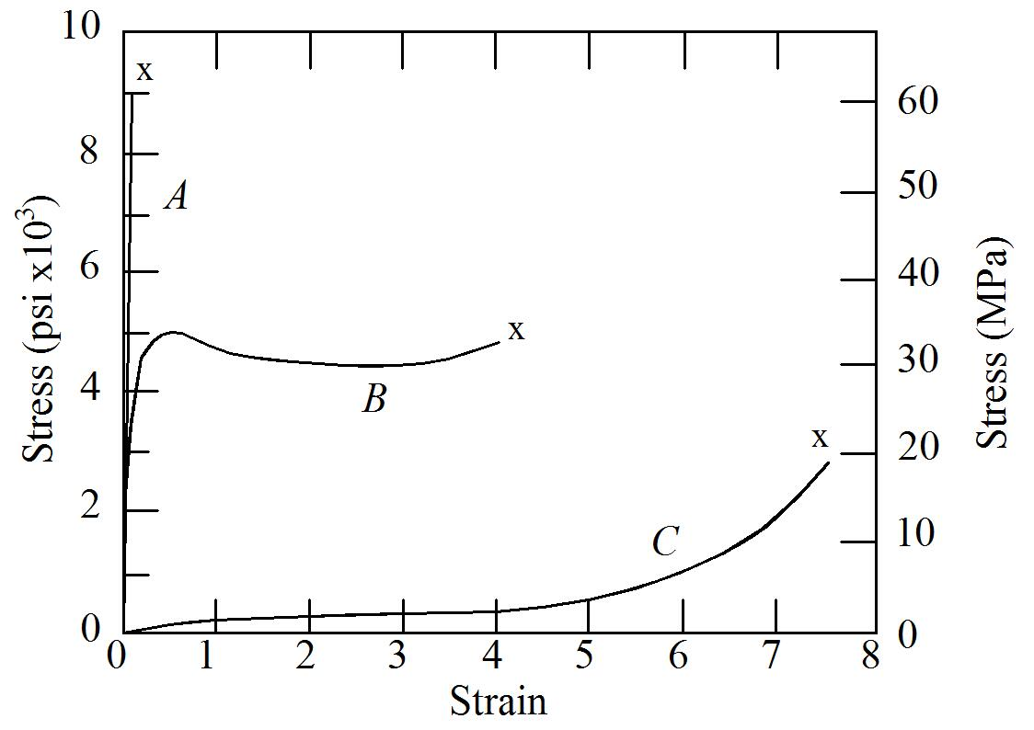
Figure 2 – Typical schematic stress-strain curves for polymeric materials

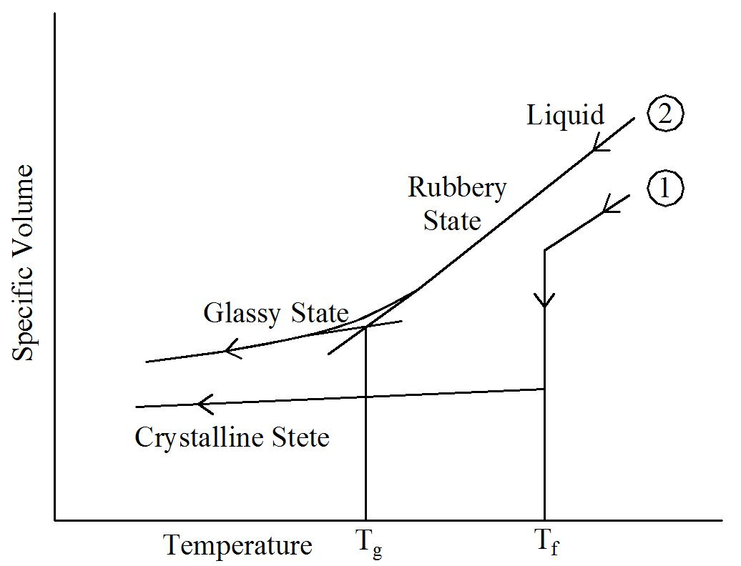
Figure 3 – Temperature behavior of polymeric materials

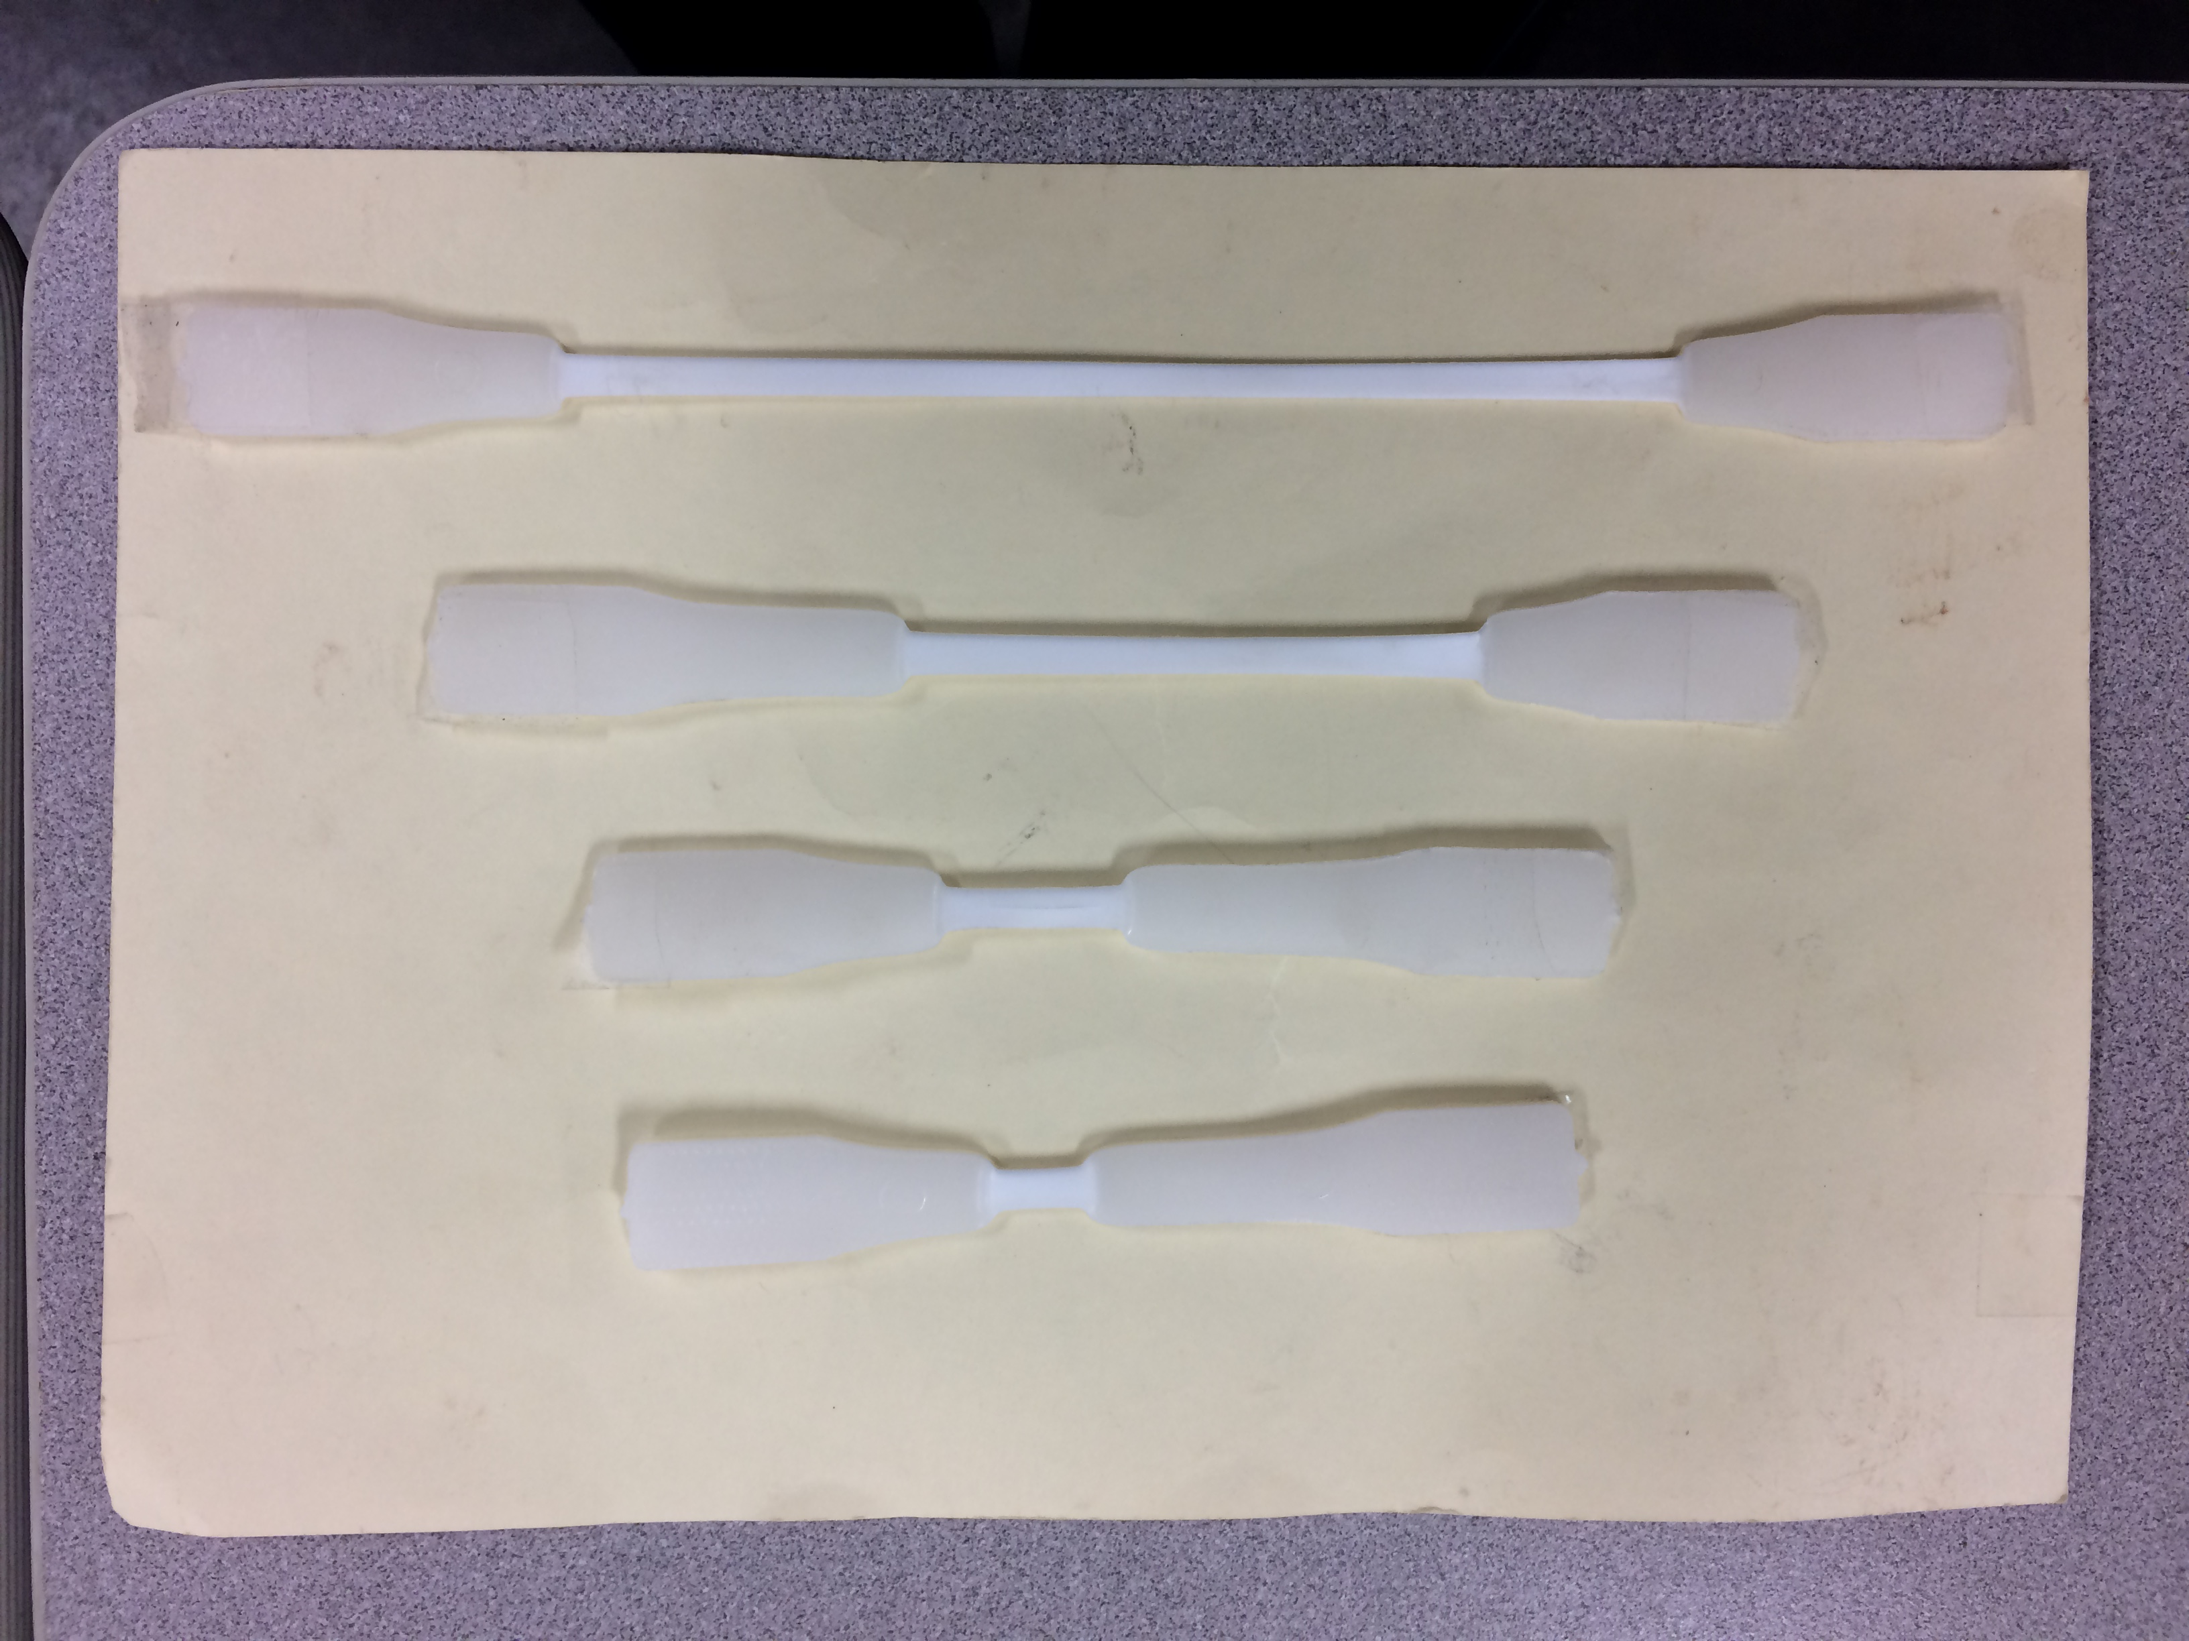
Figure 4A: Progression of necking in a short HDPE specimen
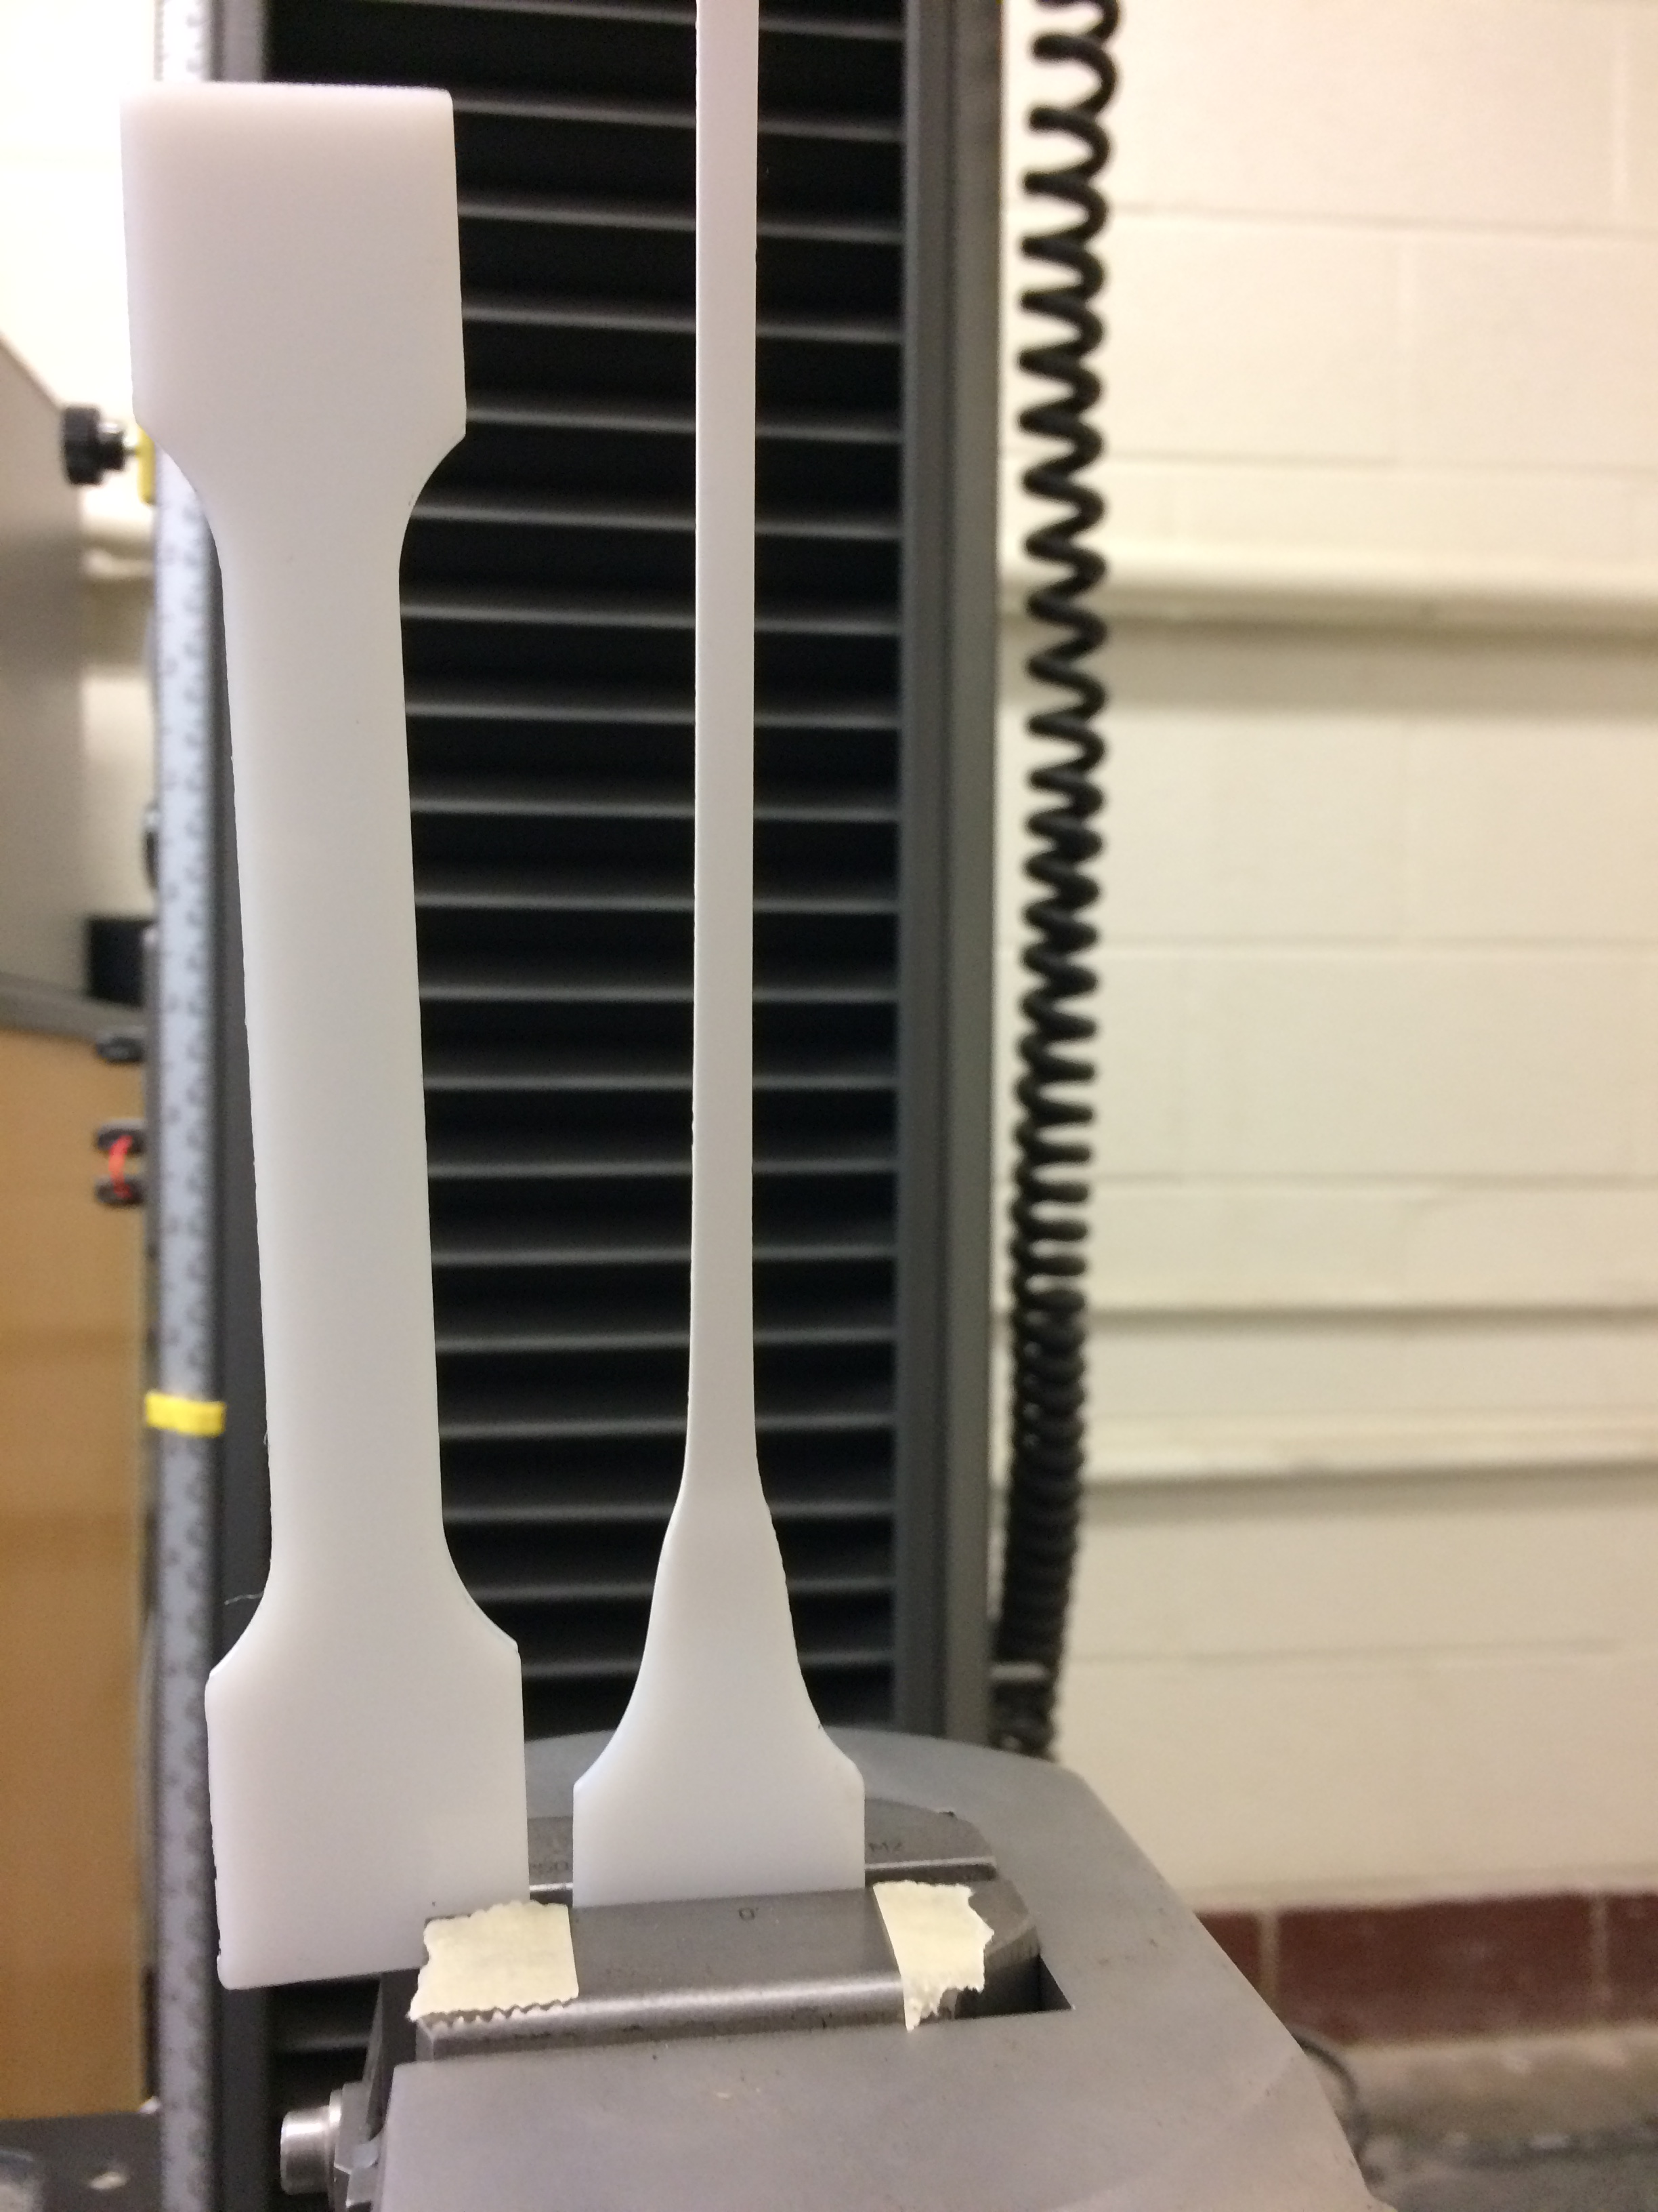

Figure 4B: Close up of necking near grip, showing comparison to original specimen
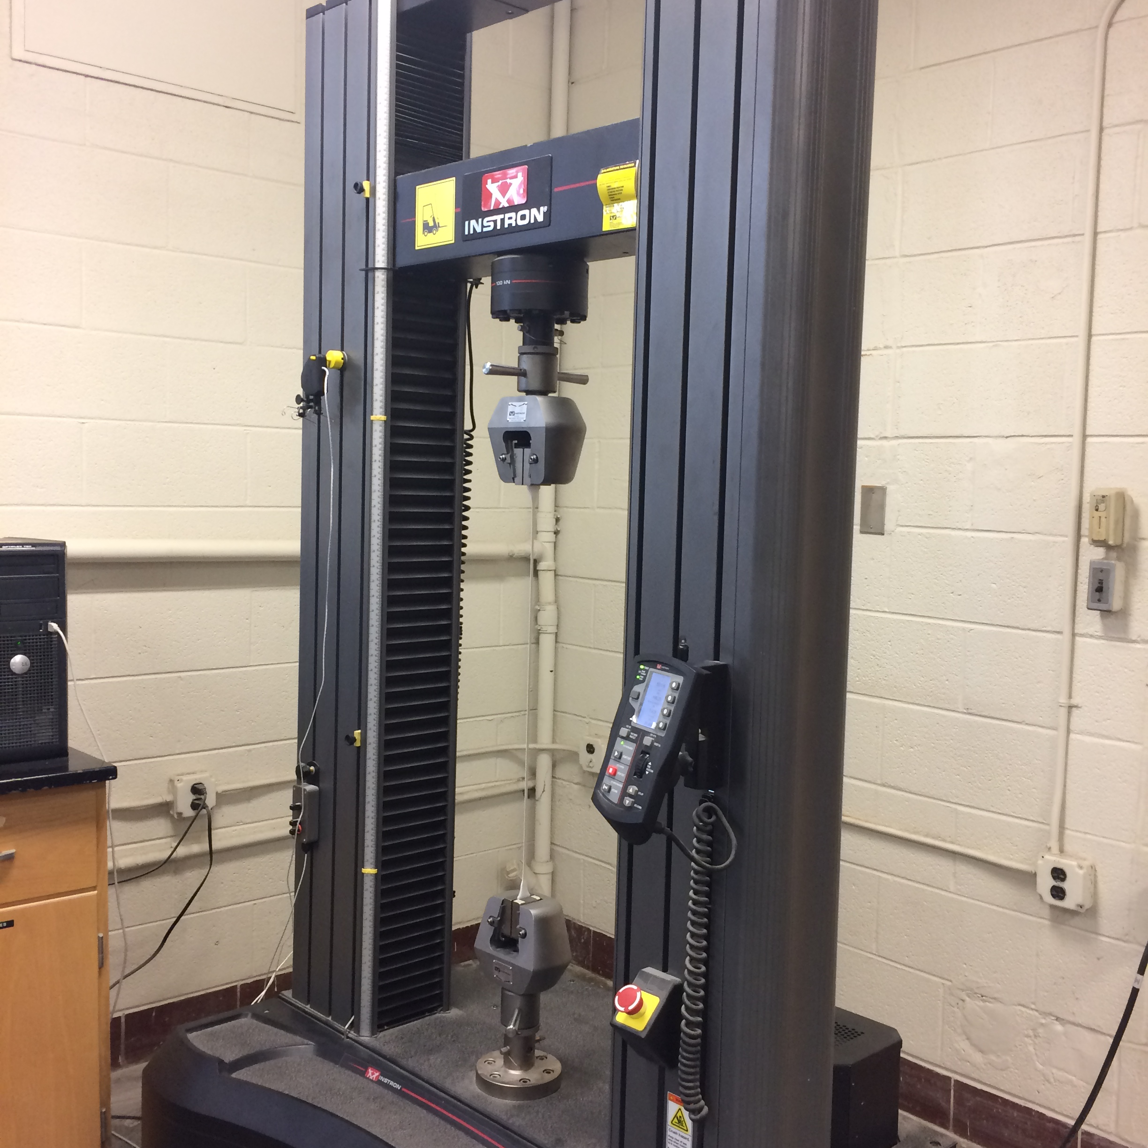

Figure 5 – Large deformations possible in a HDPE loaded slowly. The photo shows the entire specimen whose end is shown in Figure 4B

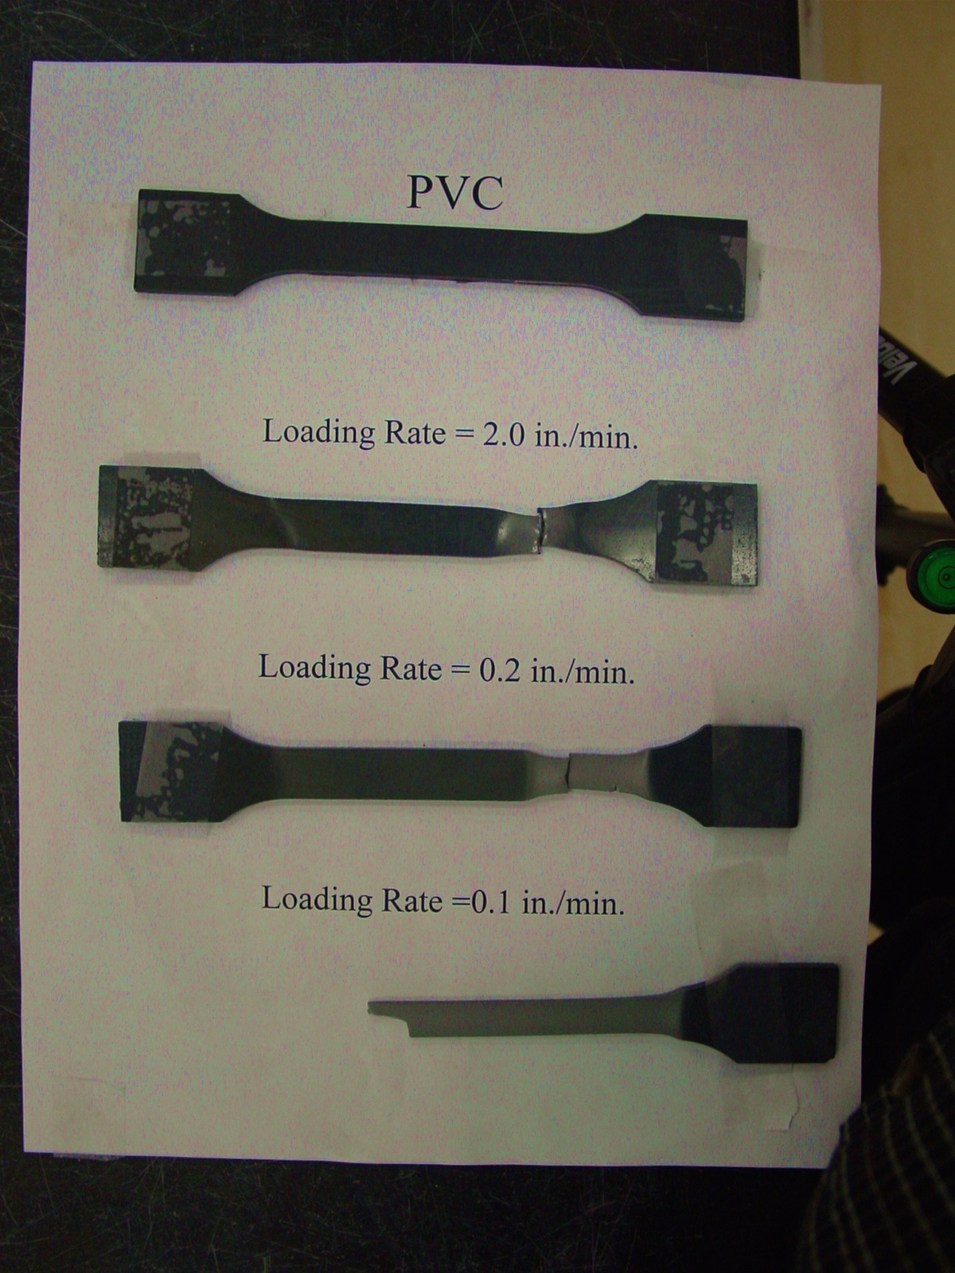
Figure 6 – Failure in a PVC specimen showing strain rate effects

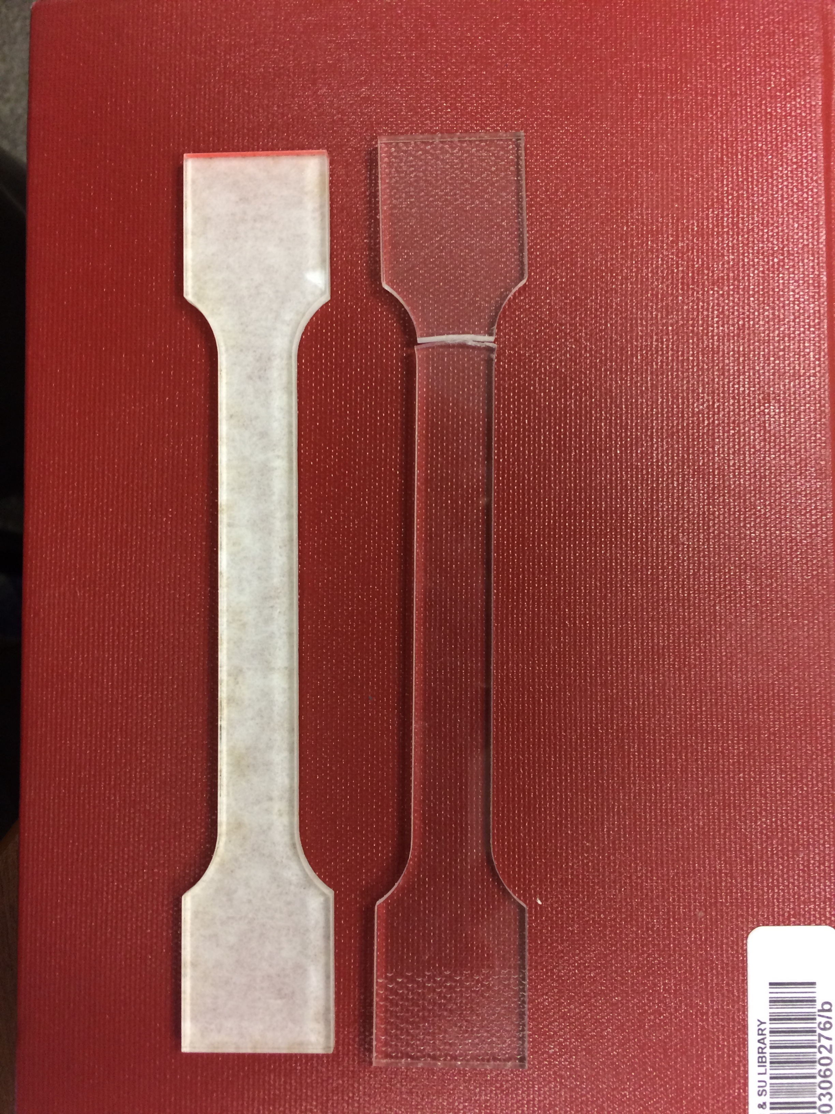

Figure 7 – Acrylic specimen with white backing and fractured acrylic specimen

Figure 8 – Stress-strain curve for HDPE

Figure 9 – Stress-strain curve for PVC

Figure 10 – Stress-strain curve for nylon

Figure 11 – Stress-strain curve for an acrylic

Figure 12 – Comparison of stress-strain curves up to 50% strain

