(a) Periodic forcing function

(b) Random forcing function
σ_{SR}=30 ksi
( c) Rainflow counting

Figure 1 – Periodic and random load histories
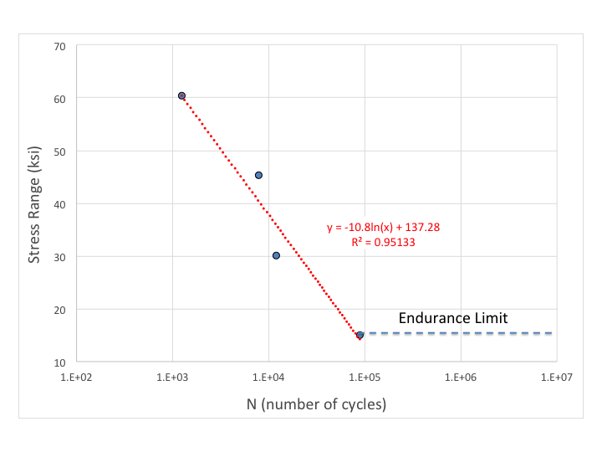
Figure 2 – Resulting S-N curve

