p(t)
u_{(t)}
m
c
k
Figure 1 – Single degree of freedom system model.

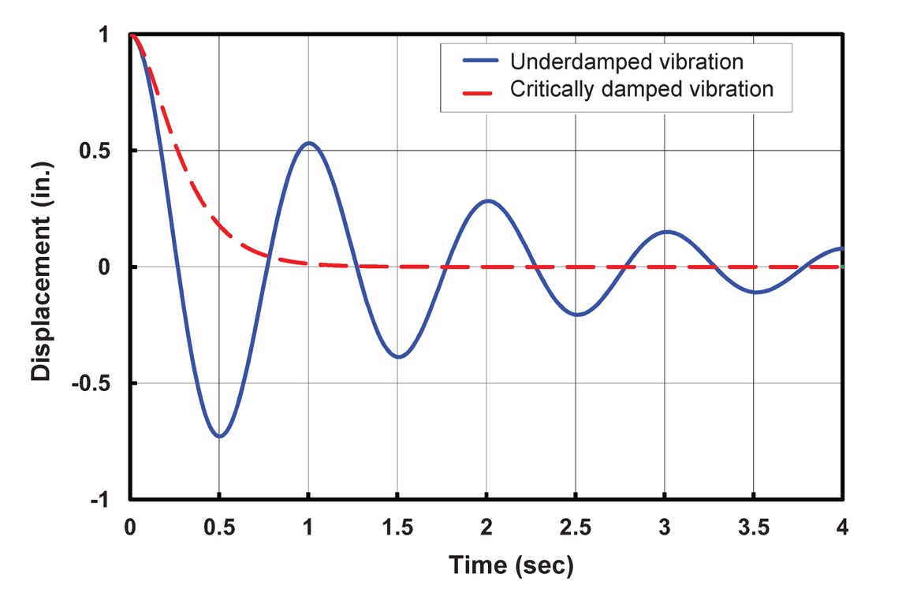
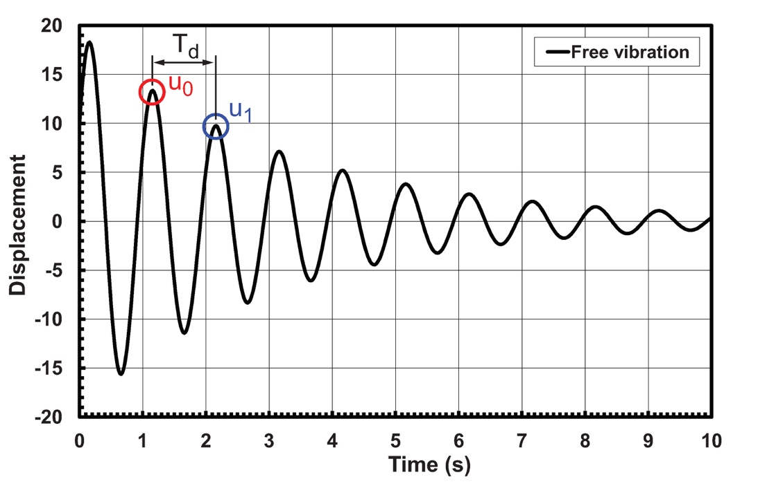

Figure 2 – Effect of damping on free vibrations: (a) definition of critical damping; (b) calculation of damping from logarithmic decrement.

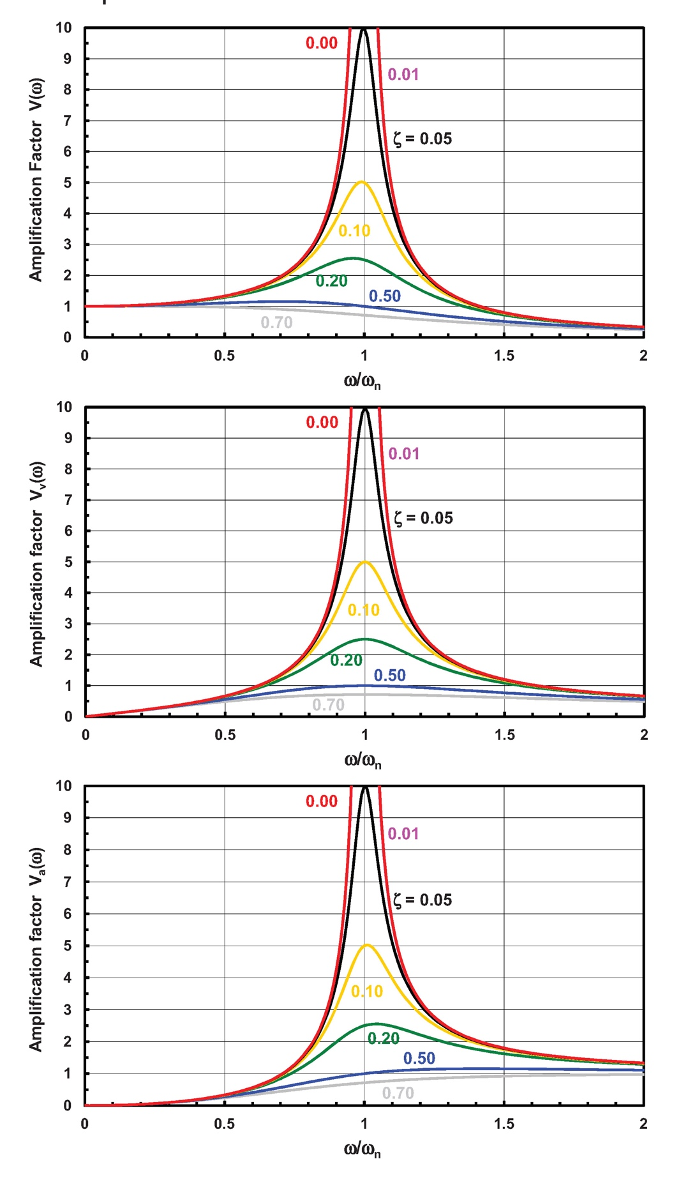

Figure 3 – Displacement, velocity and acceleration response.

Figure 4 – Deformation of Beam #1 vs. normalized table frequency.

