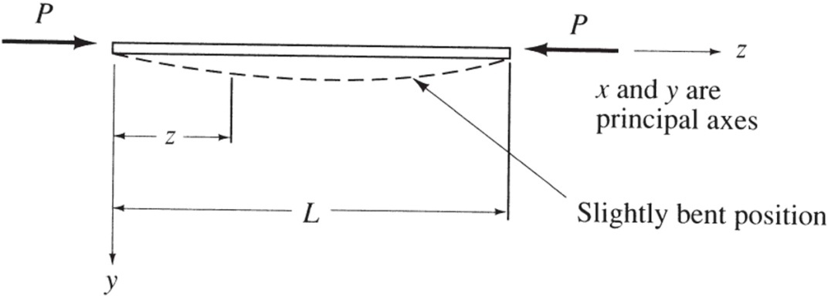

Figure 1 – Column in equilibrium in a slightly bent configuration.

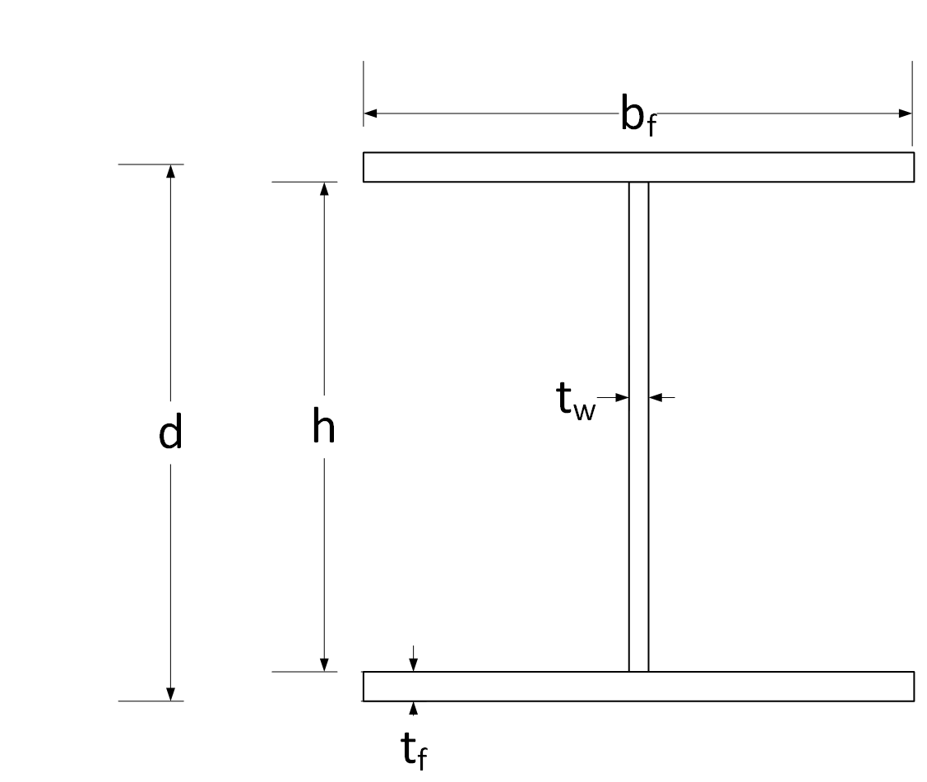
Figure 2 – Definitions of dimensions for a typical steel W-shape

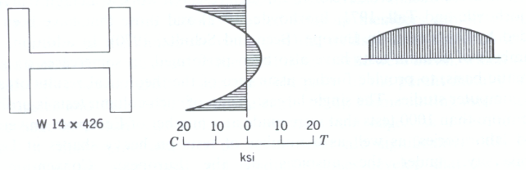

Figure 3 – Residual stresses from cooling in typical W-section.

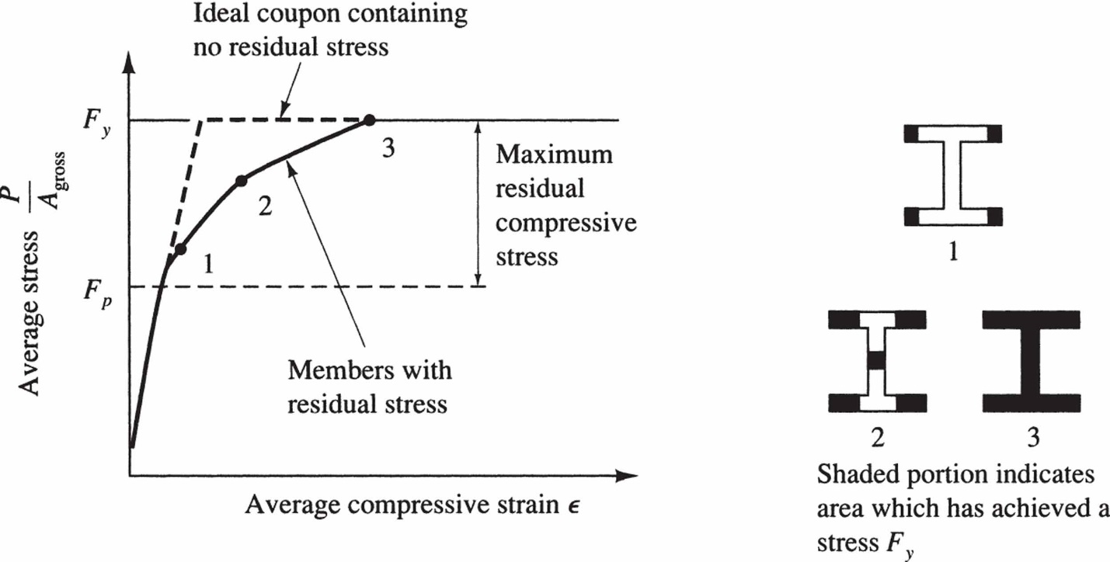
Figure 4 – Effect of residual stresses on moment of inertia and buckling.

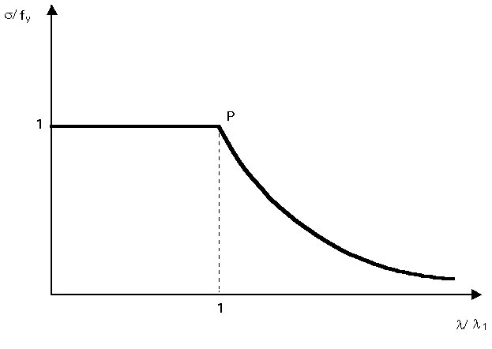
Figure 5 - Critical stress as a function of the effective slenderness

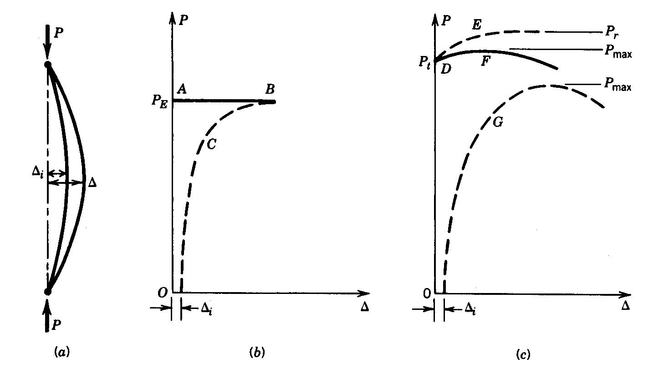
Figure 6 – Column buckling

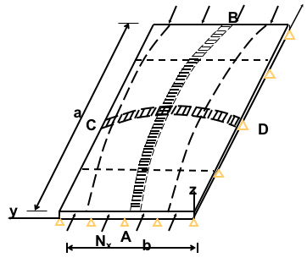
Figure 7 – Plate buckling

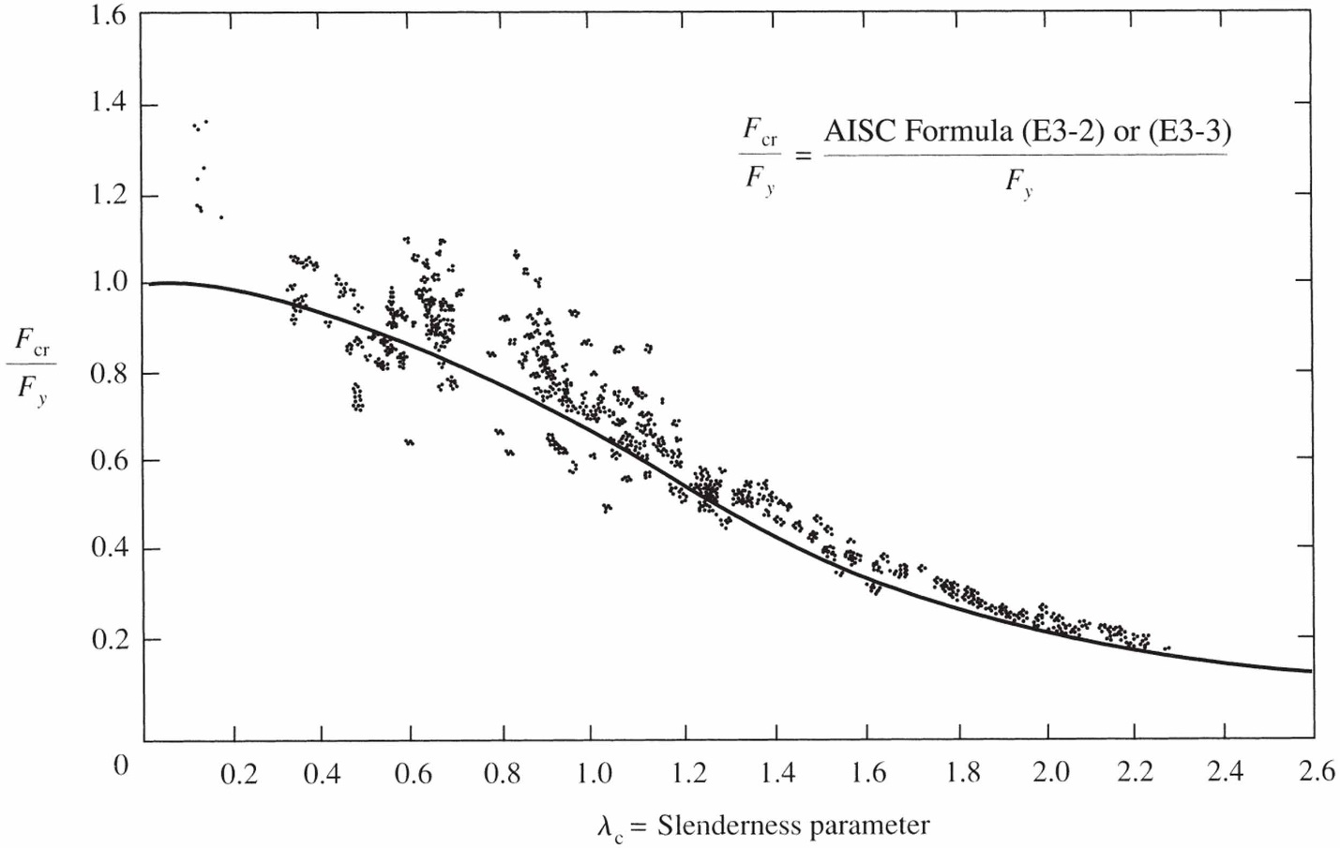

Figure 8 – Column buckling results.

