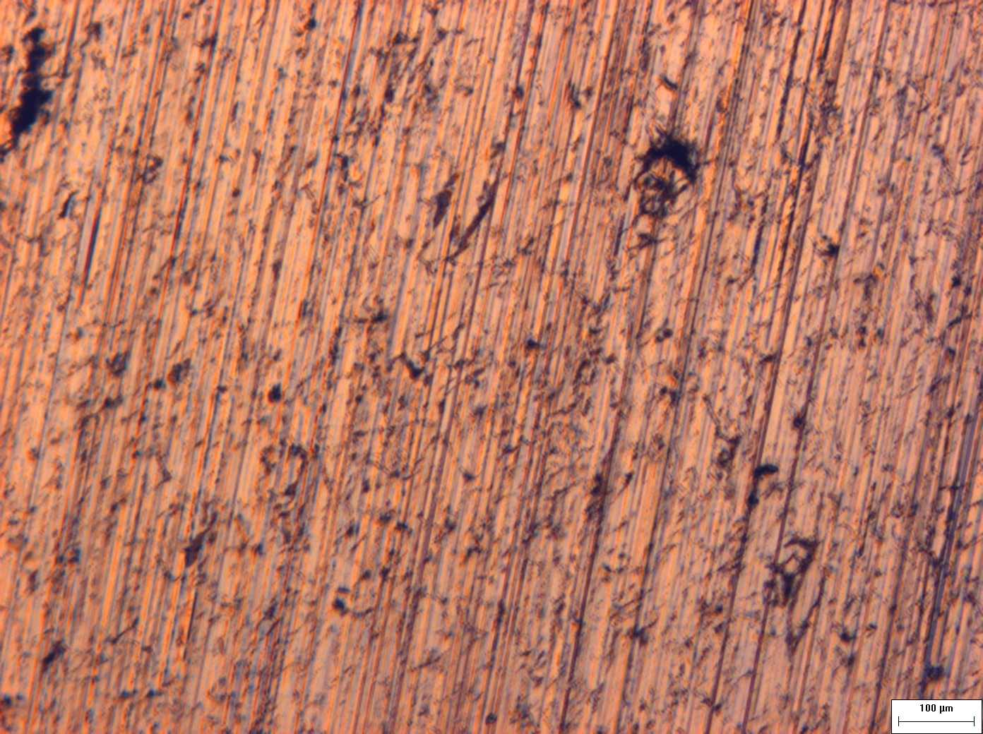
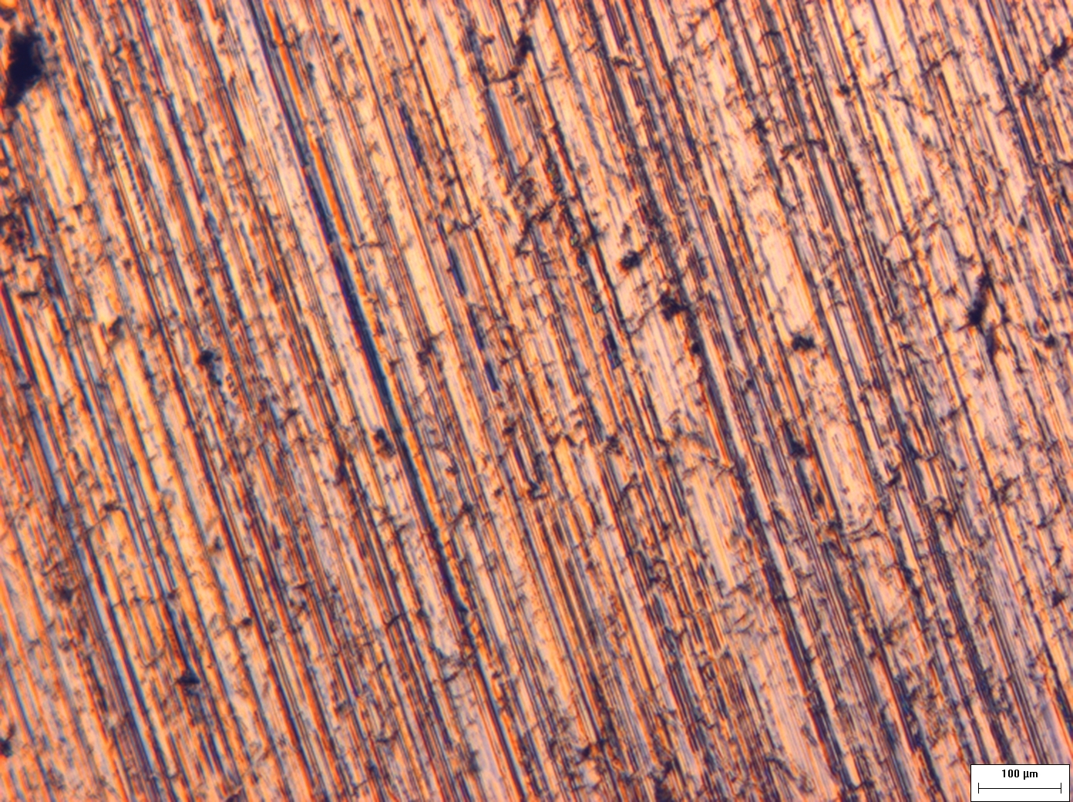
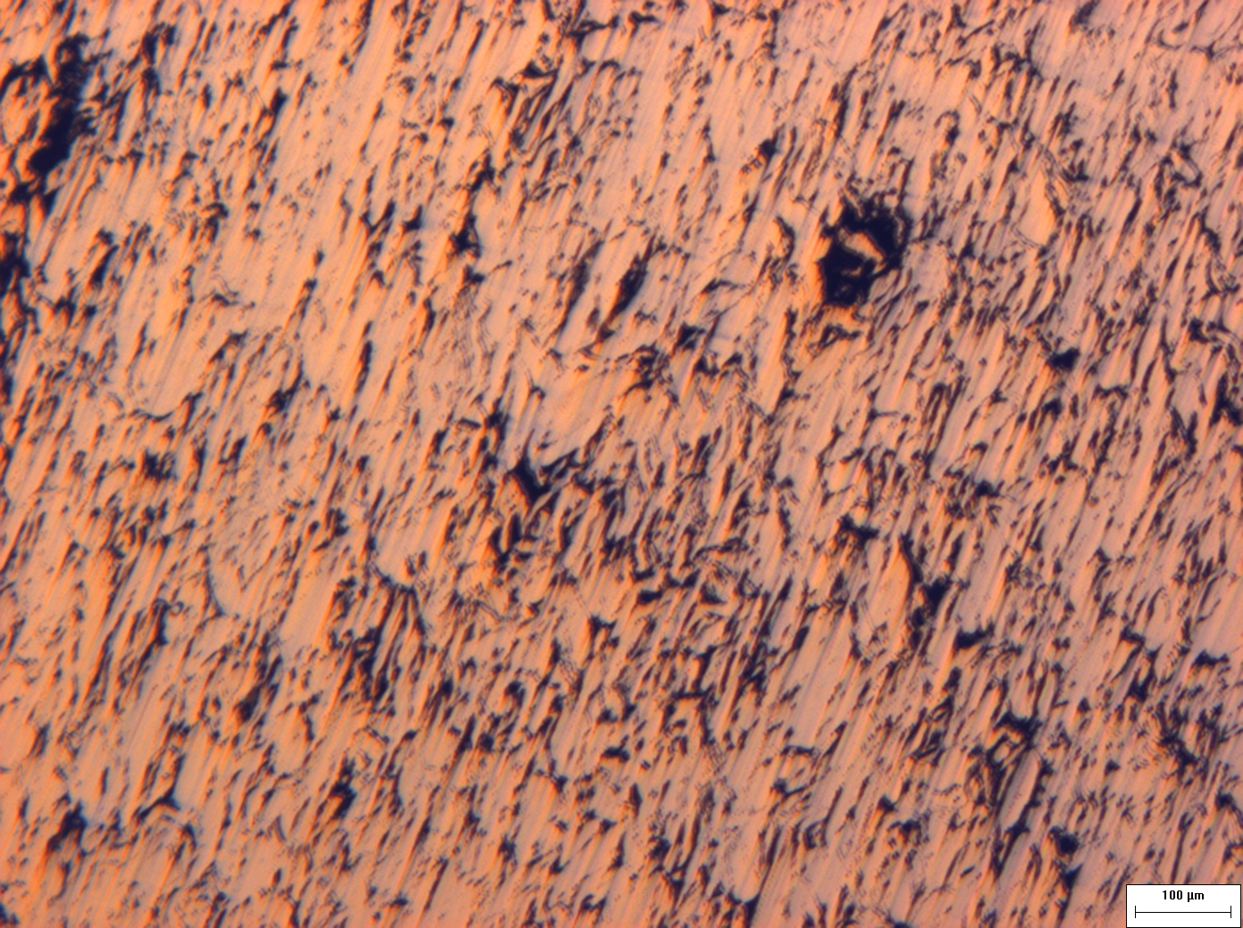
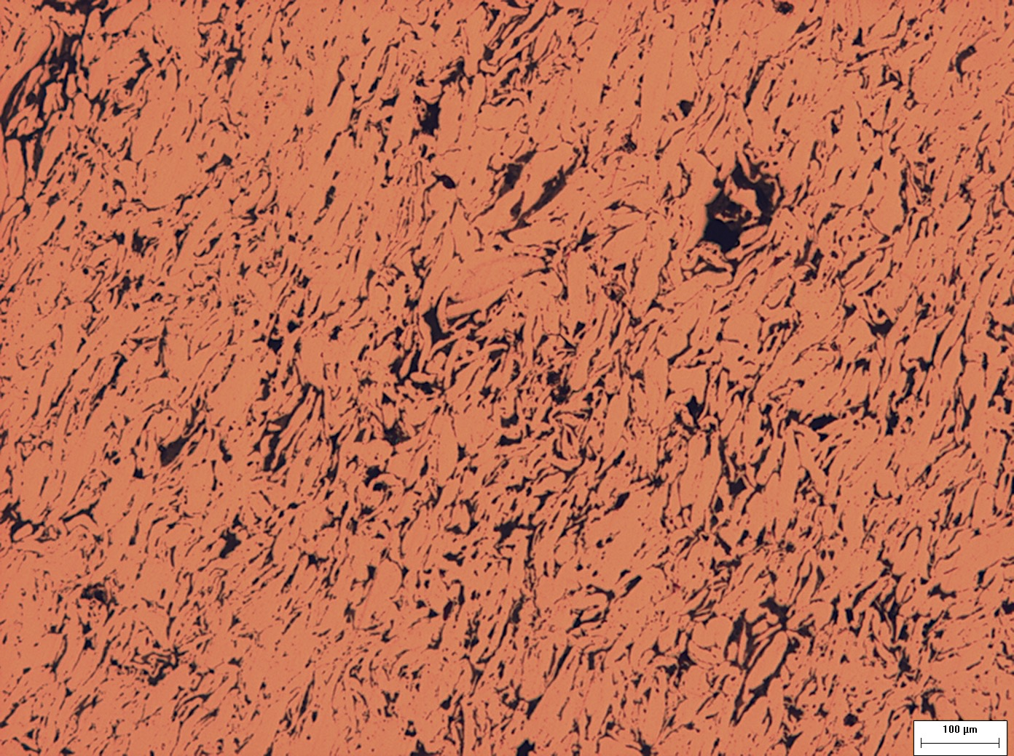
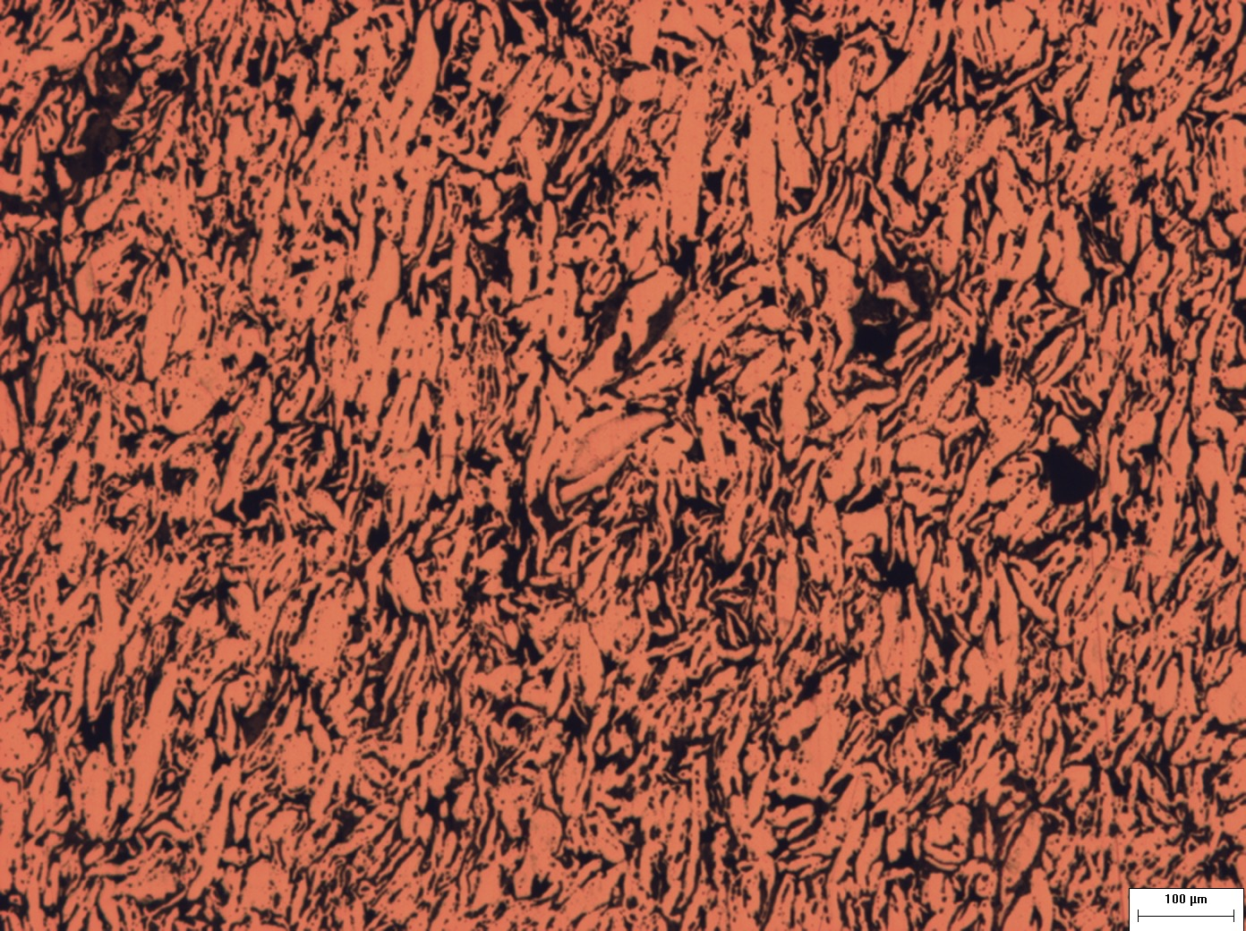
a
b
c
d
e

Figure 1: Polishing the sample with a) 600 grit, b) 1200 grit, polishing papers followed by c) 1 μm, d) 0.01 μm alumina suspensions on polishing cloths. Finally, d) etching for 20 seconds a nital solution revealed the porosity.

