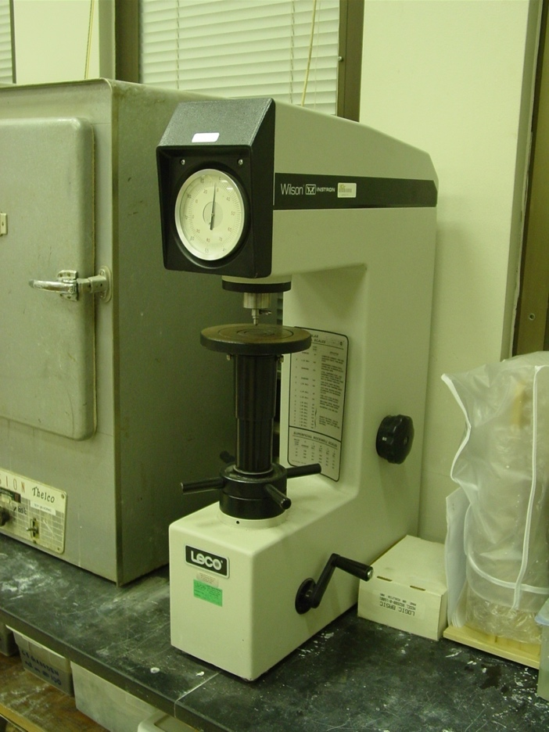

Figure 1 – Rockwell testing machine

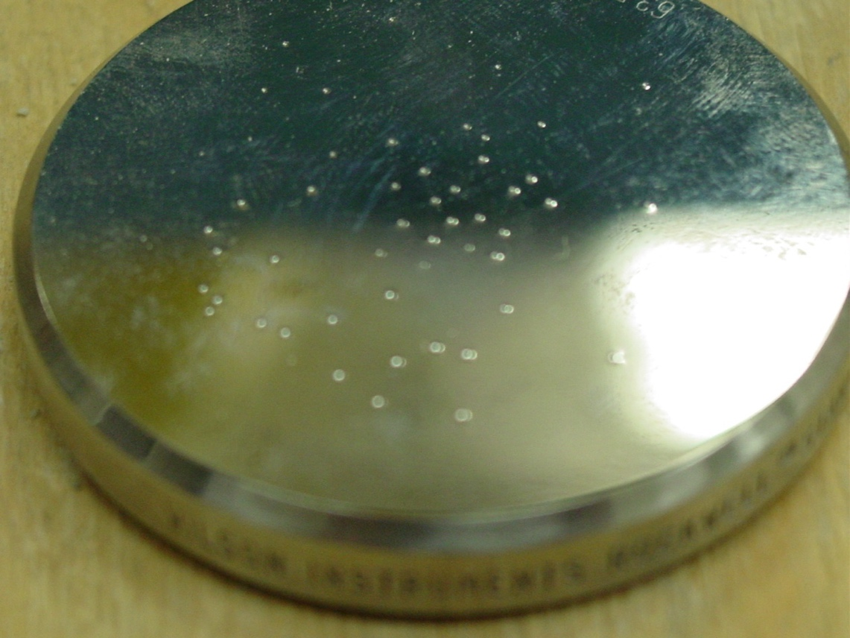
Figure 2 – Indentation on calibration block

