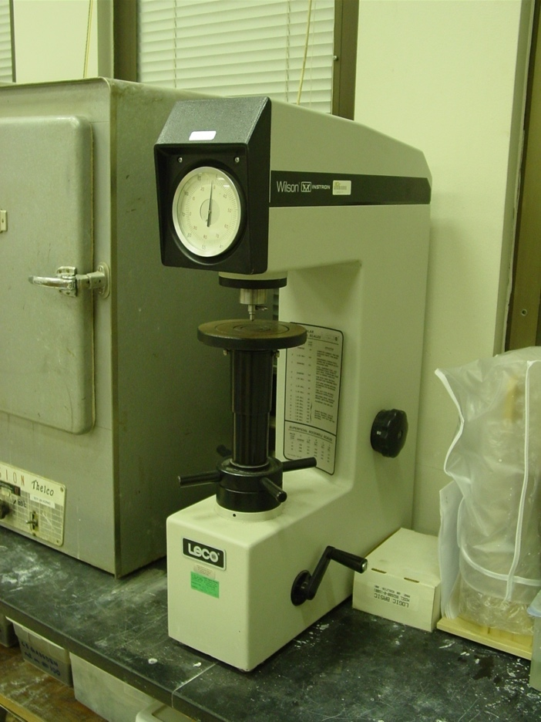
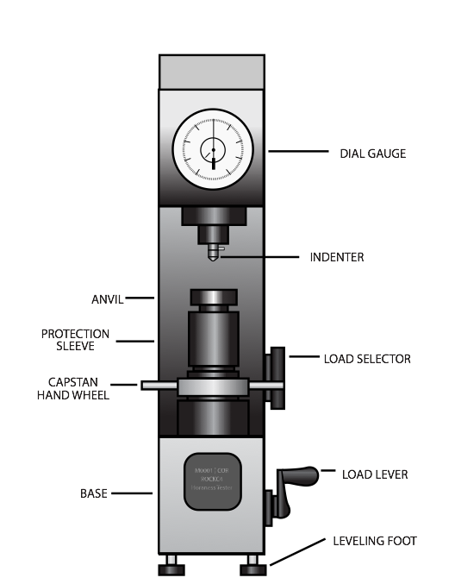

Figure 1 – Rockwell testing machine

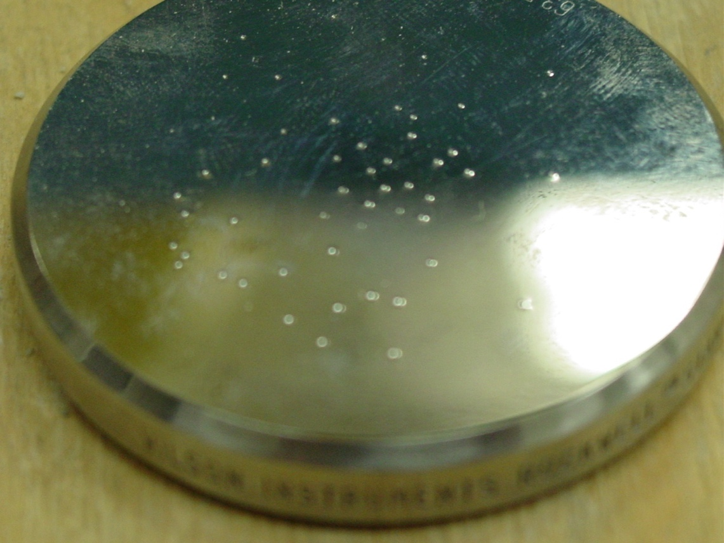
Figure 2 – Indentation on calibration block

Figure 3 – Rockwell C hardness along a Jominy specimen (redrawn from from Krauss, G., Steels: Processing, Structures and Performance, ASM, 2006)

Rockwell C (150 kg, diamond) | Tensile strength (ksi)
57 | 325
56 | 313
55 | 301
54 | 292
53 | 283
52 | 273
51 | 264
50 | 255
49 | 246
48 | 237
47 | 229
46 | 221
45 | 215
44 | 208
43 | 201
42 | 195
41 | 188
40 | 182
39 | 177
38 | 171
37 | 166
36 | 161
35 | 156
34 | 152
33 | 149
32 | 146
31 | 141
30 | 138
29 | 135
28 | 131
27 | 128
26 | 125
25 | 123
24 | 119
23 | 117
22 | 115
21 | 112
20 | 110

Figure 4 – Example conversion chart

