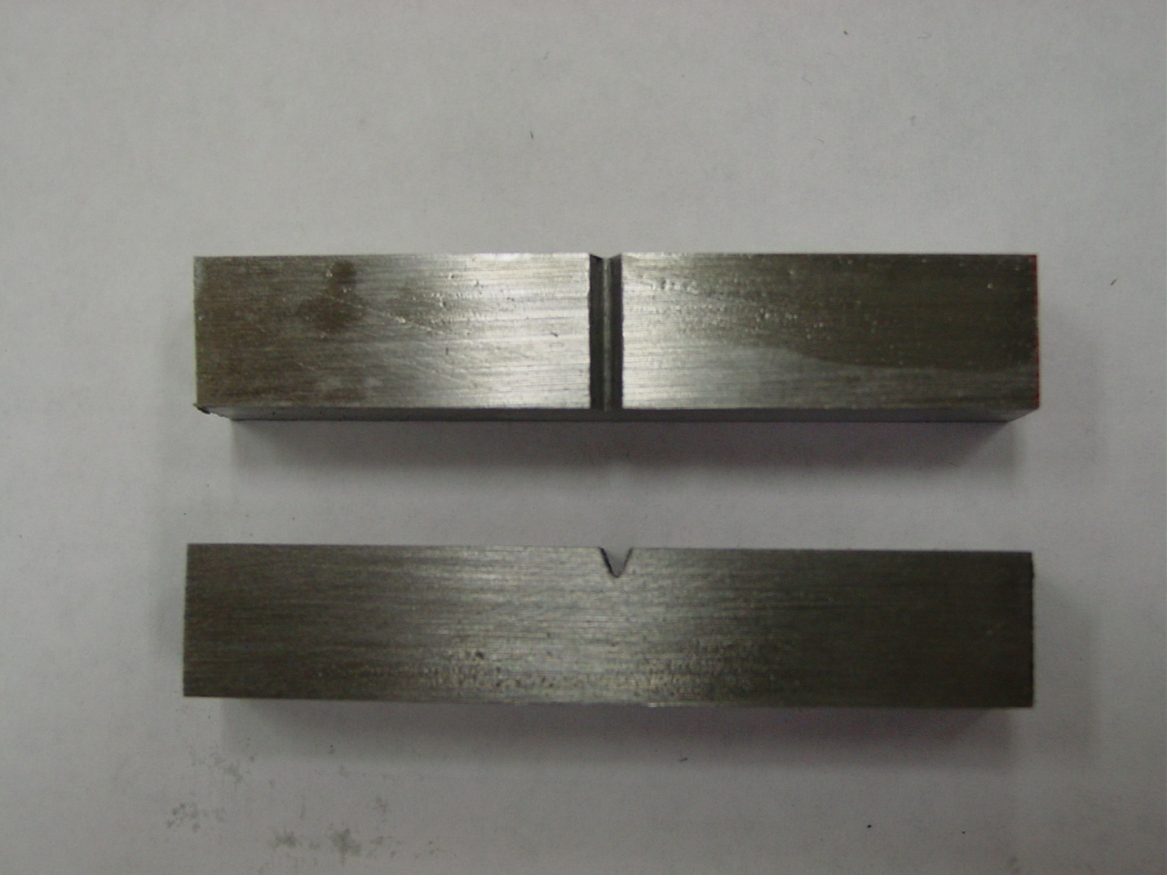

Figure 1 – Charpy specimen.

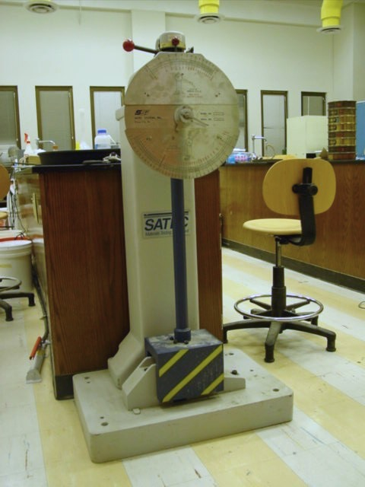

Figure 2 – Charpy testing machine.

